2021 Needs Assessment Report

Kentucky
Primary Care Office

This needs assessment was prepared by the University of Kentucky Prevention Research Center. For questions about this needs assessment contact Lynn Ann Bishop, Kentucky Primary Care Program Director, Kentucky Department for Public Health, Prevention and Quality Improvement Division, Health Care Access Branch.
Kentucky Department for Public Health, Kentucky Primary Care Office. (2021). 2021 Needs Assessment Report.

Table of Contents
Introduction 3
Methods 4
Secondary Data 4
Primary Care Needs Survey 5
Interviews 6
Stakeholders 6
Kentucky Overview 7
Demographics 7
Shortage Areas 8
Health Professional Shortage Areas: Primary Care 8
Health Professional Shortage Areas: Dental Care 9
Health Professional Shortage Areas: Mental Health Care 10
Workforce Recruitment and Retention 10
J-1 Visa Waiver 10
National Health Service Corps Program 11
Primary Care Needs: County Rankings 12
Health Status Indicators 12
Health Access Indicators 13
Primary Care Needs Survey and Interview Results 14
Respondent Characteristics 14
Health Issues 18
Disparate Populations 18
Health Care Access 19
Emerging Factors and Successes 23
Challenges 24
Primary Care Workforce 25
The Road Forward 30
Conclusion 31
References 31
Appendix A: Rankings 32
Appendix B: List of Acronyms 39

Introduction

The 2020 Scorecard on State Health System Performance ranks Kentucky as 39 out of 51 states and the District of Columbia (The Commonwealth Fund, 2020). This ranking is unchanged from the baseline ranking in 2014. Indicators used to determine the ranking include measures of access to health care, quality of care, service use and costs, health outcomes, and income-based health care disparities.

Increasing access to health care, including primary, dental, and mental health care is the focus of the Kentucky Primary Care Office (PCO). This office identifies shortage designations by facility, population or geography. Shortage destinations are used by the National Health Service Corps and others to create loan repayments, scholarships, and other incentives to encourage primary, dental, or mental health providers to practice in areas that demonstrate health care provider shortages. Bringing more health care providers to these areas will help to decrease gaps in access to care for populations that face health disparities.

The Kentucky PCO received funding from the Health Resources and Services Administration (HRSA) to produce a needs assessment report that identifies communities with the greatest unmet health care needs. This includes collecting data that identifies health workforce shortages, disparities, and barriers to accessing health care for communities across the state. This document includes the results of this needs assessment, as well as recommendations for the development of an action plan that will guide the Kentucky PCO in creating steps for future program planning.

Methods

The Kentucky PCO contracted with the University of Kentucky Prevention Research Center (UKPRC) to collaborate on developing this needs assessment. The main methods used in the needs assessment are 1) secondary data collection, 2) electronic survey, and 3) standardized interviews of key state partners.

Secondary Data
Secondary data collection includes compiling socioeconomic, health status, and health access measures. Socioeconomic data were collected to provide an overview of the state. The most recent data available were collected for health status and health access measures for each county in Kentucky. Data were collected from sources that provide county-level measurements, such as County Health Rankings. County Health Rankings uses data from other sources and these are listed below. Counties were ranked according to their measurement for each topic (health status and access), where 120 is considered the worst outcome and 1 is considered the best. Measurements that are based on small numbers are not reported, as they are unstable. The average across all items of each topic (health status and access) was then calculated and these averages were ranked to provide an overall ranking of counties for health status and access.

Health status indicators:
Poor or Fair: Percentage of adults reporting fair or poor health (age-adjusted); County Health Rankings, 2020; Kentucky Behavioral Risk Factor Surveillance System, 2017.
Physical Distress: Percentage of adults reporting 14 or more days of poor physical health per month; County Health Rankings, 2020; Kentucky Behavioral Risk Factor Surveillance System, 2017.
Mental Distress: Percentage of adults reporting 14 or more days of poor mental health per month; County Health Rankings, 2020; Kentucky Behavioral Risk Factor Surveillance System, 2017.
Obesity: Percentage of the adults (age 20 and older) that report a body mass index greater than or equal to 30; County Health Rankings, 2020 United States Diabetes Surveillance System, 2016.
Diabetes: Percentage of adults (age 20 and older) who have been diagnosed with diabetes; County Health Rankings, 2020; United States Diabetes Surveillance System, 2016.
Low Birth Weight: Percentage of live births with low birthweight (< 2,500 grams); County Health Rankings, 2020; National Center for Health Statistics - Natality files, 2012-2018.
Preventable Hospital Stays: Rate of hospital stays for ambulatory-care sensitive conditions per 100,000 Medicare enrollees; County Health Rankings, 2020; Mapping Medicare Disparities Tool, 2017.
Excessive Drinking: Percentage of adults reporting binge or heavy drinking; County Health Rankings, 2020; Kentucky Behavioral Risk Factor Surveillance System, 2017.
Smoking: Percentage of adults who are current smokers; County Health Rankings, 2020; Kentucky Behavioral Risk Factor Surveillance System, 2017.
Physically Inactive: Percentage of adults age 20 and over reporting no leisure-time physical activity; County Health Rankings, 2020; United States Diabetes Surveillance System, 2016.
Teen Births: Number of births per 1,000 female population ages 15-19; County Health Rankings, 2020; National Center for Health Statistics - Natality files, 2012-2018.
Drug OD Score: Calculated score based on fatal and non-fatal drug overdoses. Kentucky Injury Prevention Resource Center, 2018.
Health access indicators:
Uninsured: Percentage of population under age 65 without health insurance; County Health Rankings, 2020; Small Area Health Insurance Estimates, 2017.
Poverty: Percentage of all persons living in poverty; US Census Bureau, Small Area Income and Poverty Estimates, 2018.

Annual Mammogram: Percentage of female Medicare enrollees ages 65-74 that received an annual mammography screening; County Health Rankings, 2020; Mapping Medicare Disparities Tool, 2017.

Primary Care Providers: Ratio of population to primary care physicians; County Health Rankings, 2020; Area Health Resource File/American Medical Association, 2017.

Mental Health Providers: Ratio of population to mental health providers; County Health Rankings, 2020; CMS, National Provider Identification, 2019.

Dentists: Ratio of population to dentists; County Health Rankings, 2020; Area Health Resource File/National Provider Identification file, 2018.

Primary Care Needs Survey
The Primary Care Needs Survey is an electronic survey of partners that was administered in Survey Monkey. The maintenance of the survey was completed by UKPRC and the distribution by the Kentucky PCO. PCO staff shared the link with state partners and asked that they complete it and share it with local partners for participation. The survey link was also shared via email with local health departments and other health groups. The survey was open for six weeks and state partners sent a reminder to the same recipients once during this time. Data collected include perceptions about primary care needs, populations facing health disparities, health care access, and workforce concerns in Kentucky. Frequencies were calculated for answer responses and results were categorized geographically for key topics.

Interviews
Standardized interviews were conducted with key state level partners by UKPRC. The Kentucky PCO identified priority partners who were considered to have important perspectives regarding health care access and workforce in Kentucky. UKPRC contacted individuals from these organizations to schedule interviews, which were conducted by phone or video conferencing (Zoom). A questionnaire was used and the interviewer took notes, as well as recorded the interview. Data were categorized into themes and results were summarized from these.

Stakeholders
Stakeholders of the Kentucky PCO are important partners in the implementation of the office’s goals to increase access to primary, dental, and mental health care. The Kentucky PCO’s state-level stakeholders include the following organizations:
Foundation for a Healthy Kentucky
Kentucky Area Health Education Centers
Kentucky Board of Dentistry
Kentucky Board of Medical Licensure
Kentucky Cancer Consortium
Kentucky Department for Public Health
HIV Program
Infectious Disease
Laboratory Services
Maternal and Child Health
Office of Health Equity
Oral Health Program
Women’s Health
Kentucky Hospital Association
Kentucky Local Health Departments
Kentucky Primary Care Association
Kentucky Regional Health Information Organization
Kentucky Rural Health Association
Kentucky Office of Rural Health
Kentucky Youth Advocates
University of Kentucky Center of Excellence in Rural Health

Kentucky Overview

Kentucky is in the northern part of southeast United States and known historically for tobacco and coal production. A large part of the state is rural, including a significant area of eastern Kentucky, which is in Appalachia.

Demographics
The estimated population of Kentucky in 2019 was 4,467,673, which is an increase of 3% from the 2010 Census (US Census Bureau, 2020). Demographics of Kentucky residents are similar to that of the United States for age, but differ in race/ethnicity, education, and poverty/income (Figure 1).

Figure 1: Kentucky and United States Demographics 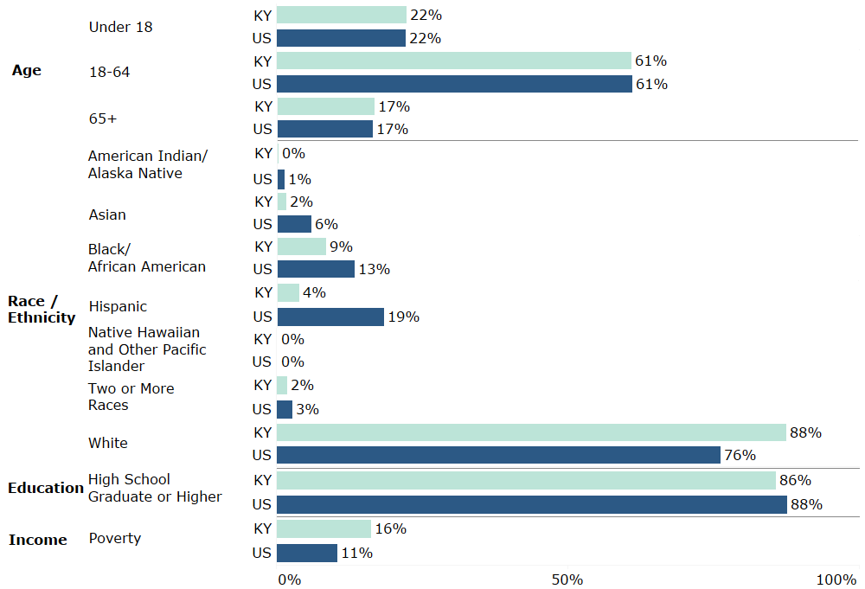
Source: US Census Bureau Population Estimates Program and American Community Survey, 2019

Shortage Areas
Areas that have been designated as having health care provider deficiencies in primary, dental, and mental health are considered to be Health Professional Shortage Areas. These designations can be based on geography, population, or facility. Medically underserved areas are areas that have a shortage of primary care providers, high infant mortality, high poverty, or high elderly population.

Health Professional Shortage Areas: Primary Care
According to 2019 HPSA designations, primary care shortages are found in all but seven counties in Kentucky (Health Resources & Services Administration, 2020). In fact, 94% of counties have a primary care shortage. A majority of the primary care HPSAs in the state are entire counties. Primary care HPSAs are found in all regions of Kentucky, with a concentration in western, southern, and eastern regions (Figure 2). Centers for Medicare and Medicaid Services (CMS) HPSA Bonus Payment Program, and the CMS Rural Health Clinic Program utilize primary care HPSAs for their programs.

Figure 2: Primary care health professional shortage areas in Kentucky, 2019
Source: data.HRSA.gov

Health Professional Shortage Areas: Dental Care
According to 2019 HPSA designations, dental care shortages are found in all but 40 counties in Kentucky (67% of the counties have a dental care shortage) (Health Resources & Services Administration, 2020). A majority of the dental care HPSAs in the state are entire counties. Dental care HPSAs are found in all regions of Kentucky, with a higher concentration in eastern Kentucky (Figure 3).
Figure 3: Dental care health professional shortage Areas in Kentucky, 2019
Source: data.HRSA.gov

Health Professional Shortage Areas: Mental Health Care
According to 2019 HPSA designations, mental health care shortages are found in all counties in Kentucky (100% of the counties have a mental health care shortage) (Health Resources & Services Administration, 2020). All of the mental health care HPSAs in the state cover entire counties (Figure 4).
Figure 4: Mental health care health professional shortage in Kentucky
Source: data.HRSA.gov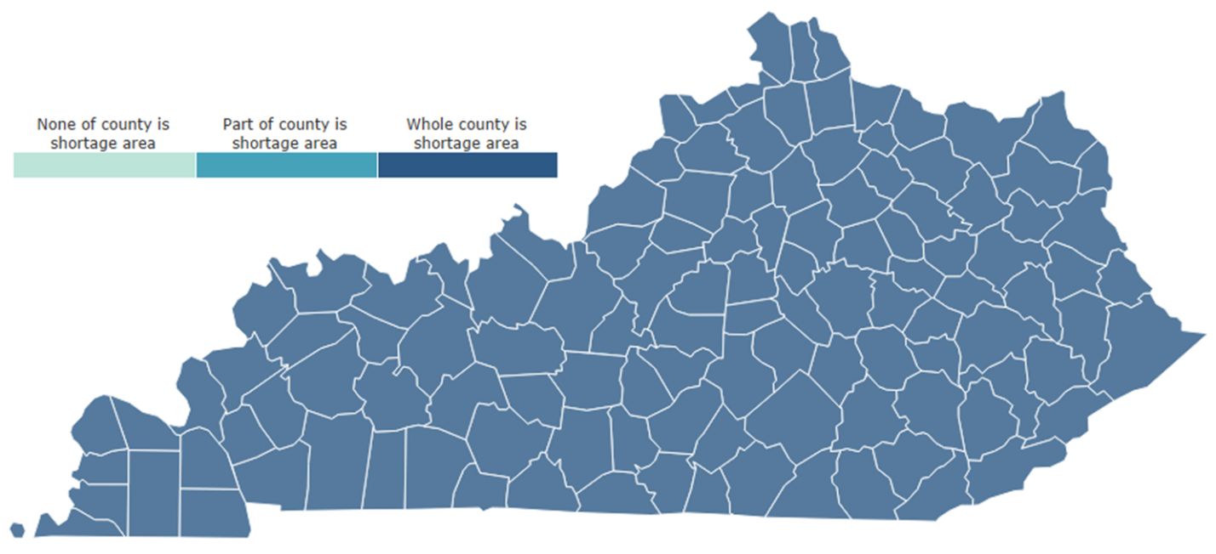

Workforce Recruitment and Retention
The Kentucky PCO administers programs that improve access to health care in Kentucky by providing increased opportunities for the health care workforce. Available workforce recruitment and retention programs are described below.

J-1 Visa Waiver
A J-1 Visa Waiver provides the opportunity for international medical graduates to waive the U.S. immigration law requirement. The requirement without the waiver is to return to their home country for two years, then apply for an H-1 B visa to re-enter and work for three years in the HPSAs in the U.S. There are four types of J-1 Visa Waiver programs available for international medical graduates in Kentucky.
The State 30 Program (also known as the Conrad 30 Program): This program allows for recommendation of up to 30 international medical graduates to receive U. S. State Department waivers each fiscal year, which is from October 1 to September 30 for the state of Kentucky.
Appalachian Regional Commission J-1 Visa Waiver Program: This program creates opportunities for health care providers located in an Appalachian county in Kentucky to recruit and retain international medical graduates through the J-1 Visa Waiver program.
HHS Exchange Visitor Program: This program enables a J-1 Visa Waiver manager to offer technical assistance to program applicants, as well as coordination of program opportunities.
The Delta Regional Authority: This program enables a J-1 Visa Waiver manager to provide technical assistance and program referrals to program applicants. The Delta Regional Authority program also allows for Waiver recommendations to be made to the U. S. State Department.

National Health Service Corps Program
The National Health Service Corps (NHSC) Program is an initiative that builds capacity among the primary care workforce by connecting trained and licensed health care clinicians to NHSC-approved sites in areas with health care workforce shortages. Eligibility includes U.S. citizens who are physicians, dentists, nurse practitioners, certified nurse-midwives, physician assistants, dental hygienists, psychologists, licensed clinical social workers, psychiatric nurse specialists, marriage and family therapists, and licensed professional counselors.
NHSC Loan Repayment Program (LRP): The NHSC LRP is a competitive program that aims to increase employment of primary medical care, dental care, and mental health care providers in HPSAs. Eligible LRP applicants are fully-trained and licensed health professionals working at NHSC-approved sites. LRP recruits may receive monetary awards to assist with repayment of outstanding qualifying education loans.
The Kentucky State Loan Repayment Program (KSLRP): The KSLRP is a loan repayment program managed by the Kentucky Office of Rural Health. The KSLRP program provides loan repayment assistance to applicants that have qualifying education loans. Applicants must make a two-year fulltime service commitment in a HPSA in order to participate and seek a sponsoring organization that would provide 50% of the loan repayment award. The remaining dollar for dollar match is pledged from a sponsor in the community, often the clinician’s employer.
NHSC Scholarship Program (SP): The NHSC Scholarship Program provides financial assistance to health professional students in need. The NHSC SP provides assistance for tuition, fees, supplies, books and a monthly living stipend. Upon completion of their degree, recipients of the SP commit to working in an area in need of increasing access to health care for the same number of years as they received educational support.
HRSA offers several NHSC incentive programs to health care participants of the NHSC, which include the LRP, SLRP and SP. Additional HRSA incentive programs include the Substance Use Disorder Workforce LRP, the Rural Community LRP, the Students to Service LRP, and the Nurse Corps. The NHSC LRP, SP and SLRP are the programs used most often in Kentucky.

Primary Care Needs: County Rankings

Health status and health access for each county in Kentucky were ranked according to their measurement for each topic, where 120 is considered the worst outcome and 1 is considered the best. The average across all items of each topic is included in the tables. These averages were ranked to provide an overall ranking of counties for health status and access. The rankings are shaded in the tables as shown in Figure 5. Measurements without ranking numbers are not shown because of small numbers.

Figure 5: Shading range (1 = best outcome/ 120= worst outcome)

Health Status Indicators
Health status indicators are measures of outcomes and factors that determine length and quality of life. Poor or fair health, physical and mental distress, and birth weight are health status indicators that are outcomes of other indicators that play a role in health status, such as tobacco use, exercise, and alcohol and drug use. Figure 6 shows the five lowest and highest ranking counties in terms of health status indicators, along with the ranking for each indicator and county. Figure 7 shows the average ranking for health status indicators geographically. The lowest ranking (better outcome) counties in terms of health status indicators are Oldham, Lyon, Woodford, Shelby, and Marshall. The highest ranking (worse outcome) counties in terms of health status indicators are Clay, Elliott, Breathitt, Bell, and Floyd. All counties and their health access rankings can be seen in Appendix A, Table A1.
Figure 6: Five lowest and highest ranking counties based on health status indicators
(low rank= better outcome/ high rank= worse outcome)
County | Poor or Fair | Physical Distress | Mental Distress | Obesity | Diabetes | Low Birth Weight | Preventable Hospital Stays | Excessive Drinking | Smoking | Physically Inactive | Teen Births | Drug OD Score | Average Health Ranking
Lowest ranking counties (best health status)
Oldham County | 1 | 1 | 1 | 1 | 6 | 5 | 5 | 114 | 1 | 1 | 1 | 47 | 1
Lyon County | 13 | 7 | 6 | 3 | 34 | 11 | 25 | 70 | 11 | 48 | 29 | 32 | 2
Woodford County | 9 | 11 | 10 | 26 | 8 | 36 | 1 | 97 | 4 | 4 | 2 | 86 | 3
Shelby County | 15 | 13 | 11 | 16 | 35 | 23 | 24 | 98 | 8 | 18 | 11 | 72 | 4
Marshall County | 11 | 12 | 17 | 93 | 20 | 7 | 23 | 79 | 12 | 28 | 24 | 30 | 5
Highest ranking counties (worst health status)
Clay County | 119 | 116 | 116 | 71 | 48 | 119 | 110 | 24 | 119 | 87 | 110 | 90 | 116
Elliott County | 114 | 113 | 110 | 105 | 110 | 111 | 61 | 20 | 115 | 97 | 114 | 83 | 117
Breathitt County | 116 | 114 | 114 | 90 | 117 | 114 | 109 | 10 | 113 | 77 | 112 | 68 | 118
Bell County | 113 | 118 | 117 | 83 | 118 | 105 | 102 | 3 | 116 | 108 | 116 | 79 | 119
Floyd County | 115 | 112 | 112 | 114 | 97 | 103 | 112 | 7 | 100 | 101 | 113 | 94 | 120

Figure 7: Average health status ranking by county

Health Access Indicators
Health access indicators are measures of access and quality of care, such as the rate of health care providers and the rate of preventable hospital stays. Accessing health care in a timely manner contributes to healthier lifestyles with an increase in prevention and early detection of diseases. Figure 8 shows the five lowest and highest ranking counties in terms of health access indicators, along with the ranking for each indicator and county. Figure 9 shows the average ranking for health access indicators geographically. The lowest ranking (better outcome) counties in terms of health access indicators are McCracken, Boone, Hardin, Jefferson, and Daviess. The highest ranking (worse outcome) counties in terms of health access indicators are Harlan, Martin, McCreary, Clay, and Casey. All counties and their health access rankings can be seen in Appendix A, Table A2.

Figure 8: Five lowest and highest ranking counties based on health access indicators
(low rank= better outcome/ high rank= worse outcome)
County | Uninsured | Poverty | Annual Mammogram | Primary Care Providers | Mental Health Providers | Dentists | Average Access Ranking
Lowest ranking counties (best health access)
McCracken County | 23 | 29 | 4 | 4 | 23 | 4 | 1
Boone County | 2 | 2 | 11 | 24 | 47 | 16 | 2
Hardin County | 7 | 21 | 40 | 25 | 8 | 5 | 3
Jefferson County | 52 | 36 | 9 | 5 | 13 | 3 | 4
Daviess County | 18 | 32 | 1 | 36 | 15 | 20 | 5
Highest ranking counties (worst health access)
Harlan County | 87 | 114 | 117 | 79 | 99 | 67 | 116
Martin County | 88 | 119 | 111 | 69 | 88 | 116 | 117
McCreary County | 111 | 115 | 116 | 90 | 50 | 111 | 118
Clay County | 116 | 118 | 120 | 58 | 92 | 101 | 119
Casey County | 119 | 98 | 102 | 115 | 64 | 108 | 120

Figure 9: Average health access ranking by county

Primary Care Needs Survey and Interview Results

Respondent Characteristics
The Primary Care Needs Survey was administered from December 2020 to January 2021. A total of 261 state and local partners and stakeholders completed the survey, representing all counties of Kentucky (Figure 9) and multiple types of organizations (Figure 10). Many respondents’ organizations served more than one county. Additionally, 18% of respondents’ organizations were statewide. Most often, respondents represented local organizations, including local health departments, schools, and community health centers or other community organizations. Most respondents’ organizations serve rural areas (Figure 11).
Interviews were conducted virtually with 12 key state partners during January 2021 to gather additional information. Participants represented the Kentucky Department for Public Health, Kentucky Primary Care Association, Area Health Education Centers, a non-profit advocacy group, state rural health agencies, and a regional health system.
Figure 9: Number of survey respondents by county of organizational service area

Figure 10: Survey respondent organization types
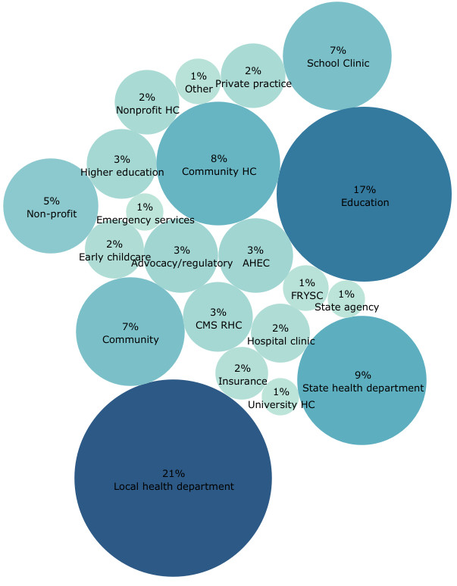
Note: ‘Other’ includes professional, religious, and local government.
Figure 11: Type of survey respondent organization service area- rural, urban, or suburban
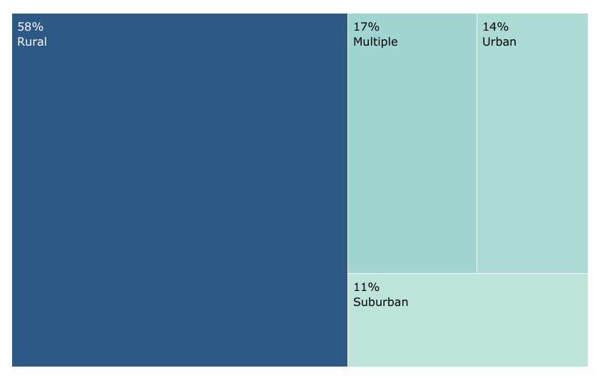

Health Issues
Survey and interview respondents shared the information about the greatest health issues facing the communities their organizations serve. A majority of survey respondents said that one of the greatest health issues in their community is drug and alcohol abuse (Figure 12). This is followed by COVID-19 and mental health issues.
Interview data echoed survey results and provided additional context on the causes of health issues that Kentuckians face. These include poverty, low health literacy, social determinants of health, uncertainty in some medical providers, parental incarceration, and what one interviewee termed “cultural fatalism,” or the idea that certain cultural behaviors, including eating habits, are a part of the way of life in Kentucky. Another interviewee shared that Kentuckians have negative attitudes towards those outside their community that tell them their “way of life isn’t ideal,” including behaviors relating to nutrition and exercise.
Figure 12: Greatest health issues facing Kentuckians*
Note: ‘Other’ includes asthma/allergies, homicide, trauma, and aging. Percentages do not add to 100 because multiple answers could have been selected.

Disparate Populations
Respondents shared information on populations that face health disparities, including differences in access to care and health outcomes, in the communities where they work. Survey respondents were most likely to say that low income populations face greater health disparities, followed by racial/ethnic minorities (including Black/African American, Hispanic/Latino, and indigenous populations), and elderly (Figure 13). Other populations not shown include low education; uninsured; homeless; unemployed; middle age; middle income; pregnant; lesbian, gay, bisexual, transgender, and queer (LGBTQ); the mental health population; and others. The ‘Immigrant’ category includes the following populations: immigrants, undocumented immigrants, refugees, migrants, and those with English as a second language.
Interview respondents echoed these results, stating that those in poverty; minorities; uninsured and underinsured, such as the mid-low income working poor; populations with language barriers; and rural populations, including eastern and western Kentuckians face a higher degree of unmet health care needs.
Figure 13: Disparate Populations of Kentucky*
Note: Percentages do not add to 100 because multiple answers could have been selected.

Health Care Access
Respondents shared information on the greatest barriers that patients face when accessing care in the communities where they work (Figure 14). Transportation was cited as the greatest health access issue by survey respondents, followed by inability to afford care, lack of insurance and lack of awareness of services. Geographically, survey respondents were more likely to state that transportation, affordability, and lack of insurance were barriers to accessing health care if their organizations served counties in the eastern and western areas of the state, compared to organizations covering central Kentucky (Figures 15-17). Respondents from organizations serving western counties cited lack of awareness as a barrier more often (Figure 18).
Figure 14: Greatest barriers for patients accessing care in Kentucky*
Note: ‘Other’ includes provider bias, housing issues, and COVID19 fears. Percentages do not add to 100 because multiple answers could have been selected.

Figure 15: Percentage of respondents that stated lack of transportation is a barrier to accessing health care in their community, by county of organization
Figure 16: Percentage of respondents that stated affordability is a barrier to accessing health care, by county of organization
Figure 17: Percentage of respondents that stated lack of insurance is a barrier to accessing health care, by county of organization
Figure 18: Percentage of respondents that stated lack of awareness of services is a barrier to accessing health care, by county of organization
Interview respondents shared additional information about health care access issues in Kentucky, including challenges relating to workforce. A lack of in-network providers, providers accepting Medicaid, and providers accepting new patients are pieces of this challenge. Multiple interviewees stated that there is a need for more dental providers that accept Medicaid, with one saying, “we definitely don’t have enough Medicaid dental providers.” This theme came up in the survey comments, as well. Another interviewee stated that there is a lack of psychiatrists in their region due to insufficient training opportunities in the state.
“We definitely don’t have enough Medicaid dental providers.”
Aside from transportation, rural areas offer additional challenges for accessing a healthy lifestyle. Multiple interviewees stated that exercise opportunities are missing in the area where they live and work. One commented that they “don’t have the ability to go walk out on the road or run. There are coal trucks. There is no structure there for exercise."
We “also have to think about health care access as: if they build it why don’t they come." We need to consider whether or not everyone "feels respected and valued by the health care system."
Interviewees stated that not having health insurance is an access issue as well, specifically with non-citizens, and lack of translation services can be a barrier for this group to access care. Even with insurance, copays can cause barriers, as some individuals are unable to afford payment. Likewise, mistrust in providers or the health care system are barriers for some groups, including in western Louisville, northern Kentucky, and Appalachia. Interviewees stated that these groups do not feel comfortable receiving health care due to mistrust, which poses access challenges even when transportation and insurance are not issues. One interviewee said that transportation is important, but we “also have to think about health care access as: if they build it why don’t they come." We need to consider whether or not everyone "feels respected and valued by the health care system."

Emerging Factors and Successes
Emerging factors that increase access to primary care in survey respondents’ communities include telehealth and Medicaid expansion (Figure 19). Interviewees said telehealth is a facilitator to increasing access to health care because it has “opened borders” for individuals accessing primary, dental, and mental health care by eliminating or reducing many access issues, and these capabilities have been fast-tracked due to the COVID19 pandemic. Telehealth provides an opportunity for individuals without personal or public transportation to receive care. It also reduces caregiver barriers of individuals needing child or elder care in order to see a provider. Telehealth reduces stigma barriers, as well. One interviewee stated that telehealth can increase the likelihood of individuals seeking mental health care because they will not worry about being recognized at a mental health clinic in a small rural town.
Multiple interviewees stated that the implementation of Federally Qualified Health Centers (FQHC) is a success in Kentucky. One interview respondent stated that Kentucky’s FQHCs are “among the more robust and well-developed” in the nation and many offer a “full-spectrum” of care that includes primary, dental, and mental health services. Another interviewee said the integration of mental, behavioral, and primary care in FQHCs helps to reduce stigma for some individuals because “no one knows what you are coming for.”
Health systems are becoming more aware as Kentucky makes the move to value-based care, “recognizing that if we are going to be compensated for outcomes rather than procedure, prevention becomes important, and then getting into communities becomes important.”
The opening of school health centers was another example of a success shared by interviewees in Kentucky, including the offering of primary, dental, and mental health care in school settings through school based clinics and programs. An additional school health program that was noted as a success is the Public Health Dental Hygiene Program, administered by the Kentucky Oral Health Program. This program sends teams to schools in rural areas to provide preventive dental services and refers children to dental offices, often for their first visit.
Interviewees also said that the COVID19 pandemic has led to successes in primary, dental and mental health care in Kentucky. This includes the increase in telehealth; funding for providers; and increased innovation, flexibility and collaboration by providers and partners. One interviewee said it was inspiring to see providers and administrators in rural areas “adapt and embrace” the situation by setting up pop-up tents to be able to see patients outside of clinics, partnering with churches and civic centers to hold screening events in larger areas, and providing tablets and internet access to patients in clinic parking lots for telehealth visits.
Other emerging factors and successes shared by interviewees include the growth of retail medicine; mobile units; leadership that prioritizes health; parity to provide insurance coverage for mental health visits; and the use and training of patient navigators or community health workers, which are seen as trusted entities in the community. One interviewee stated that a facilitator now is that health systems are becoming more aware as Kentucky makes the move to value-based care, “recognizing that if we are going to be compensated for outcomes rather than procedure, prevention becomes important, and then getting into communities becomes important.”
Figure 19: Emerging factors that are increasing primary care in Kentucky*
Note: ‘Other’ includes provider bias training, school clinics, raising awareness, church screenings, CHWs, discount program, and walk-in clinics. Percentages do not add to 100 because multiple answers could have been selected.

Challenges
“Internet is not the same up in the hollows and in the real rural parts of Kentucky.”
While telehealth was described by both survey and interview respondents as an aid to individuals accessing health care, many said there are challenges for telehealth. An overarching challenge is a lack of internet coverage across the state, particularly in rural areas. One interviewee said that “internet is not the same up in the hollows and in the real rural parts of Kentucky,” with some counties having no internet service at all. This is followed by individuals not having the equipment to engage in telehealth. Additionally, if internet coverage does exist, low income individuals may be limited to a certain number of minutes on their phone plans, which reduces their ability to have a health care visit, or have a fear of using telehealth because of privacy issues (not wanting others in the patient’s home to hear or fearing there are others on the provider side listening in).
FQHCs were noted as primary, dental, and mental health care successes by interviewees, but there are a limited number of these centers in the state. An interviewee stated that, while FQHCs are helping to increase access to health care, the impact is not broad enough to reach everyone. Kentucky has Rural Health Centers (RHC), which improve access to care by being located throughout the rural areas, but according to a survey respondent, RHCs may have limited resources. Further, not all FQHCs or RHCs offer comprehensive services, such as integrated behavioral health and dental care. Mobile units were also named as a facilitator to increase access to health care, but there is currently only one dental mobile unit and more are needed to “start to answer the need in eastern Kentucky.”
Also noted by interviewees as a success was the introduction of parity to provide insurance coverage of mental health visits. However, multiple interviewees shared limitations to parity, including how much the insurance covers and loop holes which lead to gaps in reimbursement for mental health providers. Interviewees described other challenges relating to insurance, such as insufficient reimbursement for primary care providers and dentists and provider “burnout” caused by the “amount of documentation required to get reimbursement and to make sure you are hitting all the marks and checking boxes.” Another interviewee said that, with Medicaid, it takes more time to understand the system and to be reimbursed at an adequate level and not a lot of providers accept Medicaid because of that. Echoing this, a different interviewee stated that it costs the same, if not more, for dental providers to treat Medicaid patients because they need more management and time, as their presentations are usually more severe. This also reduces the willingness of some dentists to see patients with Medicaid coverage.
Other challenges in primary, dental, and mental health care shared by interviewees are the stigma around mental health, which includes individuals not wanting others to know they are being treated for a mental health issue because they fear being looked down upon. Individuals’ fears and mistrust of providers are also challenges that Kentucky faces regarding increasing access to health care, particularly for those who never or rarely receive health care. One interviewee stated that “our biggest challenge is how to reach those people and comfort them so that they will seek care.”

Primary Care Workforce
Types of providers that most often deliver health care in respondents’ communities were most commonly said to be nurse practitioners and doctors (Figure 20). Nearly half of respondents stated that physician assistants deliver health care, as well. A lower percentage of survey respondents from organizations in some central counties stated that doctors deliver health care, compared to other areas of the state (Figure 21). Similarly, a lower percentage of survey respondents from organizations in some central and northern counties stated that nurse practitioners deliver health care (Figure 22). A higher percentage of survey respondents from organizations serving eastern counties stated that physician assistants delivered health care, compared to other areas (Figure 23).
Figure 20: Types of providers that deliver health care in Kentucky*
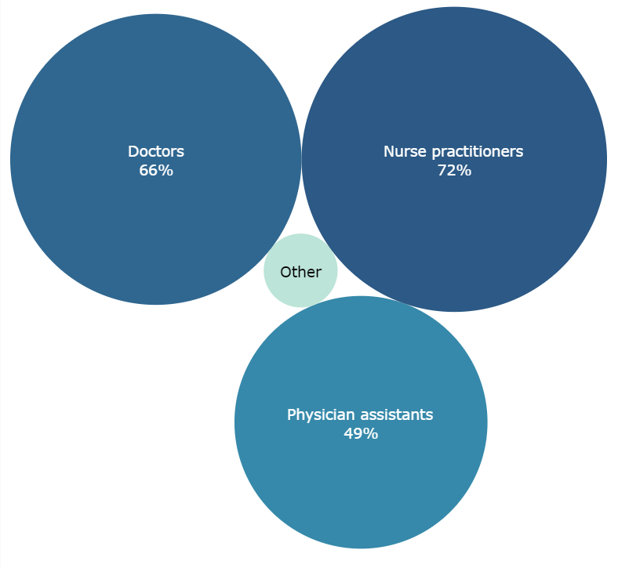
Note: ‘Other’ includes midwives, home health aides, school nurses, registered nurses, and allied health professionals. Percentages do not add to 100 because multiple answers could have been selected.
Figure 21: Percentage of respondents that stated that doctors deliver health care, by county of organization
Figure 22: Percentage of respondents that stated that nurse practitioners deliver health care, by county of organization
Figure 23: Percentage of respondents that stated that physician assistants deliver health care, by county of organization
The three greatest primary care workforce concerns facing Kentucky communities include a lack of providers in rural areas, retention of staff, and lack of competitive salary/benefits (Figure 24). Interviewees shared more information, with one stating that “there is a huge need for education in mental health, for developing professionals in mental health.” Another said that there are not enough dental providers in rural areas and for those that are there, the hours they are available are not sufficient. Another workforce concern shared was that the starting pay for primary care providers in rural areas is, at times, not enough to pay loans when just starting their career.
When asked if the primary care workforce in Kentucky is strong or weak, most interviewees said that while the state’s providers are dedicated and committed, the workforce numbers are weak. One person stated, “I think [the primary care workforce is] weak because we’ve created structures that reduce the attractiveness of being in primary care—the amount of burden on primary care [providers] to be all things to all people.” However, multiple interviewees also said that progress has been made in the primary care workforce in Kentucky in recent years, such as increasing numbers of nurse practitioners and physician assistants providing care, which allows providers to work “at the scope of their license.”
“I think [the primary care workforce is] weak because we’ve created structures that reduce the attractiveness of being in primary care—the amount of burden on primary care [providers] to be all things to all people.”
Regarding the dental workforce, interviewees stated the numbers are weak. One interviewee said, “availability does not always equal access" because dentists limit the number of Medicaid patients they see (as described earlier). Many interviewees stated that the dental workforce in Kentucky has “maldistribution.” While the ratio of people to dentists in Kentucky is close to that of the nation and there are enough dentists to address the need in urban and suburban areas of the state, there are many rural areas with too few dentists to serve the needs of residents. Some rural counties in both western and eastern Kentucky have no dentist at all, do not have dentists that accept Medicaid, or lack dentist that are trained in pediatrics.
The mental health workforce was described by interviewees as weak. One interviewee stated that part of the challenge relates back to reimbursement and compensation levels, which are not adequate to attract or keep this workforce. This includes payments for psychologists, psychiatrists, and licensed clinical social workers, which all need compensation levels that will attract them to do a demanding role. Another interviewee said that the mental health workforce in Kentucky has made progress because of an increase in awareness and recognition of mental health issues, but overall it is weak due to being overwhelmed with the opioid crisis and substance use disorder. Multiple interviewees stated that there is an increased need for behavioral health nurse practitioners. One described a challenge that there are currently not enough behavioral health nurse practitioners in the state to serve as preceptors to train the amount of these practitioners we need for the next generation.
Figure 24: Primary care workforce concerns*
Note: ‘Other’ includes lack of recognition programs, not having enough time with patients, providers not accepting new patients, lack of practice sites, long wait times for new patients, and a need for CHWs and reimbursement for these. Percentages do not add to 100 because multiple answers could have been selected.

Survey respondents were more likely to state that the NHSC Loan Repayment Program and the Kentucky NHSC Loan Repayment Program were available programs in their community (Figure 25). Nearly three fourths of respondents left this question blank or stated they were unsure of what programs were available.
Benefits of these programs cited by both survey and interview respondents are that they assist the provider by paying back education loans, encourage providers to work in rural areas they may not have chosen otherwise, and increase diversity of smaller communities. Recruitment and retention programs also increase the participating site’s ability to compete with larger, higher paying hospitals or clinics.
Challenges of these programs are that the participating provider may leave the assigned area after the commitment is over, the application process is cumbersome, awareness of the programs is low, and a lack of provider interest to participate, despite the benefits. Also, there are often financial requirements to participate that might be challenging for smaller clinics or hospitals. Another challenge noted by an interviewee is that when recruitment and retention programs bring in foreign trained providers, rural communities may have resentment and mistrust initially toward the provider.
“It is sometimes a gamble to invest in a person in the community because they could leave when they do residency outside of the community.”
Many interviewees stated that working in a rural area may be less enticing to a new graduate because they will be less likely to have equipment needed or a smaller team to work with, which may mean a more demanding working situation. Further, in rural areas, there are fewer amenities, such as tennis courts, walking paths, or dog parks. These factors, along with higher pay in urban and suburban areas, lead to higher provider turnover in rural areas. This can make it difficult for communities to gain trust and familiarity with a primary care provider. The increase in rural “Grow Your Own” strategies focuses on recruiting and training individuals from rural communities to stay and work as providers in those communities. However, not all training can be done in rural communities. As one interviewee stated, “it is sometimes a gamble to invest in a person in the community because they could leave when they do residency outside of the community.”
Figure 25: Respondent knowledge of recruitment and retention programs available in the community*
Note: ‘Other’ includes Kentucky Ready to Work, Public Service Loan Forgiveness, and Hospital/clinic recruitment. Percentages do not add to 100 because multiple answers could have been selected.

The Road Forward
Interview respondents shared thoughts on what the future looks like for improving primary, dental, and mental health care in Kentucky. These thoughts include increasing training opportunities, increasing and streamlining insurance reimbursement, using non-traditional and allied health professionals, and community engagement. Specifically, interviewees suggested:
- More residency programs in rural communities
- More community health centers (FQHCs and RHCs) across the state
- Increase competitiveness of pay through increased reimbursement
- Streamline reimbursement processes
- Conduct population health analyses and explore opportunities to incentivize prevention
- Train primary care providers in team care and align with dental and mental health; create a reimbursement system that supports team care
- Look beyond traditional clinicians to allied health practitioners
- Focus on training behavioral health nurse practitioners
- Increase use of community health workers and explore Medicaid reimbursement
- Engage communities by exploring social determinants of health with community members, including system barriers that affect vulnerable populations (inadequate housing, water, etc.)

Conclusion
According to Kentucky PCO stakeholders, Kentucky has made progress toward overcoming challenges related to primary care in recent years. The implementation of FQHCs, RHCs, mobile units, and telehealth has increased access to primary, dental, and mental health care services for Kentuckians, and begins to bridge the health care gap for those disparately affected by limited access, such as low income and racial/ethnic minorities. However, challenges still exist and more is needed to increase access and improve health outcomes in HPSA designated areas and counties with worse health status and access rankings in western, southern and eastern sections of the state. More FQHCs are needed to reach Kentuckians in these areas, RHCs that are already in these areas need a broader range of services and more resources, affordable broadband connectivity is still needed in some rural counties, and transportation remains a challenge for many. Leading primary care workforce concerns include a lack of providers in rural areas and low retention of primary care staff, which stem from a lack of competitive pay and reimbursement issues. To overcome these challenges, Kentucky PCO stakeholders recommend building training and educational capacity locally for the primary, dental, and mental health care workforce, exploring improvements to reimbursements for providers, increasing awareness of workforce recruitment and retention programs, and increasing the use of community health workers, allied health professionals, and behavioral health nurse practitioners.

References

Health Resources & Services Administration. (2020, 12 2). Data by Geography, Kentucky. Retrieved from Health Resources & Services Administration: https://data.hrsa.gov/geo
Robert Wood Johnson Foundation. (2020, 12 2). Kentucky County Health Rankings. Retrieved from County Health Rankings: https://www.countyhealthrankings.org/app/kentucky/2020/overview
The Commonwealth Fund. (2020). 2020 Scorecard on State Health System Performance. New York: The Commonwealth Fund.
US Census Bureau. (2020, 12 2). US and KY Quickfacts. Retrieved from US Census Bureau: https://www.census.gov/quickfacts/fact/table/US/PST045219?

Appendix A: Rankings
Table A1: County Health Status Rankings *
County | Poor or Fair | Physical Distress | Mental Distress | Obesity | Diabetes | Low Birth Weight | Preventable Hospital Stays | Excessive Drinking | Smoking | Physically Inactive | Teen Births | Drug OD Score | Average Health Ranking
Oldham County | 1 | 1 | 1 | 1 | 6 | 5 | 5 | 114 | 1 | 1 | 1 | 47 | 1
Lyon County | 13 | 7 | 6 | 3 | 34 | 11 | 25 | 70 | 11 | 48 | 29 | 32 | 2
Woodford County | 9 | 11 | 10 | 26 | 8 | 36 | 1 | 97 | 4 | 4 | 2 | 86 | 3
Shelby County | 15 | 13 | 11 | 16 | 35 | 23 | 24 | 98 | 8 | 18 | 11 | 72 | 4
Marshall County | 11 | 12 | 17 | 93 | 20 | 7 | 23 | 79 | 12 | 28 | 24 | 30 | 5
Boone County | 3 | 3 | 3 | 59 | 20 | 4 | 31 | 117 | 3 | 11 | 5 | 100 | 6
Fayette County | 5 | 9 | 16 | 4 | 13 | 53 | 6 | 119 | 17 | 2 | 7 | 109 | 7
Daviess County | 18 | 23 | 22 | 19 | 43 | 22 | 10 | 86 | 2 | 27 | 40 | 57 | 8
Nelson County | 6 | 6 | 9 | 55 | 28 | 40 | 3 | 108 | 7 | 19 | 20 | 83 | 9
Scott County | 7 | 8 | 8 | 45 | 3 | 34 | 40 | 115 | 6 | 20 | 10 | 97 | 10
Warren County | 17 | 25 | 19 | 11 | 3 | 69 | 52 | 112 | 21 | 7 | 6 | 57 | 11
Trigg County | 30 | 19 | 21 | 32 | 64 | 6 | 13 | 82 | 26 | 42 | 51 | 18 | 12
Campbell County | 12 | 15 | 15 | 23 | 10 | 32 | 49 | 118 | 14 | 8 | 13 | 113 | 13
Calloway County | 51 | 49 | 51 | 34 | 11 | 3 | 68 | 111 | 16 | 22 | 3 | 10 | 14
Boyle County | 23 | 42 | 28 | 8 | 76 | 45 | 27 | 87 | 27 | 3 | 23 | 68 | 15
Henry County | 45 | 41 | 43 | 9 | 17 | 17 | 34 | 68 | 38 | 9 | 39 | 101 | 16
Livingston County | 33 | 38 | 42 | 26 | 9 | 31 | 97 | 60 | 23 | 48 | 44 | 18 | 17
Kenton County | 2 | 4 | 5 | 35 | 26 | 63 | 21 | 120 | 40 | 14 | 21 | 118 | 17
Spencer County | 4 | 2 | 2 | 73 | 113 | 19 | 45 | 109 | 5 | 35 | 9 | 68 | 19
Hancock County | 39 | 21 | 33 | 18 | 90 | 9 | 2 | 96 | 47 | 39 | 84 | 7 | 20
Pendleton County | 14 | 14 | 14 | 35 | 1 | 37 | 53 | 106 | 22 | 20 | 55 | 115 | 21
Caldwell County | 28 | 43 | 39 | 39 | 81 | 26 | 32 | 59 | 19 | 28 | 90 | 9 | 22
Washington County | 21 | 34 | 23 | 50 | 87 | 51 | 16 | 85 | 24 | 13 | 18 | 75 | 23
Meade County | 27 | 27 | 20 | 74 | 68 | 10 | 56 | 104 | 48 | 42 | 16 | 7 | 24
Breckinridge County | 49 | 44 | 45 | 2 | 53 | 46 | 78 | 64 | 65 | 14 | 26 | 18 | 25
Bourbon County | 41 | 37 | 36 | 14 | 20 | 48 | 51 | 61 | 31 | 46 | 22 | 97 | 25
Madison County | 19 | 35 | 35 | 55 | 16 | 78 | 18 | 110 | 9 | 5 | 8 | 120 | 27
Clark County | 16 | 18 | 24 | 67 | 20 | 77 | 12 | 66 | 10 | 26 | 62 | 120 | 28
Jessamine County | 32 | 31 | 27 | 39 | 41 | 59 | 9 | 94 | 28 | 36 | 12 | 113 | 29
Jefferson County | 34 | 16 | 7 | 25 | 39 | 81 | 46 | 116 | 20 | 12 | 17 | 113 | 30
Bullitt County | 8 | 5 | 4 | 49 | 101 | 20 | 76 | 107 | 18 | 31 | 15 | 100 | 31
Harrison County | 25 | 28 | 32 | 59 | 14 | 42 | 35 | 78 | 25 | 58 | 49 | 90 | 32
McCracken County | 47 | 36 | 25 | 13 | 28 | 64 | 30 | 113 | 42 | 32 | 48 | 61 | 33
Carlisle County | 67 | 78 | 78 | 6 | 18 | 1 | 63 | 43 | 62 | 73 | 54 | 7 | 34
Mercer County | 36 | 40 | 38 | 7 | 76 | 73 | 43 | 80 | 34 | 34 | 36 | 54 | 35
Mason County | 43 | 32 | 40 | 48 | 43 | 29 | 11 | 50 | 66 | 63 | 52 | 80 | 36
Anderson County | 10 | 10 | 13 | 78 | 81 | 14 | 37 | 101 | 15 | 81 | 33 | 91 | 37
Bracken County | 52 | 51 | 54 | 24 | 12 | 90 | 15 | 84 | 41 | 48 | 34 | 64 | 38
Hopkins County | 24 | 30 | 37 | 65 | 79 | 41 | 60 | 25 | 32 | 70 | 87 | 22 | 39
Larue County | 55 | 47 | 47 | 67 | 15 | 58 | 81 | 62 | 49 | 46 | 37 | 14 | 40
Green County | 46 | 55 | 50 | 50 | 39 | 35 | 88 | 27 | 43 | 45 | 53 | 47 | 40
Fleming County | 38 | 56 | 61 | 45 | 55 | 33 | 59 | 92 | 59 | 30 | 32 | 25 | 42
Crittenden County | 54 | 54 | 56 | 19 | 3 | 38 | 119 | 81 | 56 | 39 | 66 | 9 | 43
Hardin County | 22 | 22 | 18 | 88 | 62 | 13 | 66 | 99 | 45 | 58 | 28 | 75 | 44
Franklin County | 31 | 17 | 12 | 81 | 51 | 89 | 64 | 102 | 13 | 16 | 25 | 104 | 45
Simpson County | 37 | 33 | 34 | 90 | 57 | 83 | 91 | 88 | 39 | 10 | 38 | 25 | 46
Edmonson County | 59 | 58 | 58 | 70 | 96 | 2 | 73 | 76 | 54 | 6 | 27 | 54 | 47
Logan County | 53 | 48 | 52 | 94 | 6 | 16 | 80 | 93 | 63 | 33 | 73 | 27 | 48
Garrard County | 35 | 24 | 30 | 96 | 99 | 88 | 17 | 89 | 30 | 22 | 47 | 63 | 49
Gallatin County | 20 | 26 | 29 | 15 | 71 | 74 | 19 | 100 | 44 | 58 | 68 | 117 | 50
Butler County | 57 | 66 | 75 | 19 | 62 | 8 | 83 | 58 | 74 | 53 | 76 | 14 | 51
Ballard County | 40 | 39 | 44 | 72 | 90 | 67 | 55 | 56 | 33 | 114 | 50 | 4 | 52
Hickman County | 93 | 88 | 94 | 12 | 64 | 21 | 111 | 9 | 70 | 89 | 19 | 2 | 53
Owen County | 44 | 29 | 31 | 57 | 110 | 55 | 8 | 83 | 37 | 84 | 31 | 114 | 54
Hart County | 81 | 86 | 80 | 16 | 1 | 24 | 48 | 31 | 78 | 89 | 81 | 70 | 55
Muhlenberg County | 63 | 71 | 55 | 59 | 36 | 30 | 70 | 38 | 55 | 84 | 91 | 38 | 56
Trimble County | 29 | 20 | 26 | 78 | 79 | 80 | 72 | 95 | 35 | 70 | 43 | 72 | 57
Cumberland County | 70 | 59 | 66 | 82 | 93 | 25 | 116 | 30 | 50 | 64 | 57 | 4 | 58
Metcalfe County | 89 | 94 | 92 | 39 | 43 | 15 | 39 | 28 | 94 | 75 | 98 | 12 | 59
McLean County | 48 | 50 | 49 | 87 | 112 | 115 | 22 | 37 | 36 | 58 | 71 | 47 | 60
Graves County | 65 | 72 | 63 | 53 | 36 | 12 | 101 | 63 | 60 | 110 | 64 | 37 | 61
Taylor County | 72 | 74 | 79 | 58 | 24 | 61 | 57 | 46 | 58 | 62 | 46 | 102 | 62
Barren County | 84 | 87 | 77 | 43 | 32 | 27 | 36 | 49 | 67 | 109 | 80 | 57 | 63
Marion County | 75 | 67 | 65 | 78 | 57 | 71 | 7 | 41 | 86 | 113 | 41 | 49 | 64
Todd County | 50 | 60 | 57 | 59 | 28 | 68 | 89 | 69 | 64 | 115 | 30 | 65 | 65
Robertson County | 90 | 92 | 97 | 5 | 120 | 75 | 69 | 13 | 81 | 38 |  | 12 | 66
Menifee County | 69 | 64 | 53 | 33 | 119 | 18 | 41 | 45 | 46 | 76 | 102 | 92 | 67
Allen County | 56 | 52 | 59 | 85 | 36 | 97 | 67 | 77 | 61 | 118 | 35 | 21 | 68
Webster County | 73 | 61 | 71 | 59 | 48 | 85 | 54 | 57 | 85 | 53 | 92 | 32 | 69
Montgomery County | 58 | 73 | 72 | 31 | 66 | 76 | 4 | 35 | 84 | 82 | 88 | 108 | 70
Russell County | 80 | 79 | 82 | 26 | 41 | 86 | 29 | 19 | 76 | 80 | 99 | 85 | 71
Henderson County | 42 | 45 | 46 | 59 | 95 | 108 | 74 | 91 | 52 | 48 | 77 | 49 | 72
Boyd County | 26 | 46 | 41 | 109 | 84 | 100 | 71 | 42 | 53 | 56 | 60 | 117 | 73
Carroll County | 61 | 69 | 62 | 10 | 55 | 62 | 103 | 67 | 68 | 42 | 101 | 107 | 74
Laurel County | 62 | 75 | 73 | 98 | 87 | 52 | 42 | 48 | 51 | 82 | 75 | 63 | 75
Christian County | 60 | 80 | 67 | 47 | 18 | 79 | 77 | 103 | 88 | 53 | 107 | 30 | 76
Pulaski County | 74 | 84 | 81 | 76 | 70 | 39 | 26 | 55 | 97 | 66 | 82 | 61 | 77
Grant County | 64 | 62 | 64 | 39 | 68 | 49 | 14 | 90 | 80 | 99 | 72 | 113 | 78
Union County | 71 | 57 | 60 | 22 | 72 | 116 | 87 | 72 | 69 | 100 | 74 | 21 | 79
Adair County | 66 | 70 | 76 | 111 | 103 | 44 | 79 | 75 | 72 | 70 | 14 | 41 | 79
Greenup County | 86 | 53 | 48 | 108 | 108 | 60 | 85 | 44 | 29 | 67 | 45 | 97 | 81
Ohio County | 79 | 65 | 70 | 65 | 51 | 43 | 62 | 71 | 71 | 115 | 104 | 54 | 82
Morgan County | 96 | 91 | 87 | 86 | 25 | 99 | 20 | 65 | 102 | 73 | 61 | 59 | 83
Fulton County | 105 | 100 | 100 | 100 | 57 | 102 | 95 | 11 | 99 | 24 | 83 | 1 | 84
Powell County | 76 | 76 | 83 | 30 | 105 | 57 | 38 | 73 | 91 | 39 | 119 | 104 | 85
Rowan County | 68 | 98 | 101 | 90 | 53 | 82 | 84 | 105 | 90 | 37 | 4 | 81 | 86
Bath County | 88 | 85 | 91 | 116 | 46 | 28 | 44 | 39 | 77 | 104 | 94 | 87 | 87
Monroe County | 78 | 68 | 69 | 77 | 114 | 66 | 120 | 52 | 82 | 92 | 56 | 41 | 88
Whitley County | 99 | 104 | 98 | 38 | 28 | 113 | 33 | 40 | 92 | 97 | 103 | 70 | 88
Lincoln County | 92 | 83 | 86 | 89 | 99 | 91 | 50 | 36 | 79 | 24 | 89 | 98 | 90
Wayne County | 102 | 97 | 89 | 107 | 57 | 72 | 28 | 26 | 93 | 101 | 105 | 42 | 91
Owsley County | 103 | 107 | 107 | 120 | 27 | 93 | 104 | 15 | 109 | 17 | 78 | 41 | 92
Rockcastle County | 77 | 82 | 74 | 44 | 61 | 106 | 98 | 74 | 89 | 91 | 42 | 85 | 93
Clinton County | 85 | 89 | 99 | 54 | 75 | 65 | 113 | 29 | 87 | 95 | 100 | 33 | 94
Nicholas County | 87 | 90 | 90 | 35 | 86 | 87 | 75 | 53 | 96 | 104 | 79 | 47 | 95
Lewis County | 91 | 93 | 96 | 117 | 66 | 56 | 47 | 47 | 104 | 107 | 70 | 37 | 96
Grayson County | 83 | 81 | 84 | 83 | 78 | 47 | 92 | 54 | 95 | 93 | 65 | 79 | 97
Johnson County | 94 | 63 | 68 | 119 | 106 | 95 | 99 | 17 | 57 | 95 | 67 | 58 | 98
Casey County | 98 | 102 | 103 | 52 | 73 | 50 | 106 | 32 | 110 | 52 | 96 | 88 | 99
Carter County | 82 | 77 | 85 | 100 | 83 | 54 | 65 | 51 | 73 | 119 | 86 | 106 | 100
Lawrence County | 106 | 99 | 88 | 102 | 116 | 112 | 90 | 34 | 75 | 68 | 63 | 37 | 101
Wolfe County | 118 | 119 | 119 | 67 | 46 | 84 | 82 | 1 | 118 | 111 | 118 | 26 | 102
Knox County | 117 | 115 | 115 | 99 | 48 | 109 | 93 | 4 | 117 | 77 | 106 | 15 | 103
Magoffin County | 110 | 105 | 106 | 74 | 93 | 101 | 94 | 18 | 106 | 56 | 108 | 47 | 104
Lee County | 109 | 109 | 111 | 103 | 32 | 94 | 107 | 16 | 112 | 69 | 85 | 76 | 105
Harlan County | 111 | 117 | 118 | 29 | 108 | 107 | 117 | 2 | 114 | 65 | 115 | 51 | 106
Pike County | 95 | 106 | 104 | 95 | 106 | 98 | 108 | 8 | 83 | 111 | 69 | 75 | 107
Jackson County | 100 | 110 | 108 | 118 | 103 | 92 | 58 | 21 | 111 | 101 | 111 | 30 | 108
Knott County | 112 | 111 | 113 | 113 | 97 | 104 | 105 | 6 | 101 | 120 | 58 | 37 | 109
Estill County | 104 | 101 | 105 | 106 | 102 | 70 | 96 | 22 | 103 | 106 | 59 | 105 | 110
Martin County | 108 | 103 | 95 | 110 | 85 | 117 | 118 | 33 | 105 | 86 | 95 | 25 | 111
Leslie County | 107 | 108 | 109 | 115 | 87 | 118 | 100 | 14 | 107 | 79 | 97 | 50 | 112
McCreary County | 120 | 120 | 120 | 103 | 74 | 96 | 86 | 5 | 120 | 117 | 117 | 21 | 113
Letcher County | 101 | 96 | 102 | 96 | 114 | 120 | 115 | 12 | 108 | 87 | 93 | 79 | 114
Perry County | 97 | 95 | 93 | 112 | 90 | 110 | 114 | 23 | 98 | 94 | 109 | 93 | 115
Clay County | 119 | 116 | 116 | 71 | 48 | 119 | 110 | 24 | 119 | 87 | 110 | 90 | 116
Elliott County | 114 | 113 | 110 | 105 | 110 | 111 | 61 | 20 | 115 | 97 | 114 | 83 | 117
Breathitt County | 116 | 114 | 114 | 90 | 117 | 114 | 109 | 10 | 113 | 77 | 112 | 68 | 118
Bell County | 113 | 118 | 117 | 83 | 118 | 105 | 102 | 3 | 116 | 108 | 116 | 79 | 119
Floyd County | 115 | 112 | 112 | 114 | 97 | 103 | 112 | 7 | 100 | 101 | 113 | 94 | 120
*Note: sources are listed in Methods Section on Pages 4 and 5.

Table A2: County Health Access Rankings
County | Uninsured | Poverty | Annual Mammogram | Primary Care Providers | Mental Health Providers | Dentists | Average Access Ranking
McCracken County | 23 | 29 | 4 | 4 | 23 | 4 | 1
Boone County | 2 | 2 | 11 | 24 | 47 | 16 | 2
Hardin County | 7 | 21 | 40 | 25 | 8 | 5 | 3
Jefferson County | 52 | 36 | 9 | 5 | 13 | 3 | 4
Daviess County | 18 | 32 | 1 | 36 | 15 | 20 | 5
Campbell County | 3 | 19 | 14 | 20 | 33 | 35 | 6
Kenton County | 20 | 9 | 31 | 9 | 30 | 26 | 7
Boyd County | 13 | 68 | 21 | 6 | 4 | 14 | 8
Boyle County | 11 | 30 | 64 | 10 | 18 | 6 | 9
Oldham County | 1 | 1 | 2 | 31 | 57 | 47 | 9
Fayette County | 91 | 28 | 9 | 2 | 9 | 2 | 11
Nelson County | 8 | 14 | 14 | 46 | 38 | 22 | 12
Hancock County | 4 | 12 | 14 |  | 76 | 13 | 13
Montgomery County | 28 | 35 | 35 | 38 | 10 | 21 | 14
Woodford County | 73 | 5 | 2 | 19 | 55 | 27 | 15
Henderson County | 17 | 44 | 26 | 35 | 43 | 32 | 16
Scott County | 9 | 4 | 31 | 32 | 68 | 53 | 16
Madison County | 31 | 46 | 14 | 34 | 39 | 34 | 18
Christian County | 49 | 66 | 55 | 23 | 6 | 1 | 19
Greenup County | 12 | 50 | 31 | 22 | 32 | 55 | 20
Mason County | 46 | 66 | 64 | 18 | 7 | 11 | 21
Clark County | 14 | 42 | 21 | 37 | 72 | 28 | 22
Warren County | 94 | 46 | 40 | 17 | 16 | 18 | 23
Franklin County | 22 | 18 | 82 | 68 | 39 | 7 | 24
Marion County | 39 | 52 | 14 | 45 | 24 | 66 | 25
Bourbon County | 110 | 46 | 14 | 15 | 44 | 12 | 26
Taylor County | 37 | 73 | 26 | 21 | 22 | 63 | 27
Whitley County | 45 | 96 | 82 | 12 | 2 | 17 | 28
Bullitt County | 6 | 6 | 21 | 103 | 60 | 58 | 28
Anderson County | 10 | 7 | 40 | 84 | 77 | 38 | 30
Hopkins County | 63 | 65 | 35 | 3 | 62 | 29 | 31
Jessamine County | 100 | 16 | 11 | 16 | 48 | 70 | 32
Washington County | 75 | 22 | 11 | 71 | 46 | 40 | 33
Rowan County | 80 | 84 | 59 | 11 | 5 | 31 | 34
Pulaski County | 71 | 75 | 91 | 13 | 12 | 10 | 35
Perry County | 65 | 104 | 97 | 1 | 3 | 9 | 36
Shelby County | 107 | 7 | 26 | 62 | 36 | 49 | 37
Barren County | 78 | 73 | 40 | 8 | 34 | 56 | 38
Caldwell County | 15 | 62 | 31 | 33 | 86 | 62 | 38
Spencer County | 5 | 3 | 35 | 52 | 104 | 90 | 38
Simpson County | 36 | 15 | 97 | 60 | 65 | 25 | 41
Marshall County | 24 | 13 | 21 | 56 | 105 | 79 | 41
Floyd County | 50 | 116 | 102 | 30 | 1 | 15 | 43
Pike County | 64 | 89 | 97 | 7 | 49 | 8 | 43
Owen County | 33 | 41 | 64 | 65 | 87 | 24 | 43
Henry County | 61 | 26 | 40 | 39 | 89 | 64 | 46
Grant County | 38 | 23 | 74 | 42 | 67 | 76 | 47
Muhlenberg County | 67 | 57 | 26 | 48 | 74 | 52 | 48
Calloway County | 32 | 79 | 59 | 40 | 73 | 42 | 49
Ballard County | 30 | 32 | 14 |  | 115 | 80 | 50
Lyon County | 25 | 27 | 21 | 66 | 106 | 81 | 51
Meade County | 16 | 11 | 64 | 97 | 66 | 82 | 52
McLean County | 42 | 23 | 5 |  | 98 | 115 | 53
Mercer County | 53 | 17 | 59 | 88 | 41 | 84 | 54
Johnson County | 41 | 91 | 82 | 14 | 31 | 89 | 55
Harrison County | 43 | 37 | 74 | 53 | 85 | 61 | 56
Bracken County | 26 | 10 | 40 | 86 | 108 | 83 | 56
Letcher County | 40 | 107 | 74 | 27 | 61 | 50 | 58
Menifee County | 66 | 99 | 82 | 44 | 11 | 65 | 59
Livingston County | 19 | 23 | 26 | 74 | 111 | 114 | 59
Union County | 83 | 44 | 5 | 100 | 97 | 41 | 61
Logan County | 70 | 62 | 5 | 80 | 83 | 71 | 62
Graves County | 96 | 51 | 50 | 75 | 63 | 39 | 63
Grayson County | 79 | 80 | 82 | 29 | 52 | 54 | 64
Ohio County | 47 | 54 | 5 | 81 | 96 | 93 | 64
Cumberland County | 92 | 87 | 97 | 49 | 19 | 36 | 66
Crittenden County | 55 | 61 | 40 | 51 |  | 113 | 67
Monroe County | 109 | 86 | 59 | 43 | 69 | 19 | 68
Carroll County | 105 | 40 | 50 | 63 | 82 | 48 | 69
Elliott County | 29 | 92 | 91 | 109 | 26 | 43 | 70
Lawrence County | 76 | 95 | 50 | 61 | 17 | 96 | 71
Carlisle County | 90 | 54 | 40 | 57 |  | 92 | 72
Adair County | 60 | 89 | 64 | 67 | 21 | 100 | 73
Pendleton County | 21 | 37 | 59 | 99 | 79 | 106 | 73
Hickman County | 58 | 59 | 40 | 95 |  | 87 | 75
Carter County | 44 | 107 | 74 | 96 | 28 | 72 | 76
Laurel County | 82 | 77 | 82 | 55 | 84 | 45 | 77
Russell County | 106 | 81 | 74 | 70 | 45 | 57 | 78
Estill County | 84 | 94 | 64 | 83 | 81 | 30 | 79
Green County | 114 | 62 | 64 | 104 | 42 | 51 | 80
Trigg County | 59 | 19 | 40 | 98 | 114 | 107 | 80
Breathitt County | 57 | 113 | 118 | 28 | 25 | 99 | 82
Fulton County | 27 | 105 | 64 | 76 |  | 97 | 83
Rockcastle County | 51 | 85 | 50 | 54 | 101 | 109 | 84
Gallatin County | 117 | 31 | 91 | 47 | 53 | 112 | 85
Larue County | 69 | 32 | 35 | 114 | 112 | 91 | 86
Breckinridge County | 95 | 71 | 50 | 85 | 51 | 102 | 87
Fleming County | 113 | 70 | 64 | 41 | 90 | 77 | 88
Powell County | 54 | 82 | 82 | 111 | 71 | 60 | 89
Trimble County | 35 | 46 | 74 | 87 | 109 | 110 | 90
Garrard County | 85 | 43 | 55 | 82 | 110 | 86 | 90
Wayne County | 104 | 102 | 102 | 26 | 56 | 73 | 92
Robertson County | 86 | 72 | 119 |  |  | 33 | 93
Hart County | 99 | 83 | 74 | 64 | 70 | 78 | 94
Metcalfe County | 56 | 87 | 82 | 101 | 54 | 94 | 95
Bell County | 74 | 109 | 111 | 50 | 113 | 23 | 96
Morgan County | 97 | 101 | 106 | 91 | 20 | 69 | 97
Allen County | 77 | 56 | 91 | 106 | 80 | 75 | 98
Lee County | 48 | 117 | 106 | 78 | 36 | 103 | 99
Jackson County | 68 | 100 | 91 | 94 | 102 | 37 | 100
Bath County | 81 | 76 | 91 | 112 | 14 | 119 | 101
Owsley County | 34 | 120 | 111 |  | 58 | 88 | 102
Clinton County | 112 | 96 | 106 | 59 | 27 | 95 | 103
Magoffin County | 118 | 103 | 106 | 77 | 35 | 59 | 104
Butler County | 101 | 59 | 35 | 113 | 75 | 120 | 105
Webster County | 115 | 69 | 55 | 89 | 95 | 85 | 106
Edmonson County | 93 | 57 | 64 | 110 | 91 | 98 | 107
Lincoln County | 108 | 77 | 82 | 72 | 59 | 118 | 108
Wolfe County | 62 | 110 | 106 | 108 | 29 | 105 | 109
Lewis County | 72 | 92 | 97 | 92 | 100 | 68 | 110
Nicholas County | 103 | 37 | 74 | 107 | 103 | 104 | 111
Knott County | 102 | 112 | 111 | 73 | 93 | 44 | 112
Knox County | 89 | 111 | 102 | 93 | 78 | 74 | 113
Todd County | 120 | 52 | 55 | 105 | 107 | 117 | 114
Leslie County | 98 | 106 | 111 | 102 | 94 | 46 | 115
Harlan County | 87 | 114 | 117 | 79 | 99 | 67 | 116
Martin County | 88 | 119 | 111 | 69 | 88 | 116 | 117
McCreary County | 111 | 115 | 116 | 90 | 50 | 111 | 118
Clay County | 116 | 118 | 120 | 58 | 92 | 101 | 119
Casey County | 119 | 98 | 102 | 115 | 64 | 108 | 120
*Note: sources are listed in Methods Section on Pages 4 and 5.

Appendix B: List of Acronyms

Acronym | Meaning
AHEC | Area Health Education Center
CMS RHC | Centers for Medicare and Medicaid Services Rural Health Center
FQHC | Federally Qualified Health Centers
FRYSC | Family Resources Youth Services Coalition
HC | Health Center
HRSA | Health Resources and Services Administration
KY PCO | Kentucky Primary Care Office
LRP | NHSC Loan Repayment Program
LRP | Loan Repayment Program
MHP | Mental Health Provider
NHSC | National Health Service Corps
PCP | Primary Care Provider
RHC | Rural Health Center
SLRP | State Loan Repayment Program
SP | NHSC Scholarship Program
SUD | Substance abuse disorder
UK | University of Kentucky

