Domestic Violence Documentation Form
(see back for Sexual Assault Documentation Form)

DV screen   DV+ (Positive)   DV? (Suspected) | Date __________________ Patient ID# ____________________  Patient Name __________________________________________
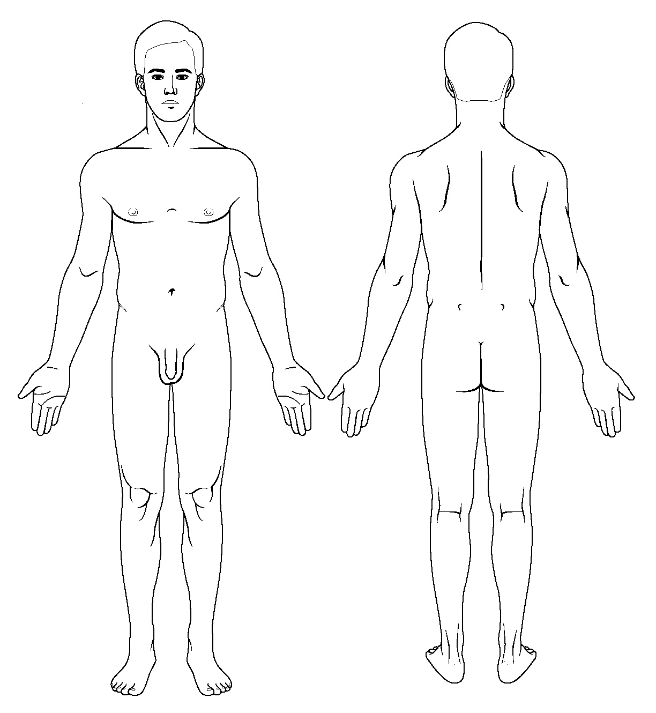
Patient Pregnant?  Yes  No
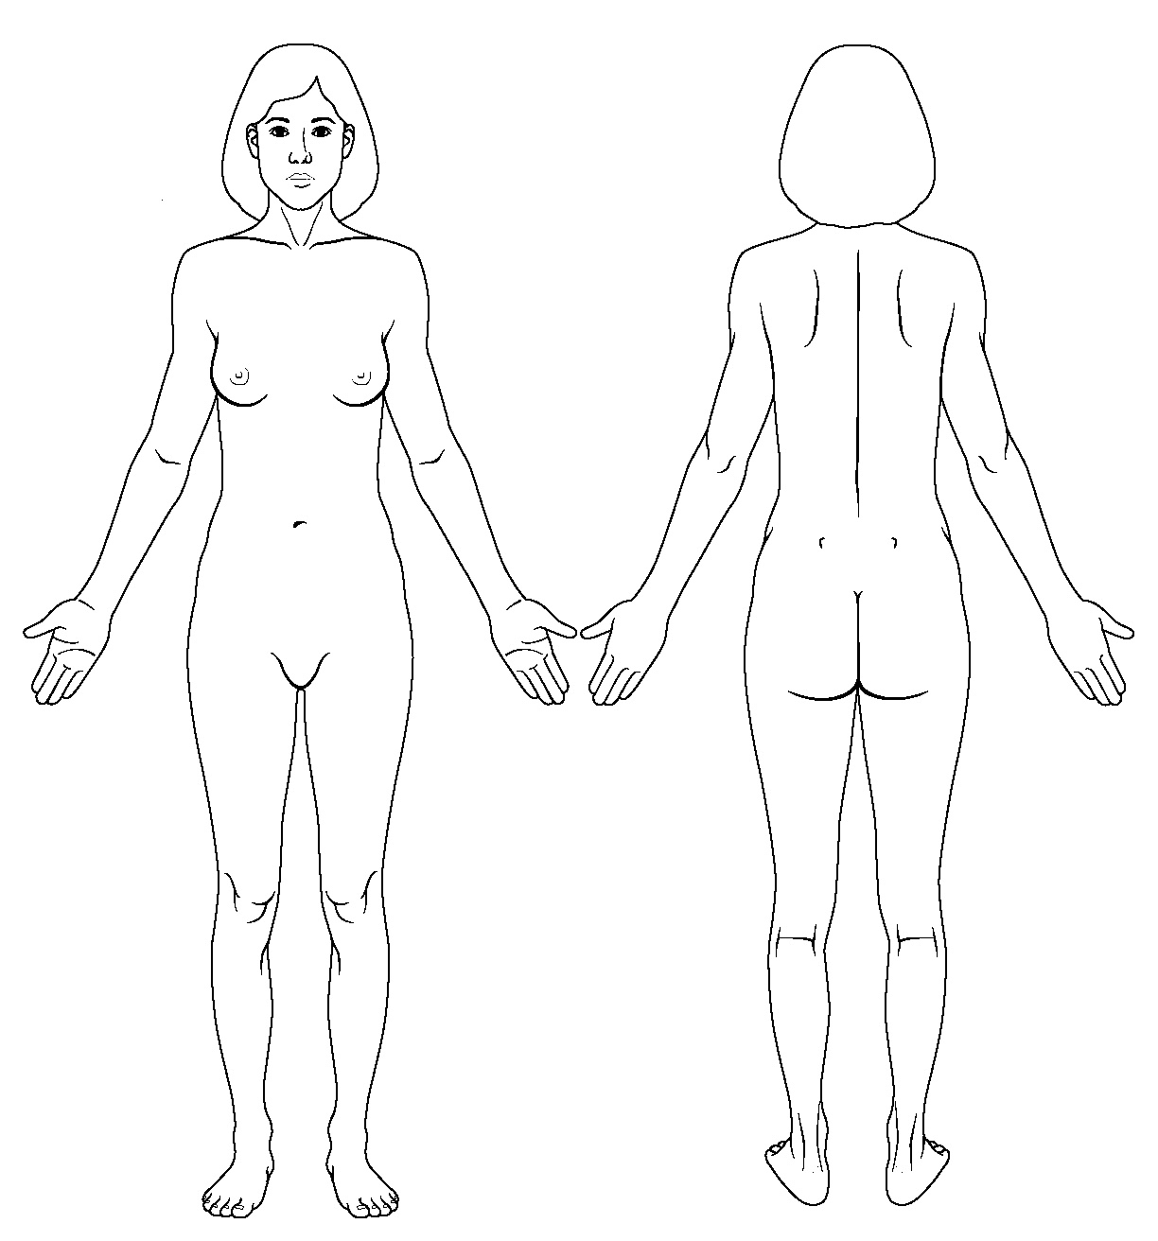
ASSESS PATIENT SAFETY  Document location of any injuries (bruises, cuts, other wounds)  - Does your partner control where you go? _______Who you see? _________ How you spend your money? __________________  - Is your partner here with you today? ______________________  - Do you ever change your behavior (e.g. change plans, don’t visit family and friends, make sure the house is perfectly clean) because you are afraid something may happen to you? ___________________________________________________  - Has your partner ever threatened to hurt you or hurt the children? _________ Family members? ___________ The pets?_______ Threats with a weapon? _______________________________  - Has your partner ever hit, slapped, pushed, kicked, or strangled you? ______________________________________________  - Does the violence continue to get worse? _________________  - Are you afraid to go home? ____________________________  - What support would be helpful to you now?________________  NOTE: Was a safety plan discussed? _______________________  (See http://hfsnet.state.ky.us/dph/Forms.htm for sample safety plan) | RESOURCES:   Hotline number given 1-800-799-SAFE   Domestic Violence Shelter information given   Follow-up with appropriate services (i.e. HIV/STD, prenatal, HANDS)  REPORTS MADE:   Law Enforcement _________________________   Child Protective Services ___________________   Adult Protective Services ___________________  PHOTOGRAPHS   Yes  No Consent to be photographed?   Yes  No Photographs taken?  Attach photographs and consent form   Consent provided in ____________ language   Consent form sight translated

Provider Signature: _________________________________________ Date: ____________________________
DV/SA - 1

Sexual Assault Documentation Form
(see front for Domestic Violence Documentation Form)

SA screen   SA + (Positive)   SA? (Suspected) | Date __________________ Patient ID# ____________________  Patient Name __________________________________________
❒ Female  Male Age ________ Patient Pregnant?  Yes  No

ASSESS PATIENT SAFETY
Please answer the following:
❒ Yes  No Has anyone pressured you to have sex when you didn’t want to?
❒ Yes  No Has someone had sex with you and afterwards you felt ashamed or confused by what happened?
❒ Yes  No Has anyone touched you against your will in a private area?
❒ Yes  No Has anyone asked you to touch their private parts and you didn’t want to?
❒ Yes  No Has anyone convinced you to have oral sex because this really wasn’t sex?
❒ Yes  No Has anyone gotten you drugged/drunk so that you would have sex with them?
❒ Yes  No Has anybody threatened to harm you or someone else if you told about something they did to you sexually?
❒ Yes  No Has anyone told you that you would get in trouble if you told about something they did to you sexually?
❒ Yes  No Do you feel safe now?
❒ Yes  No Have you told anyone about what happened?

Resources: | Reports Made:
❒ Hotline number given: 1-800-656-HOPE | ❒ Law Enforcement _________________________
❒ Rape Crisis Center information given | ❒ Child Protective Services ___________________
❒ Follow-up with appropriate service  (i.e. HIV/STD, prenatal, HANDS) | ❒ Adult Protective Services ___________________

Provider Signature: _________________________________________ Date: ____________________________

Adapted from Cumberland River Rape Crisis Center, Corbin, KY. Hotline 1-800-656-HOPE
DV/SA - 1

