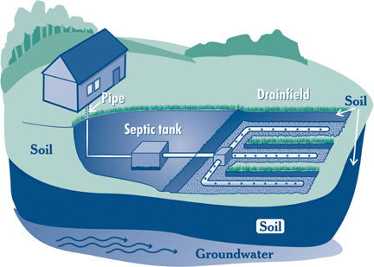
The Cabinet for Health and Family Services – Department for Public Health would like to remind you, your septic system can provide long-term, effective treatment of house hold waste water if properly designed, constructed and maintained.

Things to keep in mind:
- Know where your septic system is located.
- Inspect your system (every 3 years) and pump your tank as necessary (generally 3 to 5 years).
- Use water efficiently.
- Don’t dispose of household hazardous wastes in the sinks or toilets.
- Avoid driving or parking vehicles on your drainfield, tank, or other septic system components.
For more information contact your Local Health Department.
- Plant only grass over and near your drainfield to avoid damage from roots.
- Keep roof drains, basement sump pumps drains and other rain water or surface water drainage systems away from the drainfield.
- Keep a maintenance log including when the tanks are pumped and records pertaining to any repairs.
http://chfs.ky.gov/dph/info/phps/
enviromgmt.htm

The Cabinet for Health and Family Services – Department for Public Health would like to remind you, your septic system can provide long-term, effective treatment of house hold waste water if properly designed, constructed and maintained.
Things to keep in mind:
- Know where your septic system is located.
- Inspect your system (every 3 years) and pump your tank as necessary (generally 3 to 5 years).
- Use water efficiently.
- Don’t dispose of household hazardous wastes in the sinks or toilets.
- Avoid driving or parking vehicles on your drainfields, pipes, tank, or other septic system components.
For more information contact your Local Health Department.
- Plant only grass over and near your drainfield to avoid damage from roots.
- Keep roof drains, basement sump pumps drains and other rain water or surface water drainage systems away from the drainfield.
- Keep a maintenance log including when the tanks are pumped, any records pertaining to any repairs.
http://chfs.ky.gov/dph/info/phps/
enviromgmt.htm

The Cabinet for Health and Family Services – Department for Public Health would like to remind you, your septic system can provide long-term, effective treatment of house hold waste water if properly designed, constructed and maintained.

Things to keep in mind:
- Know where your septic system is located.
- Inspect your system (every 3 years) and pump your tank as necessary (generally 3 to 5 years).
- Use water efficiently.
- Don’t dispose of household hazardous wastes in the sinks or toilets.
- Avoid driving or parking vehicles on your drainfield, tank, or other septic system components.
For more information contact your Local Health Department.
- Plant only grass over and near your drainfield to avoid damage from roots.
- Keep roof drains, basement sump pumps drains and other rain water or surface water drainage systems away from the drainfield.
- Keep a maintenance log including when the tanks are pumped and records pertaining to any repairs.
http://chfs.ky.gov/dph/info/phps/
enviromgmt.htm

The Cabinet for Health and Family Services – Department for Public Health would like to remind you, your septic system can provide long-term, effective treatment of house hold waste water if properly designed, constructed and maintained.

Things to keep in mind:
- Know where your septic system is located.
- Inspect your system (every 3 years) and pump your tank as necessary (generally 3 to 5 years).
- Use water efficiently.
- Don’t dispose of household hazardous wastes in the sinks or toilets.
- Avoid driving or parking vehicles on your drainfield, tank, or other septic system components.
For more information contact your Local Health Department.
- Plant only grass over and near your drainfield to avoid damage from roots.
- Keep roof drains, basement sump pumps drains and other rain water or surface water drainage systems away from the drainfield.
- Keep a maintenance log including when the tanks are pumped and records pertaining to any repairs.
http://chfs.ky.gov/dph/info/phps/
enviromgmt.htm

