

Once installed your private sewage treatment system should provide many years of quality service.

But like your automobile, all sewage systems need care and maintenance.

Please contact your Local Health

Department Environmental Health Specialist or a representative from the Division of Water to learn how they can help you care for your new sewage system.

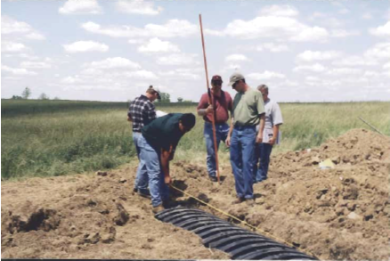





*Septic Systems Contact:*

KY Department of Public Health

Division of Public Health Protection and Safety

Environmental Management Branch

HS 1C-D

275 East Main St

Frankfort, KY 40621

## Phone: (502) 564-4856

www.chs.ky.gov/publichealth/environmental

*KPDES-Permitted Units*

*Contact:*

Division of Water

14 Reilly Rd

Frankfort, KY 40621

Phone: (502) 564-3410

Http://www.waterky.gov/permitting/wastewaterpermitting/kpdes/residences

The Commonwealth of Kentucky provides, upon request, reasonable accommodations including auxiliary aids and services necessary to afford an individual with a disability

an equal opportunity to participate in all services, programs and activities. To request materials in an alternative format, contact the Office of the Secretary, Communications Staff, 514 Capital Plaza Tower, Frankfort, KY 40601 or call (502) 564-5525. Hearing- and speech-impaired persons can contact the agency by using the Kentucky Relay Service. For voice to TDD, call (800) 648-6057. For TDD to voice, call (800) 648-6056.





Commonwealth of Kentucky

# Application & Permitting Process

For Individual Home Sewage Systems

So, You Want to Build A House?





Produced by:

KY Cabinet for Health & Family Services

&

KY Energy and Environment Cabinet

May 2013





**Commonwealth of Kentucky**

**Application & Permitting Process**

**For Individual Home Sewage Systems**

**All homes need a sewage disposal system.**

**Contact your City/County to determine if you have access to a sanitary sewage connection (City Sewer).**

**If you do not have access to sanitary sewer you will be required to install a private sewage system.**

**Many types of private sewage systems may be available depending upon where you live.**



**These may include:**

1. **Septic Tanks and Lateral Field**
2. **Gravelless Leaching Systems**
3. **Artificial or Constructed Wetlands**
4. **Sewage Lagoons**
5. **Modified or Experimental Systems**
6. **Aerobic Treatment Systems**
7. **Home Treatment Units**

**To find out what options may be available for your tract of land, follow the chart:**



Submit application for site evaluation to Local Health Department (LHD). At this time, health department issues

temporary release for Non-Manufactured (“Stick-built”) Homes.

■ = Health Department Tasks

■ = Division of Water Tasks

Site evaluation conducted by LHD or professional engineer

Site Evaluation Report-Unapproved Site

Discuss with LHD:

Site upgrade options, second evaluation, and consultation with Dept of Public Health staff

(502) 564-4856

Site Evaluation Report-Approved Site

System Options:

Conventional Septic, Modified Septic

Alternative System or Experimental System

Site **Not Approved**

Site **Approved**

System Design Layout (certified installer) and Application for On-site Sewage Disposal System (OSDS) Construction Permit (LHD) Submit to Local Health Dept

Referral to Division of

Water (DOW) for Home Treatment Unit

**Complete KY Pollutant Discharge Elimination System (KPDES) Application**

**Contact DOW KPDES Branch for Assistance**

**(502) 564-3410**

Application Reviewed; if approved:

OSDS Construction Permit issued

Permanent electrical release issued

For Non-Manufactured

(“Stick Built Homes”) / Manufactured Homes

**DOW Reviews: Completeness of Application, Receiving stream conditions, and**

**Conducts site visit**

KPDES Application

Should Include:

1. USGS Topo Map
2. Site Plan
3. Health Department

Evaluation

1. Discharge Easements
2. Approval From Regional Authority

(if applicable)

1. $450 Application Fee

Initial installation inspection scheduled

Installer’s affidavit submitted

Installation of system by certified installer

### KPDES Permit Issued

* **Your local health department can assist you through this process**

#### Final System Inspection

*This document was printed on recycled/recyclable paper.*