WHAT PARENTS NEED TO KNOW

Legislation for a new booster seat law went into effect July 15, 2008. Parents in Kentucky are now required to take new measures to protect their children in the car.

If your child is under seven years old and between forty and fifty inches tall he/she will have to ride in a booster seat. For optimum protection children should ride in a booster until they are 57 inches. A booster raises the child up so the lap/shoulder belt fits correctly. If you only have lap belts in your car DO NOT use a booster seat.

On July 15th, law enforcement began issuing courtesy warnings to those who did not have their children in booster seats. These warnings will continue through June 30, 2009. After that date, violators will be required to pay a fine of $30.

Any person who has not previously been charged with a booster seat violation can have the charged dismissed by providing proof that they have acquired a booster seat for that child.

Kentucky’s New
Booster Seat Law

Effective July 2008

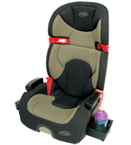

The type of seat your child needs depends on the vehicle they ride in. They need to have head and neck protection either by the vehicle head restraint (headrest) or the top of the booster
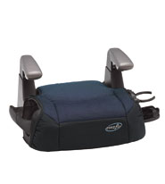

KENTUCKY’S CHILD SAFETY SEAT REQUIREMENTS

- Any child 40 inches in height or less must ride properly restrained in a federally approved child restraint.
- Every child between 40-50 inches tall and less than 7 years of age must be in a booster seat with a lap/shoulder belt. (If you do not have lap/shoulder belts in your vehicle DO NOT use a booster.)
- Everyone over age seven must be using the vehicle seat belt.

FOR MORE INFORMATION CONTACT


With special thanks –
Adapted from handout created by
Sharon Rengers RN, Kentucky
State Child Passenger Safety Advisor

