Accessing an Immunization Record in the Kentucky Immunization Registry Public Portal

This quick guide shows how patients and parents/guardians of minors under 18 years old can now ​​​​​​​​​​​​​​​​​​​​​​​​​​​​​access their immunization record through the secure Kentucky Immunization Registry (KYIR) Public Portal, a free service of the Kentucky Department for Public Health that allows individuals, parents, and legal guardians to access immunization records from KYIR.

Immunization records printed from the KYIR Public Portal may NOT be complete. Immunization providers are not required to report immunization data to KYIR and may not be providing data to the registry. If you notice missing vaccine information, contact your provider to update your record.

Note: Users must use Google Chrome, Microsoft Edge, Mozilla Firefox or Safari to access the Public Portal.

KYIR Public Portal Help

To use the KYIR Public Portal
- Allow this page to generate pop-ups (do not block pop-ups).
- If it’s not installed yet, install Adobe Acrobat Reader (used to view the Official Immunization Record).

Click on the following links for KYIR public portal information and support:
- Visit KYIR Public Portal Information for step-by-step instructions and information on using the KYIR public portal.
- If you are unable to access your (or your minor child’s) record, please complete this online form for assistance.

How to Access Your Record

Step 1: Open the KYIR Public Portal
- Open your web browser
- Navigate to the KYIR Public Portal Website
- Review the information on the welcome page
Note: Select Language in the top left corner of the screen, click the drop-down, and select English or Español (Spanish).

Step 2: Select Who You Are accessing Records for
Choose one of the following options:
- Me – Access your own immunization record
- Dependent – Access the immunization record of your child or legal dependent

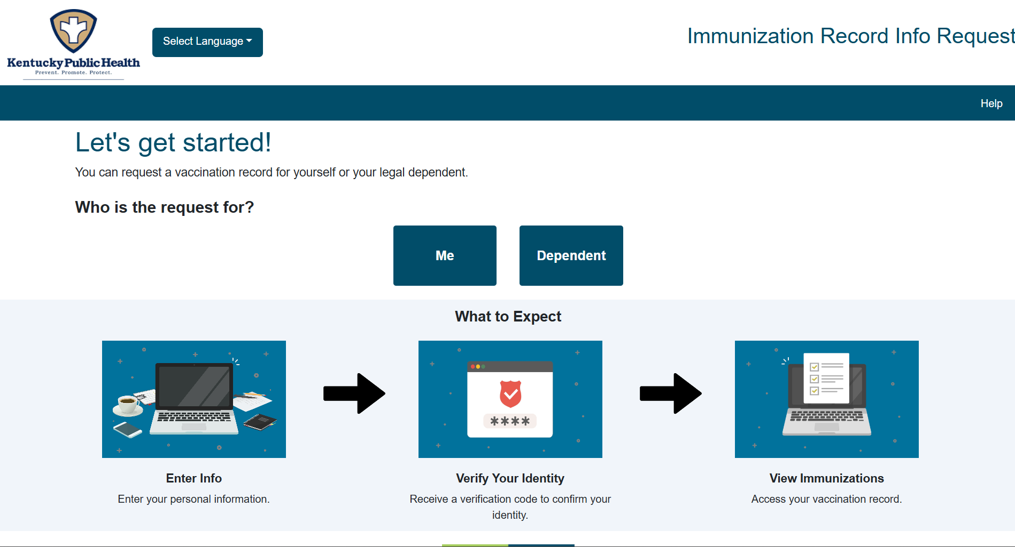

Step 3: Enter Patient Information
- First name
- Last Name
- Date of Birth (MM/DD/YYYY)
- Gender
Note: Make sure the information is entered exactly how it is documented by your health care provider. An exact match is required to obtain your immunization record.

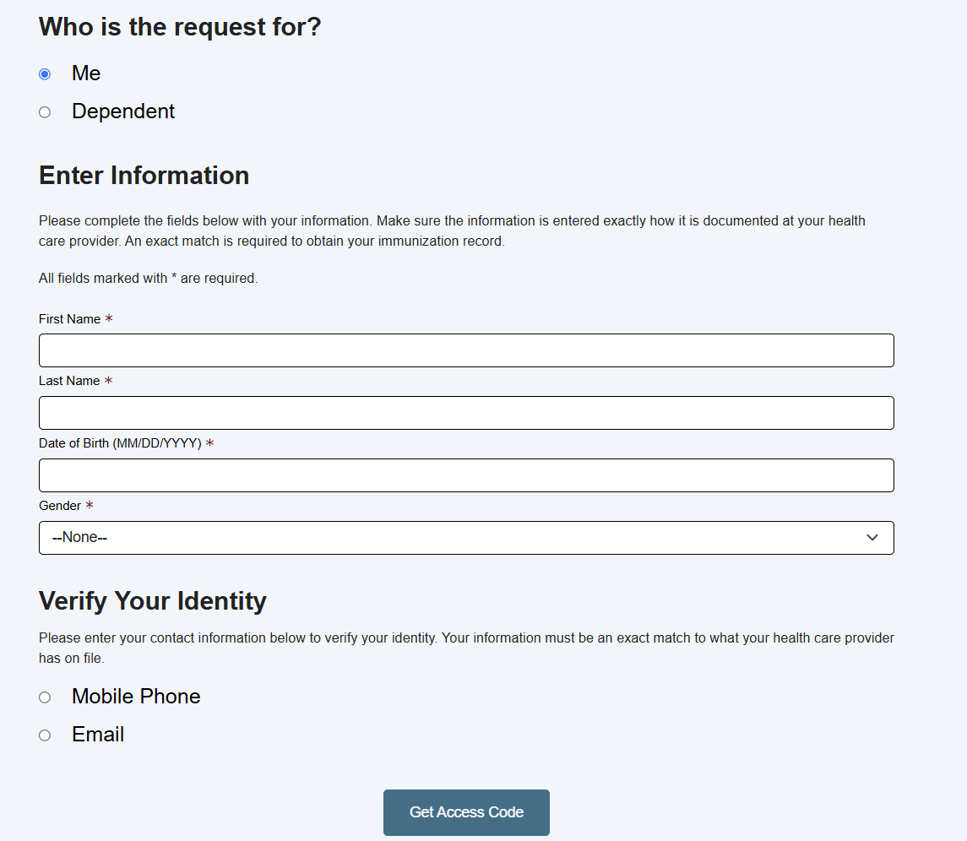

Step 4: Verify Your Identity
Choose how you would like to receive your verification code
- Mobile Phone
- Email
Enter the phone number or email address that your health care provider has on file.

Click Get Access Code.

Step 5 – Enter the Verification Code
Check your
- Text messages
- Email inbox
Enter the verification code into the portal, then select Verify.

Step 6: View Your Immunization Record

After verification is complete, your immunization record will appear.
You may choose to:
- Download Full Record
- Download Official School Certificate
- Download COVID-19 Record
- View COVID-19 QR Code

Troubleshooting

“No Record Found”
If you received a “No Record Found” message:
- Verify the spelling of the patient’s name.
- Ensure the date of birth is correct
- Confirm the phone number or email address matches the information on file with the patient's health care provider.
- If continuing to see the displayed message “No Record Found”, reach out to our KYIR Help Desk KYIRHelpdesk@ky.gov.

Public Portal Frequently Asked Questions

You can find all KYIR public portal FAQs directly on the Kentucky Immunization Registry Public Portal Page.

