Steps to CHANGE a Patient ID

A patient ID change is used to change a patient’s ID if it was entered incorrectly.

- Select Patient Number Mtce from the CMS Portal page.
- Select the appropriate County from the drop-down.
- Action should be set to Change.
- Patient # to update - the patient’s current ID. This number MUST exist.
- Update Patient # to - the patient’s correct ID. This number MUST NOT exist.
- Click Complete.
- If errors are not encountered, Patient # to update will no longer exist, and the Update Patient # to will exist.

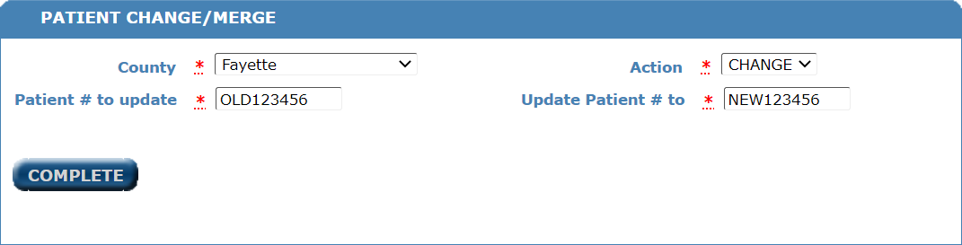

Steps to MERGE Patient IDs

A patient ID merge is used when a patient has more than 1 patient ID and they need to be combined into 1 record, 1 patient ID.

- Select Patient Number Mtce from the CMS Portal page.
- Select the appropriate County from the drop down.
- Action should be set to Merge.
- Patient # to update - the patient’s current IDs. This number MUST exist. This ID will be merged into the patient ID entered in the Update Patient # to field. After the merge has been completed, this number will no longer exist.
- Update Patient # to - the patient ID you want all records merged into. This number MUST exist. After the merge has been completed, this will be the patient’s only ID.
- For this merge to be successful,
  - The date of birth, gender and race must match on both patient records.
  - Neither patient record can have active WIC benefits.
- Click Complete.
- If errors are not encountered, Patient # to update will no longer exist, and the Update Patient # to will now be a combination of the information from both IDs.
- If an error is encountered, further research should be completed to verify that the two IDs entered are correct.
- IMPORTANT – Once a merge is done, it can’t be undone.

