Changing a patient from Insurance = Y to Insurance = N for patients in a Household

- Go to the Household search page and search for the household.
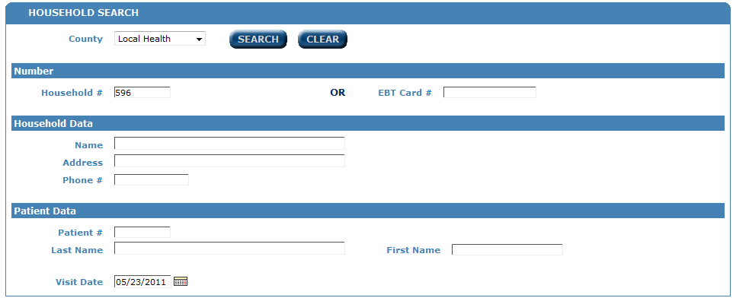

- On the Household member page, click on Save & Third Party
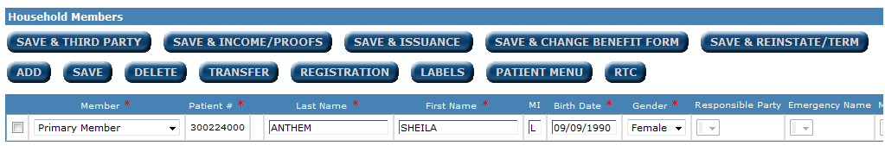

- Check the box next to the patient whose insurance information is changing.
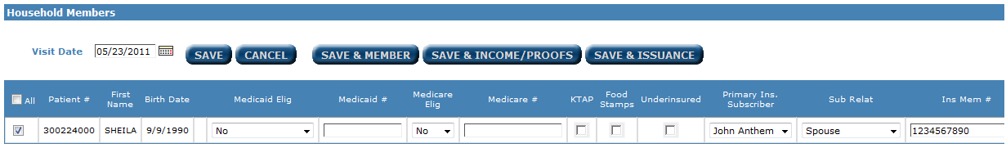

- Eliminate the Primary Ins. Subscriber, Sub Relation, and Ins Mem # if entered.
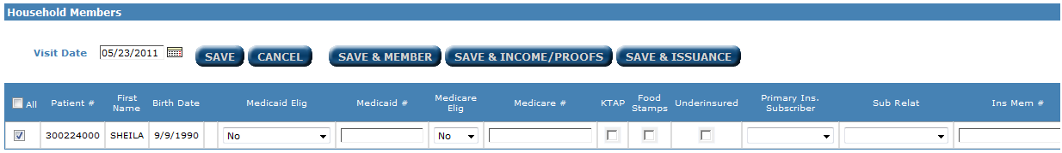

- Click on Save & Member.


The insurance has been changed to No.

If the insurance policy will no longer be used for anyone in the household, the user should delete it out of the household. The following steps will eliminate the policy. NOTE: The steps above must be completed first before eliminating the insurance policy.

- From the Member page, click on the EDIT button at the top of the page.
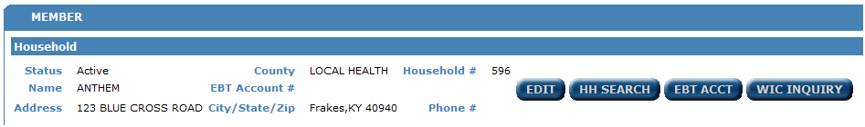

- On the Household edit page, scroll down to the Primary Insurance Company.
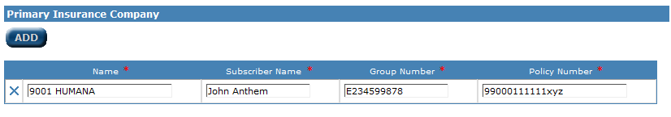

- Click the blue X to eliminate that policy from the household.
- Click SAVE.


The insurance company will still show on the Save & Third Party page but will show as inactive.

Changing a patient from Insurance = Y to Insurance = N for patients NOT in a Household

- Go to the Patient search page and search for the patient.
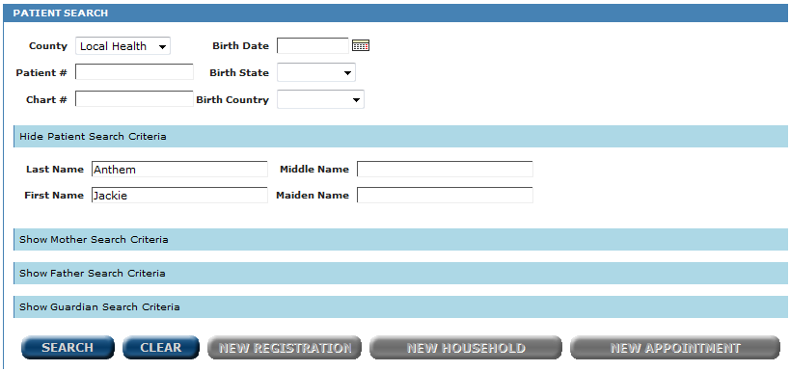

- When the patient is found, click on the registration icon.
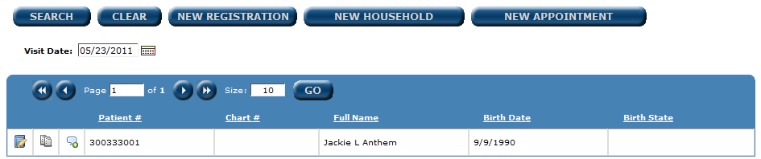

- Set your reason for visit.
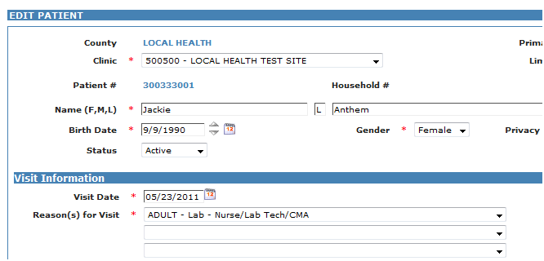

- Go to the bottom of the screen to the Third Party section and eliminate all insurance information.
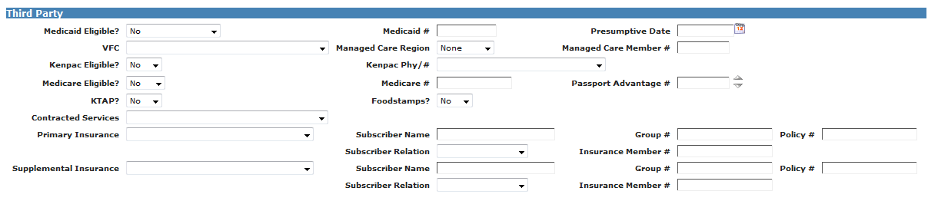

- Click on Save & Portal.


Changing a patient from Insurance = N to Insurance = Y for patients in a Household

- Go to the Household search page and search for the household.

- On the Household member page, click on Edit button at the top of the page.
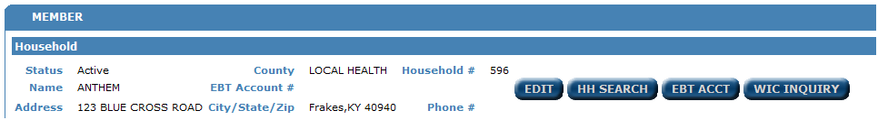

- On the Household edit page, scroll down to the primary insurance company section and click the ADD button.
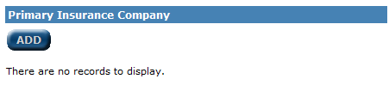
- Add the new insurance information, Insurance Name, Subscriber name, Group Number, and Policy Number
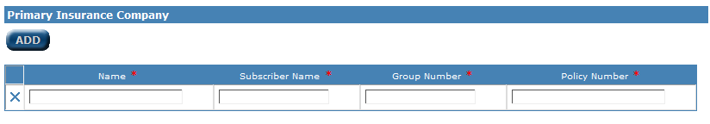
- Click Save

- When you click SAVE, you will be returned to the Household member page, click on the Save & Third Party button.
- Check next to the patient whose insurance information is changing.

- Enter the Primary Ins. Subscriber, Sub Relation, and Ins Mem # if needed.
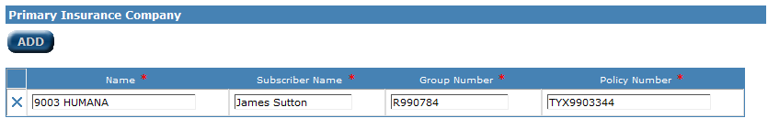
- Click the Save & Member button.


- You should now register the patient and the insurance status should show as Y on the labels.

Changing a patient from Insurance = N to Insurance = Y for patients NOT in a Household

- Go to the Patient search page and search for the patient.

- When the patient is found, click on the registration icon.

- Set your reason for visit.

- Go to the bottom of the screen to the Third Party section and enter all insurance information, Primary Insurance, Subscriber Name, Group #, Policy #, Subscriber Relation, and Insurance Member # if needed.

- Ask for the label needed, and then click on Save & Portal.

