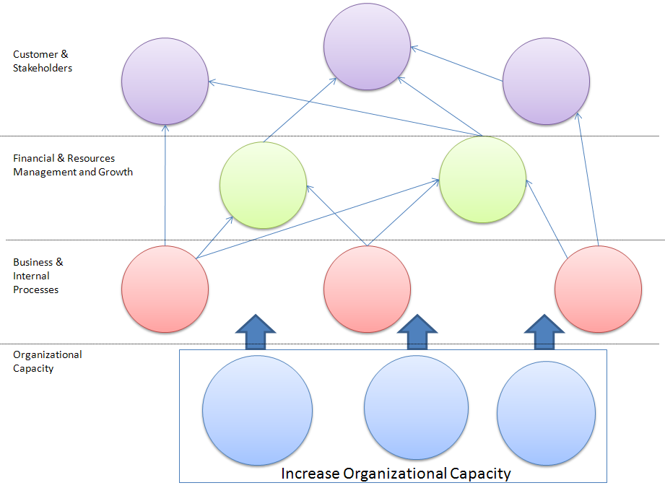
People
Quality
Efficiency & Effectiveness

Improved Outcomes

