Kentucky and Appalachia Public Health Training Center
Strategic Planning Workbook

Table of Contents

Orientation
Strategic Planning Model ……………………………………………………………….. | 4
Syllabus ………………………………………………………………………………………….. | 5
Readiness Assessment ……………………………………………………………………. | 7
Getting Started
Plan to Plan ……………………………………………………………………………………. | 10
Strategic Planning Data Needs ……………………………………………………….. | 13
Assessing the Current Situation
Mission Development ……………………………………………………………………. | 15
Vision Development ………………………………………………………………………. | 17
Stakeholder Analysis ……………………………………………………………………… | 20
Review Organization Mandates …………………………………………………….. | 21
External Assessment: 3 Questions …………………………………………………. | 23
External Assessment: Current Trends …………………………………………….. | 24
Situation Assessment: Programs, Products, Services ……………………… | 25
Internal Assessment ………………………………………………………………………. | 26
SWOT Analysis ……………………………………………………………………………….. | 27
Developing the Plan
The Strategic Initiatives Matrix ………………………………………………………. | 31
Developing Goals …………………………………………………………………………… | 33
Developing Objectives ……………………………………………………………………. | 33
Developing Objectives Matrix ………………………………………………………… | 36
Evaluation and Integration
Plan Review ……………………………………………………………………………………. | 38
Communication Plan ……………………………………………………………………… | 39
Evaluate and Improve the Planning Process …………………………………… | 40
Evaluate and Improve Strategies ……………………………………………………. | 41
Strategic Planning Resources …………………………………………………………………….. | 42

Kentucky and Appalachia Public Health Training Center
Strategic Planning
Overview

Strategic Planning Model
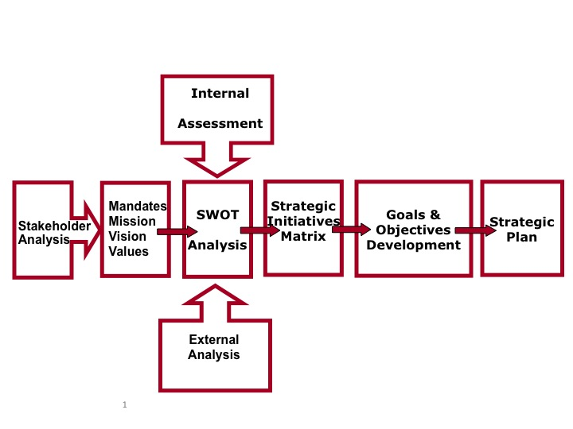

Strategic Planning Syllabus
Module | Content | Objectives | Assignment
Orient-ation | Prepare for strategic planning.  - Who should be on the team?  - Identify and prepare team  - Readiness assessment | - Participants will have a road map for the strategic planning course and process | - Select and prepare team  - Conduct readiness assessment  - Review ‘Getting Started’
Getting Started | What is strategic planning and why should we do it?  Why is it important? What it takes  Overview of the model  Plan-to plan | - Describe the purpose of a strategic plan  - List the critical elements of a strategic planning process  - Identify the benefits of strategic planning  - Identify reasons why strategic planning should be a priority in your organization  - Develop a plan-to plan  - Develop a communication plan and process for updating | - Identify benefits of strategic planning for your organization.  - Develop your Plan to Plan  - Review your organization’s existing strategic plan. Talk with others in your organization about it.  - Ask: Is this plan still relevant?  - Has it been used? Why or why not?  - What are the weaknesses & strengths of this plan?  - Develop a communication plan to educate your organization  - Review ‘Assessing the Current Situation’
Assessing the Current Situation | How to do strategic planning;  Process of change;  Environmental assessment;  Vision, Mission, Values  Mandates, Customers | - Construct a process for creating a strategic plan  - Enlist the support of key individuals for creating a strategic plan  - Identify data needs for planning  - Be able to develop a vision, mission and values | - Identify stakeholders and how you will gather information from them.  - Review your organizational mandates  - Develop Vision, mission, and values
 | Situation analysis  SWOT | - Be able to conduct a situation analysis – internal and external  - Be able to develop and conduct a SWOT analysis | - Gather data  - Conduct your SWOT  - Review ‘Developing the Plan’
Developing the Plan | Analyze data  Identify strategic priorities  Develop Goals and Objectives  Develop performance measures | - Identify strategic priorities  - Know the importance of measures  - Define the elements of a written strategic plan  - Develop goals  - Develop SMART objectives  - Identify performance measures | - Analyze SWOT and Plus/Delta info  - Identify strategic priorities  - Develop Goals  - Develop SMART objectives  - Develop measures  - Review ‘Evaluation and Integration’
Evaluation and Integration | Writing the plan  Implementation  Evaluation  Strategic plan as a foundation for succession planning | - Identify the elements of a written strategic plan  - Describe the purpose of evaluation  - Describe the types of evaluation and associated questions  - Describe how to link evaluation results to future strategic goals/ objectives | - Develop your written strategic plan  - Develop a process for implementation  - Determine how and when you will evaluate your Strategic plan  - Develop on-going monitoring process and timelines for integrated strategic planning  - Develop a change management plan

Strategic Planning Readiness Assessment
Barriers to Strategic Planning
What do you see as the barriers?
Barriers to strategic planning | Ways the barriers can be addressed

Expected Benefits of Strategic Planning
List the benefits, direct and indirect you expect from strategic planning.
Benefits | Ways to enhance the benefits

Expected Costs of Strategic Planning
List costs you anticipate (direct and indirect) of strategic planning
Anticipated Costs | Ways to manage these costs

Should we proceed with strategic planning?
 | yes | no | How to mitigate “No”s
1. We have a strong sponsor

2. We have a process champion to lead the process

3. Resources are available to do this planning

4. Resources are likely to be available to implement our plan

5. The process and plan will be linked to our budgets and operational plans

6. The benefits outweigh the costs; the process will create real value for our organization and stakeholders
7. Now is the right time to initiate the process

8. The organization is ready to do strategic planning

9. The Board is ready to engage in strategic planning

10. We can enlist stakeholders in our process

Kentucky and Appalachia Public Health Training Center
Strategic Planning
Getting Started

Strategic Planning – Getting Started
Plan to Plan
After readiness has been assessed and the organization determines that it is ready to move forward with strategic planning, it is useful to develop a plan-to-plan. In other words, to think through the scope and purpose of the plan, the resources needed (including personnel) and how the organization will go about the strategic planning process. The following list of questions will help you to think through this process and develop your plan-to-plan.
- Whose plan is this? Whole org? Sub-unit? Government agency? Community?

- Why are we doing this?

- Response to requirements (external mandate)
- Help provide direction
- Enhance organizational capabilities
- Response to a crisis
- Help prioritize efforts
- Improve communications and public relations
- Improve effectiveness and/or efficiency
- Other:

- Focus of this Strategic Plan: Programmatic? Internal organization?

- What time period will the plan cover?

- What challenges, issues, problems or concerns do we hope the planning process and the plan will address?

- Who is sponsoring the planning process? Do they have the authority and power, resources and time?

- Who is the point of contact for the process?

- Who will be on the strategic planning team?

- Do we want/need an outside facilitator?

- Who will be involved in the review of the plan prior to and during any formal adoption process?

- How much time are we willing to give to the strategic planning process? And how often will the planning team meet?

- What is the expected time frame for the planning process (6 months, 12 months, other)?

- What type of written plan do we envision?
  - Short executive summary
  - Longer more detailed plan but not including tactical and operational elements
  - A detailed plan including tactical and operational elements
  - Other

- What resources do we need for the strategic planning process?
  - Budget
- People
- Information
- Facilities for meetings
- Consultants
- Other

- What criteria should be used to judge the effectiveness of the strategic planning process?

- What criteria should be used to judge the effectiveness of the strategic plan?

Strategic Planning Phases

Getting Set up for Success | Defining Who We Are | Defining Our Challenge | Setting Our Course | Putting the pieces together | Making it Happen | Keeping the Plan Relevant
Phase 1 | Phase 2 | Phase 3 | Phase 4 | Phase 5 | Phase 6 | Phase 7
Get Ready:  Plan to Plan | Articulate Mission, Vision, Values | Assess situation | Agree on Strategic Priorities | Write the Plan Document & Commit | Implement the Plan – the Action Plan | Evaluate and Monitor the Plan
Product = Workplan | Product = Mission, Vision, Guiding Principles | Product =  Data to inform decisions.  SWOT analysis | Product = Decisions/ Agreement on Strategies, Goals, Objectives and indicators of success | Product = Strategic Plan  [Optional: Budget, Communications plan] | Product =  Annual Plan (operating plan) & Communications Plan  Action! | Product =  Best practices for future planning. Mechanism for monitoring.  Measures, milestones
Adapted from Allison and Kaye, Compass Point Non-Profit Services

Strategic Planning Data Needs
Data Need to Inform the Plan

What | Where is it located | How we will obtain it
Previous strategic plan and results
Customer data: (Survey, focus groups, etc)

Financial Data: Current and projected

Services Data: Utilization, trends

Human resources data: positions filled/unfilled, anticipated vacancies, needs, training data
Other

Kentucky and Appalachia Public Health Training Center
Strategic Planning
Assessing the Current Situation

Strategic Planning – Assessing the Current Situation
Mission Statement
A mission is a short comprehensive statement of the reason for the organization’s existence. It succinctly identifies what an organization does (or should do) and its customer base.
Components of a mission statement
- Specifies target clients
- Identifies principal services delivered
- Specific geographic domain
- Expresses commitment to specific values
Mission Statement Development
- Individually fill in a phrase or 2 answering each of the following:
What your organization (agency/division/department/unit) does:

“Your enterprise” (verb) (adjective and noun) and (adjective and noun)
Example: XYZ unit delivers performance technologies and profitability systems

- What are the results to/for your customers, organization or others?

Resulting in (noun benefit) “for” (first constituency) and (noun benefit) “for” (second constituency) Example: “resulting in enhanced performance for our clients and proper returns for our shareholders.

- Optional: What are the underlying values or beliefs upon which the above is made? [Based on a foundation of (value # 1) and (value # 2). Example: “based on a foundation of integrity and respect for the individual.”

Step 2: In each category, gather all the individual phrases on a flip chart. Discuss what each means; then narrow them down to three statements in each category.
- Good “What your organization does” phrases:

- Good “What are the results…” phrases

- Good “What are the underlying values” phrases

Step 3: Write a statement that captures the best ideas in one statement.
Try to keep it less than 25 words!

Mission statement checklist
 | YES | NO
Does the mission statement reflect the work and unique character of your team/organization…?
Is it brief and to the point?

Is it easy to understand?

Can you easily remember it?

Is it broad enough to include some growth of your products, services or customer base?
Are you proud of it? Would you frame it? Hand it out to others?

Vision Statement
A vision statement describes what the organization wants to be in the future. It is a little lofty and grand. A vision statement represents what the future could or should be. It provides a picture of the future as seen through the eyes of employees, customers, stakeholders. A great vision statement will inspire and challenge and every employee will be able to see themselves in that future.
Characteristics of a vision statement:
- What we want to create
- Not bound by time and not quantified
- Inspires and challenges
- Brief and memorable
- Provides meaning to the work
- Appealing to all stakeholders
Vision Development - The Cover Story Vision
It is now the year 2012 and we have accomplished everything that we most wanted. We have become so successful that TIME magazine featured us as its cover story in this week’s issue. Describe what this cover story says. What picture is on the cover? What are the headlines? What are the human interest stories and quotes? Remember, the story has already been written. If you find you can’t recall the details, just make it up! (work in small groups and then compile everyone’s work)

From the visioning exercise, identify common themes and phrases. Use these items to develop a vision statement. Verify your vision statement with others in the organization. Get people committed to it!

Vision Statement Checklist
 | YES | NO
Does the vision statement provide a clear picture of the organization’s ideal future?
IS the vision statement inspiring and challenging?
Is the vision statement brief enough to be remembered?
Will achievement of the mission help make the vision a reality?

Values Statements
Whether you call them values, guiding principles or beliefs, these are the core philosophies describing how an organization conducts itself in carrying out its mission. Values or Guiding principles are the beliefs supporting the mission and vision. Values are most obvious in how the organization does things and with whom it does them, not necessarily what it does.
A values statement articulates how the organization will conduct itself.
Guiding principles/core values: What do we stand for?
Guiding principles/Core values must guide the day-to-day behavior of everyone in the organization, if it is to be successful in achieving its mission. They are our most basic beliefs – our credo - that guides everything we do.
Criteria for guiding principles/values
The best statements of guiding principles express the organization’s attitude and values about three things:
- People: The way people inside and outside the organization are treated.
- Process: The way the organization is managed, decisions are made and products or services are provided.
- Performance: Expectations concerning the organization’s responsibilities and the quality of its products and services.

Guiding principles/values exercise:
- Each participant takes 3 -5 post-it notes and writes one of their guiding principles/values (a word or phrase) for the organization on each post-it.
- Each participant places their post-its on the board at the front of the room.
- Without talking, delete duplicates and sort the ideas into categories – things that seem to fit together.
- As a group, create headings for each category grouping.
- For each category, write a values statement.
- Review the values with everyone to assure understanding and agreement.
- Decide how these will be reflected in the organization and in the strategic plan

Some examples:
Ohio State University Medical Center
Vision: | Working as a team we will shape the future of medicine by creating, disseminating, and applying new knowledge and by personalizing health care to meet the needs of each individual
Mission: | To improve people’s lives through innovation, research and patient care.
Values | - Excellence  - Collaborating as one university  - Acting with integrity and personal accountability  - Openness and trust  - Diversity in people and ideas  - Change and innovation  - Simplicity in our work  - Empathy and compassion  - Leadership

Sierra Technology Solutions
Mission | The mission of Sierra technology Solution s is to create technology solutions for forward-thinking organizations
Vision | To be known as the technology experts and resource center for small to medium-sized organizations
Values | - To empower and inspire entrepreneurial leaders  - To be professional in our actions to our clients, partners and each other  - To effectively impact the marketplace  - To help all of organizations regardless of their resource constraints  - To have honesty, integrity and respect for all individuals  - To continually pursue knowledge and learn  - To practice what we teach  - To have enjoyment and fulfillment in our work

Stakeholder Analysis
Stakeholder | What do they want/need/expect from us? | What criteria does stakeholder use to assess our performance? | How are we doing with them?  How do we know? | What can we do to improve?

Review Organizational Mandates
Mandate | Source (law, rule, policy, grant requirement) | Key requirements | Effects on the organization and its services or products | Evaluation Criteria: (develop your own)  - Funded  - Still appropriate  - Out of date

What do these mandates mean about our organization’s purpose and mission?

Which mandates may need to be changed and why?

What impacts do these mandates have on our future direction? (include implications for resource availability)

External Assessment: 3 Questions
What has changed in the world in the past 3-5 years?

What has changed in healthcare and public health in the past 3-5- years?

What has changed in your organization in the past 3-5 years?

External Assessment
What are the current trends in these areas?
Economic Climate

Social

Demographics

Political

Legal

Technology

Budget

Programs and Services

Customers

Internal Assessment: Programs, Products & Services
We are moving away from: | We are moving towards:

Internal Assessment
Performance Trends:
How are we performing?
Programs
Products?
Services?
Finances?
Goals and objectives
How are we achieving against our plan? How successful have we been with recent initiatives?

What is our organization profile?

Strengths re:
- Structure
- Processes
- Finance
- Human resources
- Technology
- Culture
Areas for improvement
- Structure
- Processes
- Finance
- Human resources
- Technology
- Culture
What are our capacities?

What are our needs?

Strategic Planning: SWOT Assessment
- Review your previous strategic plan.
- Review all the data you have gathered.
- Examine the data to identify:
- Strengths – Keys to past and future successes of the organization
- Weaknesses – Potential problem areas that impact success
- Opportunities – Potential areas for growth i.e. partnerships, outside funding, trends in public health
- Threats – Outside factors to be corrected or limited

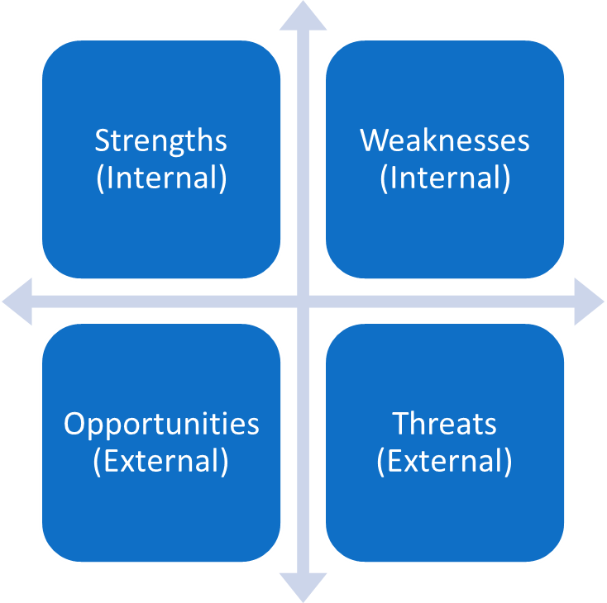
- After the initial compilation, the components of each section should be reviewed, prioritized and re-ordered. The next step is to analyze and synthesize the information. The SWOT provides information about where to leverage strengths and opportunities and what weaknesses and threats must be addressed or minimized. This analysis will generate strategic priorities.

Kentucky and Appalachia Public Health Training Center
Strategic Planning
Developing the Plan

Strategic Planning – Developing the Plan
Are you ready to develop the plan? Use this checklist to be sure.
We have developed or revised our vision, mission and values
We have gathered information from our stakeholders
We have identified our organizational mandates
We have examined our products, programs, and services for relevance and customer satisfaction
We have assessed the external environment
We have assessed our internal environment
We have gathered input from our staff
We have identified (or are beginning to identify) our strengths, weaknesses, opportunities and threats
We are ready to analyze the data and identify strategic priorities

Once you have gathered data, developed and solicited feedback on your SWOT analysis, the next section will help you to:
- Use the SWOT assessment, based on the data you have gathered,
- Analyze it for key strategic areas that will support the future you want to create
- Identify and prioritize strategies, goals, objectives, and measures
Strategic Planning: SWOT Assessment
- By now you should have gathered your data and developed your SWOT assessment.
- Strengths – Keys to past and future successes of the organization
- Weaknesses – Potential problem areas that impact success
- Opportunities – Potential areas for growth i.e. partnerships, outside funding, trends in public health
- Threats – Outside factors to be corrected or limited, i.e. competitors, future liabilities, public perception
- The components of each section should be reviewed, prioritized and re-ordered. The next step is to analyze and synthesize the information. The SWOT provides information about where to leverage strengths and opportunities and what weaknesses and threats must be addressed or minimized. Using those prioritized SWOTs, the next step is to identify strategic initiatives by comparing each of these areas with the others. This matrix is also known as a Plus/Delta analysis.

Strategic Planning: Identify Strategic Initiatives
The Strategic Initiatives Matrix
 | External Plus  Opportunities | External – Delta  Threats
 | List your top opportunities | List your top threats
Internal – Plus Strengths | Comparative Advantages | Mobilize
List your top strengths | Examining your prioritized SWOT list, compare the Opportunities against Strengths to identify Comparative Advantages. These are areas that the organization can leverage its strengths to capitalize on existing or potential opportunities. | Examining your prioritized SWOT list, compare the Threats against Strengths to identify where you need to mobilize your strengths to avoid losing ground or to transform threats into opportunities for progress.
Internal – Delta Weaknesses | Promising Futures | Reduce Vulnerability
List your top weaknesses | Examining your prioritized SWOT list, compare the Opportunities against Weaknesses to identify Promising Futures. Current weaknesses may not allow the organization to implement these initiatives in the short term, these areas hold promise. Work can begin to start these initiatives and to build the internal capacity. | Examining your prioritized SWOT list, compare the Threats against Weaknesses to identify initiatives to mitigate the threats that intersect with weaknesses to make sure the organization controls for loss of position, community presence, fiscal health and health of the community.

Strategic Planning: Identify Strategic Initiatives
The Strategic Initiatives Matrix
 | External Plus  Opportunities | External – Delta  Threats
Internal – Plus Strengths | Comparative Advantages | Mobilize
Internal – Delta Weaknesses | Promising Futures | Reduce Vulnerability

Developing Goals
Goals clarify the mission and vision of the organization. Goals represent a desired program result and translate the strategic priorities into manageable units of effort.
For each strategic priority area, list potential accomplishments. To help you identify these, use the question, “What will we have to do or accomplish in this area to achieve our vision/mission?”

Then turn these accomplishments into goal statements, then revise, consolidate, and prioritize them.

Review your Goals
- Does the goal support the mission and vision?
- Does the goal deal with just one issue?
- Does the goal represent a desired result that can be measured?
- Does the goal encompass a relatively long period of time (3-5 years)?
Developing Objectives
Objectives translate the goals into specific units of effort and are more specific. They should be SMART:
- Specific
- Measurable
- Actionable, aggressive and attainable
- Realistic and results oriented
- Time-bound
A Template for writing objectives
(verb noting direction of change) + (area of change) +
(target population) + (degree of change) + (time frame)
Example:
Direction of change: | To reduce
Area of change: | Unemployment status
Target population: | For our graduating students
Degree of change: | So that 75% gain fulltime employment
Time Frame: | Within 6 months

Process objective: Something we are going to do
Outcome objective: Describes a change in behavior, skills, awareness, health status, etc. (an end result)

Poorly written objectives | SMART objectives
To reduce processing time  (not specific or measurable) | To reduce by 5% the average cost of processing new hires by 6/15/09
To eliminate highway deaths  (too broad, not realistic) | To reduce highway death rate by 10% in 2010
To complete 3,000 record searches and 750 field investigations  (Actually two objectives, not time bound) | To complete 3,000 records searched during FY 2009  To complete 750 field investigations during FY 2009

Measurement:
To make sure that your objectives are measurable and support accountability, ask, “How will we know when this objective has been met?” “How will we know when this goal has been met?”
Performance measures track input, process, output, and outcome measures. Outcome measures include programmatic results, customer satisfaction measures, and effectiveness and efficiency. Performance measures should focus on the KEY objectives and goals. Fewer good measures are better than gathering and tracking a lot of data that may not be especially useful.
Good Performance Measures…
… Inform users with valuable information that can be used in a practical way – for decision-making, for documenting progress, providing public accountability.
Are informative:
- Clear – easy to understand by anyone
- Simple – easy to calculate and interpret
- Linked - from front line employees to the unit level to the organizational level
Are valuable:
- Meaningful – significant and directly related to goals, objectives
- Organizationally acceptable – important to the organization
- Customer–focused – Reflect the point of view of the customers and stakeholders
Are practical tools:
- Valid – Measures what you want to measure, provides the most direct and accurate measure
- Balanced – Includes several types of measures e.g. input, output, outcome, efficiency, etc.
- Timely – uses and reports data in a reasonable time
- Reliable – Based on accurate data, which provides the same information time after time
- Cost–effective – Based upon acceptable data collection and processing costs
- Compatible – Integrated with existing financial and operational systems
- Comparable – Useful for making comparisons with other data over time
Establishing performance measures is an important component of the strategic planning and management process. This worksheet may be useful for developing performance measures.
What numbers or statistics can be used to report whether this objective has been achieved?
Measures already used | How is the measure defined? | Source of data/ numbers and baseline | Frequency of data collection | Evaluate the measures advantages (+) | Evaluate the disadvantages (-)
Possible new measures

This check list can be useful once you have developed your measures.
Performance Measure Checklist | YES | NO
Does the performance measure relate to the objective it represents?
Does it measure what you want it to measure (is it valid?)
Can it provide the same information time after time (is it reliable)?
Is the measure understandable to a variety of people?
Will it be cost-effective to gather data for this measure?
Will the data be available when needed?
Is this measure the result of some activity you can control?

The "So What?” Question
When your plan has been developed, ask, “If we accomplish this, so what”? Does it move us toward our envisioned future? Will it produce results for our customers, stakeholders, organization?

Goals and Objectives Matrix
Strategic Priority:
Goal

Objective |  | Measure | Critical success factors | Barriers | Timeframe | Responsibility
Objective 1 |  |  |  |  | Start:  End:
Objective 2 |  |  |  |  | Start:  End:
Objective 3 |  |  |  |  | Start:  End:
Review date: | Notes:

Kentucky and Appalachia Public Health Training Center
Strategic Planning
Evaluation and Integration

Plan Review
Review strategic priorities/goals/objectives
- Will these goals & objectives move us toward our vision?
- Are they do-able?
Does the plan
- Provide guidance to long and short term priorities?
- Help the organization to allocate resources?
- Create understanding for those who did not participate in the process?
- Respond to our best understanding of the external and internal environments?
As you prepare to implement your plan, you may need a formal review and adoption process. In any case, a review of the plan will be helpful in assuring that clarity exists, that nothing critical has been missed, and to identify strategies for communicating the plan in your organization. The following questions may be asked of the planning team, or senior management or the Board, or others as you determine.

What are the strengths of this strategic plan?

What are the weaknesses of this strategic plan?

Are there any modifications needed?

Communication Plan
Communicating the plan, its value, and elements are essential for broad understanding and support for the strategic direction of the organization. As you have gathered information in preparing the plan, you have already identified key stakeholders and have had some communication about the plan. It is essential to let people know what has happened with the information they have provided. Planning the communication strategy is a part of the planning team’s work.
- How will the final plan be written and presented?
  - A summary of the highlights may be useful
  - Graphic presentation can make the plan an effective communication vehicle
  - Maintaining the documents that were used in the process may help inform the next round of planning
- What implementation strategies have been developed? How will implementation strategies continue to be developed and communicated?
- How will the plan be used?
- How will the plan be tracked and updated?

Different communication strategies may be needed for different stakeholders. Identify who needs what kind of information and how it will be best presented.
Who (key stakeholders) | What (do they need to know?) | How (strategies or mediums that will be most effective)

Evaluate and Improve the Planning Process
Here are some questions for discussion.
- Was the process relevant and fair to all?
- Were all impacted constituencies and groups consulted?
- Did we have the right team?
- Did we allow sufficient time to assess the organization & the environment?
- Were suggestions accepted & incorporated into the plan?
- Were we strategic?
- What could we do better?
List the elements of the planning process that you used and evaluate specific things that could be built upon and/or improved upon.
Planning Process Element | Strengths | Weaknesses | Modifications needed to improve? | Summary  Evaluation
- Maintain
- Replace
- Revise
- Terminate
- Maintain
- Replace
- Revise
- Terminate
- Maintain
- Replace
- Revise
- Terminate
- Maintain
- Replace
- Revise
- Terminate
- Maintain
- Replace
- Revise
- Terminate
- Maintain
- Replace
- Revise
- Terminate

Evaluate and Improve Current Strategies
Reviewing and examining the current strategies can occur when major changes occur in the organization or environment and should happen at least annually. Ultimately, evaluating the outcomes of the strategies focuses on the results of programs and services.
- Are the outcome goals and objectives being achieved?
- Do the programs and services have beneficial effects on the recipients?
- Is the situation the goals and objectives are intended to address made better?

Strategy | Strengths | Weaknesses | Modifications needed to improve? | Summary  Evaluation
- Maintain
- Replace
- Revise
- Terminate
- Maintain
- Replace
- Revise
- Terminate
- Maintain
- Replace
- Revise
- Terminate
- Maintain
- Replace
- Revise
- Terminate
- Maintain
- Replace
- Revise
- Terminate
- Maintain
- Replace
- Revise
- Terminate

Strategic Planning Resources

Allison, M. & Kaye, J. (2005). Strategic Planning for Non-profit Organizations (2nd edition). Hoboken, NJ: John Wiley and Sons, Inc.
Bridgespan Group, Inc. (2006). Business Planning for Non-profits: The Organizational and Leadership Benefits. Retrieved from: http://www.bridgespan.org/PDF/BusinessPlanningforNonprofits.pdf.
Bryson, J. M. (1995). Strategic Planning for Public and Non-profit Organizations. San Francisco, CA: Jossey Bass.
Idealist.org. What is Strategic Planning? Retrieved from: http://www.idealist.org/if/idealist/en/FAQ/QuestionViewer/default?section=03&item=22 on November 9, 2009
Leadership Strategies. The Driver’s Model Overview. Retrieved from: http://www.leadstrat.com/training-planning-drivers.html on June 9, 2009.
McNamara, C. (2006). Developing Your Strategic Plan. Free management Library. Retrieved from: http://www.managementhelp.org/np_progs/sp_mod/strplan.htm on September 6, 2008.
McNamara, C. (2006). Strategic Planning. Free management Library. Retrieved from: http://www.managementhelp.org/plan_dec/gen_plan/gen_plan.htm on September 6, 2008.
McNamara, C. (2007). Field Guide to Nonprofit Strategic Planning and Facilitation. Minneapolis, MN: Authenticity Consulting., LLC.
Paris, K. (2003). Strategic Planning in the University. University of Wisconsin – Madison, Office of Quality Improvement. Retrieved from: http://www.wisc.edu/improve/strplan/struniv.html on June 9, 2009.

