KENTUCKY
RESPIRATORY PROTECTION PROGRAM

Kentucky Department for Public Health

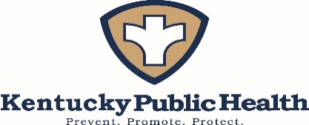
July 2018

Suggested Citation
Kentucky Cabinet for Health and Family Services. Kentucky Respiratory Protection Program: Kentucky Cabinet for Health and Family Services, Department for Public Health, Division of Public Health Protection and Safety, 2018.

Purpose of this Guide and Toolkit

The Kentucky Department for Public Health (KDPH) is committed to ensure the health and safety of its employees. Through the elimination of hazardous exposure where possible, and the use of administrative controls to minimize those hazards which can’t be eliminated, the Kentucky Department of Public Health strives to provide its employees with the necessary tools and information to protect themselves. The Respiratory Protection Program outlined in this work is an example of that commitment to health and safety to our employees.

Public health employees work in a variety of unique and sometime hazardous environments with the potential to present occupational health and safety challenges. While many large hospitals have health and safety personnel who are highly qualified to develop and implement appropriate policies and procedures to control workplace exposures, local public health departments often work with limited resources.

This document was developed to provide local health department (LHD) facilities with a template for developing, implementing, and maintaining an effective respiratory protection program, with an emphasis on protecting health department employees from respirable, airborne hazards and exposures.

Special Thanks to the Respiratory Program Workgroup for their collaboration and assistance in the development, review and preparation of these materials:

Dr. Kenneth Alea MD (Occupational Medicine Resident)
Joy Hoskins RN, BSN, BA – Director of Nursing; Director, Division of Women’s Health
Angela Kik RN, BSN, CEN, EMT – Nurse Consultant/Inspector KDPH Preparedness Branch
Emily Anderson RN, BSN – Kentucky TB Program Manager
Andrea Flinchum MPH, BSN, CIC – Healthcare-Associated Infection Prevention Program Manager
Sara Robeson MA, MSPH – Epidemiologist III
Katelyn Cox BS – Division of Lab Services, Lab Scientist II
Matthew Johnson BS – Division of Lab Services, Assistant Director
Kristie Redmon CIH, CSP – Health Standards Specialist
Kathy Gifford RN – Graves County Nursing Supervisor
Dr. Connie White MD –KDPH Senior Deputy Commissioner

This template was designed as a practical, systematic guide that can be used, adapted, or adopted by local health departments and other entities desiring to establish and implement a Respiratory Protection Program. The material is not copyrighted and may be freely distributed or reprinted.

THIS PAGE IS INTENTIONALLY BLANK

TABLE OF CONTENTS
PURPOSE OF THIS GUIDE AND TOOLKIT 3
TABLE OF CONTENTS…………………………………………………………………………………………………………………………………..5
APPLICABILITY 7
BASIC COMPONENTS OF AN EFFECTIVE PROGRAM 7
PROGRAM RESPONSIBILITIES 8
PROGRAM IMPLEMENTATION 9
RESPIRATOR SELECTION CONSIDERATIONS 10
RESPIRATOR TYPES 11
VOLUNTARY RESPIRATOR USE 12
MEDICAL SCREENING, EVALUATION AND CLEARANCE 14
OVERVIEW OF THE CLINICAL PROCESS 15
EMPLOYEE SELF ASSESSMENT: Respirator Screening Questionnaire 15
MEDICAL CLEARANCE 15
MEDICAL EVALUATION 16
MEDICAL RE-EVALUATION 16
ADMINISTERING FIT TESTING 17
FREQUENCY OF FIT TESTING 18
GENERAL RESPIRATOR USE PROCEDURES 18
BASIC EMPLOYEE EDUCATION 19
MAINTENANCE AND STORAGE 19
PROGRAM EVALUATION 19
DOCUMENTATION AND RECORD KEEPING 20
APPENDIX………………………………………………………………………………………………………………………………………………….21
DESCRIPTION OF INCLUDED APPENDICES 23
APPENDIX A: Fit test Videos and e Tools 25
APPENDIX B: Respiratory Hazards 26
APPENDIX C: NIOSH Certified Equipment 27
APPENDIX D: Respirator Fit Test Requirements 28
APPENDIX E: Acceptable and Unacceptable Facial Hair 29
APPENDIX F: Fit Test Procedures and Protocols: General Requirements 30
APPENDIX G: Employee Fit Test Log 31
APPENDIX H: Employee Fit Test Certification Card 33
APPENDIX J: Fit Test Procedure 1: Sensitivity Testing 35
APPENDIX K: Donning and Doffing a Disposable N-95 Respirator 37
APPENDIX L: User Donning and Seal Check Procedures: OSHA Procedure 38
APPENDIX M: Fit test Procedure 2: Fit Test Procedure 39
APPENDIX N: Rainbow Passage and Fit Test Cheat Sheet 43
OSHA Respirator Medical Screening Questionnaire 45
APPENDIX O: Respirator Fit Test Record 49
APPENDIX P: Respirator Storage, Cleaning, Maintenance and Repair 51
APPENDIX Q: Employee Competency Verfication 53
EMPLOYEE COMPETENCY VERIFICATION 54
TERMS TO KNOW AND ABBREVIATIONS 57
REFERENCES 60

Kentucky Respiratory Protection Program

APPLICABILITY

This template/toolkit covers program elements required by Occupational Safety and Health Association (OSHA) Standard 1910.134 to assist programs in development and implementation of a written respiratory protection program with required worksite-specific procedures and elements for required respirator use.
This program applies to all employees who are required to wear respirators during normal work operations, as well as during non-routine or emergency situations, such as responding to a bioterrorism or pandemic event in which a respiratory hazard or infectious agent is known.

BASIC COMPONENTS OF AN EFFECTIVE PROGRAM

- Procedures for selecting respirators for use in the workplace
- Develop a written program and regularly evaluate the effectiveness of the program
- Assign program roles and responsibilities
- Medical evaluations of employees required to use respirators
- Fit testing procedures for tight-fitting respirators
- Procedures for proper use of respirators in routine and reasonably foreseeable emergency situations
- Procedures and schedules for cleaning, disinfecting, storing, inspecting, discarding and otherwise maintaining respirators
- Training of employees in respiratory hazards to which they are potentially exposed during routine and emergency situations
- Training of employees in the proper use of respirators, including donning and doffing, any limitations on their use and their maintenance

PROGRAM RESPONSIBILITIES

As with any successful program, establishing structure and assigning roles and responsibilities helps ensure that specific tasks are accomplished and program goals are carried forward. There are many different ways to structure a respiratory program and assign the roles outlined below.

Program Administrator: Administer and oversees the Respiratory Protection Program

- Directs the development of the Respiratory Protection Program (RPP) and has the authority to make certain department personnel perform all provisions.
- Identifies hazards and documents, as needed, in emergency operation plans.
- Maintains records required by the program.
- Evaluates the program at least annually and routinely make sure procedures are followed, respirator use is monitored and respirators continue to provide adequate protection as job conditions change.
- Periodically checks all respirators in use (quarterly at a minimum).
- Selects the respirators, cartridges and any other related protective equipment that is appropriate and necessary for all tasks and activities carried out by employees that require respiratory protection.
- Contacts vendors and arranges to have available a variety of brands and sizes of the appropriate type of NIOSH-approved respirator for fit testing.
- Selects service providers and scheduling for medical clearance, medical exams (if necessary), fit testing and training.

Supervisor: Ensures the implementation of the RPP at specific location. May also be the program administrator

- Ensures that employees under their supervision (including new hires) receive appropriate training, fit testing and medical evaluation.
- Ensures the supply and availability of appropriate respirators and accessories.
- Be aware of tasks requiring the use of respiratory protection.
- Ensures that respirators are properly cleaned, maintained and stored.
- Continually monitors work areas and operations to identify respiratory hazards.
- Coordinates with the Program Administrator on how to address respiratory hazards or other concerns regarding the program.

Employee:

Fit testing should be completed for employees who are at risk for exposure to respiratory hazards. A record of their mask size and any special requirements should be documented. Each employee is responsible for wearing his or her respirator when and where required and in the manner in which they were trained.

- Cares for and maintains their respirators as instructed, safeguards them against damage and stores them in a clean, sanitary location.
- Informs their supervisor if their respirator no longer fits well, and requests a new one that fits properly.
- Informs their supervisor or the Program Administrator of any respiratory hazards that they feel are not adequately addressed in the workplace, as well as other relevant concerns (ex., Change in health/medical status that impacts respiratory use).
- Uses the respirator in accordance with the manufacturer’s instructions and the training received.

PROGRAM IMPLEMENTATION

Today’s infectious disease challenges are broader and more complex than they were even a decade ago, with new microbes and/or new forms of old ones emerging every year. For this reason, it is important that the Program Administrator continuously assess the types of respiratory hazards that employees might be exposed to, and ensure that the program selects appropriate respirators based on that assessment. According to the OSHA standard, the Program Administrator will conduct a hazard evaluation for each operation, process, or work area where airborne or droplet contaminants may be present in routine operations or during an emergency.

The table below offers an example of what is meant by operation, process, or work area:

Work Activities Required to Wear Respirators
Work Process | Precaution Type | Location | Types of Respirator
Contact tracing/  disease investigation | Airborne Precautions | Community Settings | N95 (disposable) or PAPR
Patient contact/ care | Airborne Precautions  Droplet Precautions | Patient Care Settings  Public Health Clinics | N95 (disposable)

The Program Administrator must revise and update the respiratory plan as needed (ex., change building locations, disease outbreak, emerging threats). If an employee feels that respiratory protection is needed during a particular activity, he/she is to contact his/her supervisor or the Program Administrator. The Program Administrator will evaluate the potential hazard and arrange for outside assistance as necessary. The Program Administrator will then communicate the results of that assessment to the employees. If it is determined respiratory protection is necessary, all other elements of the respiratory protection program will be in effect for those tasks, and the respiratory program will be updated accordingly.

RESPIRATOR SELECTION CONSIDERATIONS

After the Program Administrator assesses which employees have the potential to be exposed to airborne/droplet transmissible diseases and/or chemical hazards, the next step is to determine what type of respirators to make available for employees. All respiratory protective equipment used at local health departments (LHDs) must be approved by the National Institute for Occupational Safety and Health (NIOSH) for the environment in which it is to be used. The NIOSH Certified Equipment list can be found here. NIOSH has become aware of a few counterfeit N95 Respirators on the market, so it is important to examine the labels and identifiers to ensure that protective equipment has been approved. See Appendix C for more information how to read NIOSH labels.

Factors That Can Influence Respirator Selection
Worker Medical Condition: Wearing respiratory protection poses a physical burden on the wearer. When a worker's medical condition would prohibit restrictive breathing conditions, negative pressure respirators would not be an appropriate choice.
Exposure Risk: Determine which employees have the potential for exposure to airborne transmissible diseases (ATD). Use the ATD Standard requirements and public health guidelines in choosing the appropriate level of protection for each task (See Appendix B)
Physical configuration of jobsite: Tightly constrained areas may not permit the use of self-contained breathing apparatuses even though they might be an acceptable choice otherwise. Likewise, working around obstructions or moving machinery that can snag hoses may limit the use of airline respirators. This consideration will not likely alter respirator selection in most public health settings.
Make sure the respirators you have selected are NIOSH-approved and provide the appropriate level of protection from all types of contaminants as needed.
Make sure the chosen respirator is not putting the patient (employee) at risk and that use is consistent with other infection prevention policies.
Stay aware of changes in respirator selection guidance

For more information: https://www.osha.gov/SLTC/etools/respiratory/respirator_selection.html#respirator_selection_factors

A negative pressure respirator is a respirator in which the air pressure inside the face piece is negative during inhalation in respect to the pressure outside. A negative pressure respirator uses mechanical filters and chemical media. Dust masks are also negative pressure respirators if they are sealed.

RESPIRATOR TYPES

There are two main types of respirators: air-purifying respirators (simple respirators) and atmosphere-supplying respirators (powered respirators). Air-purifying respirators are simpler models that use filters, cartridges, or canisters to remove contaminants from the air. Atmosphere-supplying respirators, also called powered air-purifying respirators (PAPR), provide clean air from an uncontaminated source. Respirators are also classified as tight fitting or loose fitting. NIOSH developed a logic guide in 2004 to assist Program Administrators in making respirator selection choices. See NIOSH Respirator Selection Logic.

Air-purifying respirator (APR) is a respirator that removes gases, vapors, or particles, or combinations of gases, vapors, and/or particles from the air through the use of filters, cartridges, or canisters that have been tested and approved by NIOSH for use in specific types of contaminated atmospheres. This respirator does not supply oxygen and therefore cannot be used to enter an atmosphere that is oxygen-deficient. Tight-fighting, disposable N95 respirators are most commonly used in public health settings, because they are the least expensive, easy to train on, and require little maintenance and upkeep.
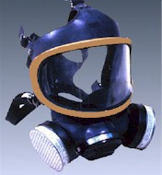
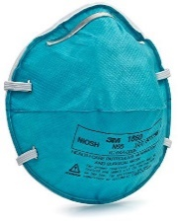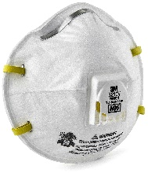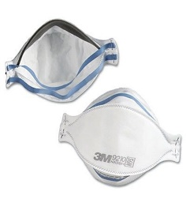
Powered air-purifying respirator (PAPR) is an air-purifying respirator that uses a blower to force ambient air through air-purifying elements to the respirator face piece, helmet, or hood. Powered air-purifying respirators use high efficiency particulate air (HEPA) filters, which are as efficient as P100 filters and will protect against airborne infectious agents. PAPRs provide a higher level of protection than disposable respirators. Healthcare facilities have used higher levels of respiratory protection, including PAPRs, for persons present during aerosol-generating medical procedures, such as bronchoscopy, on patients with infectious pulmonary diseases. PAPRs may also increase the comfort for some users by reducing the physiologic burden associated with negative pressure respirators and provides a constant flow of air on the face. In addition, there is no need for fit testing of loose-fitting hood or helmet models. This is an alternative for employees who cannot be fit tested for an N-95 disposable mask.
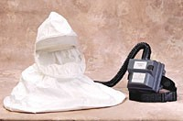

Supplied Air Respirator (SAR) is a respirator with a source of clean breathing air that is supplied to the wearer inside a face piece. This includes airline respirators connected to a free-standing cylinder of breathing air or air compressor, a self-contained breathing apparatus (SCBA) which has a tank of breathing air worn on the back of the user and escape respirators which have a small supply of air designed to last a short period of time to allow the user to leave the hazardous area. Supplied air respirators will not be used for routine health care procedures, but may be used by emergency responders. This guide does not cover fit testing on this respirator.

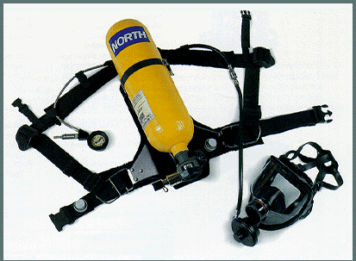

APRs, including the N-95 mask and SARs are considered tight-fitting respirators and need a tight seal between the respirator and the face and/or neck of the respirator user in order to work properly. If the respirator's seal leaks, contaminated air will be pulled into the face piece and can be breathed in. Therefore, anything that interferes with the respirator seal is not permitted when using this type of respirator. This could include facial hair, earrings, headscarves, wigs and facial piercings.

VOLUNTARY RESPIRATOR USE

The Program Administrator should authorize voluntary use of respiratory protective equipment as requested by all other workers on a case-by-case basis, depending on specific workplace conditions and the results of medical evaluations. Employees who do not have patient contact and do not work with hazardous chemicals may not need to participate in this program or be fit tested.
The Program Administrator will ensure that all employees who voluntarily choose to wear the above respirators understand the terms and conditions outlined in The OSHA Standard.

  - Information for Employees Using Respirators When Not Required Under the Standard
OSHA Appendix D to Sec. 1910.134
  - Respirators are an effective method of protection against designated hazards when properly selected and worn. Respirator use is encouraged, even when exposures are below the exposure limit, to provide an additional level of comfort and protection for workers. However, if a respirator is used improperly or not kept clean, the respirator itself can become a hazard to the worker. Sometimes, workers may wear respirators to avoid exposures to hazards, even if the amount of hazardous substance does not exceed the limits set by OSHA standards. If your employer provides respirators for your voluntary use, or if you provide your own respirator, you need to take certain precautions to be sure that the respirator itself does not present a hazard.

  - You should do the following:

  - 1. Read and heed all instructions provided by the manufacturer on use, maintenance, cleaning and care, and warnings regarding the respirators limitations.

  - 2. Choose respirators certified for use to protect against the contaminant of concern. NIOSH, the National Institute for Occupational Safety and Health of the U.S. Department of Health and Human Services, certifies respirators. A label or statement of certification should appear on the respirator or respirator packaging. It will tell you what the respirator is designed for and how much it will protect you.

  - 3. Do not wear your respirator into atmospheres containing contaminants for which your respirator is not designed to protect against. For example, a respirator designed to filter dust particles will not protect you against gases, vapors, or very small solid particles of fumes or smoke.

  - 4. Keep track of your respirator so that you do not mistakenly use someone else's respirator.

MEDICAL SCREENING, EVALUATION AND CLEARANCE

Employees assigned to tasks that require respiratory protection must be physically able to perform the tasks while wearing a respirator. This section offers guidance and instruction for Program Administrators and clinicians overseeing and/or administering employee medical screening, evaluation and clearance. Additionally, there are several templates and forms in the appendixes of this plan, which can be adopted by your program.
OSHA Standard
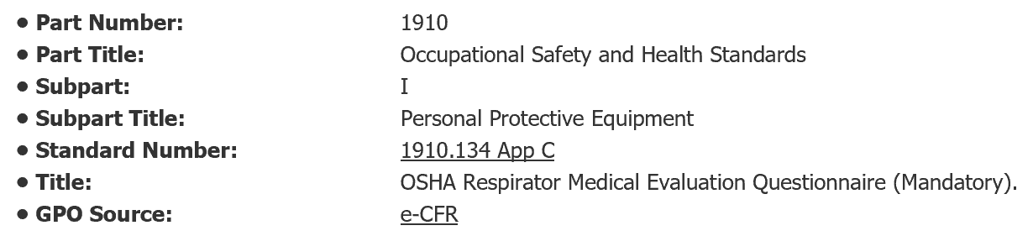

  - Question: Are physicians the only medical professionals allowed to perform medical evaluations for respirator use? (See the OSHA Standard Here)
  - Answer: No. A variety of health care professionals may perform physical assessments, depending on the scope of practice permitted by the state’s licensing, registration, or certification agencies. Each employer must check with the state licensing agency to see if other health care professionals under their state law can independently perform this evaluation, or must do so under the direction of a licensed physician. In Kentucky, a Physician’s Assistant, an Advanced Practice Registered Nurse (APRN) and a Registered Nurse (RN) are permitted to perform physical assessments. According to the Kentucky Board of Nursing Advisory Opinion Statement # 27 entitled “COMPONENTS OF LICENSED PRACTICAL NURSING PRACTICE”, a physical assessment is an ongoing process that consists of participation with the registered nurse in the determination of nursing care needs; therefore the LPN cannot performed physical assessments independently.

OVERVIEW OF THE CLINICAL PROCESS

The following process is recommended for conducting medical screening, evaluations and clearance for employees who undergo fit testing:
- Employee Self-Assessment: Respiratory Medical Screening Questionnaire
- Clinician Screening: A designated clinician will review each employee’s questionnaire and, if necessary, follow up on areas where the patient has answered “Yes”, before medically certifying that the employee may proceed with fit testing
- Designated clinician signs medical Clearance form
- Fit Test procedure is performed
- Employee and employer maintain copies of the fit test results and the make and model of appropriate mask

EMPLOYEE SELF ASSESSMENT: Respirator Screening Questionnaire

Each employee being fit tested must first complete a Respirator Screening Medical Questionnaire. The purpose of the Screening Questionnaire is to determine if an employee has a health condition or medical concern that may warrant further evaluation or the physical presence of a licensed clinical provider during fit testing. Determining whether an employee is “medially cleared” is somewhat subjective and may involve case-by case clinical judgement. OSHA does not provide specific criteria for determining the circumstances or conditions, which would lead a clinician to deem someone “medically unsuitable” to proceed with fit testing.
The screening questionnaire must be administered to the employee in a manner that is confidential and protects the employee’s privacy. The employee should also be provided the opportunity to discuss the questionnaire and/or results of the examination with the designated clinician overseeing the medical clearance component of the fit test program.

MEDICAL CLEARANCE

If further evaluation is needed by the employee, the clinician overseeing the fit testing program will review the completed questionnaire and determine if the employee is “medically cleared” to proceed with fit testing. Documentation of medical clearance will be provided to both the employee and Program Administrator. The clinician may make this determination based on the questionnaire alone, which would not involve any follow-up with the employee, but may also determine that further medical examination is warranted before proceeding with fit testing.
The information in the screening questionnaire is considered a medical record and, like all medical records, it must not be shared with management personnel. The screening questionnaire clearly states, "To maintain your confidentiality, your employer or supervisor must not look at or review your answers and your employer must tell you how to deliver or send this questionnaire to the health care professional who will review it.”

MEDICAL EVALUATION

Breathing through a respirator is more difficult than breathing in open air. People with lung disease, such as asthma or emphysema, elderly people or others may have trouble breathing. People with claustrophobia may not be able to wear a full-face piece or hooded respirator. People with vision problems may have trouble seeing while wearing a mask or hood.
There are physiological signs and symptoms that may warrant discontinuation of respirator use and/or a need for further medical evaluation.
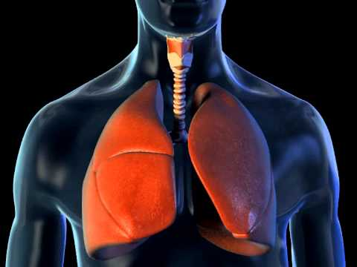
Pulmonary effects:
- Increased breathing resistance
- Increased work of breathing
- Decreased endurance
- Decrease in exercise performance
Cardiac effects:
- Increased cardiac work
- Increased heart rate
- Increased blood pressure
POTENTIAL CONTRAINDICATIONS TO RESPIRATOR USE
- Severe Pulmonary Disease
- Severe Cardiac Disease
- Uncontrolled Hypertension
- Claustrophobia
- Facial Abnormalities that prevent good fit
Psychological effects:
- Claustrophobia
- Anxiety
- Hyperventilation

Medical Re-Evaluation

Medical re-evaluation for suitability of wearing a respirator should be conducted under these circumstances:
- Employee reports physical symptoms (wheezing, shortness of breath, chest pain, etc.) that are related to the ability to use a respirator;
- It is identified that an employee is having a medical problem during respirator use or observations made during fit testing;
- The healthcare professional performing the evaluation determines an employee needs to be re-evaluated and the frequency of the evaluation;
- A change occurs in the workplace conditions that may result in an increased physiological burden on the employee;
- Employee facial size/shape/structure has changed significantly.

ADMINISTERING FIT TESTING

Fit testing is one of the most important parts of the respirator program because it is the only recognized tool to assess the fit of a specific respirator model and size to the face of the user. This section, along with the documentation tools in the appendix, including the OSHA Fit testing Video, provide guidance to help Program Administrators implement fit testing in a manner that is efficient and compliant with OSHA standards. * See Appendixes J, L and M for systematic instructions on how to perform qualitative fit testing.
Fit testing is a procedure conducted to ensure that a respirator is both comfortable and correctly fits the user. Fit testing uses a test agent, either qualitatively detected by the wearer’s sense of taste, smell or involuntary cough (irritant smoke) or quantitatively measured by an instrument, to verify the respirator’s fit. A qualitative fit test is a pass/fail test to assess the adequacy of respirator fit that relies on the individual’s sensory detection of a test agent. A quantitative fit test numerically measures the effectiveness of the respirator to seal with the wearer’s face, without relying on the wearer’s voluntary or involuntary response to a test agent. The respirator plan only covers information on qualitative fit testing procedures using Saccharin or Bitrex solution, because that is the primary method used in the LHDs in Kentucky.

Overview of fit test process:
All respirators function by forming a seal on the users face with the respirator itself. This is essential, as respirators are designed to come in contact with all air flowing through them, which is then filtered and delivered to the user.
Qualitative Fit testing uses simple equipment that places the user’s face and head into a hood, into which flavored mist is sprayed. The mist is usually bitter or sweet in flavor, with bitter (Bitrex) flavors being favored because detection of the flavor is more readily apparent to users.
Following a standard procedure, the user then breathes through the chosen respirator, and indicates whether they can detect the mist. If they cannot, the filter has passed the basic requirement of a face seal and the user also understands how to fit the mask.
It is important to note, that while the user may not detect the sweet or bitter indicator, which indicates a proper fit, this test does not provide any indication as to whether the filters or mask chosen are appropriate for the compounds, materials, mists or gases in the operating environment.

Qualitative Fit Testing Is A Pass/Fail Process
Qualitative testing is a pass/fail test that assesses the adequacy of respirator fit based on the individual's response to a test media. The pass/fail criteria is determined by an individual's response to sensory testing (smell or taste). The subject dons their respirator and a fit test hood. The test aerosol (Saccharin or Bitrex) is sprayed inside the hood while the subject performs prescribed exercises. If the subject can taste/smell the test agent, the respirator fails the test and another respirator must be tested.

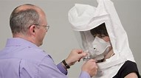
FREQUENCY OF FIT TESTING

Employees who need to wear respirators in order to perform job functions must be tested:
- After being hired and prior to being allowed to wear any respirator with a tight-fitting face piece;
- Whenever a different size, make, model or style of respirator is used;
- Whenever employee reports a change in physical characteristics that may affect fit, such as major dental work, facial surgery or injury or a change in weight;
- In addition, any scheduled retesting at a frequency determined by the Program Administrator, Supervisor or local policy or procedure.
At a minimum, employees should be fit tested initially after hire, annually and prior to responding to a disaster or event, in which there is a known respiratory hazard.

GENERAL RESPIRATOR USE PROCEDURES

Employees will use their respirators under conditions specified in this program, and in accordance with the training they receive on the use of each particular model. In addition, the respirator shall not be used in a manner for which it is not certified by NIOSH or by its manufacturer.
All employees shall conduct user seal checks each time they wear their respirators. See User Check Seal Procedures in Appendix L for more information.
Employees who have a condition, such as facial scars, facial hair or missing dentures that would prevent a proper seal are not permitted to wear tight-fitting respirators. Employees are not permitted to wear headphones, jewelry or other items that may interfere with the seal between the face and the face piece.
Before and after each use of a respirator, an employee must make an inspection of tightness or connections and the condition of the face piece, headbands, valves, filter holders and filters. The supervisor and/or Program Administrator must address questionable items immediately.

BASIC EMPLOYEE EDUCATION

All employee education should be provided at the time of initial assignment to respirator use, but before actual use, annually and then at a frequency determined by the Program Administrator. At a minimum, employees will receive training during the fit testing procedure that will provide him/her an opportunity to handle the respirator and make sure it fits properly. Every respirator wearer will receive fitting instructions, including demonstrations and practice in how the respirator should be worn, how to adjust it and how to perform a user seal check according to the manufacturer’s instructions.
Education that should be incorporated into employee fit test training:
- Why the respirator is necessary and how proper fit, usage, or maintenance can ensure the protective effect of the respirator.
- The limitations and capabilities of the respirators that will be used.
- How to effectively use the respirators.
- How to inspect, put on, remove, use, and check the seals of the respirator (for tight-fitting respirators such as N95s).
- The procedures outlined in this program for maintenance, storage, and cleaning or disposal of respirators. Employees who are issued PAPRs shall be instructed in procedures for charging and maintaining the batteries, and for checking the air flow rate.
- How to recognize medical signs and symptoms that may limit or prevent the effective use of respirators.

MAINTENANCE AND STORAGE

Respirators are to be properly maintained at all times in order to ensure that they function properly and protect employees adequately. Maintenance involves a thorough visual inspection for cleanliness and defects. Replace worn or deteriorated parts prior to use. No components will be replaced or repairs made beyond those recommended by the manufacturer. After inspection, cleaning, and necessary repairs, respirators shall be stored appropriately to protect against dust, sunlight, heat, extreme cold, excessive moisture, or damaging chemicals.
For disposable N95 respirators, this also means ensuring that supplies are stored in a climate-controlled environment and expired supplies are rotated out of inventory.

PROGRAM EVALUATION

The Program Administrator will review the Respiratory Plan annually and conduct periodic evaluations to ensure that the provisions of this program are being implemented.

DOCUMENTATION AND RECORD KEEPING

A written or electronic copy of the Respiratory Plan, and any other relevant OSHA Respiratory Protection Standards, should be kept by the Program Administrator and made available to all employees who wish to review it.
Copies of training and fit test records should be maintained by the Program Administrator. These records will be updated as new employees are trained, as existing employees receive refresher training and as new fit tests are conducted.
For employees covered under the Respiratory Plan Program, the Program Administrator shall maintain copies of the physician’s written recommendation regarding each employee’s ability to wear a respirator, if a physician’s review was required. The completed medical questionnaires and evaluating physicians documented findings will remain confidential and secured in the employee’s files.

Kentucky Respiratory Plan

Appendix

THIS PAGE IS INTENTIONALLY BLANK

DESCRIPTION OF INCLUDED APPENDICES

- Appendix A – 3M and OSHA training videos including fit test procedure videos and mandatory TRAIN videos
- Appendix B – Respiratory Hazards that would require respiratory protection for employees
- Appendix C – How to recognize a NIOSH approved N-95 mask
- Appendix D – NIOSH produced info-graphic that includes an overall summary of respiratory fit test requirements
- Appendix E – NIOSH produced info-graphic to assist fit test administrators to evaluate acceptable and unacceptable facial hairstyles which may interfere with the proper seal of face piece respirators
- Appendix F – General requirements for fit test program procedures and protocols
- Appendix G – Comprehensive fit test log for all employees
- Appendix H - These cards can be given to employees as verification of successful completion of their initial/annual fit testing requirements. This card is also meant to be a reference to the employee of their chosen respirator’s manufacturer, model, and size.
- Appendix J – Sensitivity testing instructions – the first step in fit testing
- Appendix K - This NIOSH produced info-graphic is included to provide a quick reference on the proper donning and doffing procedures of disposable respirators
- Appendix L – User seal check procedures
- Appendix M - The step-by-step instructions for OSHA compliant qualitative respirator fit test is provided here to provide easy access and reference to proper qualitative fit testing protocol to ensure testing is done correctly. These instructions can be printed and followed while performing testing to ensure validity of the test being performed.
- Appendix N – Rainbow Bridge passage and quick reference fit test procedure cards
- Medical Screening Questionnaire – The medical screening questionnaire is an OSHA required document. It is used to identify employees who may be unsuitable for fit testing. It is color-coded to assist the licensed clinician in decision-making judgement calls on fit testing suitability.
Green - May proceed with fit testing. No medical conditions or concerns identified during screening. A licensed clinician does not need to be present during employee fit testing.
Yellow – Questionnaire must first be reviewed by a licensed clinician to determine whether a licensed clinician should be present during employee fit testing due to a medical condition or concern. There are three possible outcomes for the employee if any yellow flags are checked on the screening questionnaire:
- Licensed clinician reviews the questionnaire and determines that no further assessment is necessary in order to physically clear the employee,
- Licensed clinician reviews the questionnaire, conducts a follow-up interview with the employee as needed and determines that the employee is cleared to proceed with fit testing without the physical presence of the licensed clinician, or
- Licensed clinician reviews the questionnaire, conducts follow-up interview with employee as needed and determines that the employee if cleared to proceed with fit testing with the physical presence of a licensed clinician.
Red – Stop. A medical referral to a physician must be conducted before determining that an employee is “medically cleared” to proceed with fit testing. If determined safe to proceed, a licensed clinician should be physically present during fit testing. Fit testing should be terminated immediately if the employee shows any signs of physiological distress and/or adverse reactions. This should be documented and reported to the Program Administrator.

- Appendix O – Respiratory Fit Test Record should be filled out completely following the completion of the employee respirator fit testing. It is recommended that the form be filed in the employee’s record and a copy given to the employee.
- Appendix P - This form is offered to provide Program Administrators with a resource to annotate administrative requirements regarding storage, cleaning, maintenance and repair of respirators. This form is designed as a reference regarding location of respirators as well as cleaning schedules. It also provides a point of contact for trained individuals responsible for repairs and adjustment of facility respirators.
- Appendix Q – Employee competency verification form - The purpose of this competency verification is to ensure that employees who wear respirators are familiar with basic standards established by OSHA 29 CFR 1910.134. This competency verification checklist may be used to assess employee knowledge and assure competence regarding the following fit test fundamentals.

APPENDIX A:

Fit Test Videos and eTools

3M Fit test Training Video (Saccharin and Bitrex): https://www.youtube.com/watch?v=xl4qX6qEYXU
Allegro Qualitative Fit Test Video: https://www.youtube.com/watch?v=_bT7uwRHGzI
OSHA Fit-Test Video: https://www.osha.gov/video/respiratory_protection/fittesting.html
OSHA Training Video: Donning, Doffing, User Seal Check: https://www.youtube.com/watch?v=Tzpz5fko-fg
Centers for Disease Control and Prevention (CDC) NIOSH: How to Properly Put On and Take Off a Disposable Respirator: https://www.cdc.gov/niosh/docs/2010-133/pdfs/2010-133.pdf

Respiratory Types: https://www.osha.gov/video/respiratory_protection/resptypes.html
Respiratory Types: https://www.youtube.com/watch?v=wf64hI7WYJ8&nohtml5=False

Respirator Selection: https://www.osha.gov/SLTC/etools/respiratory/respirator_selection.html
Hazard Exposure from OSHA: https://www.osha.gov/SLTC/etools/respiratory/respirator_selection.html#change_schedule_exposure
Maintenance and Care of Respirators Video: https://www.osha.gov/video/respiratory_protection/maintenance.html

Web-Based Courses

There are several relevant training videos on the OSHA website. The link will take you to a variety of training videos related to respiratory protection: https://www.osha.gov/SLTC/respiratoryprotection/training_videos.html

Required LHD training sites:

The TRAIN course number is 1074371 (note: two modules are combined into one course)
https://www.train.org/ky/course/1074371/

APPENDIX B:

Respiratory Hazards
Public health workers can be exposed to serious infectious diseases such as influenza, tuberculosis, measles and meningitis. Staff at risk for exposure to the diseases/pathogens listed below should be educated and equipped to protect themselves and prevent the spread of these diseases. Respiratory protection using N95 respirators is one important component of an effective infection control program. (See page 58, Terms to Know and Abbreviations, for definition of airborne precautions versus droplet precautions.)
  - Diseases/Pathogens Requiring Airborne Infection Isolation
Aerosolizable spore-containing powder or other substance that is capable of causing serious human disease, e.g., Anthrax/Bacillus anthracis
Avian influenza/Avian influenza A viruses (strains capable of causing serious disease in humans)
Varicella disease (chickenpox, shingles)/Varicella zoster and Herpes zoster viruses, disseminated disease in any patient. Localized disease in immunocompromised patient until disseminated infection ruled out
Measles (rubeola)/Measles virus
Monkeypox/Monkeypox virus
Novel or unknown pathogens
Severe acute respiratory syndrome (SARS)
Smallpox (variola)/Varioloa virus
Tuberculosis (TB)/Mycobacterium tuberculosis -- Extrapulmonary, draining lesion; Pulmonary or laryngeal disease, confirmed; Pulmonary or laryngeal disease, suspected
Any other disease for which public health guidelines recommend airborne infection isolation
  - Diseases/Pathogens Requiring Droplet Precautions
  - Diphtheria pharyngeal
  - Epiglottitis, due to Haemophilus influenzae type b
  - Haemophilus influenzae Serotype b (Hib) disease/Haemophilus influenzae serotype b -- Infants and children
  - Influenza, human (typical seasonal variations)/influenza viruses
  - Meningitis
  - Haemophilus influenzae, type b known or suspected
  - Neisseria meningitidis (meningococcal) known or suspected
  - Meningococcal disease sepsis, pneumonia (see also meningitis)
  - Mumps (infectious parotitis)/Mumps virus
  - Mycoplasmal pneumonia
  - Parvovirus B19 infection (erythema infectiosum)
  - Pertussis (whooping cough)
  - Pharyngitis in infants and young children/Adenovirus, Orthomyxoviridae, Epstein-Barr virus, Herpes simplex virus,
  - Pneumonia
  - Adenovirus
  - Haemophilus influenzae Serotype b, infants and children
  - Meningococcal
  - Mycoplasma, primary atypical
  - Streptococcus Group A
  - Pneumonic plague/Yersinia pestis
  - Rubella virus infection (German measles)/Rubella virus
  - Severe acute respiratory syndrome (SARS)
  - Streptococcal disease (group A streptococcus)
  - Skin, wound or burn, Major
  - Pharyngitis in infants and young children
  - Pneumonia
  - Scarlet fever in infants and young children

APPENDIX C:

NIOSH Certified Equipment

NIOSH has become aware of a counterfeit N95 Respirator on the market. While the TC number and private label holder (KOSTO) are valid, the misspelling of NIOSH on the front of the respirator can identify this unapproved unit.

How can you be sure a respirator is truly NIOSH-approved?

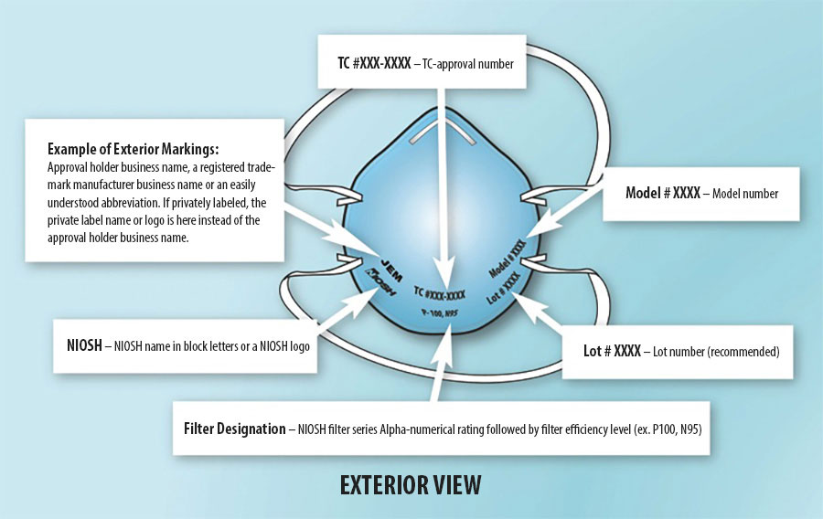
- Check the respirator approval markings or Certified Equipment list.
- Additional information is available on the NIOSH Trusted Source Page.
- As the CDC becomes aware of counterfeit respirators or those misrepresenting the NIOSH approval on the market, they will update the list here: https://www.cdc.gov/niosh/npptl/usernotices/default.html#Counterfeit%20Respirators
- More information can be found at: https://www.osha.gov/video/respiratory_protection/niosh.html

APPENDIX D:

Respirator Fit Test Requirements

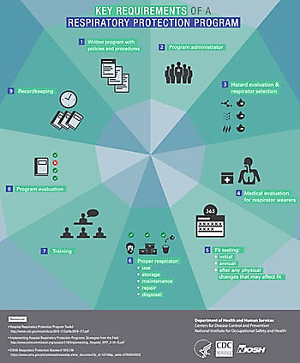

APPENDIX E:

Acceptable and Unacceptable Facial Hair

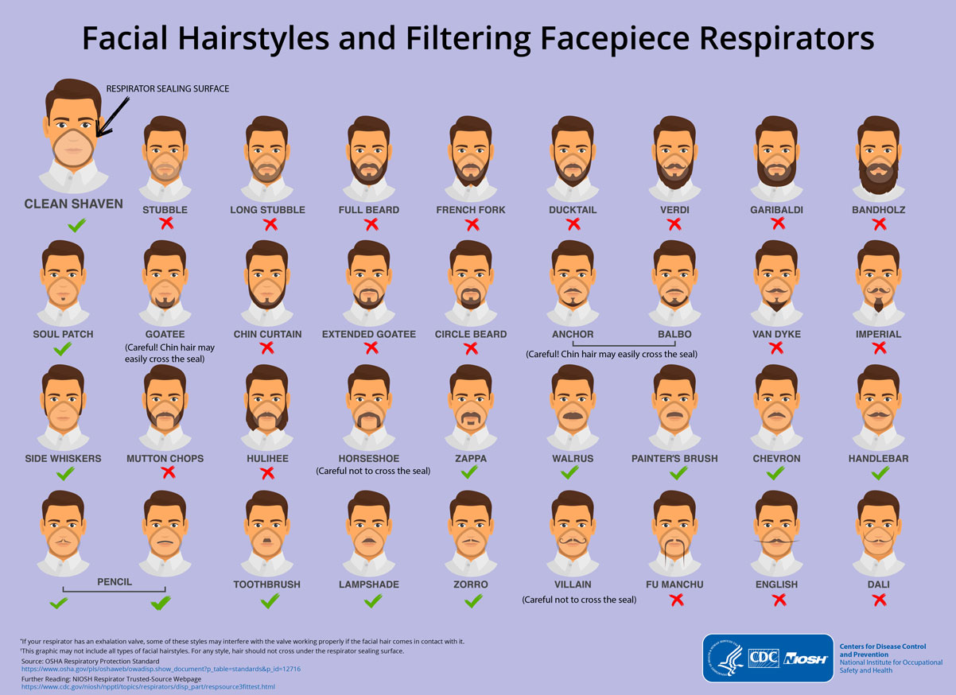

APPENDIX F:

Fit Test Program Procedures and Protocols: General Requirements
This section covers the mandatory general requirements for conducting respirator fit testing in order to maintain compliance with OSHA standards. To view the OSHA standard 1910.134 from appendix A, click here.
These are the general requirements that all fit testing programs should uphold:
1. The employee should have an active role in the selection of a respirator that fits comfortably and correctly. It is important to offer different sizes and models of respirators for the employee to select from, as there is no one-size-fits-all solution.
2. Throughout the entire fit testing process, the employee should be informed about what to expect and encouraged to ask questions. The employee should be shown how to put on a respirator, how it should be positioned on the face, how to set strap tension and how to determine an acceptable fit. A mirror should be available to assist the employee in evaluating the fit and positioning of the respirator as he or she dons and doffs the equipment.
3. During the assessment, the mask should remain donned for about 5 minutes and assessment of comfort should be discussed with employee, based on the following findings:
(a) Position of the mask on the nose
(b) Room for eye protection
(c) Room to talk
(d) Position of mask on face and cheeks

4. The following criteria shall be used to help determine the adequacy of the respirator fit:
(a) Chin properly placed;
(b) Adequate strap tension, not overly tightened;
(c) Fit across nose bridge;
(d) Respirator of proper size to span distance from nose to chin;
(e) Tendency of respirator to slip;
(f) Self-observation in mirror to evaluate fit and respirator position.

8. If the employee finds the fit of the respirator unacceptable, the test subject shall be given the opportunity to select a different respirator and to be retested.
9. The fit tester must assist the employee in performing a user seal check.
10. If the employee experiences difficulty breathing or shortness of breath, the test should be stopped immediately and she or he should be referred to a physician or designated clinician in order to determine next steps. The fit tester should make a note on Fit Test Record and ensure that Program Administrator and clinician are made aware of occurrence. The clinician who completed medical clearance should also make a note on the screening questionnaire.

APPENDIX G: Place LHD Logo Here

Employee Fit Test Log

Employee Fit Test Log
This record should be completed by the person conducting the fit testing.
Location of Fit Testing: __________________________________ Date: _______________
Name of Fit Tester: _____________________________
Signature: __________________________________
Type of OSHA Accepted Fit Test Protocol Used (Qualitative): Manufacturer:
Bitrex ❑ Saccharin ❑ Isoamyl Acetate❑ 3M ❑Kimberly Clark ❑ Allegro ❑ MSA ❑ Other❑

 | Name | Respirator Fit Tested | Fit Test |  | Could not be fit tested due to:
 | Please Print | Make, Model, Style, Size | Pass | Fail
1
2
3
4
5
6
7
8
9
10
11
12
13
14

THIS PAGE IS INTENTIONALLY BLANK

APPENDIX H: Employee Fit Test Certification Card

Employee Fit Test Certification Card  Please keep with your records Place LHD Logo Here  Fit Test Date: ______________  Employee Name: ____________________________  Respirator Type and Size:  Expiration: ___________________  Fit Tester Initial: ______ Phone #:__________________ | Employee Fit Test Certification Card  Please keep with your records Place LHD Logo Here  Fit Test Date: ______________  Employee Name: ____________________________  Respirator Type and Size:  Expiration: ___________________  Fit Tester Initial: ______ Phone #:__________________
Employee Fit Test Certification Card  Please keep with your records Place LHD Logo Here  Fit Test Date: ______________  Employee Name: ____________________________  Respirator Type and Size:  Expiration: ___________________  Fit Tester Initial: ______ Phone #:__________________ | Employee Fit Test Certification Card  Please keep with your records Place LHD Logo Here  Fit Test Date: ______________  Employee Name: ____________________________  Respirator Type and Size:  Expiration: ___________________  Fit Tester Initial: ______ Phone #:__________________

THIS PAGE IS INTENTIONALLY BLANK

APPENDIX J:

Fit Test Procedure 1: Sensitivity Testing

This is the first test completed to assure that the person being fit tested can detect the sweet or bitter taste of the test solution at very low levels. The Sensitivity Test Solution is a very dilute version of the Fit Test Solution. The objective is to find out IF the person can taste the solution and how many squeezes of the nebulizer to use during the Fit Test.
The test subject should not eat, drink (except water), or chew gum for 15 minutes before the test.
- Assess test subject for a known history of the inability to detect different tastes or smells or a diagnosis of ageusia, the loss of taste functions of the tongue, particularly sweetness and bitterness or a diagnosis of anosmia, the loss of the sense of smell.
- Have the test subject put on the hood and collar assembly without a respirator.

- Position the hood assembly forward so that there is about six inches between the subject’s face and the hood window.

- Instruct the test subject to breathe through his/her mouth with tongue extended. (Remind the person to breathe through their mouth with their tongue slightly out. Remind them that they are trying to taste the solution, not smell it.)

- Using Nebulizer #1 with the Sensitivity Test Solution, inject the aerosol into the hood through the hole in the hood window. Inject ten squeezes of the bulb, fully collapsing and allowing the bulb to expand fully on each squeeze. Both plugs on the nebulizer must be removed from the openings during use. The nebulizer must be held in an upright position to ensure aerosol generation.

- Ask the test subject if he/she can detect the bitter/sweet taste of the solution. If tasted, note the number of squeezes as 10 and proceed to the fit test.

- If not tasted, inject an additional ten squeezes of the aerosol into the hood. Repeat with ten more squeezes if necessary. Note whether 20 or 30 squeezes produced a taste response.

- If 30 squeezes do not cause the subject to detect a bitter/sweet taste, the test is ended. Another type of fit test must be used.

- Remove the test hood, and give the subject a few minutes to clear the taste from his/her mouth. It may be helpful to have the subject rinse his/her mouth with water.

THIS PAGE IS INTENTIONALLY BLANK

APPENDIX K:
Donning and Doffing a Disposable N95 Respirator

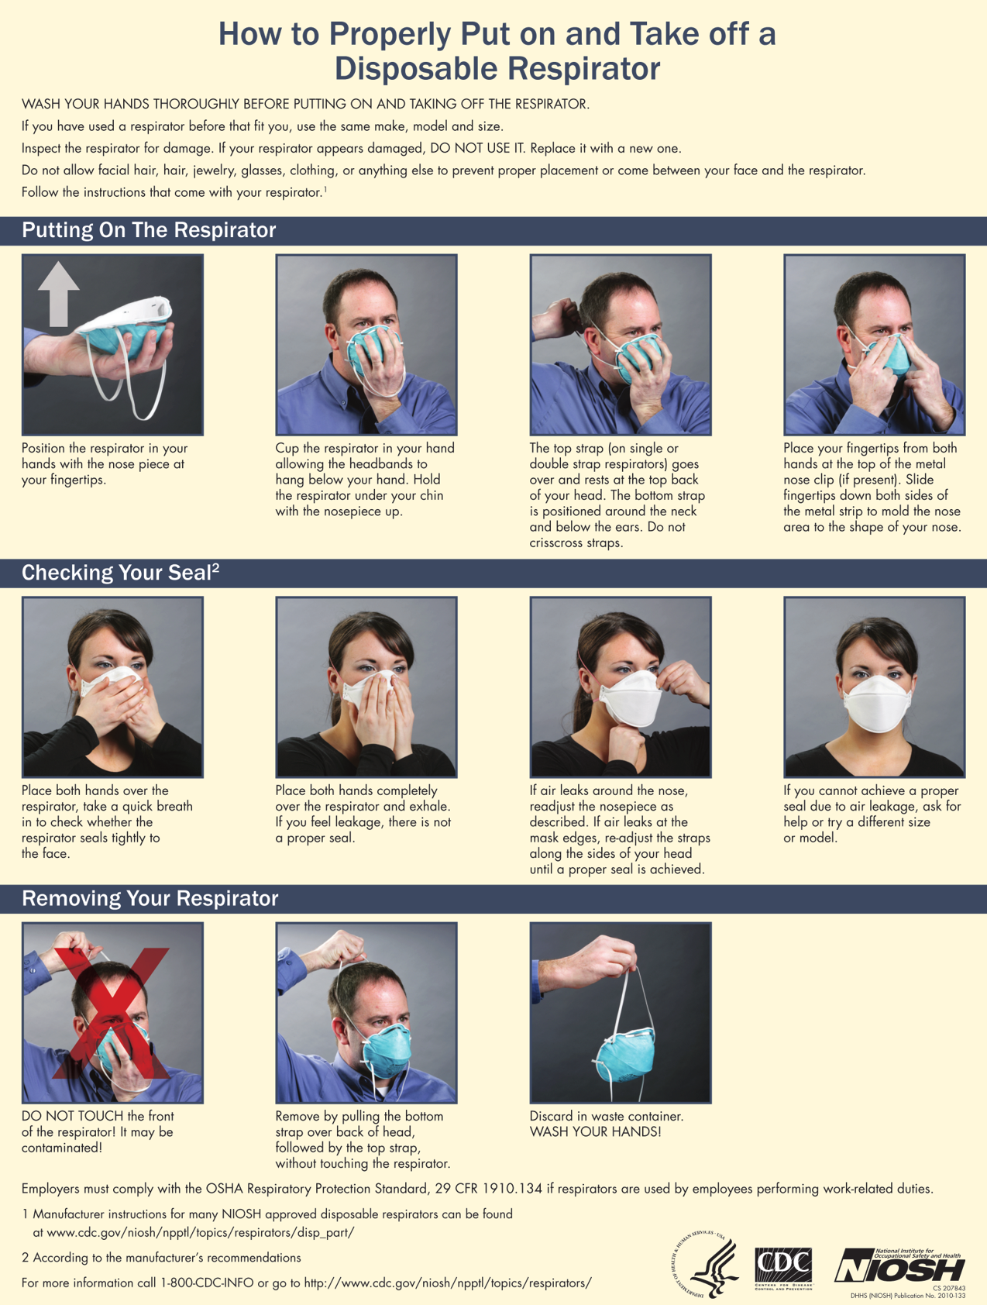

APPENDIX L:

User Donning and Seal Check Procedures: OSHA Procedure

The individual who uses a tight-fitting respirator is to perform a user seal check to ensure that an adequate seal is achieved each time the respirator is put on. Either the positive and negative pressure checks listed in this appendix, or the respirator manufacturers recommended user seal check method shall be used. User seal checks are not substitutes for qualitative fit tests.
Positive pressure check
Close off the exhalation valve and exhale gently into the face piece. The face fit is considered satisfactory if a slight positive pressure can be built up inside the face piece without any evidence of outward leakage of air at the seal. For most respirators this method of leak testing requires the wearer to first remove the exhalation valve cover before closing off the exhalation valve and then carefully replacing it after the test.
Negative pressure check
Close off the inlet opening of the canister or cartridge(s) by covering with the palm of the hand(s) or by replacing the filter seal(s), inhale gently so that the face piece collapses slightly, and hold the breath for ten seconds. If the face piece remains in its slightly collapsed condition and no inward leakage of air is detected, the tightness of the respirator is considered satisfactory.

Manufacturer's Recommended User Seal Check Procedures
The respirator manufacturer's recommended procedures for performing a user seal check may be used instead of the positive and/or negative pressure check procedures if the employer demonstrates that the manufacturer's procedures are equally effective.

Donning (Fitting) Instructions

(Must be followed each time respirator is worn)

1. Cup the respirator in your hand, with the nosepiece at your fingertips, allowing the headbands to hang freely below your hand.

2. Position the respirator under your chin with the nosepiece up. Pull the top strap over your head resting it high at the top back of your head. Pull the bottom strap over your head and position it around the neck below the ears.

3. Place your fingertips from both hands at the top of the metal nosepiece. Using two hands, mold the nose area to the shape of your nose by pushing inward while moving your fingertips down both sides of the nosepiece. Pinching the nosepiece using one hand may result in improper fit and less effective respirator performance. Use two hands.

4. Perform a user seal check prior to each wearing. To check the respirator-to-face seal, place both hands completely over the respirator and exhale. Be careful not to disturb the position of the respirator. If air leaks around nose, readjust the nosepiece as described in step 3. If air leaks at the respirator edges, work the straps back along the sides of your head. If you CANNOT achieve proper seal, DO NOT enter the isolation or treatment area. See your supervisor.
APPENDIX M:

Fit Test Procedure 2: Fit Test Procedure

1. Have the test subject don the respirator and perform a user seal check per the instructions provided on the respirator package.

2. Have subject wear any applicable safety equipment that may be worn during actual respirator use that could interfere with respirator fit.

3. Have the subject put on and position the test hood as before, and breathe through his/her mouth with tongue extended.

4. Using Nebulizer #2 with Fit Test Solution, inject the fit test aerosol using the same number of squeezes as required in the Sensitivity Test (10, 20 or 30). A minimum of ten squeezes is required, fully collapsing and allowing the bulb to expand fully on each squeeze. The nebulizer must be held in an upright position to ensure aerosol generation.

5. To maintain an adequate concentration of aerosol during this test, inject one-half the number of squeezes (5, 10, or 15) every 30 seconds for the duration of the fit test procedure.

6. After the initial injection of aerosol, ask the test subject to perform the following test exercises for 60 seconds each:

A. Normal breathing (60 seconds) – In a normal standing/sitting position, without talking, the subject shall breath normally.
B. Deep breathing (60 seconds) – In a normal standing/sitting position, the subject shall breathe slowly and deeply, taking caution so as not to hyperventilate.
C. Turning head side to side (60 seconds) – Standing/sitting in place, the subject shall slowly turn his/her head from side to side between the extreme positions on each side. The head shall be held at each extreme momentarily so the subject can inhale at each side.
D. Moving head up and down (60 seconds) – Standing/sitting in place, the subject shall slowly move his/her head up and down. The subject shall be instructed to inhale in the up position (when looking toward the ceiling).
E. Talking – The subject shall talk out loud slowly and loud enough to be heard clearly by the test conductor. The subject can read from a prepared text, count backward from 100, or recite a memorized poem or song, such as the Rainbow Passage (see appendix N).
F. Bending over (60 seconds) – The test subject shall bend at the waist, from a standing position, as if he/she were to touch his/her toes. Jogging in place may be substituted for the exercise.
G. Normal breathing – Same as exercise A above.

7. The test is terminated at any time the bitter or sweet taste of aerosol is detected by the subject because this indicates an inadequate fit. Wait 15 minutes and perform the Sensitivity Test again.

8. Repeat the fit test after redonning and readjusting the respirator. A second failure may indicate that a different size or model respirator is needed.

9. If the entire test is completed without the subject detecting the bitter or sweet taste of the aerosol, the test is successful and respirator fit has been demonstrated.

10. Periodically check the nebulizer to make sure that it is not clogged. If clogging is found, clean the nebulizer and retest.

APPENDIX M continued:

Before removing the hood

Ask the person to put their hand inside the hood and then, with one finger, break the seal of the respirator on their face. Ask them to take a breath through their mouth. They will probably grimace in surprise at the sudden taste of the strong solution inside the hood. This is a very good way of building people’s confidence in the respirator, because they will realize that if it can be this effective at keeping out an apparently high concentration of test agent for so long, then it will be able to protect them in the workplace, provided they have been careful to fit it correctly each time. Make this point to them afterwards.

Cleaning of Fit Test Equipment

At the end of each fit test session, or at least every four hours, discard the unused solutions from the nebulizers. Do not pour unused solutions back into bottles. Rinse the nebulizers with warm water to prevent clogging and shake dry. Wipe out the inside of the hood with a damp cloth or paper towel to remove any deposited test solution.

What to do if someone fails a fit test?

Remember, you can be tested twice on the same respirator. You only fail if you fail twice on the same size and model of respirator.

How often do failures happen?
It is not unusual to find that some people have difficulty obtaining a reliable fit with their selected respirator. This is not surprising, as it is impossible to design a respirator that fits everybody. When this occurs, an alternative respirator of a different design or size, but with at least the same level of protection can be offered. The fit test is then repeated using this alternative model. Usually just one alternative model or size is needed to achieve a pass of the fit test second time around.

How to Select an Alternative Respirator to Use

Several brands have a range of different respirators. There is an effective, comfortable alternative for anyone who does not pass the fit test on their first attempt. Ensure the alternative respirator selected offers the same level of protection.

Repeat Fit Testing

Arrange for fit testing on an alternative model or size as soon as possible for anyone failing the fit test.

THIS PAGE IS INTENTIONALLY BLANK

APPENDIX N:

Rainbow Passage and Fit Test Cheat Sheet

Rainbow Passage
When the sunlight strikes raindrops in the air, they act like a prism and form a rainbow. The rainbow is a division of white light into many beautiful colors. These take the shape of a long round arch, with its path high above, and its two ends apparently beyond the horizon. There is, according to legend, a boiling pot of gold at one end. People look, but no one ever finds it. When a man looks for something beyond reach, his friends say he is looking for the pot of gold at the end of the rainbow.

Sensitivity Test
Use sensitivity solution and matching atomizer
Remind person to breathe through mouth with tongue at front.
Say ... “Tell me immediately when you can taste it”
1-10 Squeezes If not tasted, repeat
11-20 Squeezes If not tasted, repeat
21–30 Squeezes STOP if not tasted

Write down which range the taste was detected = 10, 20 or 30

Fit Test
Change exercise every 60 seconds
Top up with atomizer every 30 seconds
Repeat again ... “Tell me immediately when you can taste it”
Start 10, 20 or 30 squeezes
During test Half = 5, 10 or 15 extra squeezes every 30 seconds
Exercises (7):
Breathe normally;
Breathe more deeply;
Head side to side;
Up and down;
Bending over;
Talking;
Breathe normally.

Finish Ask person to break face seal with finger and take a breath through the mouth
(Explain what this shows)
Don’t Forget to Record Results!

THIS PAGE IS INTENTIONALLY BLANK

Place LHD LogoHere
OSHA Respirator Medical Screening Questionnaire

NAME | DOB | AGE | DATE

GENDER: Male Female
HEIGHT |  | WEIGHT

YOUR JOB TITLE: _______________________

PHONE NUMBER: ______________________

(where you can be reached by the health care professional who reviews this questionnaire)

HAVE YOU EVER WORN A RESPIRATOR? Yes No

If yes, what types? ______________________________________________________________________

(ex. disposable respirator, full-face piece type, powered-air purifying, SCBA)

MANDATORY QUESTIONS
(ALL QUESTIONS IN THIS SECTION MUST BE COMPLETED BY EMPLOYEE
AND REVIEWERD BY A CLINICIAN PRIOR TO MEDICAL CLEARANCE)

Please check the appropriate box for each question
- Have you ever had any of the following conditions?
Seizures | Yes No
Diabetes | Yes No
Allergic reactions that interfere with your breathing | Yes No
Claustrophobia (fear of closed-in places) | Yes No
Trouble tasting/smelling odors | Yes No
- Have you ever had any of the following pulmonary or lung problems?
Asbestosis | Yes No
Asthma | Yes No
Chronic bronchitis | Yes No
Claustrophobia (fear of closed-in places) | Yes No
Emphysema | Yes No
Pneumonia | Yes No
Tuberculosis | Yes No
Silicosis  Pneumothorax (collapsed lung)  Lung cancer  Broken ribs  Any chest injuries or surgeries  Any other lung problem that you’ve been told about  Comments: | Yes No  Yes No  Yes No  Yes No  Yes No  Yes No
Do you currently smoke tobacco, or have you smoked tobacco in the last month | Yes No

Do you currently have any of the following symptoms of pulmonary or lung illness?
Shortness of breath |  | Yes No
Shortness of breath when walking fast on level ground or walking up a slight hill or incline |  | Yes No
Shortness of breath when walking with other people at an ordinary pace on level ground |  | Yes No
Have to stop for breath when walking at your own pace on level ground |  | Yes No
Shortness of breath when washing or dressing yourself |  | Yes No
Shortness of breath that interferes with your job |  | Yes No
Coughing that produces phlegm (thick sputum) |  | Yes No
Coughing that wakes you early in the morning  Coughing that occurs mostly when you are lying down  Coughing up blood in the last month  Wheezing  Wheezing that interferes with your job  Chest pain when you breathe deeply  Any other symptoms that you think may be related to lung problems (please explain): |  | Yes No  Yes No  Yes No  Yes No  Yes No  Yes No  Yes No

Have you ever had any of the following cardiovascular or heart problems?
Heart attack |  | Yes No
Stroke |  | Yes No
Angina (chest pain) |  | Yes No
Heart Failure |  | Yes No
Swelling in your legs or feet (not caused by walking) |  | Yes No
Heart arrhythmia (heart beating irregularly) |  | Yes No
High blood pressure |  | Yes No
Coughing that wakes you early in the morning  Any other heart problem that you've been told about (please explain): |  | Yes No

Have you ever had any of the following cardiovascular or heart symptoms?
Frequent pain or tightness in your chest |  | Yes No
Pain or tightness in your chest during physical activity |  | Yes No
Pain or tightness in your chest that interferes with your job |  | Yes No
In the past two years, have you noticed your heart skipping or missing a beat |  | Yes No
Heartburn or indigestion that is not related to eating |  | Yes No
Any other symptoms that you think may be related to heart or circulation problems (please explain :) |  | Yes No

Do you currently take medication for any of the following problems?
Breathing or lung problems | Yes No
Heart trouble | Yes No
Blood pressure | Yes No
Seizures | Yes No
Any other medications that may interfere with your use of a respirator (please explain):

If you've used a respirator, have you ever had any of the following problems?
If you've never used a respirator, check this box and proceed to question 9
_________________________________________________________________________________________________
Eye irritation | Yes No
Skin allergies or rash | Yes No
Anxiety | Yes No
General weakness or fatigue | Yes No
Any other problem that interferes with your use of a respirator (please explain): | Yes No

Would you like to talk to the health care professional who will review this questionnaire about your answers to this questionnaire: Yes No

Employee Signature ____________________________

This concludes the Employee portion of the questionnaire. Thank you for your time.

MEDICAL CLEARANCE

This portion must be completed by a designated clinician before employee can proceed with fit testing.

Clinician Name ____________________________________ Date _____________________

I have reviewed the medical questionnaire with the employee

I have reviewed the medical questionnaire without the employee

  - Based upon my findings, I recommend that:
- The employee proceeds with fit testing and does not require presence of a clinician | - The employee proceeds with fit testing with the presence of a clinician | - Further physical examination by a physician be performed in order to determine if employee is medically suited for fit testing

  - Clinician Signature ________________________

THIS PAGE IS INTENTIONALLY BLANK

APPENDIX O: Place LHD Logo Here

Respirator Fit Test Record

Employee Name: _______________________ Initials: _____
Type of qualitative fit test solution used (circle): Saccharin or Bitrex
Test Operator Name: ________________________ Initials: _____
Date: _______

Respirator Mfr./Model/Approval no. | Size | Pass/Fail
1. ____________________ | S M L | P F
2. ____________________ | S M L | P F
3. ____________________ | S M L | P F
4. ____________________ | S M L | P F
Medical Screening Questionnaire Completed? Yes ____ No ____ If no, why: _________________________________
Medical referral required? Yes ____ No ____
Medical Evaluation completion date: __________
Is Employee Able to be Fit Tested: Yes _____ No _______

NOTES:
____________________________________________________________________________________________________________________________________________________________________________________________________________________________________

This record indicates that you have passed or failed a qualitative fit test as shown above for the particular respirator(s) shown. Other types will not be used until fit tested.

THIS PAGE IS INTENTIONALLY BLANK

APPENDIX P: Place LHD Logo Here

Respirator Storage, Cleaning, Maintenance and Repair

Our non-disposable respirators will be stored in the following clean locations:

Respirators will be cleaned and sanitized every (_____) days or whenever they are visibly dirty. This does not apply to paper dust masks which are disposed daily. Respirators will be cleaned according to the attached instructions (either the manufacturer’s instructions or the Respirators Rule cleaning procedures).

For Rule-specified respirator cleaning procedures where you don’t have manufacturer’s instructions, see below.

All respirators will be inspected before and after every use and during cleaning. In addition, emergency respirators and self-contained tank-type supplied air respirators in storage will be inspected monthly.

Respirators will be inspected for damage, deterioration or improper functioning and repaired or replaced as needed. Repairs and adjustments are done by ____________ who is trained in respirator maintenance and repair.

Supplied air respirators will be checked for proper functioning of regulator and warning devices and amount of air in tanks where used.

When supplied air respirators are used, any needed repairs or adjustments will be done by the manufacturer or technician trained by the manufacturer. Our supplied air respirators are maintained and repaired by ________________________________________.

On respirators with vapor or gas cartridges, the cartridges will be regularly replaced on the following schedule. Check with respirator vendor for recommended replacement schedule for each brand and type of respirator.

Type of respirator cartridge | Location or job duties | Chemicals in use | Replacement schedule

THIS PAGE IS INTENTIONALLY BLANK

APPENDIX Q:

Employee Competency Verification (Optional)

The purpose of this competency verification is to ensure that employees who wear respirators are familiar with basic standards established by OSHA 29 CFR 1910.134. This competency verification checklist may be used to assess employee knowledge and assure competence regarding the following fit test fundamentals:

Why the respirator is necessary and how improper fit, usage, or maintenance can compromise the protective effect of the respirator

What the limitations and capabilities of the respirator are

How to use the respirator effectively in emergency situations, including situations in which the respirator malfunctions

How to inspect, put on and remove, use, and check the seals of the respirator

What the procedures are for maintenance and storage of the respirator

How to recognize medical signs and symptoms that may limit or prevent the effective use of respirators

The general requirements of the respirator standard

This competency verification may be performed prior to requiring an employee to use a respirator and thereafter if/when the following situations occur:

Changes in the workplace or the type of respirator render previous training obsolete;

Inadequacies in the employee's knowledge or use of the respirator indicate that the employee has not retained the requisite understanding or skill; or

Any other situation arises in which retraining appears necessary to ensure safe respirator use

Employee Competency Verification
Employee Name: Place LHD logo here

Date:
_________________________________________________________________________________________
1. Employee understands when and why the respirator is needed.

Employee Initials

(Respirators are needed to protect the employee from airborne and droplet borne hazards such such as tuberculosis, avian influenza, measles, and other contagious diseases)

2. Employee understands what the respirator can and cannot do to protect them.

Employee Initials
(Respirator can protect the employee from airborne and droplet borne hazards of a certain particulate size. Respirator cannot protect them against gasses or other types of hazards)

3. Employee correctly demonstrates how to inspect the mask prior to use.

Employee Initials
(Mask should be visually inspected for rips, tears or damage prior to use. Mask should be discarded if any damage is visible)

Employee Initials
4. Employee correctly demonstrates how to put on, use, and take off respirator.
(Employee dons and doffs mask in compliance with manufacturer’s instructions. Including molding nose bridge piece)

Employee Initials
5. Employee correctly demonstrates how to perform a user seal check of the respirator.
(Employee performs seal check with hands per manufacturer’s instructions)

6. Employee understands how to use the respirator in emergency situations and what to do if the respirator doesn’t work properly.

Employee Initials
(Respirator is utilized normally in “scene safe” environments. If respirator malfunctions, dispose of respirator and obtain a new one)

7. Employee understands medical signs and symptoms that may limit or prevent employee from using a respirator.

Employee Initials

(The employee may be limited or prevented from using a respirator if
the employee has difficulty forming a seal, or has difficulty
breathing while using a respirator)

8. Employee understands improper fit, usage, or maintenance can reduce the respirator’s ability to protect the employee.

Employee Initials

(Improper storage, fit or maintenance may lead to inadequate performance of the respirator)

Employee Initials

9. Employee understands the procedures for maintenance and storage of the respirator.

(Store in a clean and secured environment where no damage will occur to device)

10. Employee understands the requirements for federal OSHA’s or Kentucky’s Respiratory Protection Plan.

Employee Initials

(OSHA’s standards are in place to provide a safe workplace for the employee. This includes the employer providing respiratory protection and training free of charge to the employee)

Additional Comments:

_________________________________________________________________________________________

Employee Signature: ________________________________

Program Administrator Signature: ______________________

THIS PAGE IS INTENTIONALLY BLANK

TERMS TO KNOW AND ABBREVIATIONS
TERM | DEFINITION
Aerosol-generating procedures | Procedures that may increase potential exposure to aerosol transmissible disease pathogens due to the reasonably anticipated aerosolization of pathogens. Aerosol-generating procedures may also be known as high hazard or cough- inducing procedures.
Aerosol transmissible disease (ATD) or aerosol transmissible disease pathogen | Any disease or pathogen requiring Airborne Precautions and/ or Droplet Precautions.
Airborne Precautions | A category of Transmission-Based Precautions that CDC may recommend when Standard Precautions alone are not sufficient to prevent the transmission of disease. When Airborne Precautions are required patients should be placed in airborne infection isolation rooms and healthcare personnel sharing patients’ airspaces should wear respirators.
Air-purifying respirator (APR) | A respirator with an air-purifying filter, cartridge, or canister that removes specific air contaminants by passing ambient air through an air-purifying element.
Droplet Precautions | A category of Transmission-Based Precautions that CDC and HICPAC may recommend when Standard Precautions alone are not sufficient to prevent the transmission of disease. When Droplet Precautions are required, patients should be spatially separated, preferably in separate rooms with closed doors. Healthcare personnel should wear surgical masks for close contact and, if substantial spraying of body fluids is anticipated, gloves and gown as well as goggles (or face shield in place of goggles). Patients should be masked during transport.
Facemask | A loose-fitting, disposable device that creates a physical barrier between the mouth and nose of the wearer and potential contaminants in the immediate environment. Facemasks may be labeled as surgical, laser, isolation, dental, or medical procedure masks and are cleared by the FDA for marketing. They may come with or without a face shield. Facemasks do not seal tightly to the wearer’s face, do not provide the wearer with a reliable level of protection from inhaling smaller airborne particles, and are not considered respiratory protection.
Face piece | The part of a respirator that covers the nose and mouth of the wearer. Respirators may have half face pieces covering just the nose and mouth, or they may have full face pieces covering the nose, mouth, and eyes. They are designed to form a seal with the face.
Filtering face piece respirator | A type of disposable (single-use), negative-pressure, air- purifying respirator where an integral part of the face piece or the entire face piece is made of filtering material.
Fit test | The use of a protocol to qualitatively or quantitatively evaluate the fit of a respirator on an individual.

Healthcare personnel (HCP) | Paid and unpaid persons who provide patient care in a healthcare setting or support the delivery of healthcare by providing clerical, dietary, housekeeping, engineering, security, or maintenance services.
High-efficiency (HE) or high-efficiency particulate air (HEPA) filter | The NIOSH classification for a filter that is at least 99.97% efficient in removing particles and is used in powered air-purifying respirators (PAPRs). When high-efficiency filters are required for non-powered respirators, N100, R100, or P100 filters may be used.
Hood | The portion of a respirator that completely covers the head and neck, and may cover portions of the shoulders and torso, and through which clean air is distributed to the breathing zone.
Loose-fitting face piece | The portion of a respirator that forms a partial seal with the face but leaves the back of the neck exposed is designed to form a partial seal with the face, and through which clean air is distributed to the breathing zone.
N95 filter | A type of NIOSH-approved filter or filter material, which captures at least 95% of airborne particles and is not resistant to oil.
N95 respirator | A generally used term for a half mask air-purifying respirator with NIOSH- approved N95 particulate filters or filter material (i.e., includes N95 filtering face piece respirator or equivalent protection).
Negative-pressure respirator | A tight-fitting respirator in which air is inhaled through an air- purifying filter, cartridge, or canister during inhalational efforts, generating negative pressure inside the face piece relative to ambient air pressure outside the respirator.
Personal protective equipment (PPE) | Specialized clothing or equipment worn by an employee to protect the respiratory tract, mucous membranes, skin, and clothing from infectious agents or other hazards. Examples of PPE include gloves, respirators, goggles, facemasks, surgical masks, face shields, footwear, and gowns.
Physician or other licensed healthcare professional (PLHCP) | An individual whose legally permitted scope of practice (i.e., license, registration, or certification), as defined by the state where he or she practices, allows him or her to independently provide, or be delegated the responsibility to provide, some or all of the healthcare services required to provide a medical evaluation as described in OSHA’s Respiratory Protection standard.
Powered air-purifying respirator (PAPR) | An air-purifying respirator that uses a blower to force air through filters or cartridges and into the breathing zone of the wearer. This creates a positive pressure inside the face piece or hood, providing more protection than a non- powered or negative- pressure half mask APR.
Qualitative fit testing (QLFT) | A pass/fail fit test to assess the adequacy of respirator fit that relies on the individual’s response to the test agent.
Quantitative fit testing (QNFT) | An assessment of the adequacy of respirator fit by numerically measuring the amount of leakage into the respirator.
Respirator | A device worn over the nose and mouth to protect the wearer from hazardous materials in the breathing zone. Respirators must be certified by NIOSH for the purpose for which they are used.

Respiratory Program Administrator (RPA) | Individual designated to oversee a facility’s respiratory protection program (RPP).
Respiratory protection program (RPP) | Program required by OSHA under the Respiratory Protection standard that includes development and implementation of detailed policies and worksite- specific procedures for respirator use for control of respiratory hazards.
Surgical mask | A loose-fitting, disposable type of facemask that creates a physical barrier between the mouth and nose of the wearer and potential contaminants in the immediate environment. Surgical masks are fluid resistant and provide protection from splashes, sprays, and splatter. Surgical masks do not seal tightly to the wearer’s face, do not provide the wearer with a reliable level of protection from inhaling smaller airborne particles, and are not considered respiratory protection.
User seal check | An action conducted by the respirator user to determine if the respirator is properly seated to the face. For all tight-fitting respirators, the employer shall ensure that employees perform a user seal check each time they put on the respirator.

Abbreviation | Term
APR | Air-purifying respirator
ATD | Aerosol transmissible disease
CDC | Centers for Disease Control and Prevention
CFR | Code of Federal Regulations
CNP | Controlled negative pressure
ESLI | End-of-service life indicator
FDA | Food and Drug Administration
HE | High-efficiency
HEPA | High-efficiency particulate air
HICPAC | Healthcare Infection Control Practices Advisory Committee
KDPH | Kentucky Department for Public Health
LHD | Local Health Department
NaCl | Sodium Chloride - salt
NIOSH | National Institute for Occupational Safety and Health
OSHA | Occupational Safety and Health Administration
PAPR | Powered air-purifying respirator
PLHCP | Physician (or other medical) licensed health care professional
PPE | Personal protective equipment
QLFT | Qualitative fit test
RPA | Respiratory Program Administrator
RPP | Respiratory Protection Program
SARs | Supplied air respirators
SCBA | Self-contained breathing apparatus

REFERENCES

Georgia Department of Public Health. Respiratory Protection Program. Toolkit and Guidance for Establishing a Statewide Plan. Click here for the Georgia Department of Public Health Website.

Hospital Respiratory Protection Program Toolkit. Resources for Respirator Program Administrators.
May 2015. (https://www.osha.gov/Publications/OSHA3767.pdf)

Minnesota Department of Health (http://www.health.state.mn.us/divs/idepc/dtopics/infectioncontrol/rpp/clintemplate/program
.html)

NIOSH Respiratory Protection Program (https://www.cdc.gov/niosh/topics/respirators/)

Oregon Occupational Safety and Health Division (http://pesticideresources.org/wps/hosted/fit-testing- procedure-appendix-a-437-004-1041.pdf)

OSHA (https://www.osha.gov/video/respiratory_protection/fittesting_transcript.html)

THIS PAGE IS INTENTIONALLY BLANK

