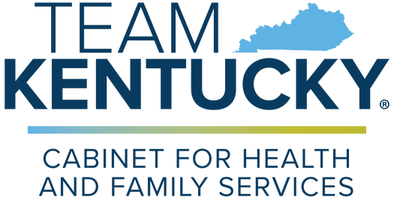
Family FAQs
1915(c) CHILD Waiver
Answers to common questions from families and caregivers.
Q

A
What is the CHILD Waiver?
The Community Health for Improved Lives and Development (CHILD) Waiver is a new Medicaid program that helps children and youth with serious behavioral health or developmental needs get intensive services at home or in their community instead of in a facility.
Q
Will this replace my child’s current services?
A
If the 1915(c) CHILD Waiver is a better fit for your child’s needs, they may apply and, if approved, transfer from another waiver. If your child receives services from a managed care organization and wants to opt into the CHILD Waiver, they will transition to traditional Medicaid. However, you can continue to receive other Medicaid State Plan services and school-based services. You may continue to get waiver services from the same provider if they are a participating CHILD Waiver provider. This program is designed to expand access to intensive supports, not take away existing benefits.
Q
Who can get services through this waiver?
A
Children and youth:
- Under the age of 21. Living in Kentucky.
- With significant behavioral, emotional, or developmental needs.
- Who would otherwise qualify for care in a psychiatric residential treatment facility, intermediate care facility for individuals with intellectual disabilities, or hospital.
- Who can be safely served at home or in the community.
Q
Is there a diagnosis requirement?
A
Your child must have a mental health diagnosis or an intellectual or
developmental disability diagnosis. Eligibility is also based on your child’s needs and the level of care they require.
Q
Is there a cost to participate?
A
No. The waiver is free for families who qualify. Waiver eligibility is not based on
family income. There are no monthly premiums, no co-pays, and no out-of-pocket expenses for services.

Q
Do I need to have Medicaid already?
A
No, you do not need to have Medicaid already. If your family is currently ineligible for Medicaid due to family income level, your child may be eligible for Medicaid after waiver allocation as family income will be disregarded for waiver purposes.

Q
A
How do I apply for the CHILD Waiver?
Applications will open in January 2026. You can apply online or get help from a
behavioral health provider. More information will be shared soon.
Q
What kinds of services are covered?
A
The waiver covers services like:
- Case management.
- Respite.
- Community living supports.
- Environmental and minor home modifications.
- Clinical therapeutic services.
- Supervised residential care.
Q
A
Will there be a waitlist?
There may be a waitlist depending on available slots and demand.
Q
What if I’m not sure if my child qualifies?
A
It’s okay if you’re unsure. If after reviewing the eligibility flowchart you are not
sure about your child’s eligibility, contact DFS.Medicaid@ky.gov for eligibility questions or 1915cwaiverhelpdesk@ky.gov for program inquiries. There’s no harm in asking questions.

Q
Can my child still go to school and live at home?
A
Yes. The waiver is designed to help children live full, meaningful lives at home
and in school, with the right supports in place.

Q
Who can help me learn more?
A
You can reach out to:
- Your child’s current behavioral health provider.
- Your local community mental health center.
- Kentucky’s Waiver Information Line: (844) 784-5614.
- Email: 1915cwaiverhelpdesk@ky.gov.
- Visit: https://www.chfs.ky.gov/agencies/dms/dca/Pages/child.aspx.

