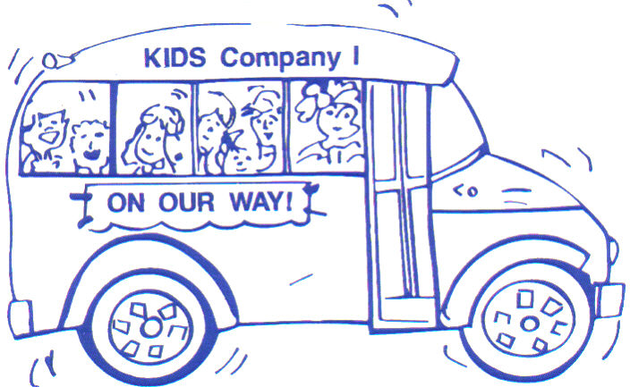

KIDS Company I Family Resource Center

Serving students & families of Clark Elementary School

3401 Buckner Lane
Paducah, KY 42001
Phone: 270-444-5730 ext. 4050

KIDS COMPANY I ADVISORY COUNCIL
February 9, 2021 at 12:00 pm via ZOOM

- Welcome & Call to order
Shanice McKinney (mom of LaMauri in 3rd grade) Anissa Johnson, Guidance Counselor at Clark (school)
Julie Hideg (mom of Olive in 2nd grade) Britne Parker (mom of Nolan in 2nd, Addy in 4th)
Lisa Chappell, Board Office (school) Crystal Hunt, Head Start (school)
Nancy Holm, Immanuel Baptist (community) Janie Criner, Child Watch (community)
Anne Bidwell from United Way (community)
Others always invited: Amie Tooley, FRYSC Contact for PPS; Nick Dietrich, Principal and Kelly Workman, Asst. Principal, Will Owen, Region 1 District Contact.

- Approval of December 8, 2020 minutes (emailed before)

- Services & Program Report
  - Services Report: December 7, 2020- February 5, 2021 Highlights
- Home visits: 91 visits; 290 duplicate visits to families
- In office: 41 in office visits; 52 duplicated visits
- Phone: 23 calls; 32 duplicated calls
- Kinvos sent for Jan: 2,400 (text messages)
- School Supplies: hundreds…folders given to teachers for take-home packets, binders given for entire classes for take home packets. Numerous school supplies given to entire classes because students did not bring back supplies when we went virtual for Nov-Dec., etc.
- Snack bags: 23 students every week (Thank you Immanuel & Jan Godwin & friends)
- Hot Spots given thru Center: 18 (2 we are trying to get parent) *Dudley Court problems

  - KIDS Co. I FRC FY21 Budget report:

  - Kids Club After School: Going OK. We’re on a hybrid. Each day we have about 15 students. Still have many on our list who are not staying. A tiny bit worried about coming back full time – will we have room in café for snack, computer lab only has 15 computers now in both labs, KIDS Club’s “mobile” computers are all checked out to students, just general safety. And a tiny bit worried about staff – some staff have asked to take a break from Kids Club for a bit – just makes for a long day from 7 am – 5 pm.

  - Needs Assessment 2020-2021 Results!

- Parent Involvement and Student Programs from December 7, 2020 – February 5, 2021
- Snowflake Sack Drive Thru: December 10 from 4-5 pm (literacy bag w/ book)300+ bags given, collected canned goods for Family Service Society & collected homemade Holiday cards for nursing homes.

- Coats given to students from Firefighters. Took names via Forms (sent kinvo) back in October. 35 coats given to students of all grades (and older siblings/younger siblings as requested)

- Black History Month: Bio Posters given, hanging in hallway as they are returned; FB posts Jan thru Feb; Black History Month Trivia on Tornado Talk; MLK worksheets given to classes.

- Tutoring program with Oscar Cross Boys & Girls Club began Feb. 2: 17 students signed up. Meet Tuesdays & Fridays from 9:00 – 12:30. Breakfast & Lunch given to kids. Mostly virtual students, but some off-hybrid day students too. FRC provides bus transportation each day, each way. We will do this until we run out of $$ and/or we have a Covid scare that has program shut down. Anticipate we will do this until the end of April 2021.

- Upcoming Programs & Ideas:
- Paint Along with Mrs. Frazier on Wed. Feb. 10 at 10:30 am. RSVPed, sent home baggie of supplies, virtual families picked up.

- Kindergarten Screening: Wednesdays in March. Working on interest list that District is putting out. Then we’ll call parents for appointments. We’ll do this safely, a few kids at a time. We HAVE to meet new students and parents this year and get some basic info.

- Feb/March: Science Month with take home, hands on experiments with Mrs. Sheffer (drive thru pick up supply bag, then log onto a zoom meeting for the guided art. Parent-child together, safe from home) Might do 1-3 experiments in the bag, Mrs. Sheffer show a more complicated experiment via zoom. Still thinking how we can do this idea.

- Spring: Black History Month/African American Read In drive thru pick up. A group of us are talking about how to do this, what to do, can we do it… Kind of a “history bag” idea.

- School-wide Kahoot online game with prizes. Possibly having a Disney movie theme, science theme, etc. We’re thinking about the time frame for this, but really neat idea. We will also incorporate a few Leader in Me questions to cover that area.

- Summer ideas are starting to brew: HUB is offering some summer camp type options. Need to look at $$, will teachers want to do a camp? June or July? Academic catch-up…what grades?

- Other business or announcements from Center, School, Agencies, Parents

- Adjourn & Next meeting: Tuesday, April 13, 2021 – location TBD

