Family Resource & Youth Services Centers

2025
Impact Report Spotlight

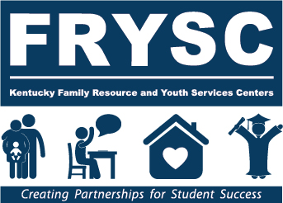
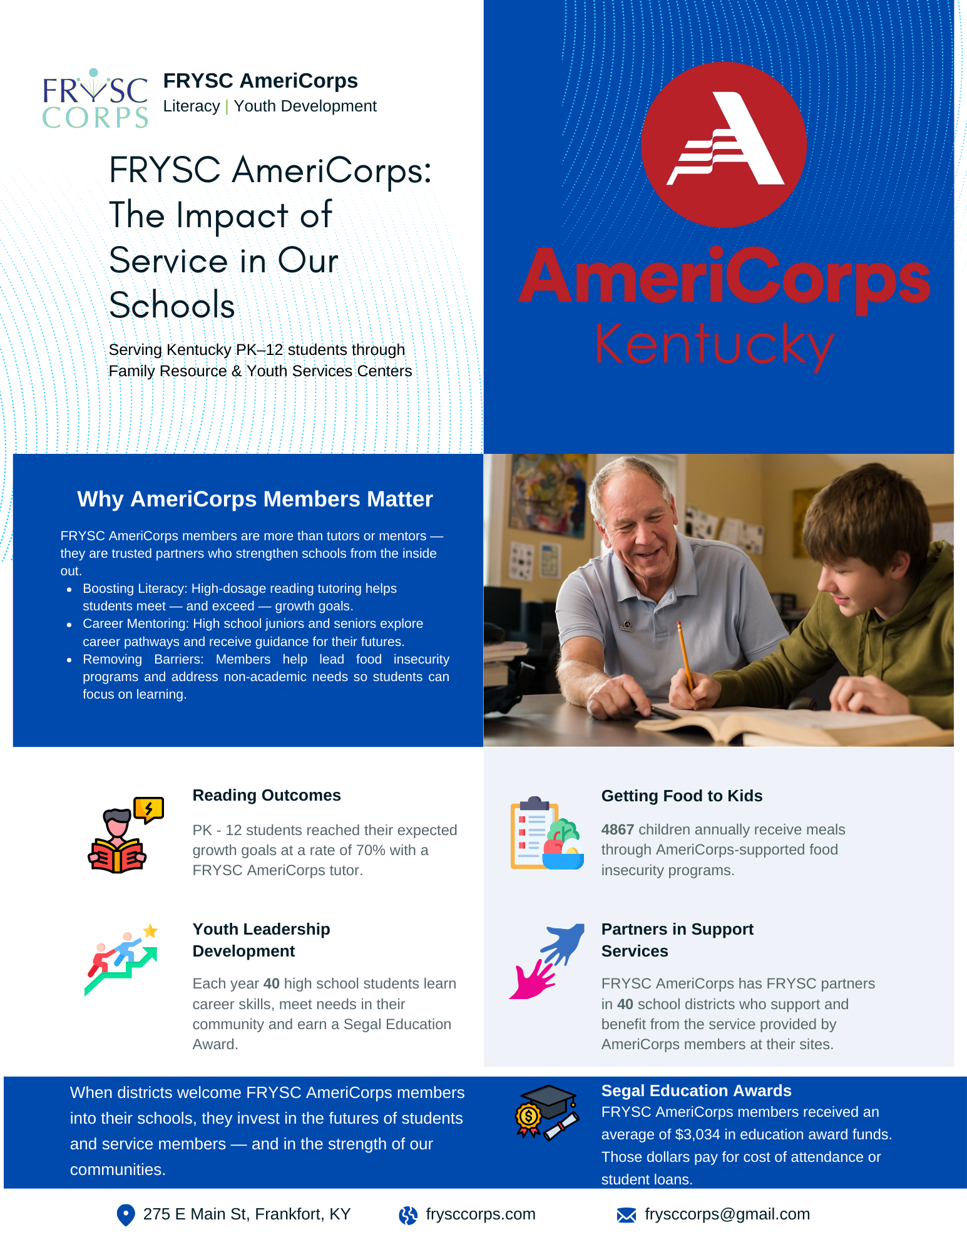

​The following is a selection of reports submitted by FRYSC coordinators highlighting the impact of their efforts to remove barriers to learning. FRYSCs are making strides at the local level in many areas including:
- ​Kindergarten Readiness
- ​Behavior
- ​Mental Health
- ​Substance Abuse Prevention
- ​Reading/Math
- ​Dental Health
- ​Health
- ​College/Career Readiness
- ​Summer/Part-time Job Development
- ​Transitioning (Elementary to Middle, Middle to High, Adulthood)
- ​Character Education and Leadership
- ​English Language Learning
- ​Family Crisis
- ​Individual Interventions
​
​FRYSC does not claim full credit for the gains reported in this document. As with any effective, forward-thinking, and resourceful program, we believe that success comes when we work together for a common goal. Collaboration is the key, and FRYSC is thankful to play a valuable part in the success of Kentucky’s students.
​This impact report spotlight has a two-fold purpose:
- ​To serve as a resource for FRYSC coordinators
​It is our hope that the reports shared in this spotlight will serve as good examples to improve data-gathering throughout the state.
- ​To document FRYSC outcomes at the local level, which may be shared with stakeholders and other interested parties.
​
​Previous Impact Report Spotlights are available on the DFRYSC home page: (https://chfs.ky.gov/agencies/dfrcvs/dfrysc)

Table of Contents
Page | District | Center | Category
7 | Adair County | Community Connection FRC | Academic
8 | Lee County | Lee County FRC | Academic
9 | Gallatin County | 3B-Gallatin Co FRC | Academic
10 | Fayette County | Lansdowne FRC | Academic
11 | McCreary County | Whitley City Elementary Family Resource Center | Academic
12 | Estill County | West Irvine Elementary Family Resource Center | Academic
13 | Henry County | 3B-Henry Co YSC | Academic
14 | Paducah Independent | KIDS CO I FRC | Academic
15 | Letcher County | Letcher Elem/MS FRYSC | Academic
16 | Carlisle County | S.T.A.R.S. FRYSC | Academic
17 | Russell County | Russell Springs Elementary FRC | Academic
18 | Pendleton County | North FRYSC | Academic/Attendance/Behavior
19 | Warren County | Richardsville FRC | Academic/Family Literacy
20 | Butler County | North Butler FRC | Academic/Family Literacy
21 | Shelby County | 3B-Northside Family Resource Center | Academic/Family Literacy
22 | Fayette County | Crawford MS YSC | Academic/SEL
23 | Kenton County | White's Tower FRC | Attendance
24 | Covington Independent | Glenn O. Swing Elementary | Attendance/Academic/Behavior
25 | Covington Independent | Latonia Elementary | Attendance
26 | Scott County | Scott County MS YSC* | Attendance
27 | Jessamine County | Red Oak FRC | Attendance
28 | Hardin County | West Hardin YSC | Attendance
29 | Daviess County | Meadow Lands FRC | Attendance
30 | Middlesboro Independent | Middlesboro FRC | Attendance
31 | Union County | Union Co. MS YSC | Attendance
32 | Fayette County | Frederick Douglass High School YSC | Attendance/Academic/Behavior
33 | Fayette County | Sandersville FRC | Attendance/Behavior
34 | Woodford County | Woodford Co. HS YSC | Attendance/Behavior
35 | Mercer County | Mercer Co. Elementary School FRC | Behavior
36 | Warren County | Alvaton FRC | Behavior
37 | Boone County | Collins Elementary FRC | Behavior
38 | Jessamine County | Jessamine Early Learning Village FRC | Behavior
39 | Madison County | Silver Creek FRC | Behavior/SEL
40 | Jefferson County | 3A-Cochran In the City FRC | Behavior/SEL
41 | Hardin County | North Middle YSC | College & Career Readiness
42 | Shelby County | 3B-Shelby Co HS YSC | College & Career Readiness
43 | Lincoln County | Family Connections FRC | Family Literacy
44 | Daviess County | West Daviess County FRC | Health
45 | Bowling Green Independent | Bowling Green High School YSC | Health
46 | Laurel County | London FRC | Health - Dental
47 | Powell County | Powell County H.S. YSC | Health - Substance Use Education
48 | Pike County | Dorton FRYSC | Health - Substance Use Education
49 | Fayette County | Beaumont MS YSC | Health/Mental Health
50 | Woodford County | Woodford FRC | Individual - Dental
51 | Marshall County | Marshall Co. Middle School YSC | Individual/Attendance/Academic
52 | Fayette County | Lexington Middle School YSC | Individual/Attendance/Behavior
53 | Fayette County | Garrett Morgan FRC | Individual/Attendance/Behavior
54 | Logan County | Adairville FRYSC | Individual/Basic Needs/Attendance/Behavior
55 | Estill County | Estill County MS YSC | Individual/Behavior
56 | Casey County | East Casey FRC | Individual/Behavior
57 | Kenton County | Scott High School - Youth Service Center | Individual/College & Career Readiness
58 | Boone County | Collins Elementary FRC | Individual: Attendance
59 | Oldham County | 3B-Crestwood/Centerfield FRC | Individual: Behavior/SEL/Attendance/Academic
60 | Cumberland County | Cumberland Co HS YSC | Life Skills
61 | Daviess County | Daviess County MS YSC | Mental Health/SEL
62 | Henry County | 3B-Campbellsburg/Eastern FRC | SEL
63 | Dayton Independent | Dayton FRC | SEL
64 | Garrard County | Garrard Co MS YSC | SEL
65 | Bullitt County | Roby/Nichols FRC | SEL
66 | Daviess County | Sorgho Elementary FRC | SEL
67 | Johnson County | Central Elementary FRC | SEL
68 | Cumberland County | Cumberland Co HS YSC | SEL
69 | Calloway County | Laker Cove FRC | SEL/Family Literacy
70 | McLean County | Green River Outreach FRC | SEL/Health

Intervention: SAFARI Summer Program
Category: Academic
Submitted by: Community Connection FRC Adair County
The Community Connection FRC collaborated with Camp SAFARI 21st CCLC Program to offer 4 weeks of summer programming. Students received daily reading and math instruction. 38 students completed pre and post tests for both reading and math.

Total possible points for reading were 121.
Total possible points for math were 100.

After screening 38 students at the end of summer programming, the following results were noted:
- 2 out of 38 students maintained their reading score.
- 36 out of 38 students increased their reading scores. An average increase of 13.9 points per student was noted.
- All 38 students increased their math score. An average increase of 13.5 points per student was noted.

Maintaining and increasing reading and math scores during summer indicates the program was successful.

Intervention: Bobcat Reading Rewards
Category: Academic
Submitted by: Lee County FRC Lee County
Prior to this program, there were no incentives at Lee County Elementary for students to read. There were not mandatory book reading and assignments in class, nor were there grades or prizes assigned to Accelerated Reader Achievements. During the 2023-2024 school year, only two students met their Accelerated Reader point goals.

The Bobcat Reading Reward Program was developed by the Lee County Family Resource Center to encourage students to read, both at school and at home with their parents, to increase their overall literacy abilities and school achievements. Small goals with short-term rewards were set for students in order to aid them in achieving the larger end of the year goal.

There was a set list of tasks students could accomplish to receive "book bucks" to purchase items like bubble gum, slim, slap bracelets, basketballs, and more from the Bobcat Book Store in the library. For each point they received on an AR test, while achieving an 80% or better, they received a book buck. For every family literacy night they attended with their family, the received 10 book bucks. For every 60 minutes they read with their family at home, and the parents signed off on a log, they received 5 book bucks. FRC Coordinator worked closely with the school librarian who also provided additional reading incentives in which students could earn book bucks, such as reading aloud to their class during library time.

Beginning in August, students and parents were informed that each student who reached their end of the year Accelerated Reader points goal would receive an end of the year field trip. Through this program, 22 students ended the school year having met their Accelerated Reader goal, with four times as many students logging AR tests as had done so in the previous year.

For this project, the Lee County FRC Coordinator purchased award items for the Bobcat Book Store, sponsored the end of the year field trip, shared communications of the program to parents, and purchased a book for each student who completed their goal. Coordinator worked closely with the school librarian, who set ability appropriate goals, tracked progress, and offered encouragement to read during library class.

Intervention: FRYSC AmeriCorps Reading Tutor - focusing on 3rd grade students underperforming in reading
Category: Academic
Submitted by: 3B-Gallatin Co FRC Gallatin County
According to the 2023-2024 KDE School Report Card, Gallatin County Upper Elementary 3rd graders struggle with reading. Only 38% of economically disadvantaged students and 41% of non economically disadvantaged students tested proficient or distinguished in reading. To assist our students to reach the goal of becoming proficient or distinguished in reading, we continued to utilize the FRYSC AmeriCorps program by having a reading tutor, Annie Koester, for the 2024-2025 school year. Annie focused her efforts on a group of students who were struggling with learning to read. Annie utilized the “Phonics for Reading” program.

For the 2024-2025 school year there were 132 third grade students enrolled at Gallatin County Schools. After fall iReady assessments, 57 of the 132 students were enrolled in the “Phonics for Reading” program. Students received daily interventions through small group instruction.

Through the efforts of FRYSC AmeriCorps reading tutor, Annie Koester, the students showed vast improvement. By the end of the 2024-2025 school year, over 59% of the students enrolled in the “Phonics for Reading” program had “graduated” out of the program and no longer needed these extra services. Only 34 students remained enrolled on the phonics continuum and with only 8 students remaining on Level 1 phonics at the end of the school year. These improvements were also confirmed with Spring iReady scores. The 2025 spring scores reflected a 127% increase in grade level progress with 70% of students meeting 100% or higher expected growth for the year. One of Ms. Annie’s students in particular had shown tremendous growth of 100 points in reading from Winter to Spring iReady scores. This student was unable to read at the beginning of the school year but at the end of the year they chose to share their accomplishment by confidently reading a passage aloud to their class.

The FRC wrote the grant to FRYSC AmeriCorps to help provide a reading tutor for third grade students struggling with learning to read. The FRC also provided books and materials needed for Ms. Koester to tutor her students.

Intervention: Porter Memorial/Immanuel Baptist 5th Grade Reading Groups
Category: Academic
Submitted by: Lansdowne FRC Fayette County
The 5th grade students at Lansdowne needed extra reading/literacy time. The 5th grade teachers spoke about the end of the day being a struggle to keep students focused and on task. Two church partners, Immanuel Baptist and Porter Memorial, offered to have volunteers come in once a week, every other week starting in February, to have small reading groups. The mean RIT Score in the winter for 5th grade reading was 206.1.

Every other week, the two churches would send 20 volunteers to Lansdowne to read with students after recess from 1:45pm-2:35pm. The 3 classrooms would break up into small groups based on reading levels. There was at least 1 volunteer for every 5 students, which allowed the group numbers to be small and allow the students to get plenty out of it. The same volunteers would come back each week and read with the same group they had the previous lesson. This allowed the volunteers to build relationships with the students and gave students something to look forward to every other Wednesday.

The mean RIT Score for 5th grade went from 206.1 in the winter to 208.1 in the spring. In addition, 4 students moved up from "Below Average" = either low/low average to "Average or Above". 3 students moved up from high average to High category. 82 students had valid growth scores from the winter to spring and 41 students were at or above District Grade Level mean RIT. The volunteers are planning to make this an every year activity with our 5th grade students due to the success of the program.

Intervention: Reading Buddy Challenge- Reading challenge with stuffed animals and family
Category: Academic
Submitted by: Whitley City Elementary Family Resource Center McCreary County
There are 32% of students reading at grade level at Whitley City Elementary School. The 2024-2025 Fall MAP (Measures of Academic Progress) Assessment Data indicates that kindergarten and 1st grade students are both in the 54th percentile.

Assessments | 2022-2023 (School Report Card) | 2023-2024 (School Report Card)
Kindergarten Readiness Composite Score | 53%  (47% of students did not meet) | 64%  (47% of students did not meet)
Kindergarten Readiness Academic / Cognitive | 18%  (82% of students did not meet) | 36%  (74% of students did not meet)
KSA (Kentucky Summative Assessment) | 47% - 3rd grade Reading Apprentice/Novice  53% -3rd grade Reading Proficient / Distinguished | 54% - 3rd grade Reading Apprentice/Novice  53% -3rd grade Reading Proficient / Distinguished

Whitley City Elementary focused on getting all kindergarten and 1st grade students to increase reading and comprehension skills to aid in the development of life skills.

Whitley City Elementary Family Resource Center worked on various interventions to achieve this goal. The FRC partnered with McCreary County Champions Against Drugs to purchase stuffed teddy bears for all kindergarten students and pocket size stuffed animals for 1st grade. In addition, the center worked with the kindergarten and 1st grade staff to develop a “Family Fun Worksheet” to promote reading both at home and in the classroom. During Read Across America Week the center handed out “Reading Buddies” teddy bears to Kindergarten and pocket animals to 1st grade while also issuing a challenge for the month of March. Kindergarten students were challenged to complete their “Meet My Reading Buddy” worksheet and 1st grade students were challenged to be the first to “Bingo” by completing their reading challenge bingo card.

Outcomes:
- 79 kindergarteners were challenged and 29 completed the reading challenge.
- 103 1st graders were challenged and 34 completed the reading challenge.
- Reading Growth was seen across kindergarten with growth in all 29 participants individually.
- Growth was seen in 10 of the 34 st graders who participated in the Reading Buddy Challenge by MAP assessment scores.

2024-2025 Spring MAP Assessment Data Kindergarten 67th percentile
2024-2025 Spring MAP Assessment Data 1st grade 45th percentile

Intervention: AmeriCorps Literacy Partner
Category: Academic
Submitted by: West Irvine Elementary Family Resource Center Estill County
iReady results in Reading showed only 19% of West Irvine students reading on grade level in August 2024. Americorp Literacy Partner grant was secured to place a Literacy Tutor at West Irvine. This person is trained in Reading Mastery and is incorporated as part of our intervention team, seeing small groups of students daily.

Our Literacy Tutor saw small groups of kindergarten, first grade and fourth grade students daily throughout the year. They used Reading Mastery each day to provide targeted instruction to these students.
As a result, kindergarten students in the Americorp group grew their reading Mastery score by an average of 44.8 points between August and December. First grade students in the Americorp group grew by an average of 22.3 points. Fourth grade students grew by an average of 16.4 points.

As a whole, West Irvine students started the year with 19% reading on grade level. By winter iReady testing, 40% of students were reading on grade level. West Irvine ended the year with 56% of students reading on grade level. Our Americorp Literacy partner played a huge role in moving our students forward, as an essential part of our intervention team.

Intervention: After-School Tutoring
Category: Academic
Submitted by: 3B-Henry Co YSC Henry County
By teacher referral, there were 16 students that consistently attended middle school after-school tutoring. There were five (5) 6th grade students, eight (8) 7th grade students and three (3) 8th grade students. Each student referred was failing or close to failing, in one or more content area (English, Math, Science, Social Studies) and/or missing assignments. In addition to teacher referrals, parent requests for participation were also considered. At the beginning of after-school tutoring, 7 (44%) of the participating students were struggling specifically in the areas of English, Math and Science.

The YSC budgeted funds to pay teachers who taught the after-school tutoring program. At the end of the program, 10 students (62.5%) improved by at least one letter grade in at least one content class. There were 8 students who maintained the same letter grade but improved by points. Below is specific data regarding the 7 students who were struggling in English, Math and Science at the beginning of the program:

ENGLISH: All 7 students increased their score by a letter grade (2 letter grades for 1 student) or in grade points
MATH and SCIENCE: 5 (71%) of the 7 students increased their score by either a letter grade or in points

Below is grade-specific data:
- Of the five (5) 6th grade students, 3 (60%) improved in one more content areas.
- Of the eight (8) 7th grade students, 7 (87.5%) improved in one or more content areas either in letter grade or in points.
- Of the three (3) 8th grade students, 2 (67%) improved by a letter grade in one or more content areas.

Below is significant, point-specific, increase information for all grades:
- 1 student increased score by 17 points in English
- 1 student increased score by 10 points in English
- 1 student increased score by 16 points in Math
- 2 students increased score by 7 points in Math
- 1 student increased score by 11 points in Science

Based on the success of the program, the YSC will budget funds again this coming school to continue after-school tutoring.

Intervention: FRYSC AmeriCorps Literacy Tutor
Category: Academic
Submitted by: KIDS CO I FRC Paducah Independent
KIDS Company I FRC applied to be part of the FRYSC AmeriCorps Literacy Tutoring program for the 2024-2025 school year. Our Center hired a part-time person who worked with approximately 23 students from August - May. After taking the initial Renaissance STAR Reading test in August/Fall, students in Kindergarten - 5th grade were flagged as "Tier 2" through the program's test analysis. The students marked as Tier 2 had scored 1-1.5 grades below their current grade in reading. This information indicated a need of someone to directly tutor with students who scored in the Tier 2 level in order to gain reading skills and knowledge, to improve their reading ability.

All students supported by our FRYSC AmeriCorps staff showed growth in their Renaissance STAR Reading scores this school year. Renaissance STAR data was accessible to our AmeriCorps staff and the FRC throughout the year and was consistently tracked as part of the federal AmeriCorps program. FRYSC AmeriCorps staff worked directly with our school's RTI Team on the reading skills students needed. Our AmeriCorps staff was part-time, working 3 days a week. She worked with small groups or one-on-one for 20-25 minutes. Additionally, she worked with a group of 3 students who were learning English.

In August/Fall, 23 students took the Renaissance STAR Reading assessment and scored below their current grade level, qualifying them for Tier 2 reading intervention and support from our AmeriCorps staff. By the final STAR assessment, 15 students scored a full grade level above their current grade, and one student scored two grade levels above. Two students who began the year significantly below grade level improved to meet their current grade’s reading level by May. Additionally, five students made progress from their initial scores, though they did not yet reach their current grade level.

KIDS Company I's contribution to this program involved partnering with AmeriCorps in the hiring of our Literacy Tutor. The center also gave a stipend to our AmeriCorps staff halfway through the year for all the extra training to help improve her skills as a tutor with the LTRs training. The center provided a space for her to work with students and groups in addition to any supplies she needed for the students.

Intervention: ESS- Learning Lab After School Tutoring
Category: Academic
Submitted by: Letcher Elem/MS FRYSC Letcher County
There were 13 students in grades K-5th who were referred by a guardian or a teacher to attend the Learning Lab After School tutoring program at Letcher Elementary School (LEMS). In the fall, these students took the pre-test for MAP and the Renaissance Learning STAR test. These 13 students tested below grade level on both reading and math.

The 13 students participated in the Learning Lab AS program two days a week. They worked in small groups on reading strategies and math skills. The FRYSC at LEMS worked with the Cafeteria Manager to ensure these students were able to receive hot dinners at the start of the program. FRYSC reached out to the guardians to help assist the students with attending the program and worked with the bus garage to provide transportation to the students who needed it. FRYSC also worked with teachers to help get materials for these students to help keep them on track.

In Spring 2026, the 13 students took the post-test and had a growth in math. For reading, the 13 students took the post test and all but 3 showed growth.

Student | Math Pre | Math Post | Reading Pre | Reading Post | Math Growth | Reading Growth
1 | 165 | 188 | 169 | 184 | 11 | 15
2 | 193 | 204 | 192 | 197 | 11 | 5
3 | 133 | 167 | 154 | 181 | 34 | 27
4 | 160 | 161 | 161 | 160 | 1 | -1
5 | 153 | 174 | 162 | 174 | 21 | 12
6 | 190 | 202 | 187 | 171 | 12 | -16
7 | 160 | 187 | 177 | 178 | 27 | 1
8 | 193 | 199 | 194 | 211 | 6 | 17
9 | 143 | 155 | 142 | 137 | 12 | -5
10 | 148 | 160 | 145 | 184 | 12 | 39
11 | 156 | 167 | 152 | 164 | 11 | 12
12 | 147 | 162 | 147 | 157 | 15 | 10
13 | 164 | 162 | 172 | 171 | -2 | -1

Intervention: Comet Reading Buddy Program
Category: Academic
Submitted by: S.T.A.R.S. FRYSC Carlisle County
S.T.A.R.S. FRYSC in Carlisle County developed a Comet Reading Buddy program. Through this program, identified kindergarten students are recommended for a mentor relationship when school staff believe the child can benefit from having an additional caring, consistent person in their life to provide encouragement and help with reading. Our High School Education Rising class are the buddies that help our kindergarten students with reading. This group of students consists of nine kindergarten students and nine high school students. All the kindergarten students took the STAR Reading Enterprise Assessment, prior to mentors beginning their bi-weekly sessions with each child. These scores were used as the baseline data for comparison on the post intervention evaluation.

The High School Education Rising class met with the kindergarten students for 20-30 minutes bi-weekly to help with reading. All students showed an increase in their STAR Reading Assessment scores. Every student increased by one grade equivalent and three students increased by two grade equivalents (please see below). This program also teaches these high school students career development in education. Since this program was so successful, we plan on continuing this program.

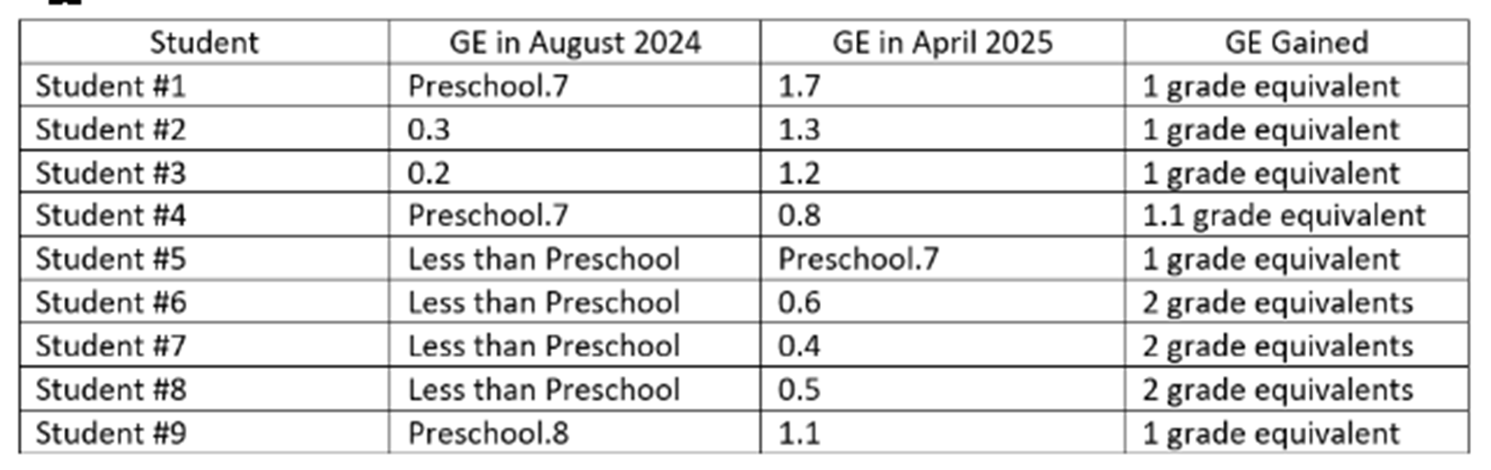

Intervention: Little Laker Summer Reading Camp
Category: Academic
Submitted by: Russell Springs Elementary FRC Russell County
The Russell Springs Elementary School (RSES) FRC met with the 3rd, 4th and 5th grade teachers to discuss the biggest academic need in their classrooms. The need that overwhelmingly came to the fore front was a need for extra reading assistance in the summer. Based on this response, the RSES FRC formed the Little Laker Summer Reading Camp. The FRC staff met with each grade level’s reading teacher and asked them to identify the lowest 3 readers in each grade level. Four of the students chosen were reading one grade level below their desired reading level. Three of the students chosen were reading at 1.5 levels below their desired reading level. When those students were located, the FRC made phone calls and or home visits to those students parents to confirm their placement in the summer reading program. After the reading teacher in each grade level identified their highest-need students, the FRC was able to get confirmations from seven students to be a part of the Little Laker Summer Reading Camp. The FRC partnered with the Russell County Public Library and retired teachers from the area. The summer day camp was held 2 days a week in the month of June at the public library. The two areas of focus at the summer reading camp were Comprehension and Fluency, to increase summer reading and confidence in each student.

The RSES FRC Little Laker Summer Reading Camp began on June 3rd, 2025 and ran through June 26th. The FRC coordinated getting the student participants and the volunteers to run the camp. The FRC staff copied all of the reading comprehension and fluency packets. At the end of the camp, a July reading packet was sent home with each student to encourage continued summer reading. The students were paired with retired teachers who worked with the students for 8 sessions in the month of June. Each camp session would begin with with reading content vocabulary review. Some vocabulary words used during this time would include compare, contrast, sequence, cause/effect, main idea, simile and metaphor. The next session of camp, each student would brake off with their instructor and work for one hour on individual reading assignments directed by the FRC staff. After individual sessions, all of the students would return as a group for word games where prizes were awarded for the winning team or student. A pre and post test was conducted at the beginning and end of the summer camp. Each of the 7 students improved on comprehension. There were 8 questions asked from a reading story. From all seven students, there were 18 questions answered correctly, showing improvement from the pre to the post test. This was a 28.5% improvement in comprehension. All students also greatly improved on reading fluency. From the pre test to the post test there was a combined 135 word per minute improvement. This was an overall 20.45% improvement in reading fluency.

Intervention: #BeSharp Brag Tag Program
Category: Academic/Attendance/Behavior
Submitted by: North FRYSC Pendleton County
After reviewing behavior data, student attendance, STAR scores, and other academic information, the administration of Sharp Middle School and the North Family Resource Center, wanted to create a program that awarded students for excelling in all of these areas. Not just looking at the highest scores academically, but recognizing students for doing better and “raising the bar” from where they previously were. Sharp Middle School needed a program to set the tone for students to excel at all times throughout the school year. The #BeSharp Brag Tag Program was created to give teachers and staff a way to award every student on various different levels academically, for their behavior, or attendance.

The #BeSharp Brag Tag Program is a program where students work hard to achieve. This program allows staff to support the students and it helps the students build their self-confidence by being awarded and collecting unique tags or charms for working hard or excelling daily throughout the school year. Students are nominated by the teachers and staff and were given a unique charm for the following categories throughout the school year: good behavior, monthly attendance, awesome work in class, hard worker, kindness, birthday, positive behavior, academic excellence, and SWAG-student with academic goals, honor roll, Star testing, principal’s award, friendship, honesty, courage, respect, compassion, cooperation, empathy, creativity, gratitude, and friendship. Students then collect and keep these unique charms on a key chain on their backpack trying to collect each charm that is offered. At the end of the year, the school recognizes students for collecting the most tags throughout the school year.

After our 2nd year of implementation of this program, we have seen huge changes in all the areas we were targeting to better our students. Before implementing this program in 2022-23, we had 94 students in the Truancy Diversion Program. This 2024-25 school year, that number of students dropped to 46 students for the year. That was a 49% drop in students in the Truancy Diversion Program (see graph below). In the 2022-23 school year, we had 595 behavior events. In the 2024-25 school year, Sharp Middle School dropped to 302 behavior events and the number of students involved in behavior incidents dropped from 172 in 2022-23 to 113 in the 2024-25 school year. The #BeSharp Brag Tag Program has impacted our students and gave them an incentive to work hard on their behavior, academics, and attendance daily. It has excited the students and it is a way for students to receive small awards each day to keep them on the right path to excel and #BeSharp!

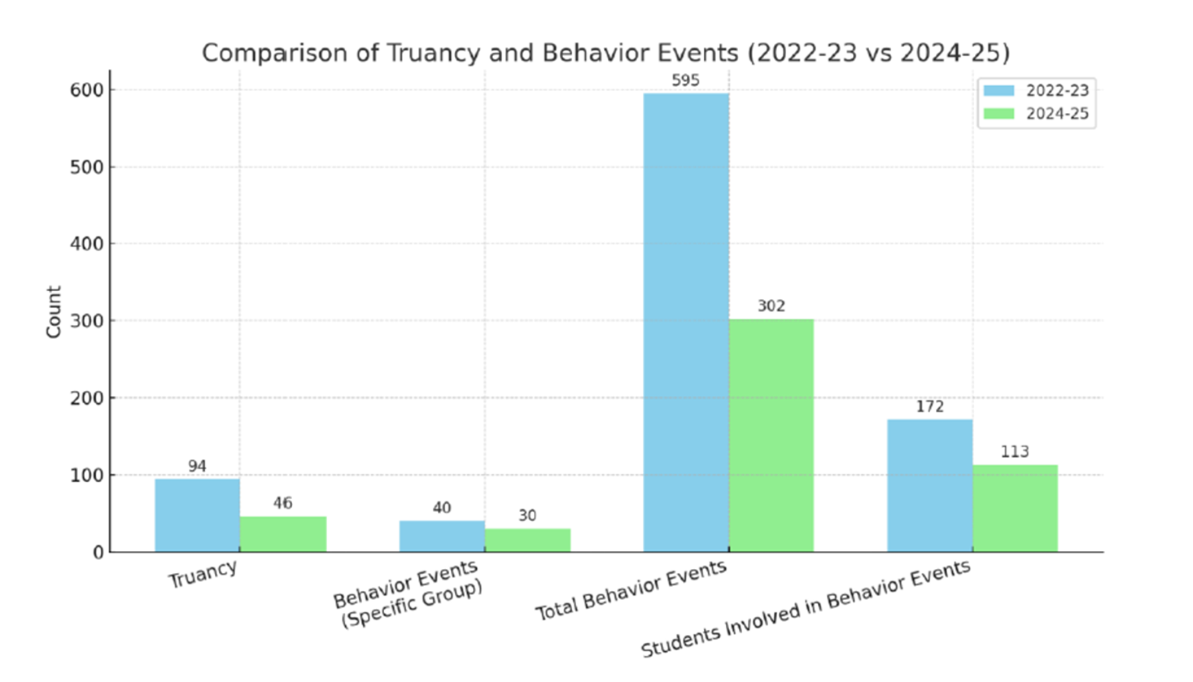

Intervention: Little Bobcat Learners
Category: Academic/Family Literacy
Submitted by: Richardsville FRC Warren County
Kindergarten brigance data from 2016 through 2019 indicated an average of only 43% of our kindergarten students were kindergarten ready.

The Little Bobcat Learners Program (LBL) was established in partnership with the Family Enrichment Center to increase Kindergarten Readiness. The program increases school readiness, establishes community connections, provides support on the challenges of parenting and aids parents on the developmental stages of children through personalized home visits. It can also be a factor in preventing child abuse.

2024-2025 Little Bobcat Learners Data
- Families Enrolled in Little Bobcat Learners: 20
- Children enrolled in LBL: 30 (ages 0-5) and 2 prenatal
- Children enrolled in LBL TESTING OUT for kindergarten: 8

*7 of 8 tested kindergarten ready
*1 of 8 was not kindergarten ready due to an Autism diagnosis

Brigance data indicate that 87.5% of Little Bobcat Learner students are ready for kindergarten.
The overall class of 2024-2025 had a 51% kindergarten readiness score.

Intervention: Camp Read-A-Lot (First Grade Family Literacy Night)
Category: Academic/Family Literacy
Submitted by: North Butler FRC Butler County
Based on STAR Screening Report (every child must be tested within the first 30 days of school; kindergarten the first 45) and conferring with administration, it was decided we would focus our Family Literacy Night on first grade students and their families. Our first grade students had the lowest scores on the STAR Early Literacy Test. 55% of first grade students scored below benchmark (at or below 39th percentile) and 25% scored in urgent intervention needed (below the 9th percentile).

The FRC and school administration discussed a possible FRC sponsored Family Literacy Event. After deciding to focus on 1st grade students and their families, the FRC met with 1st grade teachers. We discussed specific literacy skills students were struggling with and brainstormed activities that they could do at home that would help them develop those skills. The three main focus areas were phonics (recognize and use letter-sound relationships to decode words), decoding (read words by sounding them out, using phonics and word patterns), and sight word recognition (recognize frequently used words by sight without having to sound them out).

We decided stations where students and parents could learn ways to practice each skill at home in small groups, would benefit them the most. Each 1st grade teacher took a focus area and chose a game/activity that students and parents could do together at home to build those skills. We included some fun stations that would get them excited about reading & literacy and would provide parents with even more ideas for home. We incorporated 7 total stations. If they completed all the stations and returned the stamped map, they received a 1st grade literacy kit and were entered into the grand prize drawing! Camp Read-A-Lot became our theme! The FRC purchased and prepped everything for each station so that the teachers volunteering to stay and run a station would only have to do just that! The 20 volunteers were essential and invaluable!

Twenty-two students (1/3) and their families attended the Camp Read-A-Lot 1st Grade Family Literacy Night.
Based on STAR Early Literacy test data, students who attended the event with their parents scored an average of 52 points higher two months after the event than their original benchmark. Baseline scores in September the percentage of students scoring below benchmark was 55 % after our event in November, scores from January indicated those scoring below benchmark had decreased to only 40%.

Intervention: EL - SUPPORT - Academies for Parents of English Learners
Category: Academic/Family Literacy
Submitted by: 3B-Northside Family Resource Center Shelby County
At the beginning of the school year, 58 EL students were tested at school with the W-APT. The FRC organized a series of workshops that were held on one Thursday each month. There the parents participated in activities; received strategies and supplies for the development of their children's Language and Communication skills. The invitation was extended to all EL families, and 42 families participate. These parents did not speak English.

At the end of the school year, EL were screened again with W-APT. The data shows that the students belonging to the families that participated in the program EL - SUPPORT ON FRIDAYS increased their English proficiency due to the support of their parents.

W-APT Results (1-30):

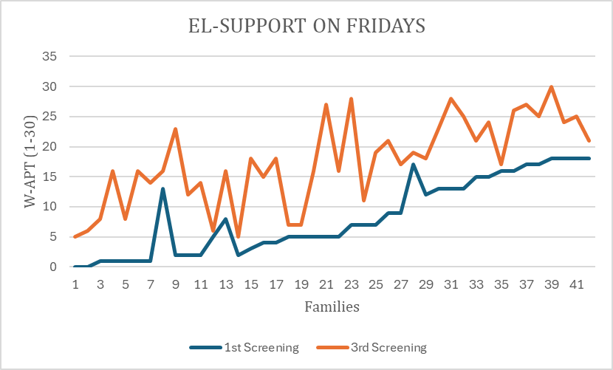

Intervention: Goys Who L.E.A.D (Listen, Engage, Achieve, Develop) mentoring program
Category: Academic/SEL
Submitted by: Crawford MS YSC Fayette County
To cultivate stronger student-staff connections, the FCPS Office of Unity & Belonging encouraged schools to create internal mentoring programs. Crawford Middle School, as one of ten participating middle schools in the Stronger Connections program, significantly impacted student achievement through this initiative. From October to May, weekly group sessions and check-ins provided targeted academic and social-emotional support to students identified by the Student Support team.

Students attended weekly workshops from October to May to help motivate them socially and academically. Out of 8 students, 6 students (75.0%) increased both their MAP Math and Reading scores.

Student 2: Math increased by 23, Reading increased by 12
Student 4: Math increased by 12, Reading increased by 18

M-Math R-Reading:

1). Fall M-219/R-220 Spring M-221/R-221
2). Fall M-188/R188 Spring M-211/R-200
3). Fall M-215/R-200 Spring M-217/ R-202
4). Fall M-206/R-197 Spring M-218/R-215
5). Fall M-227/R-217 Spring M-223/R-216
6). Fall M-220/R-223 Spring M-228/R-226
7). Fall M-204/R-200 Spring M-218/R-207
8). Fall M-222/R-227 Spring M-223/R-227

Intervention: Bearcat Attendance Club 1st and 3rd grade
Category: Attendance
Submitted by: White's Tower FRC Kenton County
Chronic Absenteeism Attendance Intervention for students identified thru the Early Warning Tool in Infinite Campus.

BASELINE DATA:
3rd Grade Student Group:
- 23-24 school year: 4 students averaged 109.5 days absent.
- The average MAP assessment score was 195. The average MAP Percentile was 72.25 percentile (May 2024).

1st Grade Student Group:
- 23-24 school year: 11 students averaged 171.5 days absent.
- The average MAP assessment score was 154. The average MAP Percentile was 51 percentile.(May 2024).

The FRC Coordinator met with the identified 3rd grade and 1st grade students in 2 groups. They met every Friday to discuss their attendance. Students were reminded weekly about the importance of attending school. They also discussed reasons why they missed school that week - sickness, anxiety, over sleeping, etc. Students with perfect attendance that week were celebrated in the group..

POST INTERVENTION DATA RESULTS
3rd Grade Student Group:
- Students participated in group with FRC Coordinator beginning in September 2024 thru May 16, 2025.
- 24-25 school year: the 4 students averaged 67 days absent.
- The groups average MAP assessment score was 216.25 and their average MAP percentile was 87.25.

*In comparison to the previous year, there was a 39% decrease in the amount of days absent. Their average MAP scores increased by 11%. The average Map percentile increased by 21%.

1st Grade Student Group:
- Students participated in group with FRC Coordinator beginning in September 2024 thru May 16, 2025.
- 24-25 school year - the 11 students averaged 112 days absent.
- The groups average MAP assessment score was 171 and their average MAP percentile was 51.

*In comparison to the previous year,, there was a 35% decrease in the amount of days absent. Their average MAP scores increased by 11%.

Meaningful relationships were built, grounded in trust and honesty. Students who participated often sought out the FRC Coordinator during the school day to say hello and let them know they were present. In the cafeteria, they would call out to ask when the Coordinator would visit them on Fridays. At times, students would even step out of line in the hallway just to get a hug.

Intervention: Buddies with Badges Mentoring Program
Category: Attendance/Academic/Behavior
Submitted by: Glenn O. Swing Elementary Covington Independent
As an inner city school, it is imperative that we reach all students. We have many students at our school that have parents or other important family members who have been incarcerated multiple times. Some of these students displayed behavior that could potentially lead them down a difficult road within the justice system. With the help of our district mentoring coordinator, we developed a mentoring program, pairing at risk students with officers from the Covington Police Department. We split them into two groups. One for boys, called the Blue Crew, and one for girls, called the Queen Squad. The Student Support Team worked together and chose 2 boys and 2 girls from the 4th grade in 2023-2024 school year, to pair with the officers. Mentoring sessions happened once a week. Activities included social skills lessons, academic support; and peer relation lessons. These same 4 students continued through the 2024-2025 school year, as 5th graders.

This program became so much more than we expected it to and we are so grateful for the relationships built between our students, staff, and the officers of our community police department. The impact this program made will reach far beyond the halls of our elementary school. Because of their weekly presence, other students in our school were able to build relationships with the officers, as well. This also led to the officers participating in all of our family events.

Fiscal Year  ~ 4 students | 2023-2024 (Baseline) | 2024-2025  (After mentoring program)
Attendance (average # of days missed) | 27 | 20.5
Behavior (average # of referrals) | 7 | 0
GPA (average) | 3.20 | 3.55

Intervention: Attendance Support Program
Category: Attendance
Submitted by: Latonia Elementary Covington Independent
At the start of the 2024–2025 school year, 23 students were identified as chronically absent (defined as missing 10% or more of instructional days). Many of these students came from households facing economic instability, transportation issues, or lacked access to basic necessities such as clothing, food, or hygiene items.
Baseline data from Infinite Campus indicated that several of these students had missed 15–25 days in the previous school year, putting them at risk of academic failure and grade retention.

The Family Resource Center (FRC) implemented a targeted Attendance Support Program, which combined basic needs assistance, home visits, and parent outreach.

Key interventions included:
- Hosting Steps to Student Success Family Night in Sept 2024, which provided over 32 families with valuable information about homework expectations, academic testing, and available school programs. During this event, the FRC presented the school attendance policy and offered practical strategies for building strong morning and evening routines to ensure on-time, daily attendance.
- Distributing clothes, school supplies, hygiene kits, and alarm clocks to families in need
- Collaborating with school administration to track weekly attendance trends
- Making 33 home visits to build relationships with families and understand root causes of chronic absenteeism
- Providing transportation assistance/referrals to community partners when needed
- Organizing fun spirit days in collaboration with school staff after long holiday break; including Fall Break, Thanksgiving Break, Winter Break, and Spring Break, to help build excitement and positive momentum for returning to school

Results:
- Of the 19 chronically absent students, 16 (84%) improved their attendance by reducing total absences by at least 30% and moved completely out of the chronic absence category
- Family participation increased, with over 97% of caregivers engaged across FRC-hosted events during the year, including attendance-focused programming
- Spirit days boosted student morale and improved post-break attendance, with administrators reporting higher energy and participation in the days immediately following each break
- Teachers noted improved morning routines, with more students arriving on time and ready to learn
- The FRC’s multi-layered approach: from education to material support to schoolwide engagement—resulted in meaningful progress toward improved attendance, stronger parent-school partnerships, and student readiness.

Intervention: Truancy Tuesday
Category: Attendance
Submitted by: Scott County MS YSC Scott County
During the 2023–2024 school year, school attendance data indicated a significant need for targeted intervention to address chronic absenteeism. According to official school reports, over 19 students had more than 9 unexcused absences, with a particularly concerning trend among middle school students. Additionally, a faculty survey revealed that 57% of teachers identified student attendance as a top concern impacting academic success and classroom engagement. To illustrate the urgency of the issue, five students were identified as those with the highest number of unexcused absences from August 2024 through December 2024 (see below). Their absences reflect a pattern of chronic absenteeism that placed students at academic risk and signaled a broader need for consistent engagement and support.

Truancy Tuesday is an ongoing initiative led by the school’s Youth Services Center (YSC) in collaboration with the school attendance clerk. The program is designed to provide consistent support to students who are at risk of chronic absenteeism through weekly outreach efforts. These include phone calls to families, home visits, and in-person meetings with students to identify barriers, provide encouragement, and offer resources.

From January 2025 through May 2025, the ongoing efforts of Truancy Tuesday showed measurable impact, particularly among the same students identified earlier in the school year as having the highest number of unexcused absences. These students demonstrated the following changes in their attendance:

Student | Fall 2024  (unexcused absences) | Spring 2025  (unexcused absences)
Student A | 15 | 1
Student B | 11 | 13
Student C | 11 | 4
Student D | 9 | 8
Student E | 9 | 3

While results varied, the data suggests that consistent, relationship-based interventions like those provided through Truancy Tuesday can positively influence student attendance. Several of the highest-risk students made significant progress after months of personalized and persistent support.

Intervention: CHECK & CONNECT Attendance Intervention
Category: Attendance
Submitted by: Red Oak FRC Jessamine County
The RED Attendance Team, composed of Jessamine County Schools Central Office Department of Pupil/Personnel members and Red Oak Elementary faculty and staff, noted an attendance and unexcused absence issue affecting a significant number of students during the 2023-2024 school year.

Based on this issue, 108 total RED students were defined as non-compliant. After review and by definition of truancy standards, 34 students, across all grade levels were determined to qualify for the 2024-2025 RED Check & Connect intervention. An 11 members from the Check & Connect Team, includeding the FRC coordinator, initiated a weekly (minimum) connection with both students and a family member.

Upon contact with family members, secondary issues and opportunities were noted. Parents/students stated:

1. No knowledge of Red Oak attendance expectations and plans.
2. No knowledge of the use of/number of allowable excuses.
3. No knowledge of time restraints regarding excuses.
4. No knowledge of the number of absences accrued.
5. No knowledge of the number of unexcused absences accrued.
6. No knowledge of the truancy process, stages or court actions.

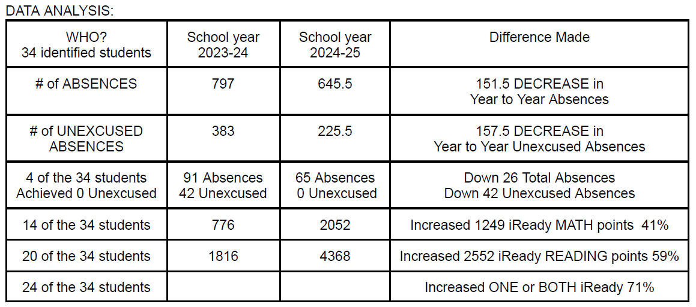

*71% of students with improved attendance experienced academic growth in one or both iReady subjects.
*59% of our students with improved attendance reached and/or exceeded their READING growth goal.
*41% of our students with improved attendance reached and/or exceeded their MATH growth goal.

Intervention: Every Day Counts-- attendance improvement program
Category: Attendance
Submitted by: West Hardin YSC Hardin County
Improving student attendance was a shared goal between the YSC and West Hardin administration team for the 2024-2025 school year. During the 2023-2024 school year, West Hardin's average daily attendance rate was ranked 4th out of 5 Hardin County Middle Schools. Along with several other attendance interventions, we decided to develop the Every Day Counts attendance program for students who meet the legal definition of habitual truancy (6 or more unexcused absences).
Twenty-five students who were considered habitually truant enrolled into the Every Day Counts program. Before beginning the program, this group had an average daily attendance rate of 74%. We learned in a training from our school district that students are statistically more likely to be negatively impacted socially, academically, and behaviorally if their attendance rate is less than 90%.

The Every Day Counts program is an 8-week check and connect program facilitated by the YSC and members of West Hardin's administration team. Each facilitator was assigned a "caseload" of 4-5 students, and was responsible for setting an attainable long-term goal for the student to work towards. Each student also had the weekly goal of attending school each day during the week.
Each facilitator met with the students on their caseload at minimum once a week on Fridays. During this meeting, the facilitator and student discussed their progress, identified any barriers, and considered ways in which school staff can support them in improving their attendance. Students who met their weekly goals were rewarded with a prize of their choosing (fidget toy, snack, etc). Facilitators also maintained contact with each student's guardian to inform them of their student's progress in the program.
In addition to once-a-week meetings, facilitators also met with students immediately following any absences. During these meetings, the student and facilitator discussed the reason for the student's absence and devised a plan for turning in any parent/doctor notes and making up any missing work. Students were required to obtain each teacher's signature showing that they asked for any work they had missed.

Before beginning the program, this group of students had an average attendance rate of 74%. After the program, this rate increased to 82%. 32% of participants met their long-term goal and "graduated" from the program. 64% of students increased their attendance rate at some capacity, and 56% of students increased by 5% or more. 28% of students increased their attendance by 10% or more.

Intervention: Leap Into Learning - attendance small group intervention
Category: Attendance
Submitted by: Meadow Lands FRC Daviess County
At Meadow Lands Elementary School, many students are chronically truant or at risk for being chronically truant. In February 2025, a report detected students who had over 10 unexcused absences and/or tardies. 14 students were selected for an attendance intervention. Please see chart to show baseline data from from the targeted students and the growth. This intervention was from March 1st to the last day of school May 20th. These students were struggling with coming in late and/or being absent the whole day. The intervention intended to encourage the child to want to be at school and on time with a mentorship AND a reward system. With elementary age students, the guardian plays a huge role in the child coming to school and being on time therefore, communication with the family was pertinent. The coordinator made contact with the caregiver about the intervention and discussed working as a team to get their child to school on time to receive their reward. The coordinator also stressed the benefits of being at school/on time and how it impacts their child's success in school and achievement down the road in life.

The first thing the coordinator did was explained to the students everything about the intervention including, the purpose behind it, how important it is to be at school and on time everyday. Everyday the coordinator praised the students by telling them they were SO glad they are there to encourage them.

Everyday when the child came in on time, they came to the FRC to pick out their sticker for the day from a sticker collection. They had a folder where they collect their stickers in their classroom. If they did not come to school or didn’t show up on time to school, they did not come to the FRC for their daily sticker. If they show up on time for a full school week, then that Friday they get to pick something from a treasure box. Every 2.5 weeks, the coordinator would choose a date to have a "lunch day". Each student that had 10 or more days of being there and on time was able to pick a friend to come eat lunch in center. Please see chart attached to see change and growth from each student.

** 6 out of the 14 students had over a 85% attendance percentage from March 1 until the last day of school.
STUDENT 3, 4, and 14 had the best percentage after the intervention began.

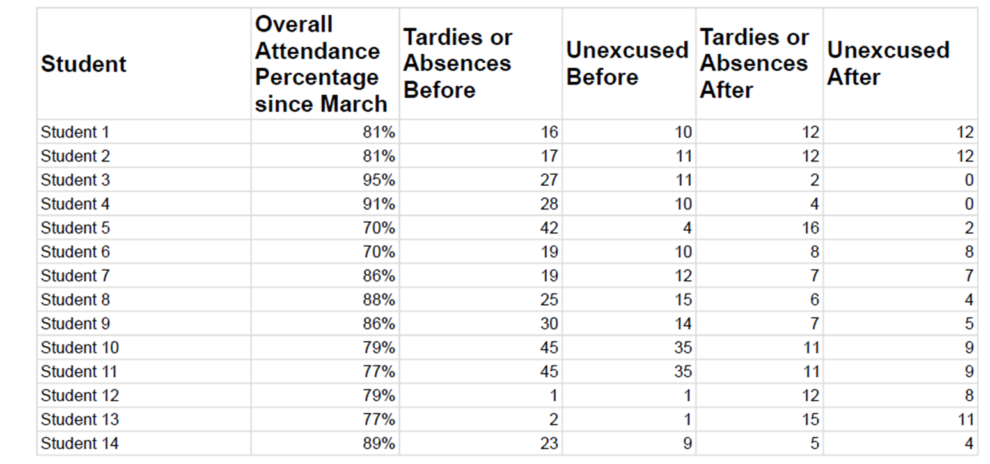

Intervention: PBIS Envelopes - Weekly Recognition Program
Category: Attendance
Submitted by: Middlesboro FRC Middlesboro Independent
Attendance at the elementary school continued to be below 90% on a weekly basis. By November, at least 50% of the school was chronically absent. The elementary school had begun an envelope rewards system last year. 36 envelopes were numbered and displayed in the hallway of each grade level. If that grade had above 90% and had met PBIS expectations (based on teacher report), they would receive the reward hidden in the envelope. This could include extra recess, popsicles, bubbles and sidewalk chalk, etc. While this improved our attendance last year, the students lost interest after the first month of school this year.

The Site Based Council recommended rewarding the homeroom in each grade level with the highest attendance instead of the grades that achieved at least 90% attendance.
The program was updated when students returned to school in January. Winning homerooms were announced during morning announcements every Wednesday. Homerooms were rewarded on Fridays. The Family Resource Center coordinated with non-homeroom staff to assign Fridays for rewards. Staff utilized easy, low-cost rewards like a 5-minute dance party, shamrock tattoos, paper airplane contests, etc. A few donations were also received for things like ring pops and sodas at lunch.

During the first 5 weeks of implementation, school was closed for sickness and weather during several days each week. Once school returned to regular schedule, students bought in to the program.

Grade Level | Fall 2024 - Baseline  (percentage of students present) | Spring 2025 - Post intervention  (percentage of students present)
Kindergarten | 88.14% | 90.71%
1st | 88.66% | 88.96%
2nd | 88.04% | 91.48%
3rd | 89.47% | 92.49%
4th | 89.19% | 90.40%

The number of chronically absent students decreased to 45.41%

Intervention: Attendance Challenge
Category: Attendance
Submitted by: Union Co. MS YSC Union County
The YSC initiated an attendance challenge/club for the top 6 students with chronic absenteeism/truancy issues for the fall semester. All students who had 10 unexcused absences were encouraged and invited to join my attendance challenge. The YSC created the attendance club during the spring in an effort to motivate these particular students to come to school. The challenge was a total of 15 weeks.

In the fall semester, they had a total combined days absent of 60 (11,11,10,10,10,8). The ultimate goal was to create a supportive outlet so these students could improve their attendance, academics and show accountability.

The YSC Coordinator met with the students weekly to go over their attendance. Students had various goals they can meet weekly/monthly. There were 5, 10, 15, 20 day streaks that the students come in and check off when they have been achieved.

In the spring semester, they had a total combined days absent of 38 (6,7,13,8,1,3), a decrease of 22 days compared to the fall semester. One student, in particular, went from 10 absences in the fall semester to only 1 absence in the spring semester. Another student, unfortunately, went from 10 absences in the fall semester to 13 absences in the spring semester.

The impact and outcome were measured by the number of days absent in fall versus spring.
The overall challenge significantly reduced absences and prevented further truancy notices. Students took ownership, self-esteem boosted, grades improved and felt overall sense of accomplishment.

Student | Fall Absences  (days missed/days of the semester) |  | Spring Absences  (days missed/days of the semester)
1 | 11/83 | 13.25% | 6/89 | 6.74%
2 | 11/83 | 13.25% | 7/89 | 7.87%
3 | 10/83 | 12.05% | 13/89 | 14.61%
4 | 10/83 | 12.05% | 8/89 | 8.99%
5 | 10/83 | 12.05% | 1/89 | 1.12%
6 | 8/83 | 9.64% | 3/89 | 3.37%

Intervention: SisterKeeper - Mentoring Program
Category: Attendance/Academic/Behavior
Submitted by: Frederick Douglass High School YSC Fayette County
There was a demonstrated need "to increase awareness of self-confidence, realization of self-discipline, improved relationships with others, develop character and empowerment to grow positively" amongst young women. Data survey results are of 9 students who consistently attended SisterKeeper meetings and events. Albeit the baselin data is positive, there is room for growth to increase their confidence which in turn can increase their academic outlook.

The SisterKeeper Mentoring Program is a district wide initiative "to empower, inspire, and develop the mind, body, and spirit of our young women into women with a purpose." Students applied to be a part of the program and were selected based on their academic and behavioral performance. Curriculum was developed by the SisterKeeper Empowerment Center, a nonprofit organization located in St. Louis, MO. Sessions were held at least twice monthly during their advisory period. Frederick Douglass YSC coordinator was a lead mentor and helped to facilitate meetings, field trips, and bring in phenomenal women for the Phenomenal Women Series. The outcome of the students are as follows:

Measure  n= 9 students | 2023-2024  Group average | 2024-2025  Group average
GPA | 3.66 | 3.43
Attendance | 96.67 | 112.22
Grad Score | 114.22 | 141.78
Behavior | 98.67 | 116.56
Curriculum | 121.44 | 137.44
*according to the Infinite Campus Early Warning Tool

Although the GPA decreased by -6.28%, 66.67% of students show a cumulative GPA of 3.0 or above. There was a 16.09% increase in their attendance scores. There was a 24.12% increase in grad scores with 100% of students having an increase or stable grad scores. Although 100% increased their behavior score at 18.14%, 66.67% of students remained stable or showed positive trends in their behavior. 13.17% increased their curriculum score with 77.77% of students showing 0 current or posted failing grades.

Post survey results indicated that 100% of the students said:
- They enjoyed being a part of the program
- They will participate in SisterKeeper next school year
- They learned something from SisterKeeper (self-confidence, sisterhood, teamwork, etc.)
Question: Did the program help them do better in school?:
- 66.67% said somewhat
- 22.22% said yes
- 11.11% said not much
Question: Are you comfortable talking to your sponsor?:
- 88.89% said yes
- 11.11% said not much

In summary, the outcomes demonstrate that the students, as a group, are significantly improving in areas related to engagement, foundational skills, and overall academic progress.

Intervention: Sandersville Elementary Flag Team
Category: Attendance/Behavior
Submitted by: Sandersville FRC Fayette County
The Sandersville Elementary Flag Team was developed to address students at risk for truancy, negative behavior and isolation. Thirty-six students were selected to participate, with half of those being from the School Resource Officer's GREAT group and the remaining students being selected by the Student Support Team and homeroom teachers. Participants were divided into 2 groups, with 20 students serving from August to December, and the remaining 16 to serve from Jan to May.

The students were trained and tasked to raise, lower, fold, store, and use proper flag etiquette when school was in session. The SRO led the Flag Team on odd weeks, the FRC led the Flag Team on even weeks. The FRC also participated in the student selection process.

 | Before Intervention | After Intervention
Group One Attendance | Average of 4 per student | Average of 2.375 per student
Group Two Attendance | Average of 10.19 per student | Average of 7.47 per student
Group One Behavior Referrals | 11 Tier 2 incidents | 0 Tier 2 incidents
Group Two Behavior Referrals | 3 Tier 2 Incidents | 0 Tier 2 Incidents

There was a total gain of 76 instructional days and zero Tier 2 behaviors for the 36 students selected for the Sandersville Flag Team.

Intervention: Team OMAC- Operation Making a Change
Category: Attendance/Behavior
Submitted by: Woodford Co. HS YSC Woodford County
Prior to the intervention, the Student Needs Team at Woodford County High School conducted a data review and identified 15 students as at-risk based on patterns of concerning behavior and poor attendance. These students had frequent disciplinary referrals and attendance rates consistently below 85%. The targeted population consisted of students who demonstrated low levels of school engagement, with behavior issues often correlating with chronic absenteeism. This data underscored the need for a focused intervention to address both behavioral and attendance-related challenges in order to improve student outcomes.

The Woodford County High School Youth Service Center partnered with Team Operation Making A Change (OMAC) to implement a weekly mentorship program led by Geo Gibson. Geo brought lived experience, powerful storytelling, and mentorship centered on goal setting, accountability, relationships, and overcoming personal obstacles such as addiction. Through open dialogue, he encouraged students to reflect on their choices, focus on dreams, eliminate toxic influences, and build self-worth. The program created a safe, engaging environment where students felt seen, heard, and supported.

Total Behavior Incidents:
- Before OMAC: 81
- During/Completion of OMAC: 21
- Behavior Incidents decreased by 74%

Attendance:
Prior to completing OMAC, students had high rates of absenteeism. After being involved in the program, there was a 77% decrease in absent events and a 26% decrease in suspensions.

Participants shared the advice that resonated most and continues to influence their daily lives:
- "Be yourself and choose your own path" – Staying authentic and true to personal values.
- Accountability and Discipline – Holding oneself accountable and applying the “5 P's” principle.
- Self-Love and Boundaries – Prioritizing mental health and cutting off distractions.
- Positive Role Modeling – “Be the person your child wants to look up to.”
- Letting Go of Negativity – “Take out the trash.”
- Time Management – “Time is moving with or without you. Use it wisely.”

When asked what part of the program had the biggest impact, students responded with:
- Community and Vulnerability – “Gathering everyone together and sharing personal stories.”
- Emotional Growth – “Learning it's okay to let people go.”
- Transparency and Honesty – “The realness and understanding,” “Him not holding back about anything.”

The OMAC program has made a measurable and meaningful difference in the lives of our students.

Intervention: Behavior Intervention Group
Category: Behavior
Submitted by: Mercer Co. Elementary School FRC Mercer County
In collaboration with the the school counselor, the FRC assisted in Check In and Check Out groups for behavior and academic needs. The FRC group included 8 students; 4 boys and 4 girls in kindergarten and 1st grade. Attendance was not a focus in the beginning but grew to include this as the program progressed through the year. Interventions were put into place in the classrooms as well as the counseling office. Students were given extra breaks with praise and encouragement for good effort, a calming corner with manipulatives, and a daily behavior chart to see their progress and have accountability throughout the day.

 | Behavior Pre- Intervention | Behavior Post- Intervention | Notable Academic Improvements- Math | Notable Academic Improvements- Reading
Child 1 | 7 | 0 | F to C | -
Child 2 | 12 | 0 | F to B | D to B
Child 3 | 14 | 3 | - | -
Child 4 | 11 | 0 | - | -
Child 5 | 13 | 1 | - | -
Child 6 | 11 | 4 | - | F to B
Child 7 | 12 | 3 | - | -
Child 8 | 4 | 0 | C to A | F to B

Outcomes:
- Average behavior incident reduction across all students: 86.2%
- Lowest absences: Child 1 and Child 5 (3 and 3.5 days)
- Highest absences: Child 2 (18.5 days, 8 unexcused)
- Average absences across all students: 9.81 days
- Average tardies per student: 7.75 tardies
- Graduated from the program: Child 1 and Child 8

Overall Impact:
- 100% of students reduced negative behavior.
- Students who improved behavior also often improved academically, especially in math.
- Reading showed improvement but with less consistency.
- Attendance and tardiness remain areas for further focus, particularly with unexcused absences.

Intervention: Behavioral Small Groups
Category: Behavior
Submitted by: Alvaton FRC Warren County
Overview:
At Alvaton Elementary, staff and administration observed a concerning trend of increasing behavioral referrals—specifically related to disrespect and disruption—across all grade levels. In collaboration with school administration and our school counselor, the decision was made to implement targeted behavior small groups with the goal of early intervention, relationship-building, and skill development for students demonstrating the highest need.

Group Selection & Structure:
Beginning in October, the top five students from each grade level with the most disrespect and disruptive behavior referrals were invited to participate in small groups, totaling 35 students. These groups met once per week during the school day. Sessions focused on:
- Making good choices in difficult situations
- Practicing self-awareness and emotional regulation
- Reflecting on alternative responses to peer and adult interactions
- Building relationships with peers and trusted adults
Each session also incorporated short student check-ins and classroom one-on-one time (approximately 5 minutes weekly), which allowed for deeper connections and individualized support.

Initial Challenges:
As expected, early group sessions were met with resistance. Students were hesitant to engage and often joked around or distracted from the purpose of the group. However, consistency, structure, and a relationship-based approach laid the groundwork for a shift in behavior.

Referral Data & Behavior Trends:
When the groups launched in October, the 35 students had already received a combined 130 referrals. While November and December showed slow and steady improvement, January marked a turning point:
- 20 of the 35 students received zero referrals that month
- 13 students received only one referral
- The remaining 2 students received two referrals each
This positive trend continued throughout the remainder of the school year, with overall behavior steadily improving and students becoming more reflective, accountable, and invested.

Student Feedback & Reflections:
At year-end, students were asked to reflect on what helped them make changes. The most common response was that they felt seen and supported. Many shared that the group, the one-on-one time, and the consistent check-ins helped them realize that attention didn’t have to come from acting out—someone genuinely cared and was willing to walk alongside them through change.

Conclusion:
The behavior small groups at Alvaton Elementary proved to be an impactful intervention for a group of students who were previously disengaged and struggling behaviorally. Through consistency, relationship-building, and intentional reflection, students began to take ownership of their actions and made noticeable improvements. This initiative not only reduced referrals but also strengthened the culture of care and connection within our school. We plan to continue and expand this model in the coming year.

Intervention: Guys with Ties and Girls with Pearls -- Behavior In School Group
Category: Behavior
Submitted by: Collins Elementary FRC Boone County
Guys with Ties and Girls with Pearls were implemented to support students identified by Panorama screening and staff as lacking self-reported grit (Guys with Ties), self-efficacy (Girls with Pearls) and strong connections with adults or peers. The program also aligned with the school's Multi Tiered System of Support goals and aimed to help students model expected behaviors and reduce behavior referrals. The students enrolled in the programs had a total of 39 behavior referrals (19 for boys and 20 for girls) and all the students either self reported having low scores for grit and self efficacy on the initial Panorama screening or were identified by teachers for these traits. The average score for grit was 3.76 out of 5 and self efficacy was 2.78.

Throughout the year, students participated in monthly sessions centered on resilience, leadership, and relationship-building. As a result, the Guys with Ties group average grit score increased from 3.76 in the fall to 4.13 in the spring, with 70% of students showing growth and an average improvement of 0.28 on a 1–5 scale. Additionally, 100% of participants reported having both a trusted adult and peer in the school. The average self-efficacy score increased from 2.78 in the fall to 3.13 in the spring, with 65% of students demonstrating growth and an average increase of 0.34 on the 1–5 scale. Furthermore, 79% of participants reported having both a trusted friend and a trusted adult they can rely on.

Reflecting the program’s impact on behavior, students in Guys with Ties had zero behavior referrals in 2024–25, down from 19 referrals the previous year. Behavior referrals among Girls with Pearls students dropped significantly, from 20 in 2023–24 to just 3 in 2024–25.

Intervention: PBIS Student of the Month
Category: Behavior
Submitted by: Jessamine Early Learning Village FRC Jessamine County
In September of 2024, 11 individual students accounted for a total of 36 office disciplinary referrals. Office disciplinary data is used to evaluate the effectiveness of Tier 1 Positive Behavioral Interventions and Supports (PBIS) at the Jessamine Early Learning Village. The Family Resource Center is part of the Tier 1 PBIS strategy aimed at reducing school-wide office referrals.

FRC is part of a Tier 1 PBIS structure at the Early Learning Village attending both PBIS committee meetings and Kindergarten Behavior RTI. The FRC works to encourage students to follow the JELV school-wide expectations through the Student of the Month program. Data is collected by utilizing classroom management data (DoJo) along with teacher observations to determine which students should be recognized for his/her outstanding demonstration of following one of the 5 STEPS to Success.

Throughout the 2024–25 school year, the FRC developed and shared five instructional videos with all preschool and kindergarten classrooms. These brief, engaging videos taught students how to apply each of the five STEPS:
- Stop and Think
- Try Your Best
- Play Nice with Others
- Express Yourself
- Safe Hands and Feet

Each month, the FRC highlighted a specific STEP and encouraged students to focus on that behavior. Recognized students received certificates and prizes through “Debbie’s Prize Cart.” This initiative ensured that 100% of selected, non-duplicated students across 24 kindergarten and 8 preschool classrooms were celebrated each month. Over the course of six monthly recognitions, 144 kindergarten and 96 preschool students were positively impacted.
The 2024–25 ODR data reflects a significant improvement in student behavior over time. From September to May, the number of referrals dropped from 36 to just 3—a 91% reduction. Similarly, the number of students receiving referrals decreased from 11 to 2, representing an 81% reduction. These results underscore the effectiveness of the FRC’s contributions to the PBIS Tier 1 framework in fostering a positive, supportive learning environment across JELV.

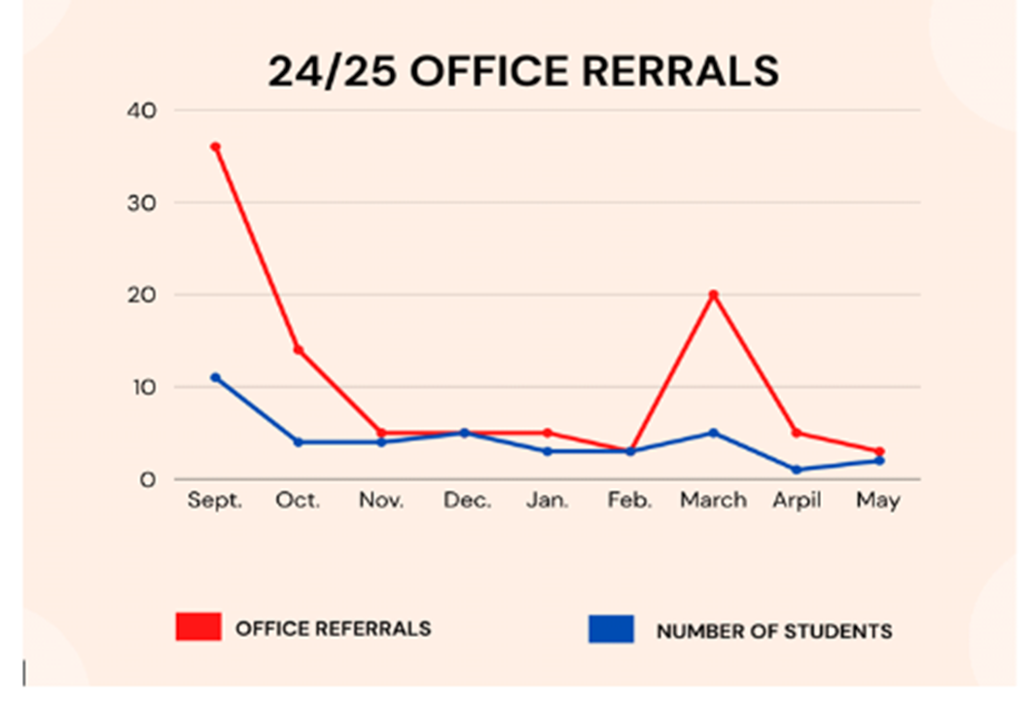

Intervention: Guys in Ties
Category: Behavior/SEL
Submitted by: Silver Creek FRC Madison County
12 male students participated in the Guys in Ties program, a faith-based club teaching young men how to be gentlemen.. Students were targeted based on teacher recommendations per classroom behaviors.
During the first nine weeks of school, teachers reported 37 classroom behavior incidents among these 12 students.

Among these 12 students, there were 18 office referrals during the first nine weeks of school.
- 7/12 (58.3%) students report NOT having a father figure in their home.
- 6/12 (50%) students report NOT having the opportunity to attend church, but would like to.

Guys in Ties is a faith-based after school program, teaching students how to be a gentleman and how to handle themselves in certain situations. The Silver Creek Elementary FRC partnered with local pastor Larry Freeman to lead these students, through scripture, on their journey to becoming gentlemen.

Guys in Ties met in the FRC each week during the 2nd nine weeks of school. During this time, teachers reported a significant decrease in classroom behaviors.

Outcomes:
- Classroom behaviors dropped from 37 in the 1st nine weeks to 18 in the 2nd nine weeks (nearly a 50% decrease).
- Office referrals dropped from 18 in the 1st nine weeks, to 2 in the 2nd nine weeks (nearly a 75% decrease).
- 12/12 (100%) students report that they feel more confident in themselves after participating in Guys in Ties.
- 12/12 (100%) students report that they have noticed a change in their attitude since participating in Guys in Ties.
- 12/12 (100%) students report they feel better equipped to make better choices since participating in Guys in Ties.
- Of the 7 students who reported they did not have a male figure in their household, all 7 reported that they feel confident in knowing they can seek out the help of positive male role models in their lives (teachers, Mr. Freeman, family friends).
- All 12 participants received a Bible at the completion of the program. Of the 6 students who reported they did not have the opportunity to attend church, but would like to, all 6 report they feel confident in using the Bible to learn more scripture in how to be a gentleman.

Intervention: Men of Quality
Category: Behavior/SEL
Submitted by: 3A-Cochran In the City FRC Jefferson County
Before the implementation of the Men of Quality boys group at Cochran Elementary, there was a clear need for structured mentorship and character-building opportunities for male students. Baseline data and staff observations showed:
- Male students, particularly in the upper elementary grades, were disproportionately represented in behavioral referrals and often struggled with emotional regulation and peer conflict.
- Many of these students lacked consistent positive male role models in their lives and were in need of guidance in areas such as responsibility, leadership, and decision-making.
- Teachers and support staff reported low engagement, poor classroom behavior, and challenges in developing social-emotional skills among a core group of boys.

Informal assessments and Family Resource Center interactions revealed that these students often faced challenges at home—such as economic hardship or family instability—that impacted their school performance and self-esteem.
The Men of Quality program was created to directly serve these at-risk male students by providing a safe and supportive space for mentoring, leadership development, and guided conversations around respect, accountability, and positive identity. The targeted population included boys identified by school staff or the Family Resource Center coordinator as needing additional support with behavior, emotional development, and peer relationships.

The Men of Quality boys group had a meaningful and measurable impact on male students at Cochran Elementary. This intervention provided a structured space where boys met regularly to engage in mentorship, character-building discussions, and activities focused on leadership, emotional regulation, and responsible decision-making.
The Family Resource Center was instrumental in the planning and execution of the group. The center identified participants, coordinated sessions, secured guest speakers, and provided materials and snacks to help create a welcoming and consistent environment. The FRC also collaborated closely with school staff to monitor student progress and reinforce key messages from the group throughout the school day.

Outcomes:
- 20 boys participated throughout the school year.
- There was a 20% decrease in behavior referrals among group members, as reported by school administration.
- Teachers noted improvements in students’ confidence, peer interactions, and overall engagement in class.
- Several students emerged as positive leaders, taking initiative in both classroom and school-wide settings.
- Feedback from participants indicated that they felt more supported, respected, and motivated to be role models for their peers.

The Men of Quality program successfully met its goal of fostering leadership and personal growth in young male students, while aligning with the Family Resource Center’s mission to support students socially, emotionally, and academically.

Intervention: GIRLS - Girls in Real Life Situations - Intervention Group
Category: College & Career Readiness
Submitted by: North Middle YSC Hardin County
Students were identified for the GIRLS intervention group based on the presence of one or more at-risk factors. The identification process utilized multiple data sources, including the Persistence to Graduation (PtG) report, attendance records, behavior referrals, and academic performance during the first and second semesters of school.

The Youth Services Center Coordinator (YSC) collaborated with the Student Support Committee to select students for the group based on the above risk factors. The average number of absences (excused or unexcused) among the selected students was six.. The participants also completed a pre-survey/self assessment.

The primary goal of the GIRLS intervention group was to promote student success by addressing individual needs in a supportive group setting.

The GIRLS group was initiated to improve student outcomes through personalized support and targeted interventions. The focus was on uncovering and addressing the underlying causes of their individual needs - academic challenges, peer relations/bullying, mental health concerns and family issues were identified by the students as contributing to their struggles. During the 12 week period, the group met weekly as a whole. Individual meetings were also available in addition to the group. This group involved intensive services tailored to meet the individual needs of the girls. In addition to meeting with the students, the YSC met weekly with the Student Support Committee to identify areas and avenues of service delivery to assist in student success. These interventions included mental health referrals for school based therapy, ESS for academic tutoring, mentoring, the BackPack Feeding Program, and additional access to family support such as case management.

Outcomes:
The GIRLS group outcomes include: academic improvement, enhanced social skills, improved mental health, increased self awareness, positive behavior changes/conflict resolution and improved attendance as shown by attendance reports, progress reports, student post surveys and behavior reports.

- 12 of the 15 showed significant progress. (1 student moved and 2 students were transferred to an alternate school setting, College View.)
- Student absences decreased significantly to ZERO unexcused and 4 excused for doctor appointments.
- All grades were passing with no student failing a subject area.
- Behavioral referrals - only one major referral out of the group! All remaining students were eligible to participate in the end of the school year PBIS rewards.
- 8 of the 12 girls enrolled in school based therapy for additional support.
- This program improved overall well-being and student success!

Intervention: Job Fair for Graduating Seniors
Category: College & Career Readiness
Submitted by: 3B-Shelby Co HS YSC Shelby County
Demonstrated Need:
Of the 228 SCHS graduates in 2024, 35% (80 students) indicated a plan to enter the workforce immediately after graduating. During the spring of 2025, counselors and YSC identified 21 soon to be graduates who reported no plans for college, vocational school, or military service after graduation. The students were invited to attend a Regional Job Fair. 11 of the 21 students signed up to participate. Pre surveys reflected that 81% reported that they had no idea where they might apply for employment or what employment opportunities were available.

The YSC partnered with the Shelby County Public Schools College and Career Program to host a field trip to a Regional Job Fair. At that job fair, 41 employers were available to discuss open positions and offer application information to the students.

Post survey results showed:
- 100% of the students attending met with at least 4 employers.
- 100% of the students applied, or confirmed they obtained the website links and intended to apply for open positions.
- 5 students submitted or would be submitting applications to 3 or more employers.
- 2 students submitted or would be submitting applications to 2 or more employers.
- 3 submitted or would be submitting an application to 1 or more employers.

Intervention: World's Greatest Baby Shower
Category: Family Literacy
Submitted by: Family Connections FRC Lincoln County
County statistics show the following statistics:
- 45% of children are in foster care
- 22.8% of births are to teen mothers
- 8.9% of babies are born with low birthweight

Lincoln County's "World's Greatest Baby Shower" is an event that allowed community partners to share available resources with local families. The Family Resource Center (FRC) sponsored and facilitated the event. The FRC secured a $1000 grant from Garrard/Lincoln Early Childhood Council to purchase door prizes. The FRC and community partners provided additional baby items and a meal at no cost for participants. Twenty-nine mothers and guests were in attendance.

The program provided the following outcomes:
- 4 new parents were paired with Havencare, a facility helping struggling mothers(parents) with education, baby supplies, referrals, counseling, etc.
- A pre-test showed that 42.9% indicated there was no benefit to the local library for their babies. After the shower presentations the percentage decreased to 7.7% seeing no benefit.
- 82.6% of participants reported knowing what the HANDS program at the Lincoln County Health Department was; by the end of the event, 100% felt they knew about this resource.

Intervention: LEAP---after school program with UK Extension Agency
Category: Health
Submitted by: West Daviess County FRC Daviess County
The West Davies Co. FRC has enjoyed a successful partnership with the UK Extension Agency and the LEAP program since 2022–2023, and we are excited to continue offering this after-school program. The 2023 FRYSC needs assessment indicated that both parents and staff chose Healthy Eating Habits as one of the top three health issues that interfere with learning. The FRC coordinator partnered with the UK Extension Agency and the afterschool program to offer the LEAP program for 16 first grade students from 1/16/25 to 2/27/25.

n=16 students | Identify My Plate Food Groups  Pre-Test | Food Groups Food Match  Pre-Test | Food Groups Color Match  Pre-Test | Identify My Plate Food Groups Post-Test | Food Groups Food Match Post-Test | Food Groups Color Match Post-Test
Protein (purple) | 54% | 53% | 27% | 100% | 74% | 80%
Vegetables (green) | 45% | 62% | 36% | 80% | 76% | 80%
Dairy (blue) | 100% | 62% | 63% | 100% | 84% | 90%
Fruits  (red) | 27% | 84% | 18% | 90% | 90% | 90%
Grains  (orange) | 18% | 60% | 9% | 90% | 76% | 70%
*% indicates percentage of students that answered correctly

Outcomes:
- Post Test: Identify My Plate Food Groups-- Protein 45% increase, Vegetables 35% increase, Dairy 0% increase, Fruits 63% increase, Grains 72% increase.
- Post Test: Food Groups Food Match-- Protein 21% increase, Vegetables 14% increase, Dairy 22% increase, Fruits 6% increase, Grains 16% increase
- Post Test: Food Groups Color Match-- Protein Purple 53% increase, Vegetables Green 44% increase, Dairy Blue 27% increase, Fruits Red 72% increase, Grains Orange 61% increase

Intervention: Vision Clinic
Category: Health
Submitted by: Bowling Green High School YSC Bowling Green Independent
The Bowling Green High School YSC saw a drastic increase with students having vision issues in the classroom. Students were screened by the school health care professionals in the building but additional supports were needed for those students who failed the screening and did not have vision insurance or the ability to pay.

The YSC coordinator organized a clinic in March, partnering with the University of Kentucky Department of Ophthalmology. Ophthalmology resident students and UK medical students volunteered their time and equipment to see 186 students. Of those 186, there were 63 students who received glasses, 23 who received referrals for follow-up care with 4 of those requiring surgery. All services were at no charge including the glasses.

Intervention: Elgin Dental Program
Category: Health - Dental
Submitted by: London FRC Laurel County
Many students in Kentucky are enrolled in Medicaid, but do not utilize the services. In 2019 Kids Count Data Center reported only 51% of children enrolled in Medicaid in Kentucky utilized the benefit. Some possible reasons could be lack of transportation, lack of knowledge of the medical system, or lack of knowledge of their own child's oral health condition. Some other reasons for lack of dental care, from anecdotal cases within London Elementary, are undocumented children who do not qualify for Kentucky Medicaid, or documented immigrants who have difficulty accessing benefits.The Elgin Dental Program does a free screening, for all students who have permission, to increase parent knowledge of their child's oral health.

The following is the preliminary screening data from 2022-2023 school year to the 2024-2025 school year:
- 2022-2023 Screening: Total screened- 120
- 2023-2024 Screening: Total screened- 108
- 2024-2025 Screening: Total screened -118

Score #1 - Your child has an abscess, infection, pain or other problems and needs to see a dentist immediately.)
Score #2- Your child has possible/obvious decay or other dental problems and needs to see a dentist for complete examination and treatment to prevent pain, loss of teeth, ect.
Score #3- Your child has no obvious dental issues; however, your child needs to have a complete dental examination and x-ray twice a year with cleaning and flouride treatment, ect.

Fiscal Year | 2022-2023 (n=120) | 2023-2024 (n=108) | 2024-2025 (n=118)
Score #1 | 12 or 10% | 9 or 8% | 4 or 3%
Score #2 | 35 or 29% | 23 or 21% | 26 or 22%
Score #3 | 73 or 61% | 76 or 70% | 88 or 75%

The Family Resource Center coordinator facilitates this program by sending, receiving, and organizing all permission forms. In addition, the coordinator assists in organizing and completing the dental screenings, by transporting students and copying the screening results for all the stakeholders. Coordinators oversee and advocate for students during transportation and dental visits. Coordinators send home reminders of dental appointments and work to get signed dental treatment plans to the dental office. Family Resource Coordinators, along with our Elgin dental liaison in Laurel County, aid parents in creating the dental appointment for their child. Coordinators and the dental liaison also help parents to understand what benefits are available to them through the Elgin Dental Program if they are lacking healthcare and refer parents to the Elgin manager at Barnhill dentistry when they are lacking in understanding their dental benefits, or their child's dental health.
- From 23-24 to 24-25 the number of students scoring a 3 increased by 5% and the number of students scoring a 1 decreased by 5%.
- From 22-23 to 24-25 the number of students scoring a 3 increased by 14% and the number of students scoring a 1 decreased by 7%.

Overall through the data we can see that the program is decreasing the amount of children in severe need of dental care. However, we can see through our personal experiences the program does so much more, helping to break down barriers for parents who need help navigating the healthcare system, educating parents on their child's healthcare needs, transporting children to appointments when parents are lacking transportation, paying for students who do not have dental coverage, empowering parents to make connections with the dentist's office outside of the school system, relieving the pain of students, and allowing them to focus on their education.

Intervention: Catch My Breath-PCHS Student Advisory Council Mentoring Group
Category: Health - Substance Use Education
Submitted by: Powell County H.S. YSC Powell County
According to pre-program surveys, 31% of 8th grade middle school students admitted to using tobacco and vaping products. 33% of 8th grade middle school students said that it was very easy to get vaping products.

The Powell County High School (PCHS) YSC and PCHS Student Advisory Council collaborated with the Powell County Health Department to teach and mentor middle school students about the dangerous effects of tobacco/vaping products. Using an evidence-based curriculum, Catch My Breath, this week long program was presented by the PCHS YSC coordinator and PCHS Student Advisory Council students to all 8th grade middle school students during the school day. The goals of the program were to educate middle school students about the the health risks and social consequences of vaping; to equip students with tools to recognize and address vaping behaviors; to engage students in peer-led prevention and advocacy activities; and to reduce incidents of vaping among middle school students.Post-surveys reported that 81% of participants became more knowledgeable about the dangerous health effects of vaping; 88% of students said they would be able to say no to vaping products, and 61% said they felt confident about telling other peers about the dangers of vaping. The overall impact of the program showed a 19% decrease in the number of 8th grade students using vaping products.

Intervention: Character Counts (Character Education Program)
Category: Health - Substance Use Education
Submitted by: Dorton FRYSC Pike County
Data from the FY 22-24 needs assessment suggested that the top three behavior violations at Dorton Elementary are disruptive classroom behavior, disrespecting teachers and harassment of another student. Additionally, there are approximately 28 students (out of a population of 284) with a parent that has been arrested and/or incarcerated over the past year, due to drug related charges, some more than once. 13.3% of 8th Grade Students report vaping or use of tobacco and 6.3% report being high or drunk at school, according to the KIP Survey.

The "Character Counts Program", which is a character education program for junior high students with monthly classes, was conducted from October thru April of the 24-25 school year. Topics covered include: How to Say No and Really Mean It, Dangers of Alcohol & Smoking, Marijuana and Vaping. The program also covered making good choices and topics such as bullying, peer pressure, cheating, online safety & dating violence. Each session began with videos with real life depictions of circumstances students may find themselves in and gave scenarios of how each situation could be dealt with. Each video segment was followed by activities and games pertaining to the topic.

After each session, pre and post tests were compared and revealed that students gained knowledge in the topics covered. However, the true success of this program was the decrease in student behavior incidents from the 23-24 school year to the 24-25 school year. The 23-24 School Year showed 97 behavior incidents by 82 separate students as opposed to the 24-25 school year, which showed 72 behavior incidents by 42 separate students. This is a 25% decrease in behavior incidents and a 50% decrease in the number of students involved in behavior incidents. Furthermore, I.C. reports indicate vaping incidents decreased by 50%.

Intervention: Sister Keeper Girls Mentoring Group
Category: Health/Mental Health
Submitted by: Beaumont MS YSC Fayette County
The need for positive mentoring was established by school counselors, the school district mental health specialist, administrative team and the YSC coordinator. The target population included students who had visited the school counseling or mental health support staff frequently and students who were new to our school and needed connections. The program goals were to improve peer relationships, self-image, reduce 'drama', and provide skills for goal setting. Students completed a survey at the start of the programming. This survey was used to guide some of the content during the semester as well as survey outcomes of the program.

The program was held weekly from January - April along with check-ins with students. The weekly program met during school for one class period. Each weekly meeting covered a different lesson which included nutrition, hygiene, self-awareness, goal setting, exercise, and more. The YSC coordinator arranged special guests to support the girls with various skills. The school nurse came to help with a lesson on nutrition and make a healthy snack. A school staff member who is a trained yoga instructor led the girls in yoga, two local female businesses owners shared their experiences, one local female business owner led them in two sessions on goal setting and they made vision boards. The girls had time to journal as well as share and connect with each other throughout the program. The girls participating in the program were grades 6 - 8 so students who participated this year can continue as student mentors for new students in the program next year.

Overall data showed an improvement in all areas surveyed. The girls also gave positive feedback stating they learned and enjoyed a variety of things:
- "I love having supportive girls my age around me, almost like a little town or community"
- "I learned to love myself more"
- "Now I have the tools I need to pursue some of the goals I set for myself.”

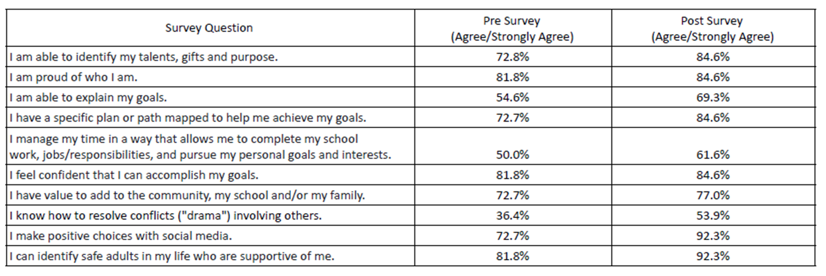

Intervention: Individual- Dental Needs
Category: Individual - Dental
Submitted by: Woodford FRC Woodford County
We had a new student start at Simmons Elementary on 8/13/2024. Her teacher quickly realized she was in need of immediate dental services so she came to FRC to see if there was anything that could be done. The student and her family only spoke Spanish so FRC asked another staff member to help translate the call to her mom to gain knowledge of dental coverage, if any. The student's mother reported they did not have dental coverage. The student's mom reported they had been involved in a car accident in Guatemala before moving to the US that resulted in her daughter losing her front teeth..

FRC quickly began seeking outside resources and was able to receive financial help from a community resource, Woodford Foundation. After going to two locations and gaining perspective for cost, the student was able to receive the care she needed from Brush Dentistry in Lawrenceburg, KY. After receiving dental services, this student began to smile more, talk without trying to cover her mouth, and began to thrive academically. Her I-Ready reading score in September was 284, in December (after receiving dental care in October) was 307, and lastly in April her score increased to 322.

Overall Diagnostic Growth

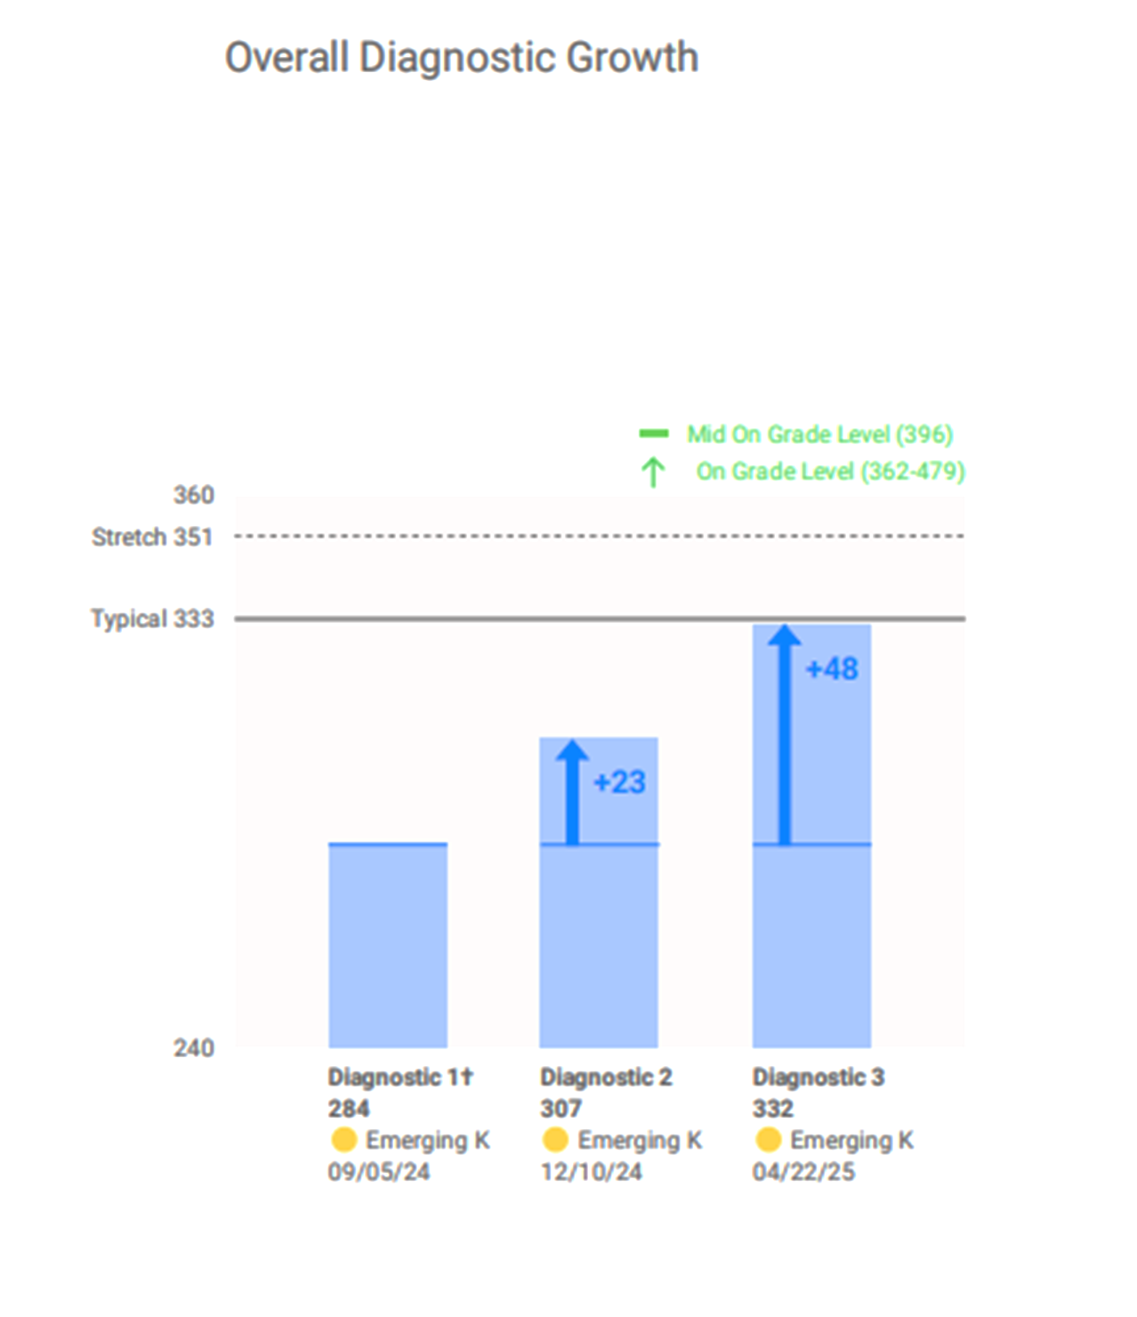

Intervention: INDIVIDUAL - Student intervention
Category: Individual/Attendance/Academic
Submitted by: Marshall Co. Middle School YSC Marshall County
Marshall Co Middle YSC received a referral from another school district about a new student who would be transferring to one of our schools. The former FRYSC office wanted to make sure that someone kept an eye on the student and supported them as needed. The center met with the student upon their arrival to our school and started to develop a relationship with them. Attendance and grades were concerns when they started school with us. Our center serves two schools and this student eventually had to transfer to the other school we serve. The center assisted in the transition and helped acclimate the student to their new school.

The center began daily check-ins with the student. She would often start her day in the center. We assisted the student through health issues, peer relations, and family upheaval. To instill confidence in her, the center coordinated community service opportunities for her. She was dependable and made important social connections through the projects. By the time she graduated from middle school, she was thriving and excelling. During her sixth grade year, she missed 11 days of school but by her 8th grade year she only missed 3 days. Her grades also improved. She now makes A's and B's. She now stays for ESS at the encouragement of the YSC and her grades in math (her lowest subject) are also improving. She served as a student representative on the center's advisory council during her 8th grade year and provided great perspective and feedback. She took the lead on our schoolwide manners initiative and created peer led videos to demonstrate what good manners look like. After encouragement from the center to try to try out for the yearbook staff, she applied and was accepted. The coordinator served as one of her school references. She handled her responsibilities on yearbook staff like a pro. She is now looking forward to high school and chasing her dreams. She has even talked about serving as a coop student in the YSC during her senior year of high school to give back to other students.

Intervention: INDIVIDUAL - Weekly Mentoring Improves Student Outcomes
Category: Individual/Attendance/Behavior
Submitted by: Lexington Middle School YSC Fayette County
A student at Lexington Middle School was involved in several disputes and physical altercations with peers and experienced ongoing conflicts with teachers and school administration. He consistently demonstrated a poor attitude, which appeared to be influenced by significant personal challenges, including housing instability, lack of adequate clothing, and food insecurity. These hardships greatly contributed to his overall mood, attendance and behavioral difficulties. The student support team found a community partner to mentor the student that started late October to help student behavior. Student baseline data from IC in September and October he had a behavior issue 4 weeks in a row. He had 7 unexcused absences December to February.

The student initially demonstrated poor behavior and a daily negative attitude. However, with consistent weekly interventions from one individual mentor, along with feedback and support from counselors and the FRYSC, his overall behavior significantly improved. He no longer had any unexcused absences - ZERO unexcused absences to be exact. His behavior improved but he did have a housing issue in the spring. He had less behavior/fights from the fall but he did have 3 behavior issues reported but the trend was less, according to IC.

He looked forward to his weekly mentor and respected him. The student looked forward to his visit each week and double checking to make sure he was still scheduled for the week. The student also was now able to come to the FRYSC for food and clothing when needed. This student wrote a letter to the counselor and FRYSC about his appreciation the impact we had on him.

Intervention: INDIVIDUAL - Check-in and Check-out- monitoring time for student behavior, attendance, expectations
Category: Individual/Attendance/Behavior
Submitted by: Garrett Morgan FRC Fayette County
Student was struggling in previous school year with a number of behavior incidents reported by classroom teacher. Student had 16 reported behavior incidents in 23-24, 4.5 days absent with 2 of them being suspensions due to behavior. The goal was to put check-in, check-out, and movement breaks in place to provide supports for student and help student decrease number of behavior incidents.

Based on student behavior data from 23-24, it was determined the student might benefit from check-in first thing in the morning, two movement breaks one being during a classroom transition time and one mid day, as well as a check-out time to assess students progress. This was also monitored on a student behavior chart that student took ownership of. FRC was identified through Student Support Team as student's identified support person. FRC greeted student every morning as he got off the bus to review school expectations, daily transition break focused on reminding student he had control over his choices, daily movement break allowed student to have a academic break and refocus for remainder of school day, check-out was focused on reviewing how student did meeting his goals.

Student behavior for 24-25 decreased to only 3 reported behavior incidents, 0 out of school suspensions, 0 in-school detentions.

Intervention: Family Crisis Intervention - Mentoring Program
Category: Individual/Basic Needs/Attendance/Behavior
Submitted by: Adairville FRYSC Logan County
In August 2022, a new student enrolled after experiencing homelessness and separation from his mother. FRYSC built a supportive relationship with the family, who had recently secured housing but lacked basic necessities such as furniture, clothing, bedding, and food. The student showed frequent outbursts and disruptive, sometimes threatening, behavior in class. Discussions with the mother revealed a history of mental health and behavior challenges, the loss of positive male role models due to death or incarceration, and discontinued medication because of access issues. At previous schools, the student had required a 1:1 classroom setting. In 2024, he experienced another significant loss with the death of his grandmother.

Over the next three years, FRYSC supported the family in numerous ways. The center helped them obtain essential furniture, clothing, beds, bedding, and a washer and dryer through community donations. Staff assisted the mother in applying for Kentucky health insurance for herself and her child, arranged and scheduled transportation for medical appointments, and completed referrals for mental health services. When transportation was unavailable, FRYSC picked up the student’s prescribed medication and provided emergency assistance with utilities, rent, groceries, and other needed resources. The mother was also connected with local job opportunities. In addition, FRYSC mentored the student on school expectations, emotional regulation, and appropriate behavior, while coordinating with school staff on regular updates and behavior support plans. In 2024–2025, the center also arranged for a male mentor to meet with the student weekly.

FRYSC has played a key role in removing barriers and supporting the family through intervention and collaboration. As a result:
- The student and mother obtained health insurance and access to medical care, allowing the student to resume medication management.
- Housing stability improved, and the family gained access to essential household items and basic needs.
- The mother secured employment.
- The student received counseling.
- The student demonstrated significant growth in behavior and emotional self-regulation during the 2024–2025 school year.
- Teachers reported improvements in the student’s classroom behavior and participation throughout the school year. The student was able to spend most of his time in the general education classroom with peers vs a 1:1 setting.

Based on data from Infinite Campus, the student received two in-school suspensions during the 2024–2025 school year, a marked improvement compared to prior years. In the 2023–2024 school year, the student had six behavioral incidents resulting in in-school suspensions, including two out-of-school suspensions. In the 2022–2023 school year, the student also had six behavioral incidents leading to in-school suspensions.

This positive change in behavior reflects the student’s response to consistent behavioral supports, strong mentorship, and improved stability in the home environment. In addition to behavioral growth, the student made measurable academic progress during the 2024–2025 school year, as shown in the i-Ready Diagnostic Reports:
- Reading: The student’s score increased + 26 points from fall to the spring.
- Mathematics: The student’s score improved from +39 points from fall to spring.

The student is better prepared to transition from middle school to high school, as a result of the ongoing support provided by FRYSC. The student's mentor has agreed to continue the mentorship and encouragement throughout the upcoming school year.

Intervention: Individual Student Behavior Modification Plan
Category: Individual/Behavior
Submitted by: Estill County MS YSC Estill County
A new 6th-grade student demonstrated persistent and significant behavioral concerns across various school settings. From August to November, the student accrued 10 office referrals. Under our school's progressive discipline policy, this number of referrals signifies that the student had previously been subject to at least 30 documented lower-level disciplinary actions implemented by staff outside of the administrative team.

In November, a targeted intervention strategy was implemented by the Youth Services Center (YSC) Coordinator, involving daily meetings with the student. A key component of this intervention involved the YSC Coordinator facilitating the care of the student's pet rat within the school office. Access to the pet was granted daily, contingent upon the student meeting classroom behavioral expectations set by her teachers. These daily interactions provided a consistent opportunity to reinforce school-wide behavioral expectations and engage the student in supportive dialogue.

Through these conversations, the YSC Coordinator successfully facilitated the student's engagement with in-school mental health services, provided by an external community partner. Furthermore, these interactions enabled the YSC Coordinator to identify and begin addressing critical family needs, such as ensuring adequate heating during winter months. The Coordinator also initiated collaboration with the student's family to establish consistent behavioral expectations and reward systems within the home environment, aiming to support improved conduct more broadly.

Following six months of this multi-faceted intervention (December through May), a substantial improvement in the student's behavior was observed. The student received only 3 office referrals during this six-month period. Comparatively, the student had accrued 10 office referrals in the preceding five-month period (August-November). This represents a 70% reduction in the total number of office referrals. When analyzing the monthly referral rate, the student averaged 2.0 referrals per month prior to intervention, which decreased to 0.5 referrals per month during the intervention period—a 75% reduction in the monthly rate of office referrals. This data indicates a significant positive shift in the student's behavior and a marked reduction in disciplinary incidents requiring administrative intervention.

Intervention: INDIVIDUAL - mentorship
Category: Individual/Behavior
Submitted by: East Casey FRC Casey County
The East County FRC assisted an eleven year old male student who participated in a mentoring partnership that began near the conclusion of the fall semester 11-19-24. This child has been under guardianship of an elderly family member since birth. He receives special education services, outside support services by a licensed professional clinical counselor, and daily support from school nurse services. The student had a prior setting of Head Start and has since been in the same school setting from Kindergarten through fourth grade. Even with the support of multiple agencies and interventions, the student currently has a total risk score of four on the cumulative, live Persistence to Graduation Data Tool (based on attendance, behavior, grades, and demographics). IReady data shows that his learning gap has been widening since beginning school.

Near the beginning of the 2024-2025 school year, the student had two major behavior events involving weapons on school grounds. This resulted in two separate suspensions from school, adding attendance issues (12.5 days absent in the first semester), and a drop in student performance. During the nine weeks of the suspensions, the student’s B average in language arts dropped to a C and his B average in science dropped to a D. Things were spiraling in a negative way for this student.

Upon the second incident, a team involving the school principal, counselor, licensed therapist, and curriculum coach decided this student needed additional support. The guardian had expressed concern about continuing guardianship. Within a meeting with the mentioned stakeholders, the guardian, and the student; two school staff members (one being FRC coordinator) agreed to mentor the student (checking in with the student on school days, assisting the student in participating in extracurricular activities, and making a concerted effort to meet his basic needs). This meeting occurred on November 19, 2024. After that date, the student continued serving out his second suspension and returned for four of the five days the next week. Since then, he had perfect attendance for the remainder of the school year, zero major behavior incidents, participated in the school play, recreation flag football, and multiple FRYSC sponsored events. The student’s grades recovered, with a higher overall average than that held prior to the behavior incidents. The student is continuing to live with his guardian and has plans to attend two summer camps, due to financial and organization assistance provided by his mentors and FRYSC. This student will return for fifth grade and the mentors are eager to continue working with the student to see what additional gains can be made, while also following guidance of SB 181. The attached table shows a detailed visual representation of the current celebrated growth within this student.

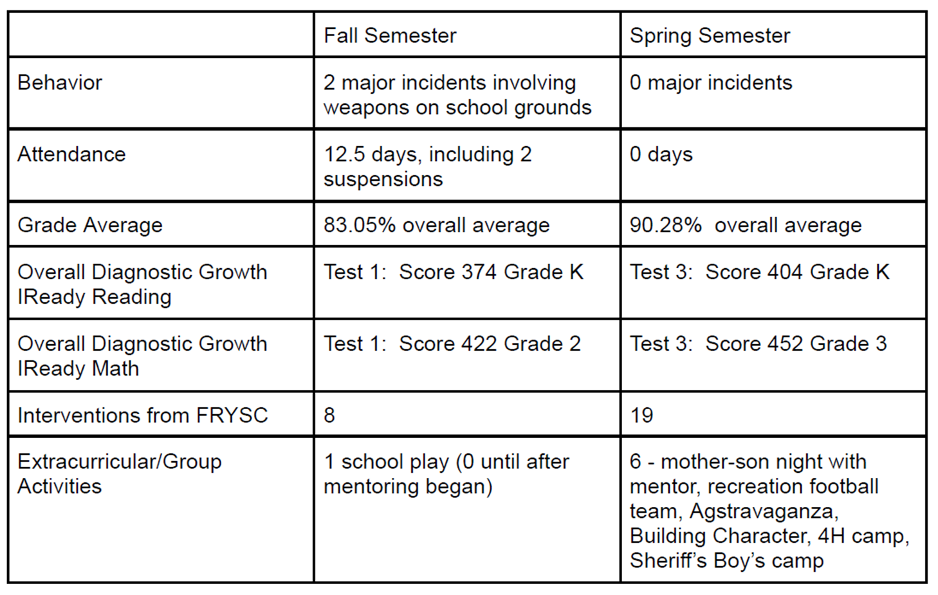

Intervention: INDIVIDUAL - College Road Trip- Summer Program, college visits for students
Category: Individual/College & Career Readiness
Submitted by: Scott High School - Youth Service Center Kenton County
College Road Trip targets 11th and 12th grade students in the Kenton County School District who are interested in attending college, but may have not have the opportunity to visit colleges or may have other barriers to admissions.
A male student from Scott High School signed up for College Road Trip in May 2024. He had many barriers to enrolling in college. He was identified as an EL student, with Spanish being the primary language spoken in his home. He would be a first generation high school graduate and college student. He was on free lunch, based on household income. He lived in a single parent household with one younger sibling. The student worked a lot at his family's restaurant in Taylor Mill. There was a period of time in his education, August 2015-November 2020, that his family returned to Mexico. A guidance counselor advocated for the student to sign up for College Road Trip.

Survey Statements | Pre-Test | Post-Test
1. I know where to get help with college admissions. | Disagree | Agree
2. I understand the differences between private colleges, public universities, and community/technical colleges. | Strongly Disagree | Neutral
3. I understand what steps to take to apply to college. | Disagree | Agree
4. I feel confident on a college/university campus. | Strongly Disagree | Strongly Agree
5. I know where I want to go for college/university. | Neutral | Agree
6. I understand all of my options for higher education. | Strongly Disagree | Agree
7. I understand the process for applying for financial aid for higher education. | Strongly Disagree | Neutral
8. I understand how my grades, test scores, extracurricular activities and field of study can impact my acceptance to college. | Neutral | Neutral

The student attended 8 of the 11 trips offered. He could not attend three trips because he needed to work. He was interested and engaged during the visits, as evidenced by asking questions of the admissions staff and tour guides and expressing interest to the YSC Coordinators during the visits. On the post survey, he indicated a change in understanding.

The student met with a guidance counselor at least once a month, during the school year, and the YSC coordinator checked in with him at least once a quarter. The student successfully completed the requirements for graduation, completed his FAFSA, and applied and was accepted to Northern Kentucky University.

Intervention: INDIVIDUAL student outcome - Parent Engagement Meeting
Category: Individual: Attendance
Submitted by: Collins Elementary FRC Boone County
The FRC Coordinator, Attendance Clerk, and Assistant Principal meet weekly to review students with attendance concerns and identify those in need of additional support. One student stood out with 13 unexcused absences and was nearing a truancy referral—an indicator of chronic absenteeism. This student had only been present 86% of the first 96 instructional days, well below the district’s expectations. The family, new to the U.S. and navigating crisis conditions in their home country, was unfamiliar with local attendance requirements. This highlighted a clear need for targeted intervention for the student and family given the number of absences and low standard achievement, specifically in Math and Reading.

The Collins Elementary Family Resource Center (FRC) Coordinator partnered with Northern Kentucky Community Action to facilitate a Parent Engagement Meeting with the student’s family. This meeting created a welcoming space to learn about the family’s unique circumstances, clarify district attendance policies, and identify barriers to consistent attendance. Together, a personalized plan was developed that included regular check-ins and wraparound supports for both the student and family. The results were immediate and significant.

Impact:

- The student’s attendance improved and was present for 99% of the remaining school year, only missing one day for illness.
- The student increased the number of reading standards met from 2 out of 17 to 5 out of 17.
- In math the student rose from his initial screening of meeting 11 of 15 standards to his final screening meeting 19 of 22 standards.

D | Intervention: INDIVIDUAL - Pathways to Thrive: Mentoring for Growth and Success  Category: Individual: Behavior/SEL/Attendance/Academic  Submitted by: 3B-Crestwood/Centerfield FRC Oldham County
D | Beginning during the 2021-2022 school year, the FRC began working closely with a student referred by their teacher due to behavior concerns. The coordinator began meeting with the student weekly as schedules permitted, initially focusing on reading books together for about 20 minutes per session. This consistent interaction helped build a trusting relationship. As rapport grew, sessions evolved to include playing games, during which the student felt comfortable discussing issues related to school and home life. Over time, activities expanded to crafts and walks, tailored to the student’s interests, fostering engagement and providing a supportive outlet.  Behavioral Improvements:  - Reduction in suspensions from multiple incidents in 2021-2022 to zero by the 2023-2024 & 2024-2025 school years.  - Decrease in office referrals and incidents requiring removal from class, indicating improved classroom behavior.  - Consistent attendance with some fluctuations, but fewer absences in recent years.  - Enhanced student openness and communication during sessions, reflecting increased trust and comfort.  Persistence to graduation Tool Results:  Using the Persistence to graduation tool, by the end of 5th grade Brooke’s indicators were all in the green category—the most favorable level—for graduation score, attendance, behavior, and stability. This data confirms Brooke’s positive trajectory and overall school success.  Summary:  The sustained mentoring relationship has positively influenced the student’s behavior and school engagement. Increased meeting frequency correlates with improved attendance and a marked decrease in disciplinary actions, reaching zero suspensions by 5th grade. The student’s willingness to share personal challenges and participate in varied activities indicates strong relational growth and a supportive environment conducive to their social-emotional development.
  Year | FRC Meetings | Absent Days | Suspensions
  2021-2022 | 21 | 3 | 2 (1 for 2 days, 1 for 1 day)
  2022-2023 | 24 | 5.5 | 1 (3 days)
  2023-2024 | 27 | 4 | 0
  2024-2025 | 29 | 3 | 0

Intervention: Adulting 101
Category: Life Skills
Submitted by: Cumberland Co HS YSC Cumberland County
Before the intervention of the Adulting 101 course, a survey was conducted among 85 students that demonstrated the needs of the students in various areas related to essential adult life skills. The results revealed a diverse range of understanding regarding key financial concepts, practical life skills, basic nutrition and safety practices.

Outcomes:
- Students felt significantly more knowledgeable about financial management, including understanding loans and budgeting.
- Many participants expressed confidence in their ability to manage their finances effectively, indicating that the course had a positive influence on their financial literacy.
- Students reported an increased understanding of basic nutrition and the importance of healthy eating habits, which contributed to their overall well-being.
- Students found practical skill lessons, such as doing laundry and basic mechanical tasks, valuable for their daily lives.
- Safety practices, both in the kitchen and in general life situations, were emphasized, and the students reported feeling more equipped to handle various safety-related challenges.
- When asked do I feel more prepared to handle everyday responsibilities after taking this course.
  - 5 - Strongly Agree: 26 (46.4%)
  - 4 - Agree: 10 (17.9%)
  - 3 - Neutral: 15 (26.8%)
  - 2 - Disagree: 5 (8.9%)
  - 1 - Strongly Disagree: 0

Intervention: Kindness Club/TOP (Teen Outreach Program)
Category: Mental Health/SEL
Submitted by: Daviess County MS YSC Daviess County
In recent years, Daviess County Public Schools has increased efforts across the district to address the growing number of students dealing with mental health issues related to trauma, bullying incidents and low self-esteem.
During the 2024-2025 fall semester, the Daviess County Middle School Youth Service Center (YSC) partnered with The TOP (Teen Outreach Program) Program Coordinator to offer the TOP program. This is a nationally recognized, evidence-based program designed to teach teens how to improve their social, emotional and life skills as well as build healthy behaviors and relationships. 23 students signed up for the “Kindness Club” utilizing the TOP curriculum, some of which were returning members who expressed the many benefits they received from being in the program during the previous school year. 7 students were incoming 6th graders already dealing with anxiety of starting a new school.

Kindness Club members began meeting every Thursday morning before school started and enjoyed breakfast together. The TOP Program Coordinator facilitated meetings with the assistance of the YSC Coordinator. Both coordinators worked collaboratively to plan activities, purchase program supplies with funds provided through the TOP Program and the DCMS YSC Grant, and most importantly, develop relationships with students. The group met 26 times throughout the school year and included curriculum specific activities such as self assessment activities, class discussion, individual and group activities, and program emphasis on the importance of giving back through volunteer work. Students were responsible for volunteering and submitting volunteer logs to the TOP Coordinator. 74% of club members completed service hours with a combined total of 720 volunteer hours. At the end of the year, students were transported to the Carmel Home to clean and to interact with and play games with the residents. Afterwards, students were transported to Chick-Fil-A for an end of the year celebration lunch and member camaraderie.

Impact:

 | Pre Survey | Post Survey
Students surveyed were able to manage their own emotions in healthy ways | 53% | 93%
Students reported they were able to get themselves to relax | 94% | 100%
Students reported they could set goals for themselves | 88% | 93%
Students stated they were confident in opening a bank account | 59% | 77%

Intervention: Girls Empowered, Motivated & Strong
Category: SEL
Submitted by: 3B-Campbellsburg/Eastern FRC Henry County
According to a 2023-2024 student survey, 82% of fourth and fifth-grade girls report low self-esteem, body image issues, anxiety about middle school transition, and problems with peer relationships and/or bullying. The *Girls Empowered and Motivated to Succeed (GEMS)* program was designed to support the social-emotional development of fifth-grade girls by addressing key areas such as self-esteem, confidence, peer relationships, social issues, peer pressure, and the transition to middle school. Through structured activities, open discussions, and skill-building exercises, participants gained tools to navigate adolescence with resilience and self-assurance.

The GEMS program served 42 out of 47 fifth-grade girls enrolled, achieving a 90% participation rate.

Outcomes:

 | Pre-Test | Post-Test | Results
Self-Esteem Growth | 46/100 | 95/100 | 106% increase in self-esteem ratings
Middle School Transition Anxiety | 93/100 | 40/100 | 57% decrease in anxiety levels related to the transition to middle school

- Teachers reported reductions in both behavioral and counseling referrals related to peer conflict among participants.
- The success of the GEMS program sparked interest across the community, inspiring others to get involved and support the mission of empowering young girls. Key community partnerships were established, significantly enhancing the program's reach and sustainability:
  - Henry County ASAP provided vital funding and resources to support program implementation and growth.
  - Henry County Public Library collaborated in delivering program activities and hosted key sessions, deepening community engagement.

TESTIMONIALS
- “I feel more confident and ready for middle school.” – GEMS Student
- “This program gave our students tools they’ll carry into the next stage of their education.” – 5th Grade Teacher
- -“My daughter now tells me she feels like she matters—and that someone would notice if she weren’t there.” – GEMS Parent
- “Attendance has always been a struggle for my daughter. We used to fight every morning about going to school. Now, she is excited to go to school." - GEMS Parent

Intervention: Upspring Small Groups - Lunch Bunch
Category: SEL
Submitted by: Dayton FRC Dayton Independent
At Lincoln Elementary School, numerous students between kindergarten and third grade have experienced or are currently experiencing homelessness as defined by the McKinney Vento Act. We partnered with UpSpring, a local nonprofit dedicated to elevating children experiencing homelessness, to create a weekly "Lunch Bunch" club for students. Students were given the DESSA (Devereux Student Strengths Assessment) Mini pretest at the beginning of the program. On the pretest, there were 2 students in the "Needs Improvement" category, 3 students in the "Typical" category, and 0 students in the "Strengths" category.

Students met with the Family Resource Center Coordinator and Ms. Meghan from UpSpring once a week on Thursdays from October to May. During the program, Ms. Meghan used the curriculum "My True Self" from the Well, another local nonprofit, to work with students on skills like self-expression, recognizing strengths, growth mindset, self-efficacy, and identifying emotions.

At the end of the program, students were reevaluated on the DESSA mini. For the post-test scores, 0 students were in the "Needs Improvement" category, 2 students were in the "Typical" category, and 3 students were in the "Strengths" category. All students improved in the social emotional skills.

A student we saw the most improvement in was V. V was one of the oldest students in the group, had a lot of traumas in her life, and scored in the "Needs Improvement" category. The Lunch Bunch gave her an opportunity to meet new students and be a role model for others. She learned more skills to help identify and manage her emotions, as well as appropriate responses.

Intervention: Lunch Bunch - social skills lunch group
Category: SEL
Submitted by: Garrard Co MS YSC Garrard County
Lunch Bunch was formed by referrals from the Garrard Co Middle School Youth Services Center ( YSC) coordinator, school counselor, principal and MTSS team (Multi-Tiered Support System). The identified need was to support students with the opportunity to learn social/emotional skills. Data was measured for three students in 6th grade and three students in 7th using pre and post tests.

The pre-test showed:
- 4 students disagree or strongly disagree with having good communication skills
- 3 disagree or strongly disagree with being a good listener
- 3 disagree or strongly disagree with knowing the difference between listening and active listening
- 2 disagree or strongly disagree that they can ask questions in conversations to gather information from the speaker
- 1 disagrees or strongly disagrees with taking turns talking, knowing the qualities of a good friend, feelings connected to their school and setting goals.

Students met with the YSC coordinator every Monday from October to May during lunch. Students created group rules and discussed different social topics or social interactions throughout the week. Topics included: setting goals, qualities of being a good friend, communication skills, how communication can impact friendship, how to take turns when having a conversation, the difference in listening and active listening, the importance of listening, how to ask questions throughout conversation, being kind, being thoughtful, setting boundaries and being respectful. Roughly 10 students throughout the school year were impacted by this program, however, only 6 students had data measured from beginning to end.

Impact:
6th grade
- All three students improved or stayed the same on good communication skills, knowing the qualities of a good friend, taking turns talking, knowing the difference between listening and active listening and feeling connected to their school.
- All three students rated “strongly agree” to having a trusted adult they can go to and knowing how to be a good friend.
- 1 student improved in 8/11 categories, 1 improved in 5/11 categories and 1 improved on 4/11 categories.

7th grade
- All three students improved in knowing the qualities of a good friend. All three students improved or stayed the same in knowing how to be a good friend, being an active listener and having a trusted adult they can go to.
- All three students strongly agree they have a trusted adult they can go to and are good active listeners.
- 1 student improved in 6/11 categories, 1 improved in 4/11 categories and 1 improved in 2/11 categories.

Feedback given by students:
- "We better do this next year!"
- "Can my friend join?"
- "We want to meet more than 1 day a week."

Intervention: Knights on the Run "The Girls Movement" - Girls Physical & Social/Emotional Health Club
Category: SEL
Submitted by: Roby/Nichols FRC Bullitt County
To address concerns about the social/emotional health of pre-teen female students, the Ruby/Nicholas FRC began a program called "Marathon Kids" that included a curriculum specifically targeted for 4th-8th grade girls called "The Girls Movement." As a school with over 65% free/reduced students, we qualified for all parts of the program for free - including a tablet and student code cards to record participants' physical activity.

The group met on Wednesdays for 8 weeks throughout October, November, and December 2024. There were 19 3rd, 4th, and 5th grade female students that chose to participate. Participants took a pre/post survey on the first and last day of the program. To fulfill the physical health component, participants chose to do 30 minutes of activity before or after school on Wednesdays. Facilitated by the FRC and school counselor, participants did warm up/cool down games and stretches and walked/jogged/ran for 20 minutes. Participants could also log any extra physical activity done at home and get their log signed by an adult. To fulfill the social/emotional health component, students participated in a group lesson led by the FRC for the last 30 minutes of the school day on Wednesdays. Lessons were provided by Marathon Kids Girls Movement curriculum and supplemented activities by the FRC. Lessons featured content on setting goals, building positive relationships, and improving self-esteem.

According to activity logs kept by the FRC, 100% of participants met their physical activity goals. Based on data pulled from IC before and after the program, 52.6% of participants had a GRAD score (based on attendance, behavior, curriculum, and stability) that increased or stayed the same. The pre/post survey results showed 62.5% of participants had scores that increased or stayed the same. Overall, 68% of participants had an increase in self-assessment scores or GRAD scores!

Intervention: Girls With Goals: 5th Grade Girls Small Group
Category: SEL
Submitted by: Sorgho Elementary FRC Daviess County
At Sorgho Elementary, the Family Resource Center (FRC) and school guidance counselor collaborated to create a small group for 5th grade girls. The Sorgho Girls Small Group aimed at supporting participants' social-emotional development before transitioning to middle school. The group was formed in response to observed needs including improving social skills, strengthening communication, building friendships, and providing a safe space for students to share openly. The ultimate goal was to promote confidence and leadership as the girls prepare for the next stage in their education.
The group was intentionally kept small, with six students meeting every Friday for six weeks. To guide the intervention, all participants completed a pre-survey. The results revealed several concerning trends. Four out of six girls reported they did not enjoy coming to school, and three said they felt uneasy talking to their teacher or expressing concerns. Additionally, five of the six girls reported low self-esteem and negative self-perception, while four shared that they had trouble making friends or socializing with peers. Four students also indicated they lacked confidence in completing their schoolwork.
Despite these challenges, the majority of the girls expressed a strong desire to grow. They stated that they wanted to learn how to make friends, boost their confidence, and develop social skills to help them succeed both academically and personally. The group was co-led by the FRC coordinator and the school counselor and featured sessions focusing on empathy, communication, conflict resolution, and leadership. Activities were interactive and reflective, allowing students to practice new skills in a safe setting.This proactive collaboration served as a valuable step in preparing these students for middle school.
The group followed the “Girls in Real Life Situations” (G.I.R.L.S.) curriculum, focusing on self-esteem, communication, goal setting, and peer relationships. Pre- and post-surveys were conducted to evaluate impact.

Outcomes:
- 5 out of 6 girls reported feeling better about attending school and looked forward to Fridays.
- 3 out of 6 girls reported feeling more comfortable seeking help from their teacher.
- 5 out of 6 girls noted an increase in self-esteem after learning new coping and social skills.
- All 6 girls reported improved peer relationships and an easier time making friends.
- At the beginning of the program, each participant set three personalized goals. By the end, 100% of the girls reported achieving all of their goals. Some also noted additional improvements such as higher grades, better peer interactions, and enhanced problem-solving skills.

This group not only provided emotional and social support, but also equipped the girls with real-life tools to aid in their transition to middle school. The success of this initiative highlights the importance of intentional, small group interventions and the positive impact of collaboration between school staff. The Sorgho Girls Small Group will continue to serve as a model for future student support programs.

Intervention: Character Education Program
Category: SEL
Submitted by: Central Elementary FRC Johnson County
Prior to implementation, it became evident that there was a significant need for the Character Education Programming at Central Elementary.. Baseline data revealed gaps in students' understanding of critical social-emotional skills. The targeted population for this program consisted of students in grades 4-6. This age group represents a critical developmental period, where students begin to form their identities, enhance their social networks, and develop essential life skills.

- 4th Grade: The focus was on coping strategies, which are vital for managing stress and emotions. The pre-test indicated that only 61% of students had some knowledge of effective coping strategies.
- 5th Grade: The emphasis was on leadership skills. The pre-test revealed that only 62% of students possessed a foundational understanding of these skills, which are essential for collaboration and responsibility.
- 6th Grade: The focus was on emotional intelligence (EQ). Alarmingly, only 39% of students showed awareness of EQ concepts, limiting their capabilities to navigate interpersonal relationships.

The Family Resource Center collaborated with special teachers and Camp Shawnee to organize and develop a schedule to provide a 5 week Character Education Program. The program included a series of structured activities, workshops, and lessons designed around three core components. The program was led by a Community Educator & camp counselors from Camp Shawnee. The FRC and support staff monitored students during the classes and provided assistance to anyone that needed help.

Outcomes:
- Post-program evaluations demonstrated notable improvements in student understanding. The impact of the Character Education Program extended beyond knowledge acquisition; significant behavioral and academic improvements were observed:
- 4th Grade Coping Strategies: Awareness of coping skills Increased from 61% to 75%
- 5th Grade Leadership Skills: Knowledge of leadership principals increased from 62% to 75%
- 6th Grade Emotional Intelligence: Awareness of EQ concepts Increased from 39% to 53%

Teachers reported a marked decrease in classroom disruptions. Students exhibited improved cooperation during group activities and increased respect for peers and teachers. The development of social-emotional skills translated into enhanced focus and engagement in classrooms. Students applied learned coping strategies effectively in real-life situations, showcased leadership qualities in group projects, and displayed heightened emotional regulation and empathy towards classmates.

Intervention: Sources of Strength
Category: SEL
Submitted by: Cumberland Co HS YSC Cumberland County
Based on student survey results, the demonstrated need before the intervention/service/activity is to increase the number of positive affirmations that students receive from their peers.

To address the low percentage of students who have received positive affirmations, the Cumberland Co High School Youth Service Center (YSC) implemented a “Sources of Strength” intervention. Students created cards with positive affirmations and taped them to Little Debbie cakes. The students then went around the school and personally distributed the cakes to their peers, while also verbally speaking kind words and affirmations.

By addressing this demonstrated need, the school can work towards improving the overall well-being, self-esteem, and sense of belonging among the student population, which can have far-reaching benefits for their academic, social, and emotional development.

Impact:

 | Pre-Intervention | Post-Intervention
Students who recall receiving positive affirmations from their peers | 11.67% | 69.33%

- This intervention helped foster a more supportive and encouraging environment within the school community, where students felt empowered to provide meaningful positive feedback to one another.
- It increased sense of belonging, self-esteem, and overall well-being among the students can have long-lasting benefits for their academic, social, and emotional development.
- The "Sources of Strength" student-led intervention, with the support of the YSC, was highly successful in addressing the demonstrated need and increasing the frequency and impact of positive peer-to-peer interactions within the school.

Intervention: All Pro Dad
Category: SEL/Family Literacy
Submitted by: Laker Cove FRC Calloway County
The All Pro Dad Program at Southwest Elementary started in 2023-24. This is a monthly meeting for fathers and father figures to eat breakfast with their child and then move to the library to do an "I am Proud of you today because..." father to child and child to father. They then listen to a short topic together and end with door prizes.
Average monthly attendance for the 2023 - 2024 school year was 12 fathers - 15 students for 7 meetings.

For the 2024 - 2025 the Laker Cove Family Resource Center received a grant from The Commonwealth Center for Fathers and Families for $5000. With this additional money for this program, the FRC was able to:
- Have a flyer professionally made that was sent home at the beginning of the school year describing the program and giving dates for all the meetings throughout the year.
- Purchase a Pull Up Banner advertising the program.
- Provide each father that attended a meeting a family centered gift that was to be used with the entire family
- Advertise and provide a Black Stone Griddle as a grand prize for the first meeting and at the end of the year - the more meetings the father attended, the more tickets they would get for the drawing.
- Allow for larger and more monthly door prizes for the fathers and kids.

The FRC coordinator is solely responsible for organization, preparing, securing school staff collaboration (lunch staff and librarian), finding monthly speakers (always use a father that has attended the program in the past) and advertising the program.

Outcomes:
Average monthly attendance for the 2024 - 2025 school year was 54 Fathers and 70 students. That is a 129% difference of attendance in the two years.

Intervention: Girls on the Run
Category: SEL/Health
Submitted by: Green River Outreach FRC McLean County
According to parent surveys, one of the top 5 issues that interfere with learning is low confidence. This survey also showed that parents need more help with teaching their children about weight, exercise, and nutrition more than they need help with healthcare. 15% of parents also believe their children are not active enough.
According to the US Census Bureau, and information provided at an Audubon Area Community Meeting for McLean County, there is a huge need for Licensed Child Care for ages 0-5, school age care, and summer child care. Other than Calhoun Elementary Afterschool, there are 0 licensed childcare facilities in McLean County.
According to the pre-test given:
- 0% percent of the team selected "Strongly Disagree" with the statement, "Sometimes I think I am no good at all"
- 12% disagree that there are a lot of good things about them
- 50% disagree they can do things as well as most other people.
- 12% strongly agree they feel useless at times
- 12% strongly disagree that they are a person of worth

To address these issues, the Family Resource Center (FRC) started a Girls on the Run group at Calhoun Elementary. The FRC Coordinator was the main coach, and one of the teachers was the assistant coach. The program was promoted at back to school events and during lunch. Girls on the Run teaches girls to set goals, be confident in themselves, and to be a good friend.

Nine girls participated, meeting weekly on Tuesdays and Thursdays for 8 weeks. Sessions would include a healthy snack, an icebreaker question and workbook time. Topics included: how to be a good friend, how to reach for the stars, how to collaborate with the community to help others, and a community service activity. Afterwards, participants would warm up and run. The girls learned to set their own pace and to push themselves with newfound confidence learned from the lessons. The entire program is based on being active, so even during the workbook activities, the girls were on their feet team building and learning to think outside the box.

After the program, most girls participated in a 5K in Louisville.

Outcomes:
- 44% now strongly disagree with the statement, "Sometimes I think I am no good at all".
- 100% agree or strongly agree that there are a lot of good things about them!
- 89% agree they can do things as well as most other people
- 0% strongly agree they feel useless at times
- 0% disagree that they are a person of worth

