Family Resource and Youth Services Centers
Alternative Funding Distribution Program Process

The Division of Family Resource and Youth Services Centers (DFRYSC) Alternative Funding Distribution (AFD) option allows school districts additional flexibility when distributing FRYSC funds within a school district. Districts could benefit from the AFD option if the cost for keeping a center open for the required 240 days is more than the funding amount the district receives from DFRYSC to operate the center. If approved to participate in AFD, a school district may combine all center funds received into a district budget and subtract all coordinator salaries and fringes, leaving an amount to be divided based on the free lunch count for each center.

PROGRAM ELIGIBILITY
- Districts must seek approval from the DFRYSC after discussion with the assigned DFRYSC Regional Program Manager (RPM), in order to participate in AFD.
- It is the expectation of the FRYSC district contact to communicate the effect of AFD with all coordinators within the district prior to submitting the request for approval.
- Prior to submission, all FRYSC Coordinators must be on a defined salary scale in accordance with district policy. The school district must maintain uniform educational requirements across all FRYSC positions. All district coordinators shall be enrolled in either KTRS or CERS. Dual participation in both retirement systems is prohibited due to inequities in required contribution rates.
- AFD approval is valid for one year only. The Superintendent or designee must submit a request including detailed justification on school letterhead for participation annually to the DFRYSC. Please reference the example included.
_______ County Public Schools requests approval to participate in the Alternative Funding Distribution (AFD) for the 2026-2027 school year.
Purpose for Alternative Funding Distribution:
Without the use of the AFD, two of our centers will not be able to employ a full-time coordinator and several centers will struggle to maintain programming. The AFD will allow our district to meet the growing and ever-changing needs of our students, families, and community with flexibility. We greatly appreciate your consideration of this request.
Superintendent Signature

SUBMISSION PROCESS
- The following must be submitted to the Regional Program Manager by (Date is subject to change and Districts will be notified 4-6 weeks before due date):
  - A Letter of Intent to participate in the AFD process on district letterhead
  - A spreadsheet detailing salary and fringe for each coordinator and operational budget for each center (see “Calculating the Operational Funds” section below for additional spreadsheet details).
- The DFRYSC Director will approve or deny requests and send notice directly to the FRYSC district contact and RPM with copy uploaded to the DFRYSC data system.
NOTE:
- The DFRYSC may request a copy of the FRYSC district salary schedule.
- Coordinators should prepare individual center budgets after the AFD request has been processed.

CALCULATING THE OPERATIONAL FUNDS
- To calculate the new district operational budget, deduct the sum of all coordinator salaries and fringes from the total district allocation of FRYSC Funds. Example:
School | 2026-27 Salary and  Fringe | 2025-26  Free Lunch | $170.05 per  Student
Western Elementary | $40,195 | 237 | $40,301.85
Northern Elementary | $34,603.68 | 165 | $28,058.25
Eastern Middle | $42,165 | 401 | $68,190.05
Southern High School | $39,567 | 395 | $67,169.75
TOTALS | $156,530.68 | 1198 | 203,719.90

2027 allocation: $203,719.90
-
2027 Salary & Fringe: $156,530.68
District Operational Budget: $47,189.22
- To calculate the per pupil average cost, divide the free lunch count for all free lunch students enrolled at schools served by FRYSC into the remaining balance. Example:
District Operational Budget: $47,189.22
2025-26 Free Lunch Count: 1,198

$47,189.22/ 1,198 = $39.39 is the new per pupil average cost

- To calculate the operational budget for each center, multiply the center’s total number of free lunch students by the new per pupil average cost. Example:
School | 2026-27  Salary and Fringe | 2025-26  Free Lunch | $170.05 per Student | Center Op. Budget Figured at $35 per  student
Western  Elementary | $40,195 | 237 | $40,301.85 | 237*39.39=  $9,335.43
Northern Elementary | $34,595 | 165 | $28,058.25 | 165*39.39=  $6,499.35
Eastern  Middle | $42,165 | 401 | $68,190.05 | 401*39.39=  $15,795.39
Southern High School | $39,567 | 395 | $67,169.75 | 395*39.39=  $15,559.05
TOTALS | $156,530.68 | 1,189 | $203,719.90 | $47,189.22

- Once all calculation have occurred, districts are required to submit a spreadsheet on the FRYSC AFD Budget Worksheet.
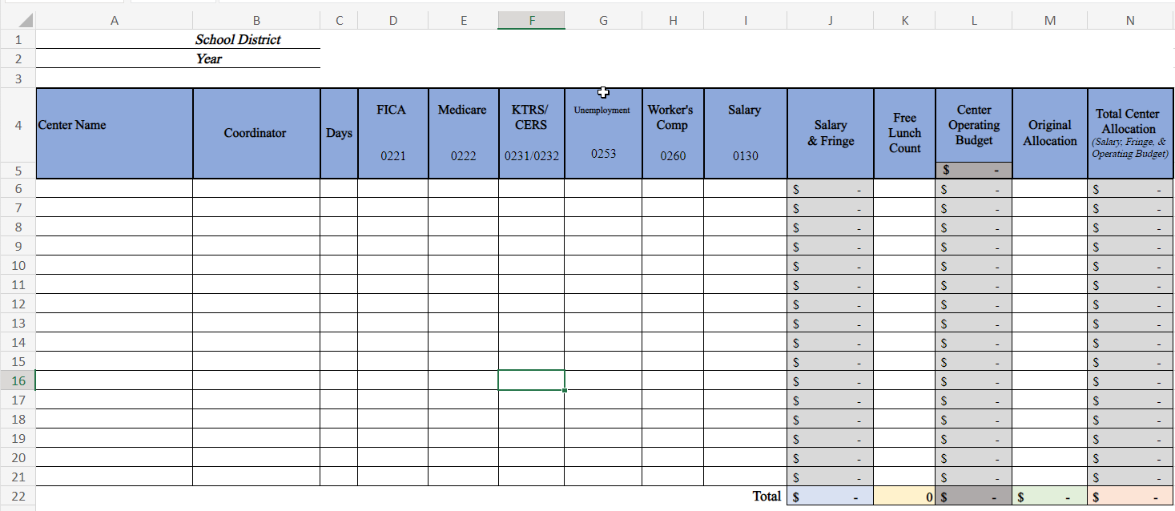

BUDGET TRACKING, REVISION, AND CARRY FORWARD REMINDERS
- Each coordinator must keep budget balance sheets (including salary and fringes) based on the last approved district AFD Spreadsheet. Each center should receive a monthly detailed journal Munis report from their district that shows salary and fringes and all budgeted line items.
- Any realized savings from coordinators’ salaries and fringe (i.e., new hire, FMLA, unpaid leaves) must be redistributed to all centers. This should be reviewed at mid-year by January 15th and within 30 days of District deadline for Purchase Order Request/Encumbrances.
- All centers in AFD districts are required to follow the budget amendment process on FRYSC Counts when making a budget change.
- State general funds cannot “carry forward” to the next year. Therefore, if any FRYSC funds remain unspent, that amount stays at the district the amount will be subtracted from the next fiscal year’s revenue.
- Unspent funds in one center cannot offset over spent funds at another. Each center is responsible for tracking the funds reflected in the last budget approved by the Regional Program Manager.

EXAMPLE: A center coordinator has extended medical leave and the salary line item is decreased by $2000. These funds must be redistributed, using the process above to calculate operational funds, to all centers in the district. The funds cannot be absorbed by one particular center in the district. Changes to the AFD spreadsheet must be approved by the RPM before revisions are made to Munis and center budgets.

