Provider Portal Tips:

- The My Apps landing page displays once you’ve successfully logged onto the KY Online Gateway.
- KICCS Provider Portal will be listed for anyone with approved KICCS Portal roles.
- See the KICCS Portal User Guide on the KICCS Provider Portal Launch Site for instructions on requesting roles.

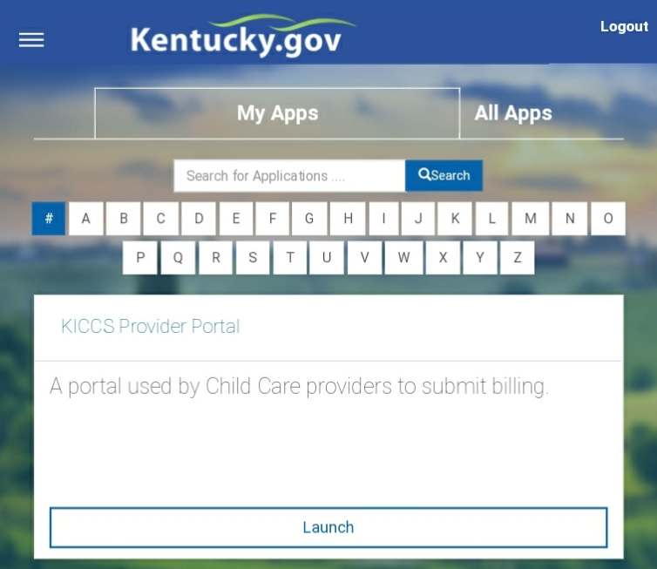

- All CLR#’s associated with the account display in the Assigned Providers grid.
- Contact Division of Child Care if an expected CLR# is not listed.

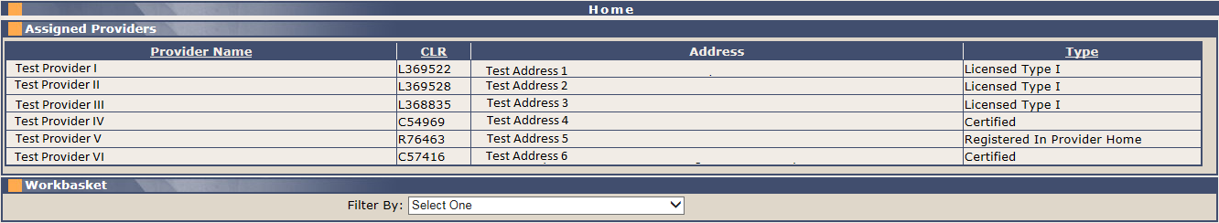

- The menu items on the left are used to navigate to different pages within the Provider Portal.
- The specific options are determined by the user’s approved roles.
- A provider must be selected prior to clicking View/Process PBFs, Print PBFs, Renewal/Change App, or any of the All STARS options.

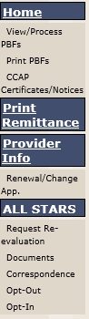

- A Workbasket feature will display below the Assigned Providers grid for users that also have the Renewal/Change App and/or All STARS menu option(s).
- Click on the Filter By drop-down menu to view/select a Workbasket option
- Results will display in a grid with a link to the applicable page

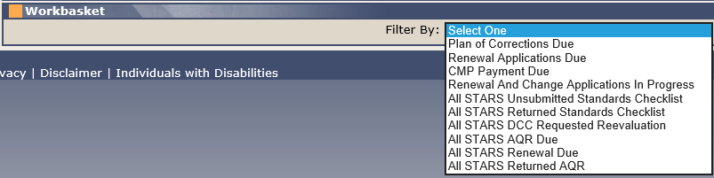

General Tips:

- The Back and Forward buttons in the browser toolbar should not be used in the Provider Portal.
- The screen may refresh or ‘flash’ when clicking menu items or action buttons, such as Print. There may be a delay before the new screen/view loads, depending on your connection or processor speed.

- Don’t double-click the Save button on any screen.

- Status and error messages will display on a page, either at the top of the page or beside the field in which an error exists. Green messages notify that an action was successful. Red messages and/or asterisks denote missing, invalid, or improperly formatted data.

- Accepted date formats are: MM/DD/YYYY or MM/DD/YY or MM/YYYY

- Below are the minimum user system requirements for the KICCS Provider Portal. Performance and compatibility issues may exist when operating outside of these parameters. Chrome is the suggested browser.
- Pentium i5 2.20 GHz or faster
- 4GB RAM or higher
- Display Resolution of 1024 x 768
- Latest browser version
- Windows 7 SP1 or higher
- Network connection speed 100M bps or faster
If you need assistance with these tips, please contact the KICCS HelpDesk.
Local: 502-564-0104 Option 6
Toll Free: 866-231-0003 Option 6
Email: CHFS.KICCSHelpDesk@ky.gov

