How to Complete a
Significant Change

PRO has just completed your annual LOC reassessment and provided you with a list of individuals that should have had a significant change. How should you proceed?

Being directed to complete a significant change does NOT mean that the person will necessarily meet criteria for significant change and need an evaluation.

Significant Changes can be completed for two reasons:
- To document a change in the individual’s diagnosis or other care needs; or
- To request a review of new information to see if the individual now meets PASRR criteria, a current PASRR individuals needs a change in specialized services or level of care.

How do you know which one it is?
- Take each question on the significant change screen and ask yourself if all parts of the question are met with the information you have.
- The first 3 categories in section 1 are for individuals that are not currently identified as PASRR but need to be evaluated to determine if they meet PASRR criteria.

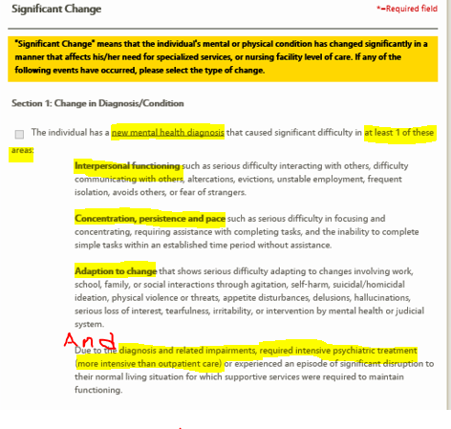
Significant Change example below:

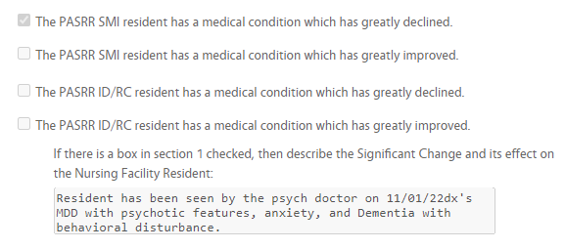

This referral does not meet significant change criteria because there is no psychiatric hospitalization related to the diagnosis.

- For Severe Mental Illness you must meet all 3 criteria to check the box:
  - A new mental health diagnosis; and
  - That diagnosis affects at least one of the following: interpersonal functioning; concentration, persistence and pace; or adaption to change; and
  - Due to the diagnosis and related impairment required intensive psychiatric treatment (inpatient) or a significant disruption to their normal living situation.
- If the person doesn’t meet all 3 then don’t check the box.
- Here is an example of one that would NOT meet criteria for a significant change:

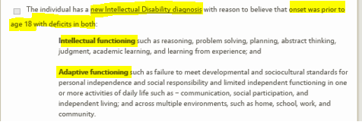
- For Intellectual Disability you must have a newly found diagnosis of ID or a newly validated diagnosis of ID and the individual has deficits in both intellectual functioning and adaptive functioning.
- If the person doesn’t meet this criteria then don’t check the box.

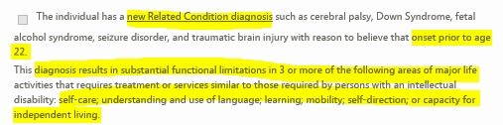
- For Related Condition you must have a newly found Related Condition diagnosis or a newly validated Related Condition diagnosis that meets the Related Condition criteria: substantial functional limitations similar to someone with ID in 3 or more of the following areas, self-care, understanding and use of language, learning, mobility, self-direction or capacity for independent living.
- If the individual doesn’t meet this criteria then don’t check the box.
- The next 4 categories are for individuals that are already identified as PASRR but have either had a significant improvement or significant decline in their medical condition that would affect their specialized services or their level of care.

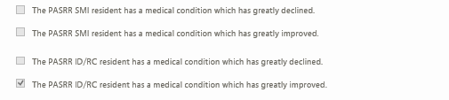
- If none of these apply then skip.
- If you have marked any of the above boxes (SMI, ID, RC or change in medical condition) then please explain in detail the change and how it has affected the resident.


- If you have marked any of the above boxes and provided an explanation then you will mark “Yes” in the section below (section 2).
- If you haven’t marked any of the above boxes then you will mark “No” in the section below (section 2). If you mark “No” please describe the change and why it doesn’t meet PASRR referral criteria in the box provided.

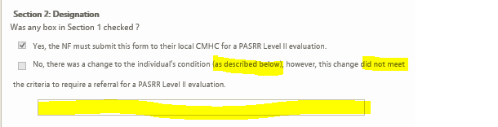

If you have questions please reach out to your local CMHC that completes PASRR evaluations for your facility.

