Community Mental Health Center (CMHC) Point People
Deaf and Hard of Hearing Services
Each Community Mental Health Center (CMHC) has received training on screening for and meeting the language and communication access needs of people who are Deaf or Hard of Hearing. Seven Counties and New Vista each have a therapist and case manager who can provide services directly in American Sign Language (ASL) either in person or via telehealth.
Each CMHC is required to provide language access to its full range of services. Point People in each region can help remove barriers such as scheduling interpreters. Please see below for their contact information. To find the correct CMHC by county, please go to https://www.chfs.ky.gov/agencies/dbhdid/Pages/cmhc.aspx.
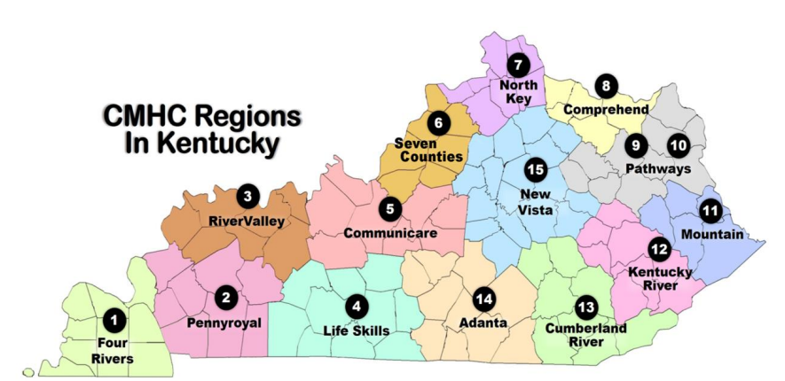
Region # | Region Name | Contact Person | Email Address
1 | Four Rivers | Megan Champy | mchampy@4rbh.org
2 | Pennyroyal | Michael Daniel | mdaniel@pennyroyalcenter.org
3 | River Valley | Mary Kay Lamb  Megan Yeckering | marykaylamb@rvbh.com  Yeckering-megan@rvbh.com
4 | Lifeskills | Londa Stockton | lstockton@lifeskills.com
5 | Communicare | Sylvia K. Binder | skprice@communicare.org
6 | Seven Counties | Kourtnee Seymour | kseymour@sevencounties.org
7 | North Key | Jennifer Miller  Paula Brun | jmiller@northkey.org  Paula.Brun@northkey.org
8 | Comprehend | Mary McDaniel | mmcdaniel@comprehendinc.org
9/10 | Pathways | Shanalee Branham  Amy Workman | Sbranham@pathways-ky.org  aworkman@pathways-ky.org
11 | Mountain | Kimberly Sparks | Kimberly.Sparks@mtcomp.org
12 | Kentucky River | Autumn Melton  Vicie Pelfrey | Autumn.Melton@krccnet.com  Vicie.Pelfrey@krccnet.com
13 | Cumberland River | Greta Baker | Greta.Baker@crccc.org
14 | Adanta | Kymberly Dykes  Kenny Garvin | kdykes@adanta.org  kgarvin@adanta.org
15 | New Vista | Anna Duncan | Anna.Duncan@newvista.org

Updated 7/2/26

