

Social Security Disability In Kentucky
The Evolution of Dependence
1980 - 2015

FOREWORD

This work is offered as a labor of love on behalf of all Kentuckians. We hope its legacy will contribute to a future wherein we all live together on our feet rather than survive on our knees.

W. Bryan Hubbard
Acting Commissioner, DIS

Table of Contents

Methods and Terms 5
I. Program History and Description 8
II. Enrollment and Economic Evolution (1980 – 2015) 11
III. Points of Award 14
IV. Awarded Conditions 14
V. Childhood Enrollment 18
VI. Pharmacology of Dependence 19
VII. Dependence and Permanence 22
VIII. Dependence and Mortality 23
IX. Drivers of Dependence 23
X. Obstacles to Change 25
XI. First Steps for Radical Reform 28
XII. Conclusion 32
XIII. Credits 44
XIV. Appendices 46
Appendix A - Case Studies 46
Generational Dependence 46
The “Lost Folder” Policy in Action 87
Adjudication Absurdity 88
How to Think Like an ALJ 92
15 Steps to SSI 93
Appendix B – OIG Audit Report 95
Appendix C - Raw Data Tables 127
Claims and Allowance Rates 128
Table 1 – Initial Determinations, Kentucky (2015) 129
Table 2 – Reconsideration Determinations, Kentucky (2015) 129
Table 3 – Combined Initial and Reconsideration Determinations, Kentucky (2015) 130
Table 4 – Net Allowance Rate, Kentucky and Nation (2015) 130
Table 5 - Award Data for ALJ’s Processing Kentucky Claims (FY 2010) 131
Table 6 - Award Data for ALJ’s Processing Kentucky Claims (FY 2015) 134
Table 7 - Title II Disabled Workers Claims, Kentucky 136
Economic Factors 137
Table 8 – Average Monthly Benefit Payments (In Dollars) 138
Table 9 – Disability Payments vs. Government Expenditures (Nation) 139
Table 10 – Poverty Rate 139
Table 11 – Employment Numbers, Kentucky (Age 16 or Older) 140
Table 12 – Employment Numbers, Nation (Age 16 or Older) 141
Table 13 – Labor Force Participation Rates (Age 16 or Older) 142
Table 14 – Workplace Accidents in Kentucky 143
Conditions of Beneficiaries 144
Table 15 – Top Five Physical Conditions Per Year (As Percentage of Total) 145
Table 16 – Top Five Mental Conditions Per Year (As Percentage of Total) 146
Table 17 – Top Five Overall Conditions Per Year (As Percentage of Total) 147
Table 18 –Title XVI Disabled Child Beneficiaries, By Condition (Nation) 148
Population and Enrollment 149
Table 19 – Population for Kentucky, 1980-2015 150
Table 20 – Population for Nation, 1980-2015 150
Table 21 – Kentucky’s Ranking for Disabled Beneficiaries 151
Table 22 – Disabled Beneficiaries in Kentucky 152
Table 23 – Disabled Beneficiaries in the Nation 153
Table 24 – Disabled Beneficiaries in Kentucky, By County (2001) 154
Table 25 – Disabled Beneficiaries in Kentucky, By County (2005) 158
Table 26 – Disabled Beneficiaries in Kentucky, By County (2010) 162
Table 27 – Disabled Beneficiaries in Kentucky, By County (2015) 166
Table 28 – County Rankings for Title II Disabled Workers, Kentucky 170
Table 29 – County Rankings for Title XVI Disabled Beneficiaries, Kentucky 175
Table 30 – County Rankings for Total (Title II & Title XVI) Disabled Beneficiaries, Kentucky 180
KASPER Dosage Rates 185
Table 31 – KASPER Psychotropic Dosages Per Capita (Kentucky, All Ages) 186
Table 32 – KASPER Opioid Dosages Per Capita (Kentucky, All Ages) 191
Table 33 – KASPER Combined Psychotropic and Opioid Dosages Per Capita (Kentucky, All Ages) 196
Table 34 –KASPER All Controlled Substances Per Capita (Kentucky, All Ages) 201
Medicaid Dosage Rates (All Ages) 206
Table 35 –Psychotropic Dosages to Title XVI Disabled Beneficiaries Receiving Medicaid in 2000 (Kentucky, All Ages) 207
Table 36 –Psychotropic Dosages to Title XVI Disabled Beneficiaries Receiving Medicaid in 2005 (Kentucky, All Ages) 210
Table 37 – Psychotropic Dosages to Title XVI Disabled Beneficiaries Receiving Medicaid in 2010 (Kentucky, All Ages) 213
Table 38 –Psychotropic Dosages to Title XVI Disabled Beneficiaries Receiving Medicaid in 2015 (Kentucky, All Ages) 216
Table 39 – Opioid Dosages to Title XVI Disabled Beneficiaries Receiving Medicaid in 2000 (Kentucky, All Ages) 219
Table 40 – Opioid Dosages to Title XVI Disabled Beneficiaries Receiving Medicaid in 2005 (Kentucky, All Ages) 222
Table 41 – Opioid Dosages to Title XVI Disabled Beneficiaries Receiving Medicaid in 2010 (Kentucky, All Ages) 225
Table 42 – Opioid Dosages to Title XVI Disabled Beneficiaries Receiving Medicaid in 2015 (Kentucky, All Ages) 228
Medicaid Dosage Rates (Adults) 231
Table 43 – Psychotropic Dosages to Title XVI Disabled Beneficiaries Receiving Medicaid in 2000 (Kentucky, Ages 18-64) 232
Table 44 – Psychotropic Dosages to Title XVI Disabled Beneficiaries Receiving Medicaid in 2005 (Kentucky, Ages 18-64) 235
Table 45 – Psychotropic Dosages to Title XVI Disabled Beneficiaries Receiving Medicaid in 2010 (Kentucky, Ages 18-64) 238
Table 46 – Psychotropic Dosages to Title XVI Disabled Beneficiaries Receiving Medicaid in 2015 (Kentucky, Ages 18-64) 241
Table 47 – Opioid Dosages to Title XVI Disability Beneficiaries Receiving Medicaid in 2000 (Kentucky, Ages 18-64) 244
Table 48 – Opioid Dosages to Title XVI Disability Beneficiaries Receiving Medicaid in 2005 (Kentucky, Ages 18-64) 247
Table 49 – Opioid Dosages to Title XVI Disability Beneficiaries Receiving Medicaid in 2010 (Kentucky, Ages 18-64) 250
Table 50 – Opioid Dosages to Title XVI Disability Beneficiaries Receiving Medicaid in 2015 (Kentucky, Ages 18-64) 253
Medicaid Dosage Rates (Children) 256
Table 51 – Psychotropic Dosages to Title XVI Disabled Beneficiaries Receiving Medicaid in 2000 (Kentucky, Ages 0-17) 257
Table 52 – Psychotropic Dosages to Title XVI Disabled Beneficiaries Receiving Medicaid in 2005 (Kentucky, Ages 0-17) 260
Table 53 – Psychotropic Dosages to Title XVI Disabled Beneficiaries Receiving Medicaid in 2010 (Kentucky, Ages 0-17) 263
Table 54 – Psychotropic Dosages to Title XVI Disabled Beneficiaries Receiving Medicaid in 2015 (Kentucky, Ages 0-17) 266
Table 55 – Opioid Dosages to Title XVI Disabled Beneficiaries Receiving Medicaid in 2000 (Kentucky, Ages 0-17) 269
Table 56 – Opioid Dosages to Title XVI Disabled Beneficiaries Receiving Medicaid in 2005 (Kentucky, Ages 0-17) 272
Table 57 – Opioid Dosages to Title XVI Disabled Beneficiaries Receiving Medicaid in 2010 (Kentucky, Ages 0-17) 275
Table 58 – Opioid Dosages to Title XVI Disabled Beneficiaries Receiving Medicaid in 2015 (Kentucky, Ages 0-17) 278
Appendix D – Maps 281
Beneficiary Maps 282
Map 1 – Estimated Title II Disabled Workers in 2015, By County (Kentucky) 283
Map 2 – Estimated Title XVI Disability Beneficiaries in 2015, By County (Kentucky) 284
Map 3 – Estimated Total Disability Beneficiaries in 2015, By County (Kentucky) 285
KASPER Maps 286
Map 4 – KASPER Psychotropic Usage in 2015, By County (Kentucky) 287
Map 5 – KASPER Opioid Usage in 2015, By County (Kentucky) 288
Map 6 – KASPER Combined Opioid and Psychotropic Usage in 2015, By County (Kentucky) 289
Map 7 – KASPER Controlled Substances Usage in 2015, By County (Kentucky) 290
Medicaid Maps (Adults) 291
Map 8 – Medicaid Psychotropic Usage in 2015 for Ages 18-64, By County (Kentucky) 292
Map 9 – Medicaid Opioid Usage in 2015 for Ages 18-64, By County (Kentucky) 293
Map 10 – Medicaid Combined Opioid and Psychotropic Usage in 2015 for Ages 18-64, By County (Kentucky) 294
Medicaid Maps (Children) 295
Map 11 – Medicaid Psychotropic Usage in 2015 for Ages 0-17, By County (Kentucky) 296
Map 12 – Medicaid Opioid Usage in 2015 for Ages 0-17, By County (Kentucky) 297
Map 13 – Medicaid Combined Opioid and Psychotropic Usage in 2015 for Ages 0-17, By County (Kentucky) 298

Methods and Terms

- Beneficiary numbers have been provided by the Social Security Administration (SSA). Beneficiaries counted in this study are limited to individuals who have been found to be disabled as a result of a physical or mental condition, or a combination of both. Beneficiary numbers do not include family members who also receive payments but have not been found to be disabled.

- Net award percentage is calculated as the percentage of all claims that result in an award at all levels of review – DDS (Initial and Reconsideration) and ODAR during a calendar year. This percentage does not include decisions made at the Appeals Council or Federal Court levels.

- KASPER was calculated on a statewide and county per capita basis by dividing the total number of doses of controlled substances dispensed to all individuals in the state (or county) by the population of the state (or county). Population estimates of each county were obtained from data provided by the United States Census Bureau.

- Title XVI Medicaid data was calculated on a statewide and county per capita basis by dividing the total number of doses of controlled substances (opioid and psychotropic) dispensed to only SSI (Title XVI) disabled beneficiaries receiving Medicaid in the state (or county) by the number of SSI (Title XVI) disabled beneficiaries receiving Medicaid.

- County disability percentages represent an estimated percentage of the county’s population who are receiving any type of Social Security disability benefit (Title II, Title XVI or both). The county disability percentages were calculated using the following numbers:
- the estimated total number of beneficiaries per county, divided by
- the total population for the county.

Item (a) above is approximately equivalent to:
- the number of Title II disabled workers, plus
- the number of Title II childhood disability beneficiaries, plus
- the number of Title II disabled widow(er)s, plus
- the number of Title XVI disabled beneficiaries, minus
- the number of concurrent beneficiaries who are receiving more than one type of benefit (subtracted to avoid double-counting).

Only the following data was available per county:
- the number of Title II disabled workers, and
- the number of Title XVI disabled beneficiaries.

The following data was not available per county:
- the number of Title II childhood disability beneficiaries,
- the number of Title II disabled widow(er)s, and
- the number of concurrent beneficiaries who are receiving more than one type of benefit.

Therefore, the number of total disabled beneficiaries per county was estimated as follows:

- The sum of Title II disabled workers and Title XVI beneficiaries for each county were divided by the sum of Title II disabled workers and Title XVI beneficiaries for the state. This gives a percentage allocation per county.

- It was assumed that the allocation of total beneficiaries per county would be similar to the allocation of Title II disabled workers and Title XVI disabled beneficiaries per county (although it is recognized that there could be some minor variation by county). Therefore, the percentage allocation for each county (obtained in step 1) was multiplied by the known total number of beneficiaries in the state to obtain an estimated number of total beneficiaries per county.

- Administrative Law Judge (ALJ)
A judge who presides at hearings and issues decisions for the Office of Disability Adjudication and Review.

- Continuing Disability Review (CDR)
A periodic review of the beneficiary’s medical condition(s) to determine if there has been sufficient medical improvement so that the individual is no longer disabled or is able to return to work.

- Cooperative Disability Investigations (CDI) Units
Agencies which investigate suspicious or questionable Social Security disability claims.

- Disability Determination Services (DDS)
The state agency responsible for making initial and reconsideration determinations about whether an individual is disabled or continues to be disabled under the law.

- Disability Hearing Unit (DHU)
A separate DDS unit which holds hearings for beneficiaries whose benefits have been ceased.

- Fiscal Year (FY)
For the federal government, this runs from October of the current year through September of the next calendar year.

- Kentucky All Schedule Prescription Electronic Reporting (KASPER)
A system which tracks controlled substance prescriptions dispensed in Kentucky.

- Medical Improvement Review Standard (MIRS)
A legal standard enacted in 1984 which states there must be sufficient medical improvement in order to terminate benefits during a continuing disability review (CDR). Prior to implementation of the MIRS standard, benefits could be terminated if the beneficiary no longer met the current disability criteria. Implementation of the MIRS standard in 1984 resulted in a large decrease in the number of terminations.

- Office of Disability Adjudication and Review (ODAR)
The SSA office responsible for holding hearings and issuing decisions on disability claims denied at both the initial and reconsideration levels.

- Office of Inspector General (OIG) of SSA
A federal office responsible for detecting “fraud, waste and abuse” within the SSA. OIG illustrates problems and provides solutions to both SSA and Congress.

- Opioid
“A compound resembling opium in addictive properties or physiological effects.”

- Program Operations Manual System (POMS)
A comprehensive set of instructions used to guide programs administered by the SSA.

- Psychotropic Medication
“Relating to or denoting drugs that affect a person’s mental state.”

- Redacted
Removal of information that could be used to obtain the identity of specific individuals involved in the case studies. This information is commonly referred to as personally identifiable information (PII).

- Substantial Gainful Activity (SGA)
An amount established by the SSA to determine whether an applicant is engaging in significant work activity. The SSA provides a monthly amount which is updated yearly. For example, the monthly amount for 2015 is $1,090.

- Social Security Disability Insurance (SSDI)
A federal program which pays (Title II) benefits to a disabled individual and certain members of his/her family if the individual is “insured”, meaning that the individual has worked long enough and paid enough in Social Security taxes to gain coverage.

- Supplemental Security Income (SSI)
A federal program based on financial need which pays (Title XVI) benefits to a disabled or aged individual.

- Title II Beneficiary
An individual who is receiving benefits from the SSDI (Title II) program.

- Title XVI Beneficiary
An individual who is receiving benefits from the SSI (Title XVI) program.

I. Program History and Description

A Glance at the History of the Disability Program
In his article titled “Social Security and the ‘D’ in OASDI: The History of a Federal Program Insuring Earners Against Disability”, John R. Kearney provides the following history of the disability insurance program:
Today it is widely recognized that the acronym "OASDI" refers to the Old-Age, Survivors and Disability Insurance program of the Social Security Administration (SSA). However, the program that began in 1935 originally did not contain provisions for disability insurance. In fact, the "D" in OASDI was implemented more than 20 years later, on August 1, 1956. This is the date that President Dwight D. Eisenhower signed into law the 1956 Amendments to the Social Security Act establishing the Social Security Disability Insurance program. At first, the program provided monthly benefits only to disabled workers between the ages of 50 and 65 who met certain requirements for insured status. Even though the program later significantly expanded its coverage, its implementation in 1956 represented the historic culmination of an effort by Social Security planners that began in the 1930s.
….
There had been much resistance to the introduction of disability benefits. Major concerns then underscore the same operational issues that challenge the program today: the difficulty in determining whether a disabled individual has lost the capacity to work and the concern over managing program costs. Opponents of implementing cash disability payments had legitimate concerns, and Social Security planners recognized this. However, historically, as well as currently, planners believed that problems encountered were surmountable and that the need for disability benefits was so great that the federal government had an obligation to address the issue.
Mr. Kearney continues his discussion of the program by delving into the recommendations of the 1948 Advisory Council on Social Security. The Council provided continued support for the disability program and recommended extending benefits to those with a permanent disability.Error: Reference source not found However, two members of the council wrote a memorandum of dissent. Those two authors were M. Albert Linton, an executive with Provident Mutual Life Insurance Company, and Marion B. Folsom, treasurer of the East Kodak Company.
The authors of the memorandum of dissent maintained that it was virtually impossible to evaluate total disability when a person is determined to prove that he or she is disabled in order to obtain a guaranteed income from the government. They also claimed that cash disability benefits were a deterrent to rehabilitation and, once on the disability rolls, most people would prefer to remain there. They predicted that the system would break down during a period of high unemployment, just as private disability insurance programs had been overwhelmed during the 1930s.

The following is Mr. Kearney’s timeline of the program’s development:
1954—Social Security Amendments of 1954 establish the disability "freeze."
1956—Monthly benefits are provided to disabled workers aged 50–64 and to disabled children (aged 18 or older) of retired or deceased workers.
1958—Benefits are established for the dependents of disabled workers.
1960—The requirement that a worker must be at least 50 years of age to be eligible for disability benefits is eliminated.
1968—Benefits for disabled widow(er)s aged 50 or older are enacted.
1972—Medicare coverage is extended to Disability Insurance beneficiaries after 24 months of entitlement, and the Supplemental Security Income program is established.
1977—A new benefit formula is introduced that "decouples" the cost-of-living adjustment from wage increases in an effort to control spiraling Social Security program costs.
1980—Social Security Amendments of 1980 place a cap on family benefits to disabled workers, require periodic continuing disability reviews, and create work incentives.
1984—Congress requires the development of new criteria for adjudicating claims involving mental impairments and establishes a "medical review standard" for making determinations on continuing disability reviews.
1999—The Ticket to Work and Work Incentives Improvement Act of 1999 is enacted, enabling disability beneficiaries to seek employment services and other support services needed to help them reduce their dependence on cash benefits.

A Closer Look at the SSA’s Two Disability Programs

The SSA describes the two disability programs as follows:
The Social Security Administration administers two of the largest disability programs in the United States, and perhaps the world: the Social Security Disability Insurance (DI) program and the Supplemental Security Income (SSI) disability program…. Both programs have grown substantially in cost and number of participants, although the level of growth has varied from time to time and both programs have had periods of contraction, mainly in the early 1980s.
The programs share a common definition of disability for adults: the inability to engage in substantial gainful activity based on a medically determinable impairment that is expected to last at least 12 months or result in death. Both programs also consider blindness when defining disability. The SSI children's benefit category has a different definition of disability.
Other than the common definition, the programs differ in many respects. Social Security disability benefits are an earned right. Individuals must have worked in employment covered by Social Security for a specified time to be insured for benefits. However, disabled adult children and disabled widow(er)s may qualify on the record of a parent or spouse. There is no means or resource-testing of Social Security benefits, although there are limitations on earned income in some situations. Social Security benefits are funded by a dedicated payroll tax paid by the worker and the worker's employer and by taxes paid by a self-employed person. SSI benefits are intended to alleviate poverty and are means-tested. There is no insured status or prior-work requirement for SSI, and the program is funded from general revenues rather than from a dedicated tax.

Social Security Disability contains two beneficiary classes - Title II and Title XVI beneficiaries.

- Title II beneficiaries must meet the following eligibility requirements:
- Have worked long enough to become insured for Social Security benefits,
- Be younger than full retirement age,
- Have filed an application for benefits,
- Be blind or disabled per Social Security rules, and
- Have served a 5-month waiting period (except for certain exemptions)

- Title XVI beneficiaries must meet the following criteria:
- Be blind or disabled per Social Security rules,
- Reside in one of the 50 States, the Northern Mariana Islands, or the District of Columbia, or be the child of a military parent assigned to permanent duty outside of the United States,
- Be a United States citizen or national who meets the applicable alien status or residency requirements,
- Have income and resources below specified limits, and
- Have filed an application

The average monthly Title II disabled worker benefit payment is $1,166 per month while the average monthly Title XVI benefit payment is $578 per month.

Total federal expenditures for FY 2015 equaled $3.7 trillion. The Social Security disability program paid out benefits totaling $192.3 billion. As of FY 2015, Social Security disability comprised 5.2% of federal expenditures.

Title XVI beneficiaries are automatically enrolled in Medicaid which typically takes effect on the date of the application or as early as three months prior to the date of application. Kentucky’s General Fund is directly impacted by Title XVI enrollment through its Medicaid expenditures. Title XVI Medicaid expenditures are split on an approximately 70/30 basis, with Kentucky picking up 30% of direct Title XVI Medicaid costs. In 2015, Kentucky’s Medicaid expenditures equaled $7,360,430,465.56.Error: Reference source not found Title XVI Medicaid expenditures for blind and/or disabled individuals under age 65 were $2,040,788,670, 27.7% of Kentucky Medicaid expenditures.

II. Enrollment and Economic Evolution (1980 – 2015)

The population of the United States has grown from 226,542,199 in 1980 to 320,896,618 in 2015, an increase of 42%. In 1980, Kentucky had 3,660,324 people. As of 2015, its population had grown 21% with 4,424,611 of individuals living within the state. Between 1980 and 2015, Title II enrollment increased 212% across the country. Title II enrollment in Kentucky increased by 257%. U.S. Title XVI enrollment increased 210%. Kentucky’s Title XVI enrollment increased by 240%.Error: Reference source not found Combined Title II and Title XVI enrollment saw an increase of 211% nationally and 249% within Kentucky.

In 2015, the U.S. Labor Force Participation rate stood at 62.7 % while Kentucky’s was 57.1%. The country’s poverty rate was 13.5 % in 2015 while Kentucky’s was 19.5%, an increase for Kentucky of 0.6% since 1980. In 2015, there were 93,671,000 Americans not working, nor looking for work. These people comprise 37% of the country’s working age population, defined as individuals age 16 or older. In Kentucky 1,475,300 people of working age were neither working nor looking for work, 43% of a working age population of 3,440,966.

Enrollment and Economics in Kentucky
(1980-2015)

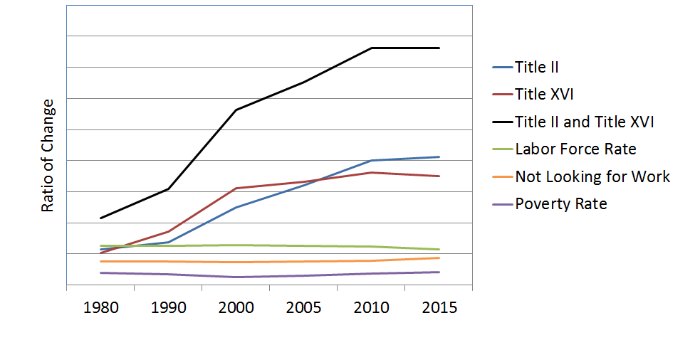
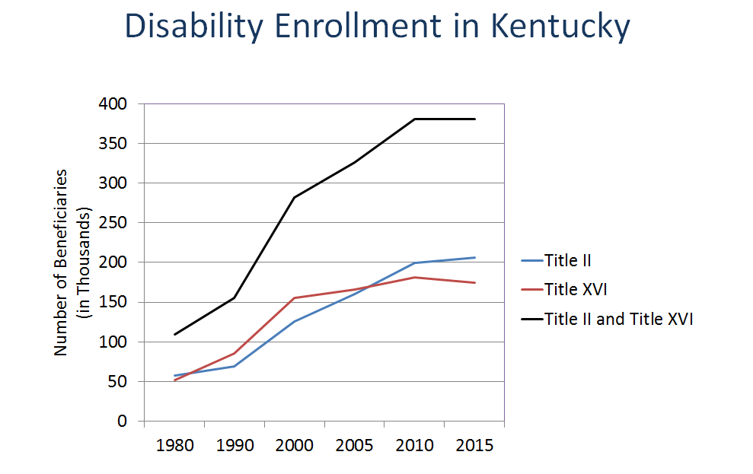

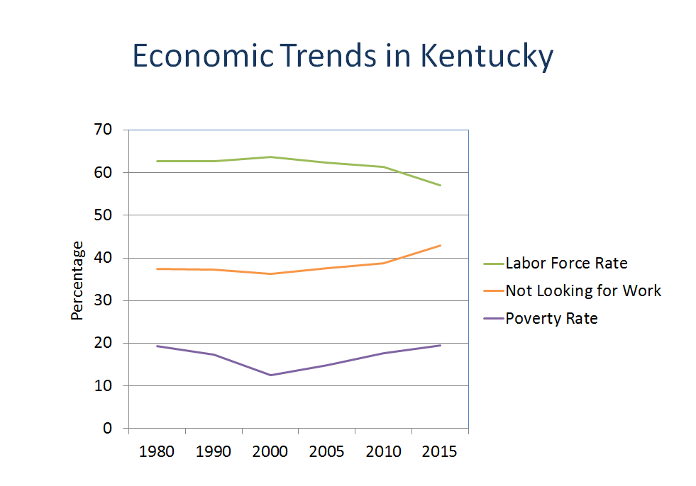

In 2015, 11.2 % of Kentuckians were receiving some form of disability benefit payment, the second highest percentage in the country. Since 2002, the percentage of Kentucky’s population receiving disability payments has never fallen below second among the fifty states. The top 12 counties receiving benefits in 2015 were:
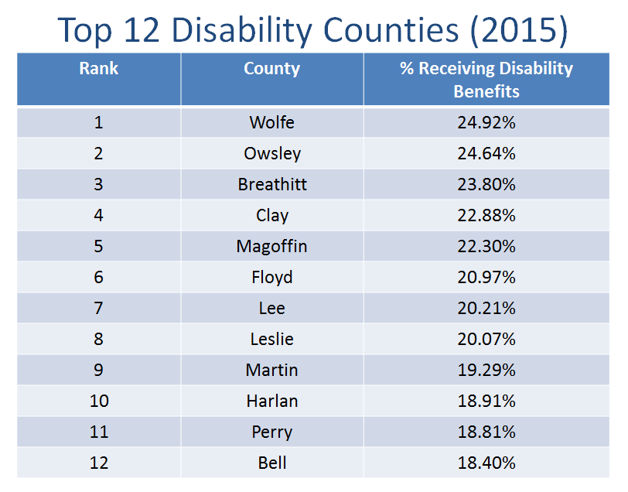

Seven counties housed the highest benefit enrollment in 2001, 2005, 2010 and 2015. They are:

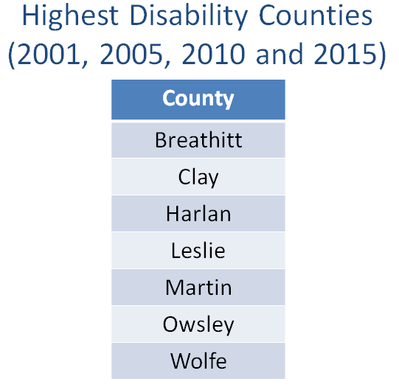

Based on national composite data, a Title II disabled worker beneficiary is most likely to be a 54 year old male who has received an award for a disease of the musculoskeletal system and connective tissue. A Title XVI beneficiary is most likely to be a female aged 50-59 who has received an award for a mental disorder.

III. Points of Award

Social Security Disability claims receive three levels of review – initial, reconsideration and appellate review by SSA ALJs. Initial determinations and reconsideration decisions are made within each state’s Disability Determination Services (DDS) office. Denials at the initial and reconsideration stages are appealed to administrative law judges who are directly employed by the SSA. In 2015, the national average award percentage at the DDS level was 28.7%. Kentucky’s DDS awarded 23.8% of claims at the initial and reconsideration stages. The national ALJ award percentage was 53.4% in 2015, down from 67.2% in 2010. ALJs processing Kentucky claims had an average award percentage of 50.4% in 2015 compared to 69.1% in 2010. The national net award percentage was 32.1% in 2015. Kentucky’s net award percentage was 28.3 %.

IV. Awarded Conditions

The SSA publishes a listing of physical and mental conditions for which an award of benefits may be made for a medically qualifying individual. There are hundreds of conditions which can be separated as being either physical or mental in nature. Physical and mental conditions can be classified within sub-set categories. For the national Title II beneficiary population, the top five overall conditions in 2015 were:

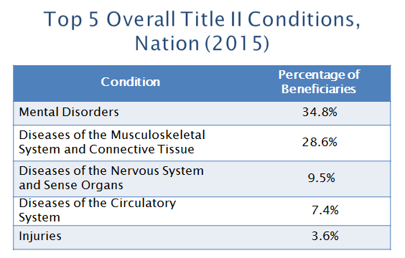

The top five physical conditions in 2015 wereError: Reference source not found:

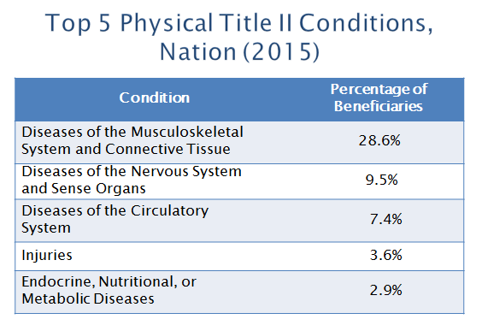

The top five mental conditions in 2015 were:

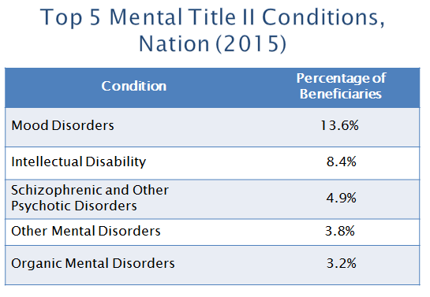

Kentucky’s Title II population had the following overall top five conditions in 2015:

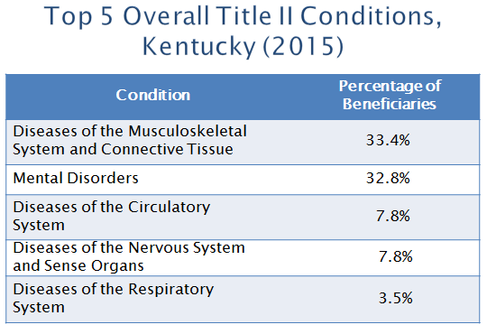
Kentucky’s top five Title II physical conditions wereError: Reference source not found:

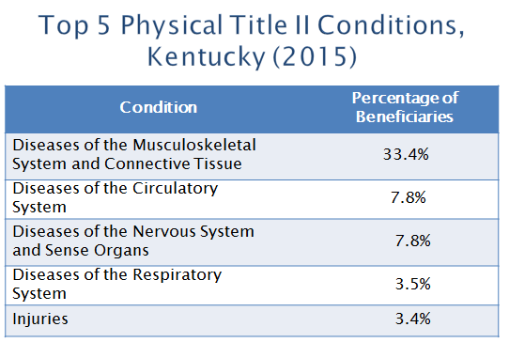

Kentucky’s top five Title II mental conditions were Error: Reference source not found:

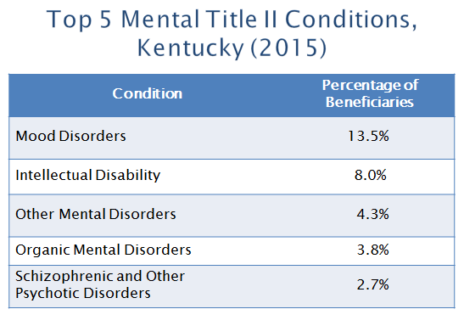

In 2015, the overall top five conditions for the nation’s Title XVI population were:

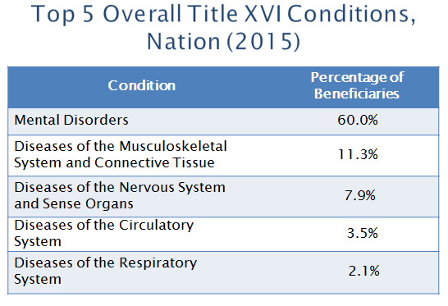
The top five physical conditions wereError: Reference source not found:

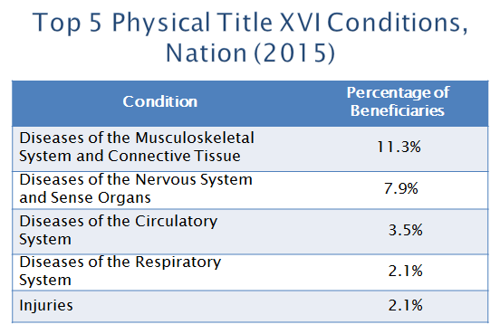

The top five mental conditions were:

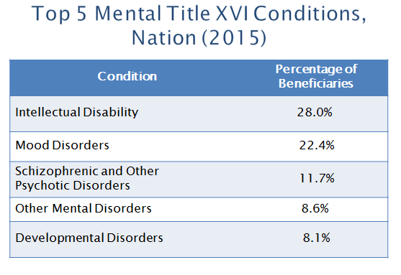

Kentucky’s Title XVI population was comprised of the following top five overall conditions in 2015Error: Reference source not found:

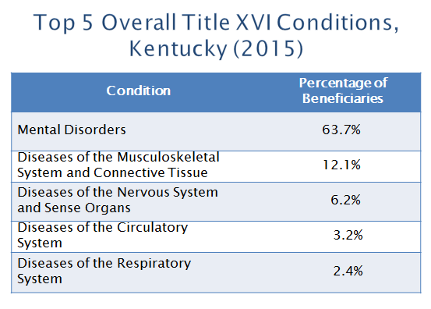
The top five physical conditions wereError: Reference source not found :

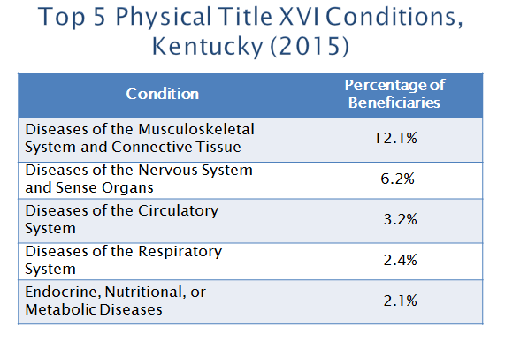

The top five mental conditions were Error: Reference source not found:

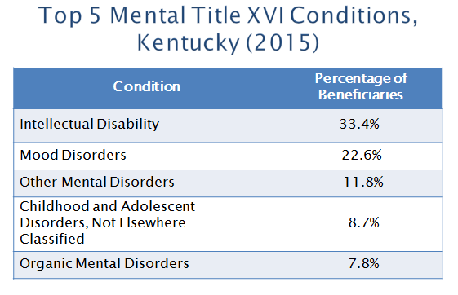

V. Childhood Enrollment

As this study’s scope of statistical development began to take its final shape, numbers which tracked the enrollment of children under age 18 from 1980 – 2015 drew focused attention. The final assessment of those numbers gave rise to significant concerns centered upon the exponential growth of childhood enrollment in Title XVI of the SSI program – growth which stands apart from that of the adult, working age population.

Since 1980, the national Title XVI childhood beneficiary population has increased by 476%. Kentucky’s Title XVI childhood population has increased by 449%Error: Reference source not found, 21 times the organic growth of its general population. The top five Title XVI childhood conditions in 2015 were:

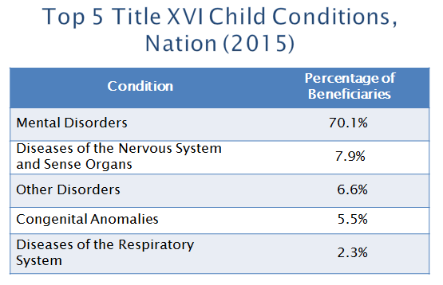

VI. Pharmacology of Dependence

Enrollment trends within Kentucky’s disability population have been matched with trends in statewide prescription drug use. Utilizing data supplied by KASPER, state and county de-identified benefit dependence statistics have been paired with state and county prescription drug utilization. The following substances have been paired with disability data for the purposes of this study:

Psychotropics
- Xanax/Alprazolam
- Valium/Diazepam
Opioids
- Butrans/Buprenorphine
- Hydrocodone
- Methadone
- Morphine
- Opana/Oxymorphone
- Oxycodone
- Suboxone/Buprenorphine-Naloxone
- Ultram/Tramadol

Per capita usage was calculated on a statewide and county per capita basis by dividing the sum of the prescribed medication doses to all individuals by the population of the county. In 2015, 15.57 doses per capita of the controlled psychotropic medications listed above were prescribed for every man, woman, and child in Kentucky for the year. 71.60 doses per capita of the controlled opioids listed above were also prescribed for 2015. The following 12 counties had the highest per capita opioid use in 2015Error: Reference source not found:

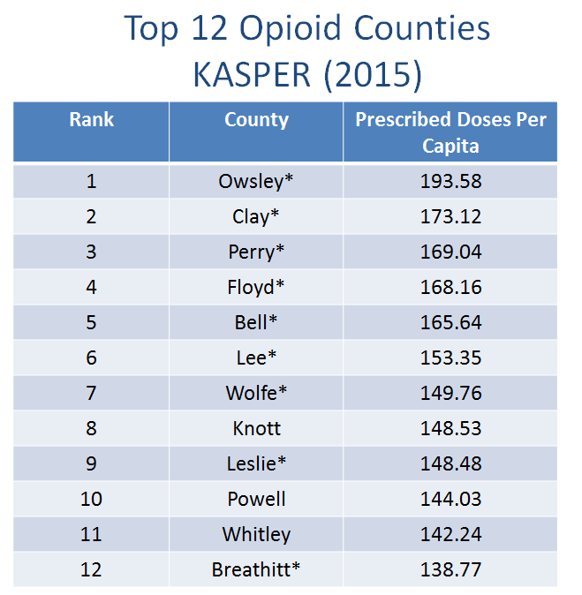

These counties had the highest per capita use of tracked psychotropic medications Error: Reference source not found:

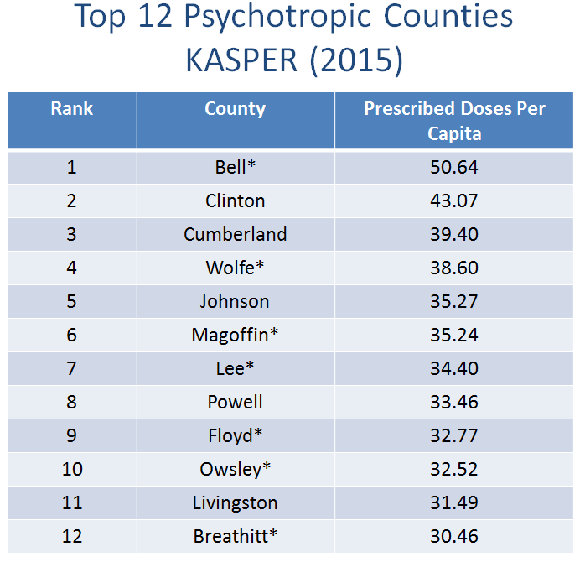

Kentucky’s Medicaid program supplied data which focused on the dispensation of opioid and psychotropic medication to Kentucky’s Title XVI population. From 2000 to 2015, prescriptions of opioids to Kentucky’s adult Title XVI population increased 210% from 47.58 to 147.29 doses per capita. Prescriptions of psychotropic medications to Kentucky’s adult Title XVI population increased 60% from 323.53 to 517.32 doses per capita. In 2000, Title XVI children were issued 7.37 opioid doses per capita. In 2015, they received 8.35 doses per capita, a 13% increase. Kentucky’s Title XVI children received 272.61 psychotropic doses per capita during the year 2000. As of 2015, Title XVI children received 456.87 psychotropic doses per capita – an increase of 168%.

Data from Kentucky’s Medicaid program showed that the following 12 counties had the highest per capita opioid use in 2015:

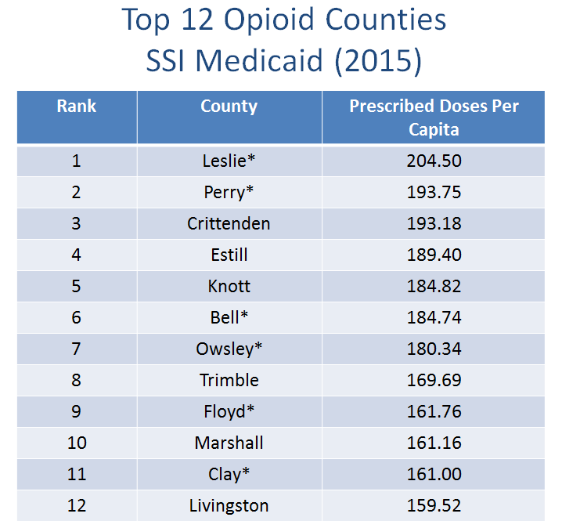
These counties were within the top 12 per capita psychotropic consumers in 2015:

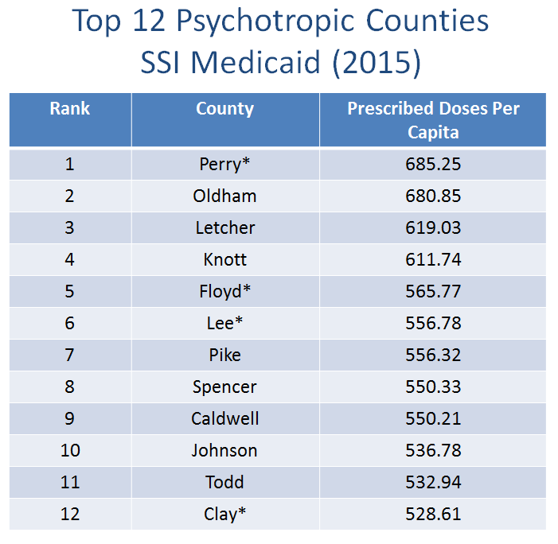
These counties were within the top 12 in both disability enrollment and per capita opioid prescriptions:

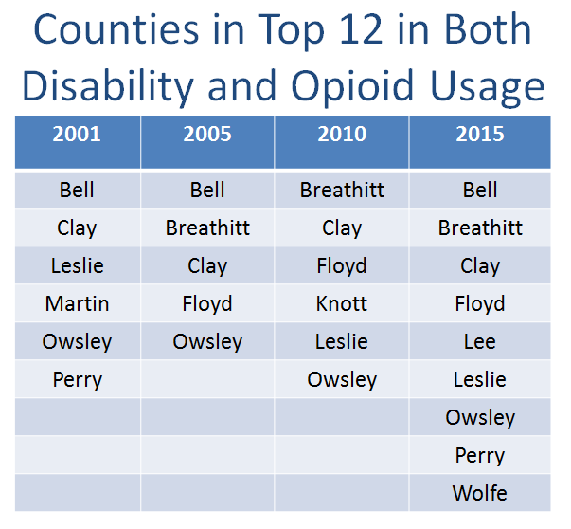

EXACTA COUNTIES

Clay County and Owsley County were in the Top 12 for disability dependence and opioids per capita in the years 2001, 2005, 2010, and 2015.

SUPERFECTA COUNTY

Owsley County was also in the Top 12 for psychotropic medications per capita in the years 2001, 2005, 2010, and 2015.

VII. Dependence and Permanence

Rather than providing a helping hand for a better future, the current dependence culture has become a permanent cycle for the overwhelming majority of awardees. Only 3.7% of SSDI beneficiaries and 5.5% of SSI beneficiaries make a successful return to work after a benefit award. In 2015, Kentucky’s economy was valued at $170.8 billion. The total Title II and Title XVI benefit population was an estimated 374,996. Total Social Security disability benefit payments to Kentuckians equaled $4,434,924,000. The average annual benefit payment was $11,826 in 2015. If half of these beneficiaries were employed at Kentucky’s 2015 median per capita income, their total income would have contributed $4,467,702,344 to Kentucky’s economic value instead of $2,212,351,345. When measured by per capita productivity, the loss to Kentucky’s economy is $2,250,350,996. Insofar as benefit dependence is effectively permanent, this loss of income and productivity will be perpetual without radical change to the Social Security disability program.

VIII. Dependence and Mortality

Between 1980 and 2014, twenty U.S. counties experienced a decline in the life expectancies of their residents. These are counties where a child born today is not expected to live as long as his/her parents. Eight of the twenty counties which had the steepest declines are Kentucky counties.Error: Reference source not found

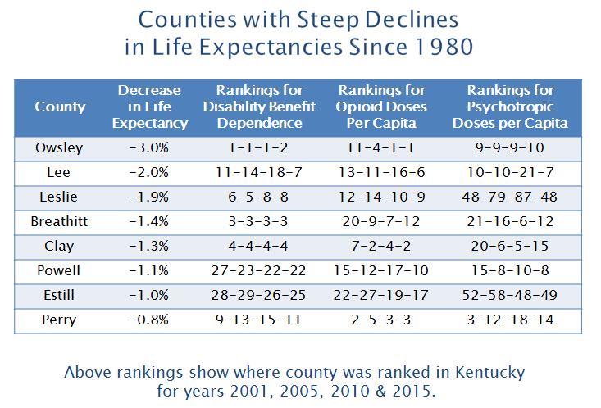

IX. Drivers of Dependence

1984 Revisions

In 1984, Congress enacted several statutory changes which were followed by a revision of regulatory protocols by the SSA which relaxed eligibility standards by emphasizing functional limitations of pain associated with musculoskeletal injuries and other physical conditions. The 1984 enactments relaxed and expanded the criteria for which an award of permanent disability benefits could be granted for a mental condition.

Sullivan v. Zebley, 493 U.S. 521 (1990)

In 1990, the U.S. Supreme Court invalidated the SSA’s requirement that a child be found disabled only if he/she had a condition which met specific medical criteria. The court ordered the SSA to create new criteria which emphasized the assessment of a child’s functional limitations. The Supreme Court’s order triggered an explosion in childhood enrollment.
Relaxation of Standards at Age 50

In 1979, the SSA published medical-vocational guidelines to promote consistency in the adjudication of claims. These guidelines mandate consideration of age, education, residual functional capacity and work experience in the disability determination. For claimants age 50 or older, these factors maximize the likelihood of an award of benefits, even when the claimant does not meet a medical listing.

Social Security Administration ALJs

Since the inception of statistical tracking, award percentages demonstrate that SSA ALJs award benefits at rates substantially higher than state-level DDS. In 2010, SSA ALJs granted awards in 67.2% of their cases.Error: Reference source not found These approval rates have declined over the past several years and, as of 2015, stand at 53.4%.Error: Reference source not found The average rate of approval among Kentucky ALJs processing Kentucky claims for 2015 was 50.4%.Error: Reference source not found The award rates for Kentucky’s SSA ALJs varied widely.

Allowance Rates for ALJs (2015)

Judge | Allowance Rate | Judge | Allowance Rate
Kelly III, John T | 83.8% | Zuber, William C. | 48.7%
Jamison, Peter | 81.5% | Nichols, Michael J | 48.6%
Traver, Daniel A | 75.0% | Mather, Roland D | 48.3%
Varo, Gregory O | 74.9% | Temin, Larry A | 46.1%
Lowther, Sheila | 69.9% | Meade, Jerry | 45.9%
Prince, John M | 69.5% | Kawalek, Matthew C | 45.3%
Flynn, Robert W | 67.6% | Downs, Amber | 44.9%
Lassy, Mary S | 64.7% | McDaniel, Candace A | 44.8%
Kimberlin III, Patrick B | 63.9% | Spangler, Todd | 44.5%
Thomas, Billy | 62.7% | Stanley, Jonathan | 44.4%
York, Gloria B | 62.4% | Panter, Marjorie | 44.0%
Eaton, Marci P | 61.7% | Holsclaw, Greg | 43.8%
Sprague, Jonathan | 60.7% | Lott, Roger | 42.6%
Gollin, Andrew | 59.7% | Hodges, Maria | 42.4%
Collins, Steven | 56.8% | Ballengee, Ben | 41.5%
Nguyen, Thuy-Anh T | 58.3% | Reynolds, Roger L | 38.6%
Price, John R | 57.4% | Jackson, Karen R | 37.8%
Shaughnessy, Anne | 57.3% | Walter, Nicholas | 35.4%
Mangus, Tommye C | 56.7% | Collins, Steven | 34.1%
King, Kristen | 54.6% | Sheppard, Christopher | 30.5%
Kraft, Emilie | 53.7% | Kittinger, Bonnie | 25.7%
Sokolski, Deanna L | 52.3% | Bowling, Robert B | 24.2%
Boylan, Peter J | 50.5% | Paris, Don C | 23.8%
Detherage, Kevin J | 50.5% | Kayser, Ronald M | 17.5%
Wilkerson, Dwight D | 50.3% | Smith, Deborah | 16.4%
Rising, Donald A | 49.6% | Bowling, Robert B | 11.6%
Morris, Scott T | 49.4% | Kelley, Michele M | 7.0%
Hansen, Dennis | 49.2%

X. Obstacles to Change

Social Security Administration Culture

As a bureaucratic institution, the SSA is motivated to protect and, if possible, expand the scope of its activities across the full horizon of its operational domain. For the SSA, claims and beneficiaries equal budget. This simple equation drives the SSA’s internal culture thereby making it a significant obstacle to long-term change.

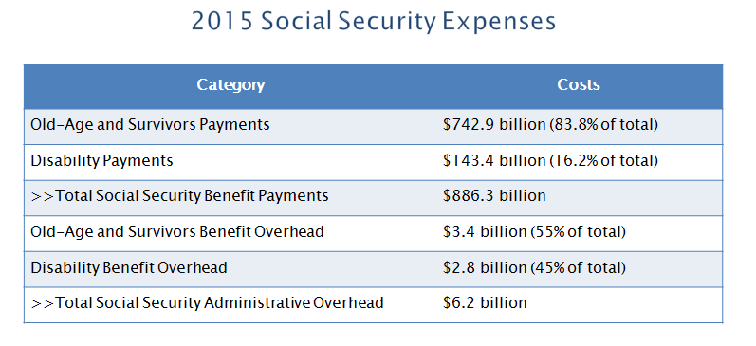

Institutional Redirection

Actors within private and public sectors misuse the Social Security disability program as an expedient solution to long-term economic and political challenges. During the last recession, large corporations laid off a disproportionate number of workers aged 50 and older. As long-term unemployment benefits ran out and the job market remained stagnant, Title II claims soared. The Social Security disability system absorbed large numbers of older workers, an absorption which was a result of the SSA’s medical-vocational guidelines which make it more likely that a claimant aged 50 and older will be found disabled. This dynamic was compounded by the efforts of private sector pension systems to redirect retirees onto Social Security disability income and medical benefits. The increase in Kentucky’s Title II population was not accompanied by companion increases in reported Lost Time work accidents between 2000 and 2015.

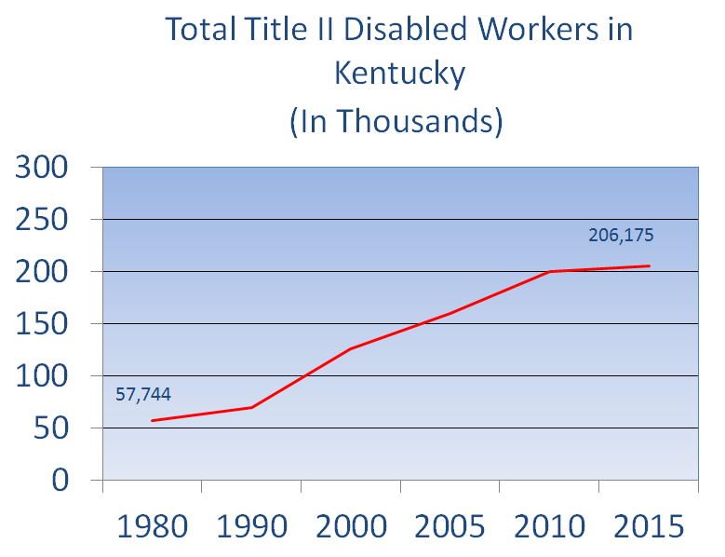

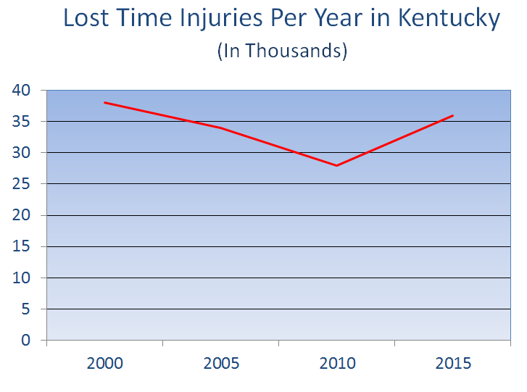
The vast expansion in the number of formerly incarcerated individuals poses a myriad of public policy challenges – first among which is the return of the individual to a happy and productive life. Felony convictions hobble the vocational prospects of those who are or are about to be released from federal and state correctional facilities. The SSA liaisons with the federal and state prison systems to ensure that pre-release counseling includes an overview of the Social Security disability application process. At present, Social Security disability is systematically absorbing formerly incarcerated individuals who are functional but not employable due to felony convictions – a disproportionate number of which arose from non-violent drug offenses.
Benefit dependence is highest in states and counties within Kentucky which are historically affected by under-education, long-term unemployment and persistent poverty. Anecdotally, these areas appear to be home to the highest concentrations of generational beneficiaries. The failure to implement durable long-term public policy solutions to endemic socio-economic afflictions has been answered with the absorption of these most desperate individuals into the Social Security disability system. This is done even among those who are functional and might be capable of moving away from dependence and into self-sustaining employment and independence.

The Doctor-Lawyer Disability Complex

The Doctor-Lawyer Disability Complex is a symbiotic economic relationship which has evolved among doctors, lawyers and judges who commodify the Social Security disability system and its recipients. Since 2000, attorney fee awards have increased from $461 million per year to $1.1 billion per year in 2015 with a peak year of $1.4 billion in 2010.

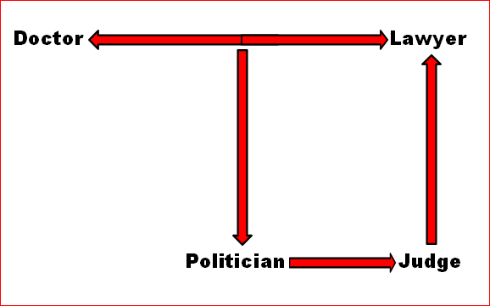

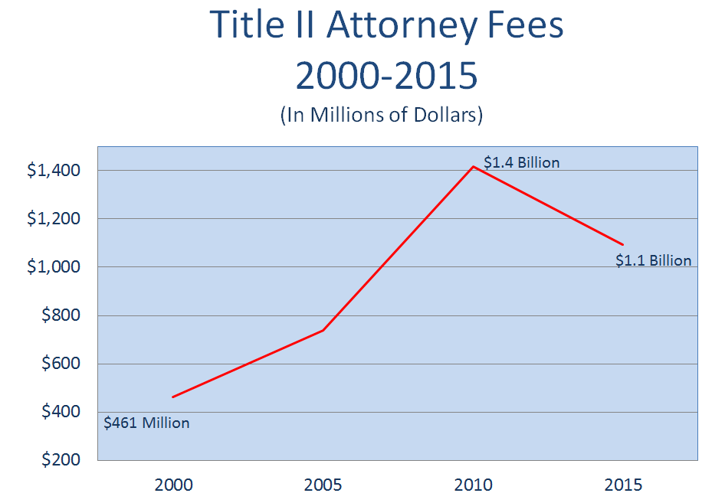
Exploitation of Vulnerable Individuals

There are individuals and institutions which exploit and derive power from an ever-expanding dependency class populated by desperate but functional people. These actors promote a dependence system which often functions as an apparatus of state sponsored suicide – anesthetizing and euthanizing its victims – a disproportionate number of whom are either young, poor, or both.

XI. First Steps for Radical Reform

SSA POMS

The SSA governs the administration of the Social Security disability program through its Program Operations Manual System (POMS). POMS is an enormously byzantine regulatory protocol comprised of 23 chapters which currently contain approximately 23,538 sets of instructions. POMS is dense, obtuse, and infinitely manipulable. When combined with the prevailing operational culture within the SSA, POMS maximizes the portals of entry into the Title II and Title XVI programs by dictating heavy and near-exclusive reliance on subjective, self-supplied data. Comprehensive review and overhaul of POMS must begin with these changes:

1) Mandate the use of objective medical evidence using best practices in forensic evaluation to determine benefit eligibility. Objective evidence of injury or illness must be paired with objective functional capacity evaluations that include cross-validation and intra-test reliability protocols which measure the legitimacy of demonstrated physical effort and limitation.

2) Mandate the use of best practices in forensic psychological evaluation to include symptom and performance validity tests such as the Miller Forensic Assessment of Symptoms Test (M-FAST), the Structured Inventory of Malingered Symptomatology (SIMS), the Test of Memory and Malingering (TOMM), and the Rey 15 Item Memory Test. These tests should be accompanied with the application of clinical thresholds of benefit eligibility.

3) Remove all subjective non-severe conditions from the listing of eligible conditions and require mandatory termination reviews for all recoupable conditions based on clinically accepted recovery timelines.

4) Eliminate the SSA’s “Medical Improvement” evidentiary standard of continuing disability review in favor of an “Objective Functionality” review founded upon objective forensic evaluation standards.

5) Cease payment of benefits upon CDR termination pending the outcome of an appeal to an ALJ.

6) Eliminate the SSA’s “Lost Folder” policy which restricts the re-evaluation of a beneficiary whose file has been lost. This policy is referred to as the “Golden Ticket” because the individual whose file is lost will likely receive benefits for the rest of his/her life without any prospect of termination.

Cap Childhood Checks

Child beneficiaries fall within the Title XVI population. They are enrolled in Medicaid and the parent(s) receive a monthly check of up to $735 per disabled child to be used to offset expenses related to their care. This redundant benefit structure is not connected to any income eligibility threshold. The delivery of checks to the parents of Title XVI children should be capped at an eligibility cut-off at 150% of poverty-level income. The Title II maximum family benefit is $5,268 per month in 2017. Title XVI beneficiary families (with at least one child beneficiary) are not subject to a maximum limitation. The Title II maximum family benefit cap should be applied to the Title XVI program. Finally, the issuance of a Medicaid card should be accompanied by mandated treatment with objective clinical improvement benchmarks for medical providers who diagnose or treat a mood or behavioral disorder for which benefits were awarded.

Cooperative Disability Investigations Units

Cooperative Disability Investigations Units exist in the majority of states and are comprised of SSA-OIG officers, deputized state investigators and state DDS claims examiners who investigate Social Security disability fraud. Funding and personnel for these units must dramatically increase and their efforts focused upon the investigation and prosecution of the primary facilitators of Social Security disability fraud and abuse – lawyers and doctors.

Eliminate De Novo Review Power of SSA ALJs

“[The judicial branch] of the government was at first considered as the most harmless and helpless of all its organs, but it has proved that the power of declaring what the law is, ad libitum, by sapping and mining, slyly and without alarm, the foundations of the constitution, can do what open force would dare not attempt.”

– Thomas Jefferson to Edward Livingston, March 25, 1825

SSA ALJs review cases appealed from state-level Departments of Disability Determination Services pursuant to “de novo” review authority. This power allows SSA ALJs to completely disregard all prior DDS determinations as well as the entire evidentiary record on which those prior decisions were based. There is a marked disparity between rates of state-level approvals and those which occur at the ALJ level. In addition, the wide variation of approval rates among ALJs suggests that de novo review authority is arbitrarily used and abused by a cadre of ajudicants whose lifetime appointments are often driven by the operation of longstanding political patronage systems within the states from which they are chosen. De novo review authority of SSA ALJs must be revoked and their appellate review functions strictly limited to corrections of patent errors and remands to Departments of DDS pursuant to the proper application of an abuse of discretion standard of review.

Eliminate Separate and Unequal Treatment
of Title II and Title XVI Beneficiaries

Upon an award of benefits to a Title XVI claimant, financial remittances and Medicaid enrollment occur instantaneously. Title II claimants must wait five months before the first check is issued and 24 months for the extension of insurance coverage through Medicare. The waiting periods appear to rest on the assumption that Title II claimants who worked and paid taxes into the Social Security system have enough accumulated savings or access to other short-term/long-term disability coverage to financially weather the delay. The reality is that the vast majority of working and middle class families have neither. Even families in the top quintile of income lack sufficient liquid savings to replace two months of lost earnings.

The financial solvency of the average American family has drastically deteriorated since 1980.

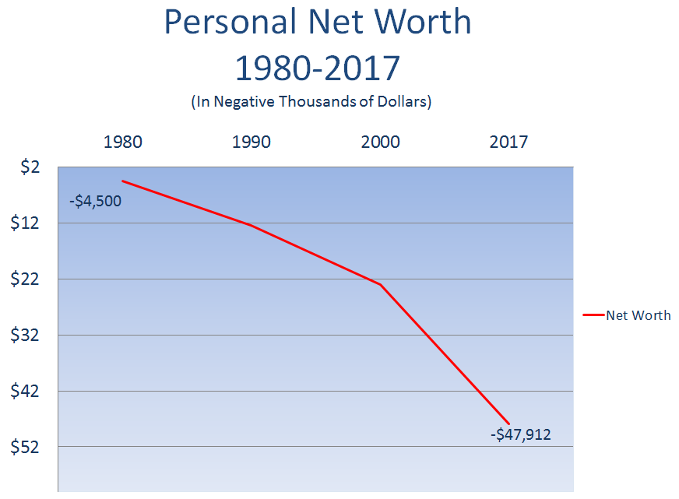

The injustice of the Title II/Title XVI disparity is best illustrated by Title II cancer cases, which are filed daily. A Title II claimant with an advanced or aggressive form of cancer may be eligible to receive an expedited benefit award but may not live long enough to receive the first check. If a check is issued shortly after a claimant dies, the check must be returned to the SSA by the decedent’s survivors. Delaying benefit payments and insurance enrollment for disabled workers pursuant to Title II rules creates substantial hardships for those whose payroll taxes fund the system. The disparate treatment of Title II and Title XVI claimants is indefensible.
Retraining, Rehabilitation, and Culture

Workforce Retention and Re-Training Incentives for Workers Aged 50 or Older Who Lack a College Degree

Growth in Title II enrollment has been fueled by long-term unemployment among this population. Since the financial crash of 2008, the disability program has been utilized as a landing spot for these individuals. Their entry onto the rolls has been accommodated by SSA policy which emphasizes benefit allowances for injured workers aged 50 and older who have not received a college education.Error: Reference source not found Private employers have redirected long-term employees into the Social Security disability program as a method of managing the long-term healthcare and retirement costs associated with an aging blue collar workforce. Addressing the economic and vocational needs of this group will likely result in the most immediate reduction in benefit dependency.

Vocational Rehabilitation for Disabled Individuals With Manageable Conditions

Many individuals receiving either Title II or Title XVI benefits are employable with the assistance of vocational rehabilitation programs which emphasize workplace functionality, transferability of functional skills, the introduction of new skill sets, and the facilitation of workplace accommodation on an individual basis. Addressing the functional needs of this population will likely yield steady employment results.

Creating a Culture Which Honors Work

Tragically, some individuals in Kentucky have never experienced life without public assistance. A large percentage of these individuals are found within Kentucky’s Title XVI population. Most have never enjoyed the independence that comes through work. Education and training which emphasize the value of becoming a productive member of the community and the ensuing benefits to self-confidence can provide life-changing benefits for this segment of the population.

Graduated Migration

Kentucky’s DDS currently estimates that a private sector job would need to pay approximately $30,589, exclusive of health benefits, in order to financially induce a Title XVI beneficiary with two children to move from the benefit to work. Identifying beneficiaries with manageable conditions for placement into a Vocational Introduction Program (VIP) that undertakes the challenge of building a work ethic within those who have aged past formative development years is a necessity. Ideally, those beneficiaries would be placed in a job (public or private) with wage progression, which would enable them to move off the disability rolls by supplanting the value of the benefit with the value of earned income. This must be done on a graduated, tiered-down basis with benefits being offset by increasing earnings.

XII. Conclusion

Social Security disability benefit dependence should be created by genuinely disabling conditions which permanently preclude individuals from ever performing remunerative work. For people so afflicted, the integrity and solvency of the system must be preserved. Much of the exponential growth of benefit dependence over the past 35 years has been fueled by a multitude of factors which are completely unrelated to the mitigation or treatment of hardship borne of genuine disability. Whether by accident or design, the expansion of benefit dependence has proven harmful. As the statistics contained in this report demonstrate, far from helping families improve their lives, the dependency culture has been detrimental. It has harmed families, communities and states both socially and economically. Armed with this statistical reality of these flawed public policy measures over the past 35 years, we can seek better outcomes over the next 35 years.

XIII. Credits

W. Bryan Hubbard – Acting Commissioner – DIS

Policy and Statistical Research Team

Debbie Haydon
Kelley Scott
Kim Mink
John Page

Technical Advisor

Doug Lefevers

Sincere thanks are extended to the following individuals whose contributions to this study proved invaluable:

Dr. Jessica Cunningham
Research Director, Education and Workforce Development

Kurt Godshall
Executive Advisor, Department for Medicaid Services

Stephanie Hold
Division Director, CHFS OIG

Dave Hopkins
Manager, CHFS OATS

Van Ingram
Executive Director, Kentucky Office of Drug Control Policy

Dr. Gil Liu
Chief Policy Advisor, Department for Medicaid Services

Samantha McKinley
Pharmacy Services Program Manager, Department for Medicaid Services

Barrett Ross
Staff Assistant, Kentucky Center for Education and Workforce Statistics

Angela Taylor
Business Analyst, Department for Medicaid Services

Pamela Wright
Business Analyst, Department for Medicaid Services

Sincere thanks to these individuals who provided informational and statistical contributions which proved invaluable:

Elizabeth Whitehouse
Director of Education and Workforce Development, Council of State Governments

Keifer Williams
Fiscal Research Associate, Council of State Governments

Special Thanks To:

Kentucky’s Cooperative Disability Investigations Unit

See Table 4 (Net Allowance Rate, Kentucky and Nation).
Kentucky Cabinet for Health and Family Services, Office of the Secretary, Inspector General, KASPER (Kentucky All Schedule Prescription Electronic Reporting), http://chfs.ky.gov/os/oig/KASPER.htm.
L. Scott Mueller, Brett O’Hara and John R. Kearney, Social Security Administration, Office of Policy, Office of Research, Evaluation and Statistics, Trends in the Social Security and Supplemental Security Income Disability Programs, pp. 79-80, SSA Publication No. 13-11831 (Released August 2006), available at https://www.ssa.gov/policy/docs/chartbooks/disability_trends/index.html (authors discuss MIRS and effects of implementation on continuing disability reviews).
Office of the Inspector General of the Social Security Administration, About the OIG, https://oig.ssa.gov/about-oig (last accessed July 21, 2017).
https://en.oxforddictionaries.com/definition/opioid (to access definition, please copy and paste hyperlink into address line of a web browser).
https://en.oxforddictionaries.com/definition/psychotropic (to access definition, please copy and paste hyperlink into address line of a web browser).
Social Security Administration, Representative Payee Pro Bono Pilot, Safeguarding Beneficiary Information, para. 1 (last accessed July 24, 2017), https://www.ssa.gov/payee/rp_pii.htm. SSA provides the following examples of PII: “PII includes a person’s name, date of birth, Social Security Number, bank account information, address, health records, and Social Security benefit payment data.” Id.
POMS DI 10501.001 (Jan.5, 2007).
POMS DI 10501.015B and C (Tables 2 and 3) (Oct. 19, 2016).
Social Security Administration, Disability Planner: Social Security Protection If You Become Disabled, Disability and SSI section, para. 1 (last accessed July 21, 2017), https://www.ssa.gov/planners/disability/.
Id. para. 3.
John R. Kearney, Social Security Administration, Office of Policy, Office of Research, Evaluation, and Statistics, Social Security and the “D” in OASDI: The History of a Federal Program Insuring Earners against Disability, Introduction section, paras. 1, 3, Social Security Bulletin, Vol. 66, No. 3 (2005/2006), available at https://www.ssa.gov/policy/docs/ssb/v66n3/v66n3p1.html.
John R. Kearney, Social Security Administration, Office of Policy, Office of Research, Evaluation, and Statistics, Social Security and the “D” in OASDI: The History of a Federal Program Insuring Earners Against Disability, Continued Advocacy for a Disability Program: “The 1948 Advisory Council” section, para. 1, Social Security Bulletin, Vol. 66, No. 3 (2005/2006), available at https://www.ssa.gov/policy/docs/ssb/v66n3/v66n3p1.html.
John R. Kearney, Social Security Administration, Office of Policy, Office of Research, Evaluation, and Statistics, Social Security and the “D” in OASDI: The History of a Federal Program Insuring Earners Against Disability, Continued Advocacy for a Disability Program: “The 1948 Memorandum of Dissent: A Grants-in-Aid Alternative section”, paras. 1-2, Social Security Bulletin, Vol. 66, No. 3 (2005/2006), available at https://www.ssa.gov/policy/docs/ssb/v66n3/v66n3p1.html. (“As in 1938, the 1948 arguments against Social Security disability were based on the losses suffered by private disability insurance.”).
Id. para. 1.
Id. para. 2.
John R. Kearney, Social Security Administration, Office of Policy, Office of Research, Evaluation, and Statistics, Social Security and the “D” in OASDI: The History of a Federal Program Insuring Earners Against Disability, The 1954 Disability “Freeze” section, Box 1, Social Security Bulletin, Vol. 66, No. 3 (2005/2006), available at https://www.ssa.gov/policy/docs/ssb/v66n3/v66n3p1.html.
Social Security Administration, Office of Policy, Office of Research, Statistics, & Policy Analysis, Trends in the Social Security and Supplemental Security Income Disability Programs, Introduction section, paras. 1-3 (2017), available at https://www.ssa.gov/policy/docs/chartbooks/disability_trends/overview.html.
POMS DI 10105.060 (June 12, 2009).
POMS SI 00501.001B1 (Jan. 18, 2005).
Social Security Administration, Office of Retirement and Disability Policy, Office of Research, Evaluation, and Statistics, Annual Statistical Report on the Social Security Disability Insurance Program, 2015, Table 3. Number, average, and total monthly benefits, December 1960-2015, p. 21, SSA Publication No. 13-11826 (Released October 2016), available at https://www.ssa.gov/policy/docs/statcomps/di_asr/2015/sect01b.pdf.
Social Security Administration, Office of Research, Evaluation, and Statistics, SSI Annual Statistical Report, Table 39. Average monthly payment, by state or other area and diagnostic group, p. 21, SSA Publication No. 12-11827 (Released January 2017), available at https://www.ssa.gov/policy/docs/statcomps/ssi_asr/2015/sect06.pdf.
Office of Management and Budget, Historical Tables, Table 1.1—Summary of Receipts, Outlays and Surpluses or Deficits (-): 1789-2022, https://www.whitehouse.gov/sites/whitehouse.gov/files/omb/budget/fy2018/hist.pdf.
Social Security Administration, Office of Research, Evaluation, and Statistics, SSI Monthly Statistics, Table 6. Total payments by eligibility category, age and source of payment, (2015), https://www.ssa.gov/policy/docs/statcomps/ssi_monthly/2015/table06.pdf and Social Security Administration, Office of Retirement and Disability Policy, Office of Research, Evaluation, and Statistics, Annual Statistical Supplement to the Social Security Bulletin, 2016, Table 5.J1—Estimated total annual benefits paid, by state or other area and program, 2015, sec. 5.84, SSA Publication No. 13-11700 (Released May 2017), available at https://www.ssa.gov/policy/docs/statcomps/supplement/2016/5j.pdf. Totaled estimated annual benefits were calculated by adding individual total monthly SSI benefit amounts with total estimated annual SSDI benefits for 2015.
POMS DI 25501.370A1 (July 6, 2015) and SI 01730.010A3 (Feb. 6, 2013).
Federal and state contributions are determined annually by a special formula (FMAP) based on the per capita income in each state. Alison Mitchell, Medicaid’s Federal Medical Assistance Percentage (FMAP), pp. 1-2, Congressional Research Service (Feb. 9, 2016), https://fas.org/sgp/crs/misc/R43847.pdf. Federal assistance ranges from 50% up to 83%. Id. Since fiscal year 2012, the federal contribution for Kentucky has ranged from a low of 69.83% (FY 2014) to a high of 71.18% (FY 2012). Id. at 14 (Appendix A). See also Sylvia M. Burwell, Secretary of Health and Human Services, Federal Financial Participation in State Assistance Expenditures; Federal Matching Shares for Medicaid, the Children’s Health Insurance Program and Aid to Needy Aged, Blind or Disabled Persons for October 1, 2016 through September 30,2017, ASPE FMAP 2017 Report (Nov. 25, 2015), https://aspe.hhs.gov/basic-report/fy2017-federal-medical-assistance-percentages.
The Kentucky Department of Medicaid Services noted that the total Medicaid expenditures includes only medical and pharmacy claims and does not include capitation. Capitation includes payments to both Managed Care Organizations (MCOs) and the Transportation Cabinet for administrative costs.
Information on Medicaid expenditures within Kentucky was provided by the Department for Medicaid Services located within Kentucky’s Cabinet for Health and Family Services.
U.S. Census Bureau, 1980 Fast Facts (last accessed July 22, 2017), https://www.census.gov/history/www/through_the_decades/fast_facts/1980_new.html.
U.S. Census Bureau, National Population Totals Tables: 2010-2016, Table 1. Annual Estimates of the Resident Population for the United States, Regions, States and Puerto Rico: April 1, 2010 to July 1, 2016 (last accessed July 22, 2017), https://www.census.gov/data/tables/2016/demo/popest/nation-total.html.
U.S. Census Bureau, Resident Population and Apportionment of the U.S. House of Representatives (last accessed July 22, 2017), https://www.census.gov/dmd/www/resapport/states/kentucky.pdf.
U.S. Census Bureau, National Population Totals Tables: 2010-2016, Table 1. Annual Estimates of the Resident Population for the United States, Regions, States and Puerto Rico: April 1, 2010 to July 1, 2016 (last accessed July 22, 2017), https://www.census.gov/data/tables/2016/demo/popest/nation-total.html.
Social Security Administration, Office of Retirement and Disability Policy, Office of Research, Evaluation, and Statistics, Annual Statistical Report on the Social Security Disability Insurance Program, 2015, Table 1. Number, December 1960-2015, selected years, p. 17, SSA Publication No. 13-11826 (Released October 2016), available at https://www.ssa.gov/policy/docs/statcomps/di_asr/2015/di_asr15.pdf. For purposes of Title II enrollment and comparison between the nation and Kentucky, only the disabled worker population was selected because that was the only data available for the 1980 Kentucky Title II population.
Social Security Administration, Office of Retirement and Disability Policy, Office of Research, Evaluation, and Statistics, Annual Statistical Report on the Social Security Disability Insurance Program, 2015, Table 9. Distribution, by state or other area, December 2015, p. 31, SSA Publication No. 13-11826 (Released October 2016), available at https://www.ssa.gov/policy/docs/statcomps/di_asr/2015/di_asr15.pdf and Social Security Administration, Office of Research, Evaluation, and Statistics, Social Security Bulletin: Annual Statistical Supplement, 1980, Table 121 (1981), available at http://cdm16760.contentdm.oclc.org/cdm/ref/collection/p16760coll5/id/2547.
Social Security Administration, Office of Retirement and Disability Policy, Office of Research, Evaluation, and Statistics, SSI Recipients by State and County, 2015, Table 1. Number of recipients by state or other area, eligibility category, age, and receipt of OASDI benefits, December 2015, p. 1, SSA Publication No. 13-11976 (Released Sept. 2016), available at https://www.ssa.gov/policy/docs/statcomps/ssi_sc/2015/ssi_sc15.pdf and Social Security Administration, Office of Research, Evaluation, and Statistics, Social Security Bulletin: Annual Statistical Supplement, 1980, p. 4, Table 1.—Number of adults and children receiving federally administered payments by State, June 1980 (1981), available at http://cdm16760.contentdm.oclc.org/cdm/ref/collection/p16760coll5/id/2547.
See Social Security Administration, Office of Retirement and Disability Policy, Office of Research, Evaluation, and Statistics, Annual Statistical Report on the Social Security Disability Insurance Program, 2015, Table 1. Number, December 1960-2015, selected years, p. 17, SSA Publication No. 13-11826 (Released October 2016), available at https://www.ssa.gov/policy/docs/statcomps/di_asr/2015/di_asr15.pdf (provides number of Title II disabled workers in nation for 1980 and 2015); Social Security Administration, Office of Retirement and Disability Policy, Office of Research, Evaluation, and Statistics, SSI Recipients by State and County, 2015, Table 1. Number of recipients by state or other area, eligibility category, age, and receipt of OASDI benefits, December 2015, p. 1, SSA Publication No. 13-11976 (Released Sept. 2016), available at https://www.ssa.gov/policy/docs/statcomps/ssi_sc/2015/ssi_sc15.pdf (provides number of Title XVI beneficiaries for nation in 2015); Social Security Administration, Office of Retirement and Disability Policy, Office of Research, Evaluation, and Statistics, Annual Statistical Report on the Social Security Disability Insurance Program, 2015, Table 9. Distribution, by state or other area, December 2015, p. 31, SSA Publication No. 13-11826 (Released October 2016), available at https://www.ssa.gov/policy/docs/statcomps/di_asr/2015/di_asr15.pdf (provides number of Title II disabled workers in Kentucky for 2015); Social Security Administration, Office of Research, Evaluation, and Statistics, Social Security Bulletin: Annual Statistical Supplement, 1980, Table 121 (1981), available at http://cdm16760.contentdm.oclc.org/cdm/ref/collection/p16760coll5/id/2547 (provides number of Title II disabled workers in Kentucky in 1980) and Social Security Administration, Office of Research, Evaluation, and Statistics, Social Security Bulletin: Annual Statistical Supplement, 1980, p. 4, Table 1.—Number of adults and children receiving federally administered payments by State, June 1980 (1981), available at http://cdm16760.contentdm.oclc.org/cdm/ref/collection/p16760coll5/id/2547 (provides number of Title XVI beneficiaries in Kentucky and nation for 1980). For purposes of comparing the growth of the combined Title II and Title XVI beneficiary populations between 1980 and 2015 for both Kentucky and the nation, only the Title II disabled worker and Title XVI disabled beneficiary populations were considered. The disabled adult children and disabled widow(er) populations were not included in the Title II population for either Kentucky or the nation because that information was not available for the Kentucky beneficiary population in 1980. Additionally, concurrent beneficiaries were also not considered or removed from the combined population totals because that information was not available for the beneficiary population in Kentucky or the nation in 1980. Therefore, only known Title II and Title XVI beneficiary populations for both Kentucky and the nation were considered when determining the growth of combined enrollment (Title II and Title XVI) from 1980 to 2015. For 2001, 2005, 2010 and 2015, the beneficiary populations for disabled adult children and disabled widows in Kentucky accounted for approximately 7.25 to 7.9 percent of the combined Title II disabled worker and Title XVI disabled beneficiary population while the concurrent beneficiaries accounted for approximately 9.4 to 10.5 percent of the above combined population. For the same years as noted above, the beneficiary populations for disabled adult children and disabled widows in the nation accounted for approximately 7.93 to 8.8 percent of the combined Title II disabled worker and Title XVI disabled beneficiary populations while the concurrent beneficiaries accounted for approximately 8.36 to 10.10 percent of the above combined populations.
Bureau of Labor Statistics, Current Population Survey, Table 1. Employment status of the civilian noninstitutional population, 1946 to date (last modified Feb. 8, 2017), https://www.bls.gov/cps/cpsaat01.pdf.
Bureau of Labor Statistics, Local Area Unemployment Statistics, Annual Average Series, Employment status of the civilian noninstitutional population, annual averages (last modified April 19, 2017), https://www.bls.gov/lau/staadata.txt.
U.S. Census Bureau, POV-46: Poverty Status by State: 2015. Below 100% and 50% of Poverty—All Ages (1) (last accessed July 22, 2017), https://www.census.gov/data/tables/time-series/demo/income-poverty/cps-pov/pov-46.html.
Bureau of Labor Statistics, Current Population Survey, Table 1. Employment status of the civilian noninstitutional population, 1946 to date (last modified Feb. 8, 2017), https://www.bls.gov/cps/cpsaat01.pdf. To calculate the estimated total number of Americans age 16 or older who were not employed and also not looking for work, the total for the national civilian labor force was subtracted from the total national civilian noninstitutional population.
Bureau of Labor Statistics, Local Area Unemployment Statistics, Annual Average Series, Employment status of the civilian noninstitutional population, annual averages (last modified April 19, 2017), https://www.bls.gov/lau/staadata.txt. The same method noted above was used to calculate the number of Kentuckians age 16 or older who were not employed and also not looking for work.
The sources of economic information provided in this graph do not document the data consistently. The data considered was documented in either raw numbers or percentages but not both. Therefore, to allow a uniform comparison of the information, ratios were created to document the relative changes in each category for each of the respective years. When creating the ratios, 1980 was considered the base year from which changes were noted. Once the ratios were calculated, the changes (if any) for each category were then plotted and graphed.
Social Security Administration, Office of Retirement and Disability Policy, Office of Research, Evaluation, and Statistics, Annual Statistical Report on the Social Security Disability Insurance Program, 2015, Table 68. Number of aged 18-64 as a percentage of the resident population aged 18-64, by state December 2015, p. 168, SSA Publication No. 13-11826 (Released October 2016), available at https://www.ssa.gov/policy/docs/statcomps/di_asr/2015/sect05.pdf.
Social Security Administration, Office of Policy, Office of Research, Evaluation, and Statistics, Annual Statistical Report on the Social Security Disability Insurance Program, 2005, Table 66. Number aged 18-64 as a percentage of the resident population aged 18-64, by state, December 2005, p. 149, SSA Publication No. 13-11826 (Released Sep. 2006); Social Security Administration, Office of Policy, Office of Research, Evaluation, and Statistics, Annual Statistical Report on the Social Security Disability Insurance Program, 2006, Table 66. Number aged 18-64 as a percentage of the resident population aged 18-64, by state, December 2006, p. 153 (Released Aug. 2007); Social Security Administration, Office of Retirement and Disability Policy, Office of Research, Evaluation, and Statistics, Annual Statistical Report on the Social Security Disability Insurance Program, 2007, Table 67. Number aged 18-64 as a percentage of the resident population aged 18-64, by state, December 2007, p. 155, SSA Publication No. 13-11826 (Released Aug. 2008); Social Security Administration, Office of Retirement and Disability Policy, Office of Research, Evaluation, and Statistics, Annual Statistical Report on the Social Security Disability Insurance Program, 2008, Table 67. Number aged 18-64 as a percentage of the resident population aged 18-64, by state, December 2008, p. 155, SSA Publication No. 13-11826 (Released July 2009); Social Security Administration, Office of Retirement and Disability Policy, Office of Research, Evaluation, and Statistics, Annual Statistical Report on the Social Security Disability Insurance Program, 2009, Table 67. Number aged 18-64 as a percentage of the resident population aged 18-64, by state, December 2009, p. 156, SSA Publication No. 13-11826 (Released July 2010); Social Security Administration, Office of Retirement and Disability Policy, Office of Research, Evaluation, and Statistics, Annual Statistical Report on the Social Security Disability Insurance Program, 2010, Table 67. Number aged 18-64 as a percentage of the resident population aged 18-64, by state, December 2010, p. 161, SSA Publication No. 13-11826 (Released Aug. 2011); Social Security Administration, Office of Retirement and Disability Policy, Office of Research, Evaluation, and Statistics, Annual Statistical Report on the Social Security Disability Insurance Program, 2011, Table 67. Number aged 18-64 as a percentage of the resident population aged 18-64, by state, December 2011, p. 162, SSA Publication No. 13-11826 (Released July 2012); Social Security Administration, Office of Retirement and Disability Policy, Office of Research, Evaluation, and Statistics, Annual Statistical Report on the Social Security Disability Insurance Program, 2012, Table 67. Number aged 18-64 as a percentage of the resident population aged 18-64, by state, December 2012, p. 164, SSA Publication No. 13-11826 (Released Nov. 2013); Social Security Administration, Office of Retirement and Disability Policy, Office of Research, Evaluation, and Statistics, Annual Statistical Report on the Social Security Disability Insurance Program, 2013, Table 68. Number aged 18-64 as a percentage of the resident population aged 18-64, by state, December 2013, p. 166, SSA Publication No. 13-11826 (Released Dec. 2014); Social Security Administration, Office of Retirement and Disability Policy, Office of Research, Evaluation, and Statistics, Annual Statistical Report on the Social Security Disability Insurance Program, 2014, Table 68. Number aged 18-64 as a percentage of the resident population aged 18-64, by state, December 2014, p. 168, SSA Publication No. 13-11826 (Released Nov. 2015); Social Security Administration, Office of Retirement and Disability Policy, Office of Research, Evaluation, and Statistics, Annual Statistical Report on the Social Security Disability Insurance Program, 2015, Table 68. Number aged 18-64 as a percentage of the resident population aged 18-64, by state, December 2015, p. 168, SSA Publication No. 13-11826 (Released Oct. 2016). All of the above sources can be accessed via https://www.ssa.gov/policy/docs/statcomps/di_asr/index.html by selecting the corresponding year for the needed report within the “Other Editions” section on the page.
Social Security Administration, Office of Retirement and Disability Policy, Office of Research, Evaluation, and Statistics, Highlights, SSA Publication No. 13-11826 (Released Oct. 2016), available at https://www.ssa.gov/policy/docs/statcomps/di_asr/2015/di_asr15.pdf.
Social Security Administration, Office of Retirement and Disability Policy, Office of Research, Evaluation, and Statistics, Highlights, SSA Publication No. 13-11827 (Released Jan. 2017), available at https://www.ssa.gov/policy/docs/statcomps/ssi_asr/2015/ssi_asr15.pdf and Social Security Administration, Office of Retirement and Disability Policy, Office of Research, Evaluation, and Statistics, Table 65. Awards for adults aged 18-64, by selected characteristics, 2007-2015, SSA Publication No. 13-11827 (Released Jan. 2017), available at https://www.ssa.gov/policy/docs/statcomps/ssi_asr/2015/ssi_asr15.pdf (references number of awardees for each age group).
Social Security Administration, Office of Retirement and Disability Policy (ORDP), Office of Disability Programs (ODP), SSA State Agency Monthly Workload Data (2017), https://www.ssa.gov/disability/data/ssa-sa-mowl.htm. The monthly statistics for both initial and reconsideration determinations and allowances for each state agency were totaled and then divided to compute the national award percentage. Continuing Disability Reviews were not included in the above totals.
Social Security Administration, Hearings and Appeals, ALJ Disposition Data FY 2015 (For Reporting Purposes: 9/27/2014 through 9/25/2015) (last accessed July 19, 2017), https://www.ssa.gov/appeals/DataSets/archive/03_FY2015/03_September_ALJ_Disposition_Data.html, and Social Security Administration, Hearings and Appeals, FY 2010—ALJ Disposition Data (Cumulative for 9/26/09 through 9/24/2010) (2017), https://www.ssa.gov/appeals/DataSets/archive/03_FY2010/03_September_ALJ_Disp_Data_FY2010.html. SSA notes the cited data above is raw and provided by each hearing office. Id. (FY 2015). SSA also indicates that “ALJs may work in multiple hearing offices[]” and states that “[a]n office or individual not included indicates there was no report-specific data for that office or individual for the report period.” Id. The total number of determinations and awards were added and then divided to determine the total award percentage for fiscal years 2010 and 2015. The same method was used to compute the award percentage of ALJs who process Kentucky claims, except only hearing offices within Kentucky were included (along with the Huntington and Cincinnati hearing offices which also hold hearings for claims originating in Kentucky and whose offices border the state of Kentucky).
Statistics were calculated by totaling the number of determinations and allowances at the initial, reconsideration and ALJ levels in fiscal year 2015 for both Kentucky and the nation. These numbers were then divided to determine the net award percentage for both Kentucky and the nation. These numbers do not include favorable awards made at the Appeals Council and Federal Court levels. Continuing Disability Reviews were not included in the DDS totals for Kentucky and the nation.
When considering the top conditions for which recipients of the disability program were receiving benefits, there was a diagnostic group titled “Unknown” in the reports published by the Social Security Administration. However, this diagnostic group was not considered when determining the top conditions for which recipients were receiving benefits because parameters for this diagnostic group were not provided in the tables. Therefore, it was not possible to determine the specifics of condition(s) or group(s) of condition(s) considered within the above diagnostic group.
See Social Security Administration, Medical/Professional Relations, Disability Evaluation Under Social Security (last accessed July 19, 2017), https://www.ssa.gov/disability/professionals/bluebook/index.htm. For adult listings see, Disability Evaluation Under Social Security, Listing of Impairments – Adult Listings (Part A) (last accessed July 19, 2017), https://www.ssa.gov/disability/professionals/bluebook/AdultListings.htm. For childhood listings, see Disability Evaluation Under Social Security, Listing Impairments – Childhood Listings (Part B), https://www.ssa.gov/disability/professionals/bluebook/ChildhoodListings.htm.
Social Security Administration, Office of Retirement and Disability Policy, Office of Research, Evaluation, and Statistics, Annual Statistical Report on the Social Security Disability Insurance Program, 2015, Table 11. Number and percentage distribution, by state or other area and diagnostic group, December 2015, pp. 39-42, SSA Publication No. 13-11826 (Released Oct. 2016), available at https://www.ssa.gov/policy/docs/statcomps/di_asr/2015/sect01b.pdf.
Social Security Administration, Office of Retirement and Disability Policy, Office of Research, Evaluation, and Statistics, Annual Statistical Report on the Social Security Disability Insurance Program, 2015, Table 11.A. Percentage distribution, by state or other area and mental disorders diagnostic group, December 2015, p. 43, SSA Publication No. 13-11826 (Released Oct. 2016), available at https://www.ssa.gov/policy/docs/statcomps/di_asr/2015/sect01b.pdf.
Social Security Administration, Office of Retirement and Disability Policy, Office of Research, Evaluation, and Statistics, Annual Statistical Report on the Social Security Disability Insurance Program, 2015, Table 11. Number and percentage distribution, by state or other area and diagnostic group, December 2015, pp. 39, 41, SSA Publication No. 13-11826 (Released Oct. 2016), available at https://www.ssa.gov/policy/docs/statcomps/di_asr/2015/sect01b.pdf.
Social Security Administration, Office of Retirement and Disability Policy, Office of Research, Evaluation, and Statistics, SSI Annual Statistical Report, 2015, Table 38. Percentage distribution of recipients by diagnostic group, by state or other area, December 2015, pp. 76-77 , SSA Publication No. 13-11827 (Released January 2017), available at https://www.ssa.gov/policy/docs/statcomps/ssi_asr/2015/sect06.pdf. For Title XVI recipients under the age of 65 in the nation, “Diseases of the Respiratory System”, “Endocrine, Nutritional, or Metabolic Diseases” and “Injuries” all tied at 2.1 percent in 2015. However, to determine which of the above conditions would be listed in both the top five overall conditions and the top five physical conditions in the nation for Title XVI beneficiaries in 2015, the total number of recipients for each condition was considered. When considering the total number of recipients for each of the above conditions, “Diseases of the Respiratory System” had the most at 131,613 recipients while “Injuries” had the second most at 129,724 recipients and last in the above group was “Endocrine, Nutritional, and Metabolic Diseases”, which accounted for 127,751 recipients. Social Security Administration, Office of Retirement and Disability Policy, Office of Research, Evaluation, and Statistics, SSI Annual Statistical Report, 2015, Table 36. Recipients, by diagnostic group, age, and sex, December, 2015, December 2015, p. 74 , SSA Publication No. 13-11827 (Released January 2017), available at https://www.ssa.gov/policy/docs/statcomps/ssi_asr/2015/sect06.pdf. Therefore, “Diseases of the Respiratory System” and “Injuries” were listed in the top five physical conditions for 2015 and “Diseases of the Respiratory System” was listed in the top five overall conditions.
Social Security Administration, Office of Retirement and Disability Policy, Office of Research, Evaluation, and Statistics, SSI Annual Statistical Report, 2015, Table 38.A. Percentage distribution of recipients by mental disorders diagnostic group, by state or other area, December 2015, p. 80, SSA Publication No. 13-11827 (Released January 2017), available at https://www.ssa.gov/policy/docs/statcomps/ssi_asr/2015/sect06.pdf.
Social Security Administration, Office of Retirement and Disability Policy, Office of Research, Evaluation, and Statistics, SSI Recipients by State and County, 2015, Table 1. Number of recipients by state or other area, eligibility category, age, and receipt of OASDI benefits, December 2015, p. 1, SSA Publication No. 13-11976 (Released Sept. 2016), available at https://www.ssa.gov/policy/docs/statcomps/ssi_sc/2015/ssi_sc15.pdf and Social Security Administration, Office of Research, Evaluation, and Statistics, Social Security Bulletin: Annual Statistical Supplement, 1980, Table 1.—Number of adults and children receiving federally administered payments by State, June 180, p. 4, (1981), available at http://cdm16760.contentdm.oclc.org/cdm/ref/collection/p16760coll5/id/2547.
Social Security Administration, Office of Retirement and Disability Policy, Office of Research, Evaluation, and Statistics, SSI Annual Statistical Report, 2015, Table 20. Recipients, by diagnostic group and age, December 2015, p. 51, SSA Publication No. 13-11827 (Released January 2017), available at https://www.ssa.gov/policy/docs/statcomps/ssi_asr/2015/sect04.pdf.
Information on state and county drug prescriptions and dosages was provided by Kentucky’s KASPER Program which is maintained and administered within Kentucky’s Cabinet for Health and Family Services, Office of Inspector General. For more information on KASPER, see http://chfs.ky.gov/os/oig/KASPER.htm.
Only select opiate and psychotropic medications were considered for the purposes of the per capita calculations. The opiate medications include the following: Buprenorphine (Butrans), Buprenorphine-Naloxone (Suboxone), Hydrocodone, Methadone, Oxymorphone (Opana), Oxycodone, and Tramadol (Ultram). The psychotropic medications include the following: Alprazolam (Xanax) and Diazepam (Valium). It should also be noted that not all of the above opiate and psychotrophic medications were considered for each respective year (2001-2015). For example, in 2002, the only opiates considered were Hydrocodone, Methadone and Oxycodone. Additionally, data for opiate prescriptions and doses was not included for some of the counties in the years reviewed (2001-2015). When data is not included, this means there were no prescriptions for those substances for the respective years. For example, there was no reported data regarding prescriptions or doses for Oxymorphone (Opana) for Carlisle, Fulton, Hickman and Russell counties in 2015. This means that there were no prescriptions for that substance in the aforementioned counties in 2015.
See Table 31 (KASPER Psychotropic Dosages Per Capita (Kentucky, All Ages)).
See Table 32 (KASPER Opioid Dosages Per Capita (Kentucky, All Ages)).
Information was provided by the Department for Medicaid Services located within Kentucky’s Cabinet for Health and Family Services. Data is derived from the Kentucky Department of Medicaid’s Decision Support System (DSS). Age categories are based on the recipient’s age as of the last day of the calendar year. The following information on how to interpret the data was provided by Kentucky’s Department of Medicaid. “Quantity dispensed” or “dosages” does not strictly equate to number of pills as medication is not always prescribed or dispensed in pill-form. “Dosages” can also include but is not limited to the following: medication in liquid and/or powder-form or suspension-type prescriptions. Therefore, “quantity dispensed” or “dosages” in those situations would not necessarily be number of pills and could be another type of quantity such as milligrams (mg) or milliliters (mL). Additionally, if a pharmacy does not have a prescription that can be dispensed in the amount prescribed then it may dispense two prescriptions that will equal the correct prescribed dosage. For example, if a prescribed dosage for Zyprexa was 35 mg but the manufacturer did not have a medication with this particular dosage available, then the pharmacy may dispense two prescriptions (for example, one with a 25 mg dosage of the medication and another with a 10 mg dosage of the same medication) to cover the prescribed amount. Moreover, individuals may be prescribed more than one medication and this may occur more frequently among individuals who are prescribed psychotropic medications. Lastly, as noted above, the reported “quantity dispensed” for medications in liquid-form does not necessarily correlate with “quantity dispensed” for medications dispensed in pill-form. For example, if the prescribed medication was dispensed in pill-form, the “quantity dispensed” would typically equate to the total number of pills dispensed. However, if the medication dispensed is in liquid-form, then “quantity dispensed” may be reported as the total liquid dosage amount, e.g., milliliters, for the prescribed period (typically reported as a specified number of days). For example, in 2015, the quantity dispensed for opiates in Estill County for the 0-17 age population was listed as 19,951, which is extremely large considering the Medicaid population for that county (134). However, while this appeared to be a data anomaly, it was actually related to the way the medications were dispensed. In Estill County, the opiate dispensed was Hydrocodone but it was dispensed in a liquid-form and the “quantity dispensed” was reported as 1,800 for each prescription (10 prescriptions multiplied by 1,800 doses for a total of 18,000 dosages). The prescribed period for each medication was either 20 or 30 days. Therefore, the “quantity dispensed” is very large for this one type of medication but it appears related to the type of dosage for the medication, i.e., milliliters versus number of pills. As such, while the liquid-form and pill-form medications prescribed may be equivalent in dosage, the “quantity dispensed” may not be equivalent. On the aforementioned basis, alternative dosage types (liquid vs pill) could have a significant impact on the total reported number of dosages or “quantity dispensed”. It is noted that this disparity in “quantity dispensed” could, in return, have a significant impact on the per capita basis reported for a particular county.
See Table 47 (Opioid Dosages to Title XVI Disability Beneficiaries Receiving Medicaid in 2000 (Kentucky, Ages 18-64)).
See Table 50 (Opioid Dosages to Title XVI Disability Beneficiaries Receiving Medicaid in 2015 (Kentucky, Ages 18-64)).
See Table 43 (Psychotropic Dosages to Title XVI Disabled Beneficiaries Receiving Medicaid in 2000 (Kentucky, Ages 18-64)).
See Table 46 (Psychotropic Dosages to Title XVI Disabled Beneficiaries Receiving Medicaid in 2015 (Kentucky, Ages 18-64)).
See Table 55 (Opioid Dosages to Title XVI Disabled Beneficiaries Receiving Medicaid in 2000 (Kentucky, Ages 0-17)).
See Table 58 (Opioid Dosages to Title XVI Disabled Beneficiaries Receiving Medicaid in 2015 (Kentucky, Ages 0-17)).
See Table 51 (Psychotropic Dosages to Title XVI Disabled Beneficiaries Receiving Medicaid in 2000 (Kentucky, Ages 0-17)).
See Table 54 (Psychotropic Dosages to Title XVI Disabled Beneficiaries Receiving Medicaid in 2015 (Kentucky, Ages 0-17)).
See Table 42 (Opioid Dosages to Title XVI Disabled Beneficiaries Receiving Medicaid in 2015 (Kentucky, All Ages)). Estill County is listed in the top 12 counties for opioid dependency in 2015 and this considers all age groups. For the Medicaid age group 0-17, Estill County’s per capita dosage rate was 146.20, which was more than 110 above the second highest per capita dosage rate for that same age group. See Table 58 (Opioid Dosages to Title XVI Disabled Beneficiaries Receiving Medicaid in 2015 (Kentucky, Ages 0-17)) (Cumberland County had the second highest per capita dosage rate for the specified age group at 34.63). Estill County’s dosage rate was considered an anomaly when compared to the data from the other counties. Kentucky’s Department of Medicaid was contacted about this anomaly and the reason for the high dosage rate was due to an opiate (Hydrocodone) being dispensed in liquid-form. The quantity of dosages dispensed for liquid-form medications may be reported as the total amount of liquid dosages dispensed for the prescribed period versus the number of dosages prescribed per day. This occurred in Estill County in 2015 for the Medicaid age group 0-17. There were 10 prescriptions at 1,800 dosages per prescription for the liquid-form of the opiate Hydrocodone resulting in a total of 18,000 dosages being reported to the Medicaid program for 2015. Nevertheless, even if the 18,000 dosages were completely removed from the overall number of dosages dispensed in 2015 for Estill County, the per capita dosage rate for all Medicaid age groups would still be 176.30 (260,233 dosages minus 18,000 dosages divided by 1,374 Medicaid recipients). Even with the reduced per capita dosage rate, Estill County would remain in the top 12 in opioid dependence in 2015.
See Table 38 (Psychotropic Dosages to Title XVI Disabled Beneficiaries Receiving Medicaid in 2015 (Kentucky, All Ages)).
See Table 30 (County Rankings for Total (Title II & Title XVI) Disabled Beneficiaries, Kentucky) and Table 42 (Opioid Dosages to Title XVI Disabled Beneficiaries Receiving Medicaid in 2015 (Kentucky, All Ages)).
Su Liu and David Stapleton, Longitudinal Statistics on Work Activity and Use of Employment Supports for New Social Security Disability Insurance Beneficiaries, p. 35, Social Security Bulletin, Vol. 71, No.3 (2011), https://www.ssa.gov/policy/docs/ssb/v71n3/ssb-v71n3.pdf.
Yonatan Ben-Shalom and David C. Stapleton, Social Security Administration, Office of Retirement and Disability Policy, Office of Research, Statistics, & Policy Analysis, Long-Term Work Activity and Use of Employment Supports Among New Supplemental Security Income Recipients, Introduction section, para. 8, Social Security Bulletin, Vol. 75, No.1 (Nov. 1, 2015), available at https://www.ssa.gov/policy/docs/ssb/v75n1/v75n1p73.html. The article explains that 9.8% of beneficiaries in the study returned to work and relinquished their monthly SSI benefits but of that sample group, some continued to receive DI benefits in months where no SSI benefits were received. The number cited in our study (5.5%) was selected because that is the percentage of beneficiaries in the study who returned to work and did not continue to receive either SSI or DI monthly benefits. Therefore, it was determined that this number is more reflective of SSI beneficiaries who successfully returned to work to forego the continued receipt of monthly benefits from either of the disability programs.
Bureau of Economic Analysis, U.S Department of Commerce, Regional Data, Real GDP by state (millions of chained 2009 dollars), https://www.bea.gov/regional/index.htm. Totals were computed by using Interactive Tables: Gross Domestic Product (GDP) in chained dollars. The interactive tables are within the “Data” section and can be accessed through the “GDP by State” hyperlink. Once the tables are accessed, please open the “Annual Gross Domestic Product (GDP) By State” heading and then click on the “Real GDP in chained dollars” hyperlink. From that point, please select “NAICS (1997 forward)” and click on the “Next Step” arrow. Please use the “All Industries” filter and again select the “Next Step” arrow. On the next page, please select “Kentucky” for the “Area” and then select “Levels” for the “Unit of Measure”. After making the above selections, please click the “Next Step” arrow and then select “2015” as the “Time Period” to consider. Please then click the “Next Step” arrow to generate the cited information. For information on chained-dollar indexes see J. Steven Landefeld, Brent R. Moulton, and Cindy M. Vojtech, Chained-Dollar Indexes: Issues, Tips on Their Use, and Upcoming Changes, pp. 8-16 (Nov. 2003), https://www.bea.gov/scb/pdf/2003/11November/1103%20Chain-dollar.pdf.
See Table 27 (Disabled Beneficiaries in Kentucky, By County (2015)). See also Methods and Terms for methodology.
Social Security Administration, Office of Retirement and Disability Policy, Office of Research, Evaluation, and Statistics, SSI Recipients by State and County, 2015, Table 2. Amount of payments, by state or other area, eligibility category, and age, December 2015, p. 2, SSA Publication No. 13-11976 (Released Sept. 2016), available at https://www.ssa.gov/policy/docs/statcomps/ssi_sc/2015/ssi_sc15.pdf. and Social Security Administration, Office of Retirement and Disability Policy, Office of Research, Evaluation, and Statistics, Annual Statistical Supplement to the Social Security Bulletin, 2016,Table 5.J1—Estimated total annual benefits paid, by state or other area and program, sec. 5.84, SSA Publication No. 13-11700 (Released May 2017), available at https://www.ssa.gov/policy/docs/statcomps/supplement/2016/5j.pdf. Total estimated annual benefits were calculated by adding the estimated annual SSI benefit amounts with total estimated annual SSDI benefits for 2015. Total estimated annual SSI benefits were calculated by multiplying the estimated 2015 Kentucky monthly SSI benefit payments by 12.
The average annual benefit payment was calculated by dividing the total estimated Kentucky annual benefit amount by the estimated total number of disabled beneficiaries (both Title II and Title XVI, all ages) in Kentucky.
Median Income in the Past 12 Months (In 2015 Inflation-adjusted Dollars) by Place of Birth in the United States, American Community Survey 2015 1-year estimates (last accessed July 19, 2017), https://censusreporter.org/data/table/?table=B06011&geo_ids=01000US,04000US21&primary_geo_id=01000US. The median per capita income includes ages 15 or older.
Olga Khazan, Kentucky Is Home to the Greatest Declines in Life Expectancy, The Atlantic (May 8, 2017), https://www.theatlantic.com/health/archive/2017/05/kentucky/525777/.
L. Scott Mueller et. al., Trends in the Social Security and Supplemental Security Income Disability Programs, at 7-8.
Id. at 77.
POMS DI 25025.001A (Feb. 13, 2015) states that “In 1979, [SSA] published the medical-vocational guidelines in Appendix 2 to Subpart P of the regulations.” The stated purpose was to “increase the consistency of disability determinations and decisions at Step 5 of sequential evaluation.” Id.
See Table 6 (Award Data for ALJ’s Processing Kentucky Claims (FY 2015)) for more detailed information regarding office location of each ALJ and number of decisions, awards and denials. Additionally, the names of individual ALJs were only included if that ALJ made a statistically significant number of dispositions. The mean number of dispositions per ALJ was 242 while the median number was 154. The minimum threshold for the number of dispositions was established as 24. While our threshold is significantly below both the average and median numbers, it is still considered to represent a significant number of dispositions because it would only exclude seven of sixty-two ALJs and because the most dispositions made by any one of the excluded ALJs was 17.
Matthew S. Rutledge, Natalia Orlova and Anthony Webb, How Will Older Workers Who Lose Their Jobs During the Great Recession Fare in the Long Run, Abstract section, para. 1, Boston College Center for Retirement Research Working Paper No. 2013-9 (Last Revised May 20, 2015), https://papers.ssrn.com/sol3/papers.cfm?abstract_id=2233057.
See Table 7 (Title II Disabled Workers Claims, Kentucky).
POMS DI 25025.035A (Feb. 19, 2015).
Social Security Administration, Statistics on Title II Direct Payments to Claimant Representatives, https://www.ssa.gov/representation/statistics.htm (last accessed 10/05/2017).
POMS DI 28005.001 (June 3, 2015).
See DI 28001.070 (May 18, 2015) which states “an individual whose disability has ceased for medical reasons may elect to continue to receive benefits and Medicare coverage, if applicable, or Medicare only while appealing the medical cessation through the administrative law judge (ALJ) hearing level”.
POMS DI 28035.025A (Jan. 12, 2016).
Social Security Administration, SSI Federal Payment Amounts, SSI Monthly Payment Amounts, 1975-2017 (last accessed July 21, 2017), https://www.ssa.gov/OACT/COLA/SSIamts.html. This payment amount cited is the monthly maximum Federal SSI payment amount for an eligible individual and does not account for any state supplementation amount.
Compare Social Security Administration, Understanding Supplemental Security Income SSI for Children—2017 Edition, “How Does Deeming Work For a Child?” section, paras. 1-3 and Deeming Eligibility Chart for Children for 2017 (last accessed July 25, 2017), https://www.ssa.gov/ssi/text-child-ussi.htm (discussing how deeming applies to determine SSI eligibility for children along with multiple exceptions to deeming, including when “[t]here is more than one disabled child applying for or receiving SSI benefits.”).
POMS RS 00615.770C36 (July 24, 2017) (applicable amount is effective when “maximums are first combined or recombined in 2017”).
Office of the Inspector General, Social Security Administration, About the OIG, Offices, The Office of Investigations, Cooperative Disability Investigations (CDI) (last accessed July 20, 2017), http://oig.ssa.gov/cooperative-disability-investigations-cdi which states that “The program currently consists of 39 Units covering 33 states, the District of Columbia, and the Commonwealth of Puerto Rico.”
20 C.F.R § 416.927(e)(2) (2012), https://www.gpo.gov/fdsys/pkg/CFR-2012-title20-vol2/pdf/CFR-2012-title20-vol2-sec416-927.pdf and HALLEX II-4-1-2 (section 6).
Compare Table 4 (Net Allowance Rate, Kentucky and Nation (2015)) with Table 6 (Award Data for ALJs Processing Kentucky Claims (2015)).
POMS SI 01730.010A1 and 3 (Feb. 6, 2013). Medicaid eligibility can occur as early as “the first day of the third month preceding the month an application for SSI payments or SSP’s is effectively filed if the individual would have met the eligibility criteria during this time.” Id.
POMS DI 10105.070A (April 18, 2013) with exception to 5-month waiting period noted in DI 10105.075 (Feb. 12, 2013) and POMS HI 00801.146B (April 22, 2015).
The Precarious State of Family Balance Sheets, p. 11, The Pew Charitable Trusts (Jan. 2015), http://www.pewtrusts.org/~/media/assets/2015/01/fsm_balance_sheet_report.pdf.
http://www.usdebtclock.org/1980.html; http://www.usdebtclock.org/1990.html; http://www.usdebtclock.org/2000.html and http://www.usdebtclock.org/. The amounts cited in the chart include “Savings Per Family” and “Personal Debt Per Cit.” which were provided by the above sources for the respective years of 1980, 1990, 2000 and present day. The “Savings Per Family” amount was provided by CBO and “Personal Debt Cit.” was calculated by dividing the total personal debt (source noted as the Federal Reserve) with the total population of the United States (source noted as the U.S. Census). The above site provides information in real-time based on the date accessed. The size of the family in the “Savings Per Family” category is not provided by the above source.
Michael Tanner and Charles Hughes, The Work Versus Welfare Trade-Off: 2013, An Analysis of the Total Level of Welfare Benefits by State, Table 14, p. 33, Cato Institute (2013), https://object.cato.org/sites/cato.org/files/pubs/pdf/the_work_versus_welfare_trade-off_2013_wp.pdf. Table 14 of the article cited above shows the total value of welfare benefits offered by each state. For Kentucky, the total value of the welfare benefits package for 2013 is $18,763 for a single parent with two children. It was previously estimated that the average annual disability benefit payment per beneficiary in Kentucky for 2015 was $11,826. Therefore, when the value of available welfare benefits for 2013 is combined with the estimated annual disability benefit payment for 2015, it is estimated that a disability beneficiary in Kentucky would be able to receive a total of $30,589 in public benefits. Additionally, it should be noted the total welfare benefits number cited in Table 14 takes into account the variances that may occur when receiving multiple types of benefits. Id. at 29, 31. “In computing the total value of the benefits package that our hypothetical family receives, it is necessary to adjust those benefits to reflect the fact that receipt of one type of benefit may reduce the amount received under another program. After making all of the necessary calculations, the results are summarized in Table 14.” Id. Nevertheless, our total number does not take into account how disability benefit payments may affect eligibility for other types of public assistance. The cut-off estimate cited above assumes the average disabled beneficiary in Kentucky would be eligible for the full amount of the welfare benefits package.

